**PLACEMENT EMPOWERMENT PROGRAM**

**CLOUD COMPUTING AND DEVOPS CENTRE**

Automate File Copying with a script

Create a script to copy files from one folder to another automatically

NAME: SHARUKA S

DEPT: ADS-ENGG

STEPS:

STEP 1:

Create two folders named source and destination.

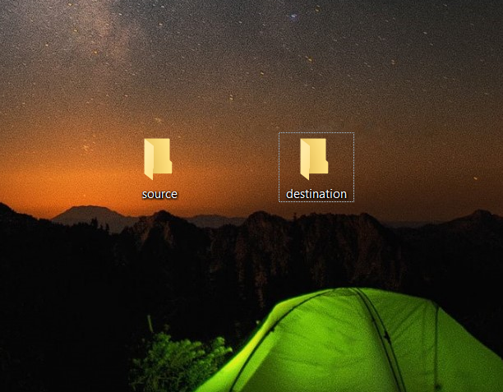

Step 2:

Add some files inside source to automate it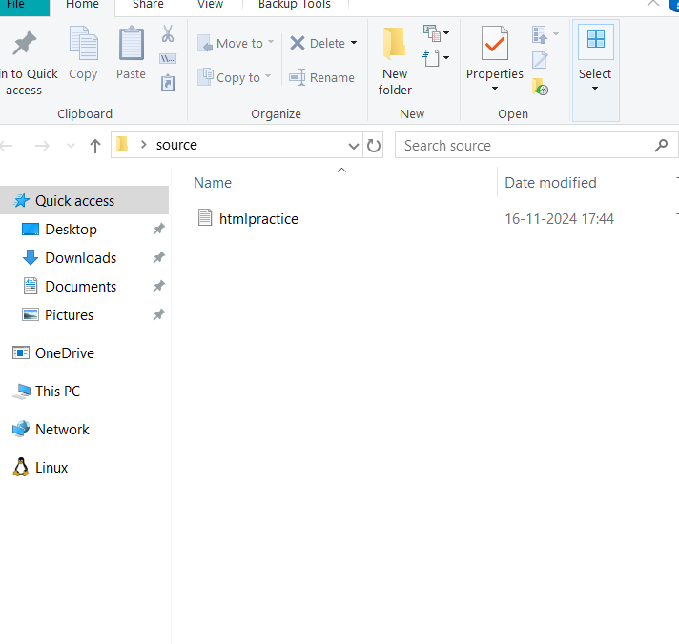

Step 3:

Open Notepad and write the code to set the SOURCE to source folder and DESTINATION to dest folder. Save the file with .bat extension. Ex: index.bat

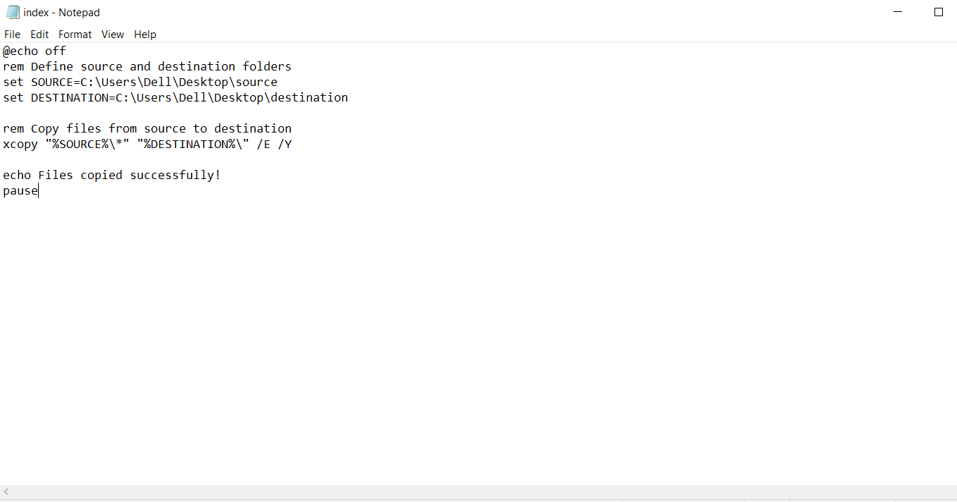

Step 4:

Press Win+R on your keyboard, a “Run” dialog box appears. Type “taskschd.msc” in the Run box and click OK. This will open task scheduled window

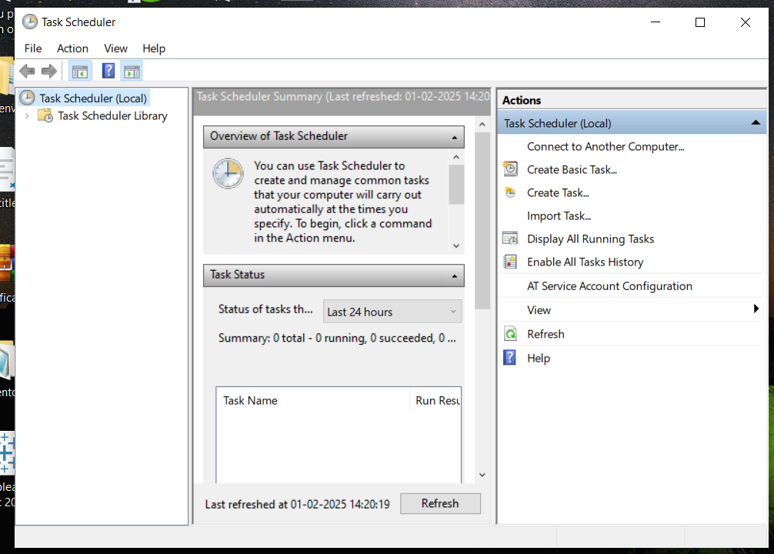

Step 5:

Select create basic task (shown above) on the RHS. A wizard will open to guide you through the set up.

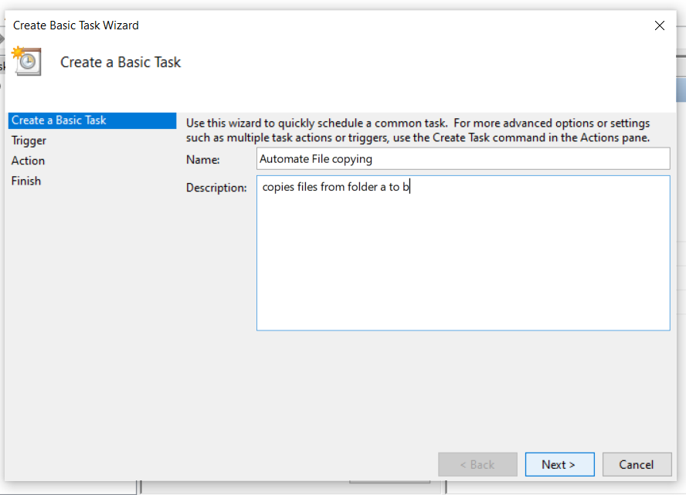

Step 6:

Enter the name and description of the task as shown above.

Step 7:

Choose a schedule

Choose what works for you and click Next

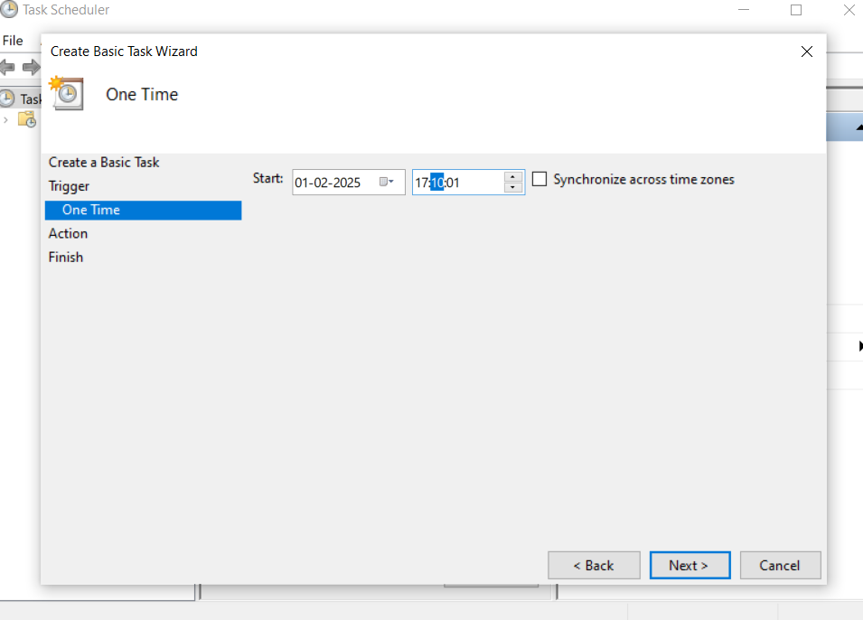

Step 8:

Choose the time and frequency as shown above.

Click Next

Step 9:

Set the action to “Start a program”

Click Next

Point to the program, click browse and navigate to the .bat file you created.

Click next

Review and Finish

Step 10:

Go to Task Scheduler Library , Find your task for ex: Automate File Copying.

Right click and select run.This will manually trigger the task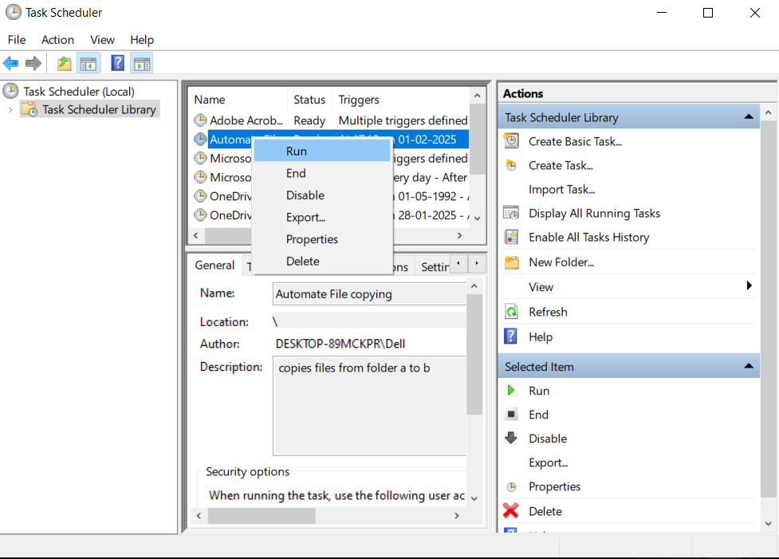

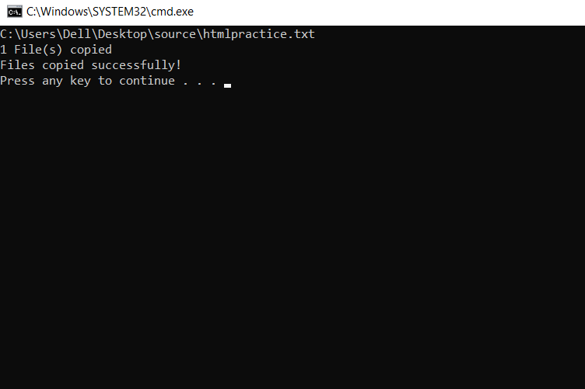

Step 11:

Check Destination folder,

The files have been copied successfully.

