**PLACEMENT EMPOWERMENT PROGRAM**

**CLOUD COMPUTING AND DEVOPS CENTRE**

Host a static website locally; Set up a Local Server Apache and Host a simple HTML page with your name

NAME: SHARUKA S

DEPT: ADS-ENGG

Introduction :

In this POC, we will learn how to host a static website using the Apache HTTP server. This process involves setting up a local web server, configuring it correctly and hosting a simple html page. By following these steps, you’ll get handson experience with configuring and running a local Apache server , which is a foundational skill for web hosting and server management.

Steps:

Step 1:

Search for “Apache Lounge” in Google and click the first link to download and access the latest version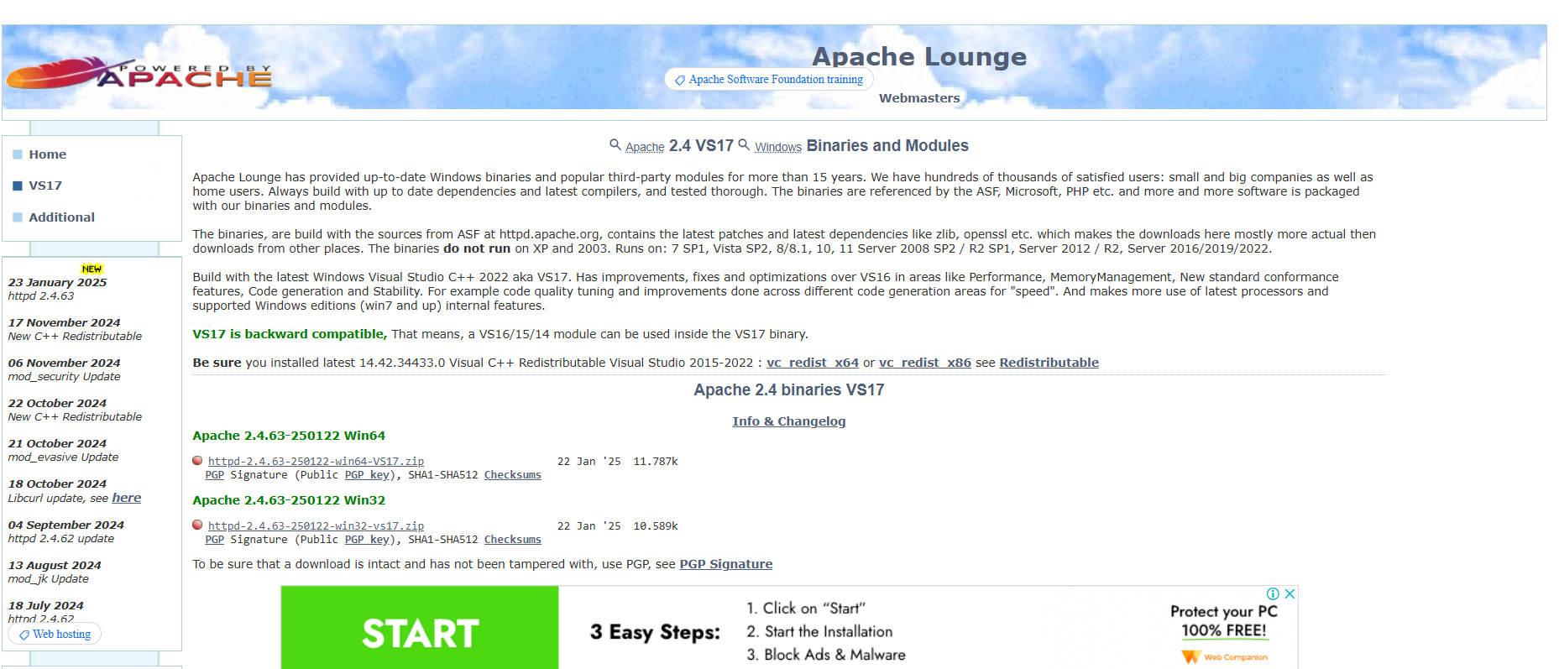

Step 2:

Open the Command Prompt as Administrator (Windows+R, type cmd, right click and select ‘Run as Administrator). Use cd to set path to Apache bin folder.

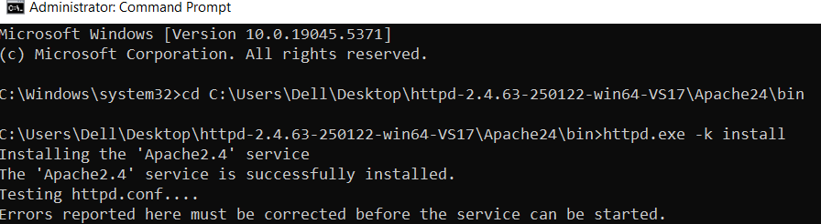

Step 3:

Run the installation command: httpd.exe -k install

(as shown above)

Step 4:

Navigate to the Apache folder you downloaded, go to the config folder > right click httpd conf file > open with notepad

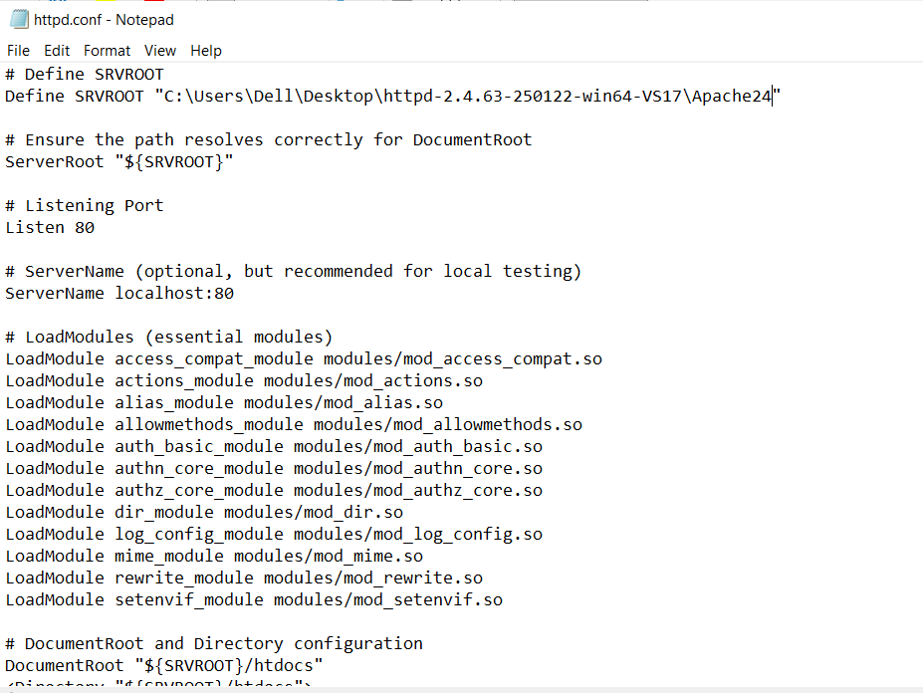

Step 5:

Inside the httpd.conf file, replace the content with the provided config. Save the file.Refer the above image.

Step 6:

Open command prompt and type: httpd.exe -t to test the config file, if it is correct , it displays, “SYNTAX OK”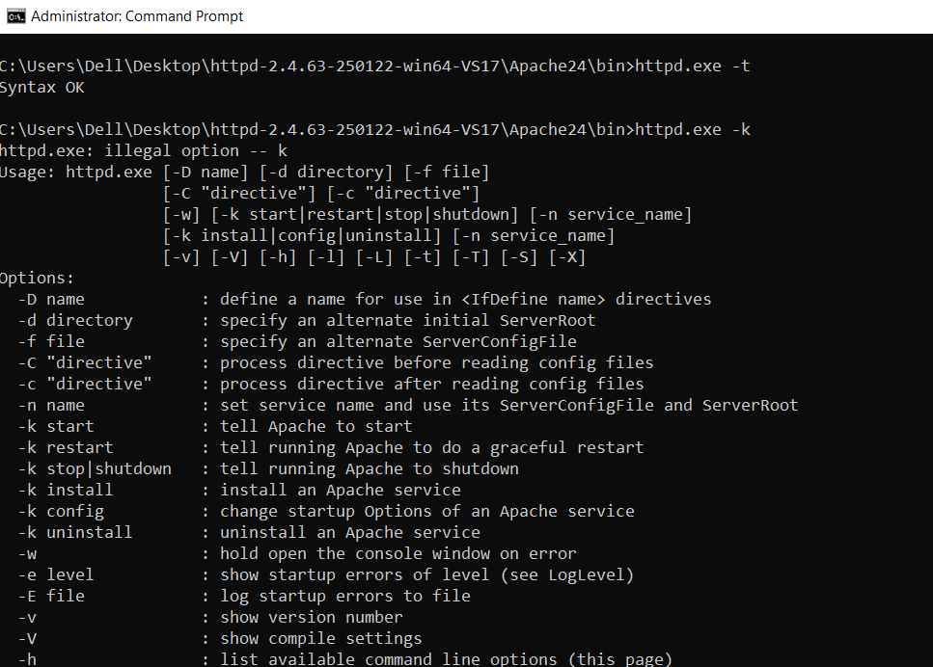

Step 7:

Once you verified if it’s the correct config, type the following command to start: httpd.exe -k start

Refer the above image.

Step 8:

Go to the Apache folder, navigate to the htdocs folder > index.html file>right click>edit with vscode

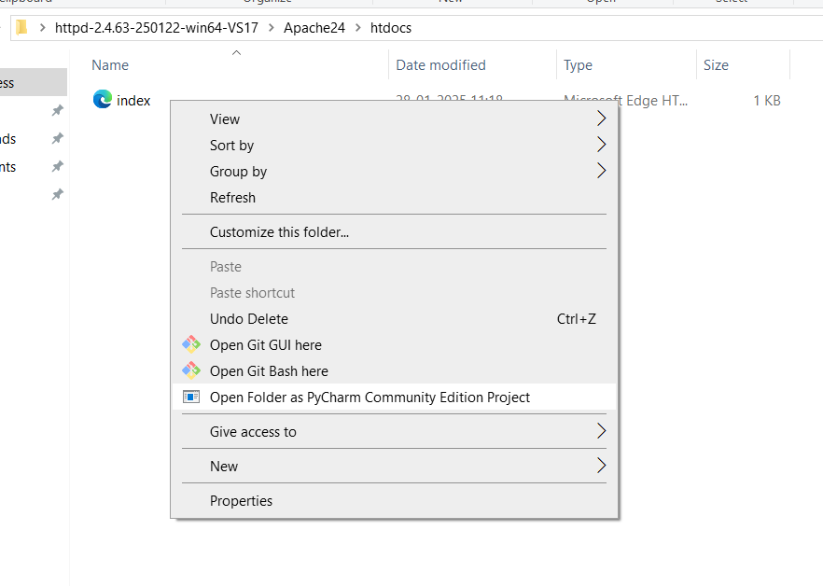

Step 9:

Inside the index.html file create a simple mode to display your name

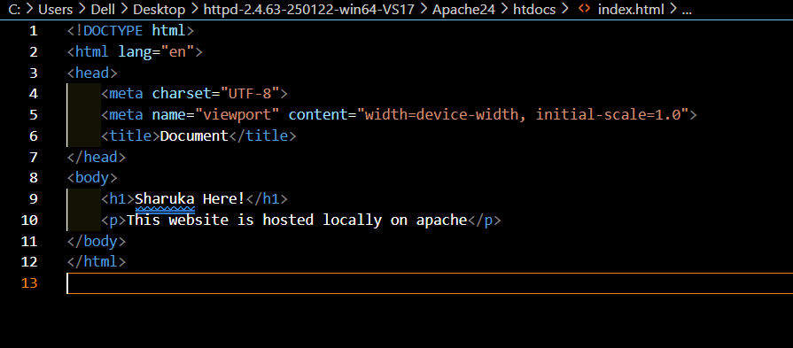

Step 10:

Save the file, open the chrome browser and enter localhost/index.html in the address bar. You should be able to see the website hosted successfully.