**PLACEMENT EMPOWERMENT PROGRAM**

**CLOUD COMPUTING AND DEVOPS CENTRE**

Set Up a Private Network in the Cloud : Create a Virtual Private Cloud (VPC) with subnets for your instances.

Configure routing for internal communication between subnets.

Name: SHARUKA S Department: ADS

Step 1:

In the **VPC Dashboard**, click the **Create VPC** button.

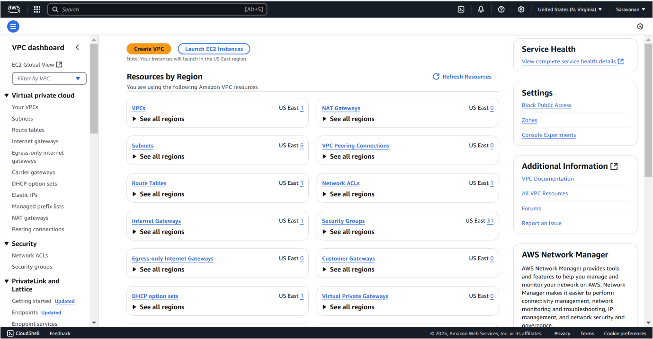

In the VPC creation wizard, select **VPC only**.

**Name tag**: Enter MyVPC .

**IPv4 CIDR block**: Enter 10.0.0.0/16 (this defines the IP range for your VPC).

**Tenancy**: Leave it as **Default**.

Click **Create VPC**.

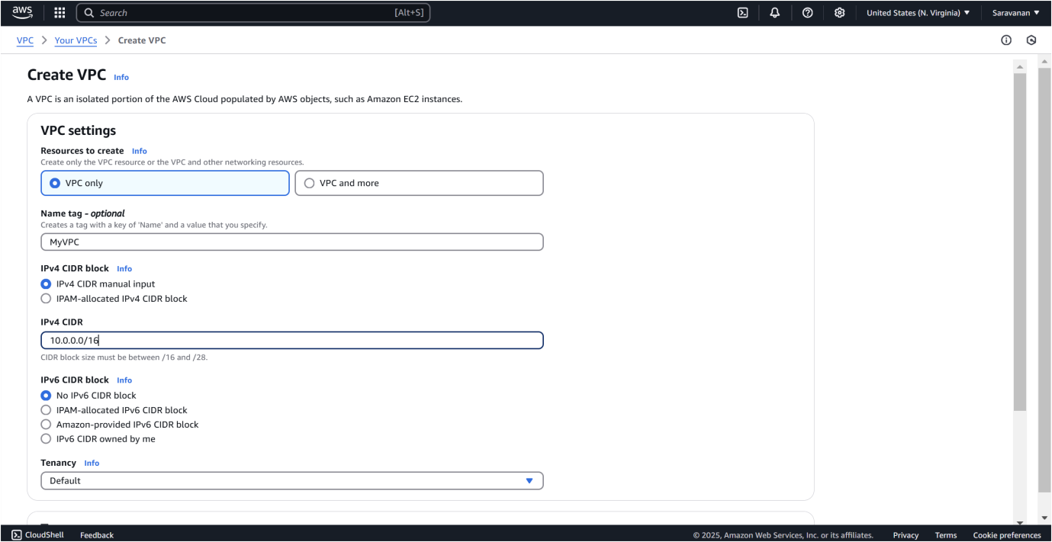

Step 3:

In the **VPC Dashboard**, click on **Subnets** in the left-hand menu.

Click the **Create subnet** button.

**VPC**: Select MyVPC (the one you just created).

**Subnet name**: Enter Private-Subnet.

**Availability Zone**: Pick any (e.g., us-east-1a or any zone from your region).

**IPv4 CIDR block**: Enter 10.0.1.0/24 (this is a smaller range within the VPC's IP range).

Click **Create subnet**.

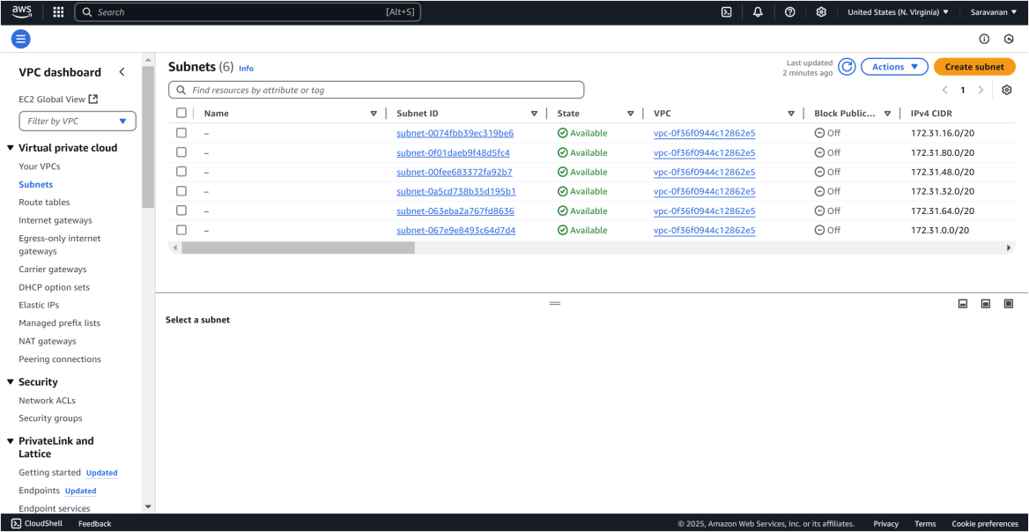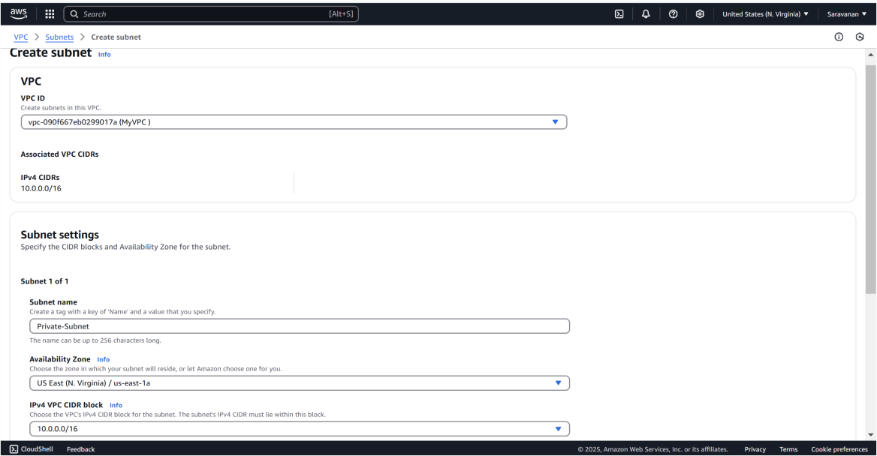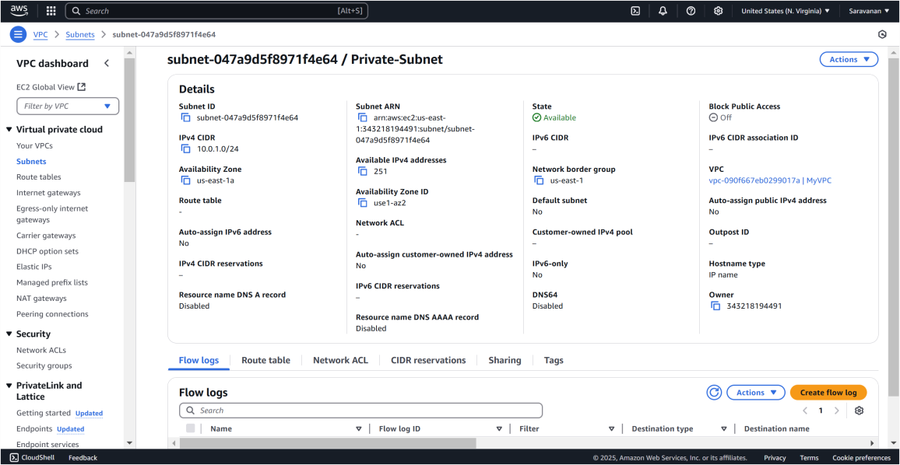

In the **VPC Dashboard**, click on **Route Tables** in the left-hand menu. Click **Create route table**.

**Name tag**: Enter InternalRouteTable.

**VPC**: Select MyVPC (the one you created earlier).

Click **Create route table**.

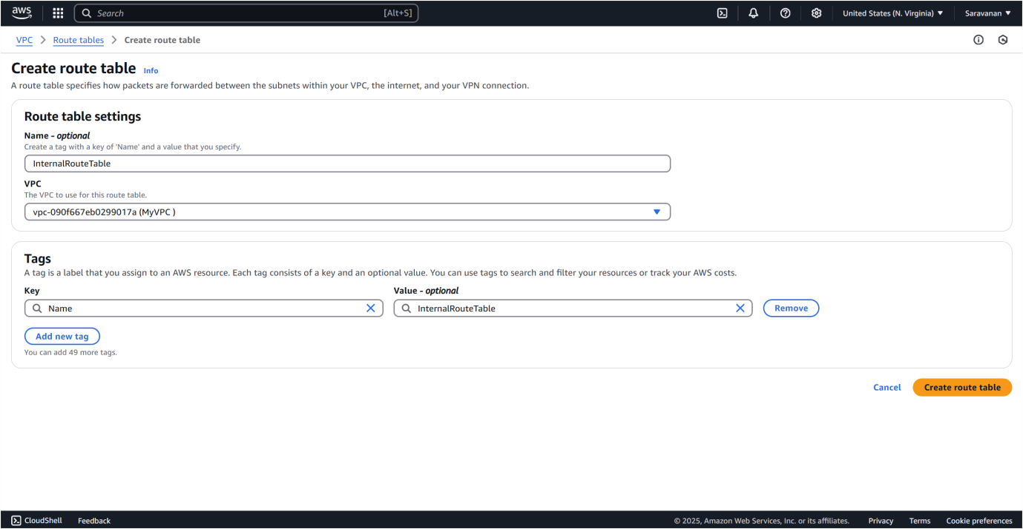

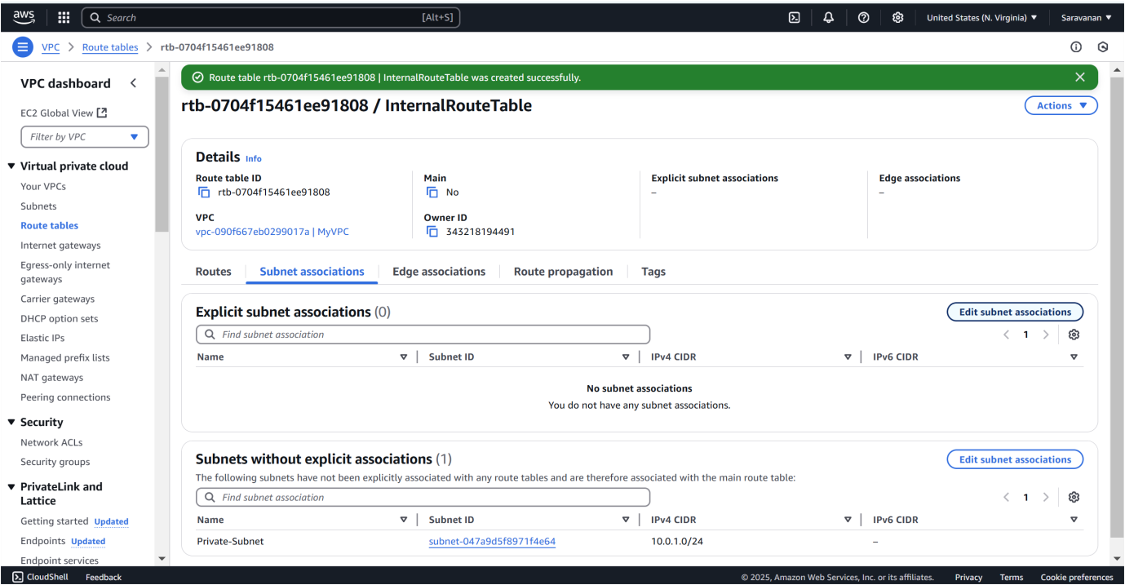

Step 6:

Select the InternalRouteTable you just created.

Go to the **Subnet Associations** tab (it’s near the bottom).

Click **Edit subnet associations**.

Select Private-Subnet (the subnet you created earlier).

Click **Save associations**.

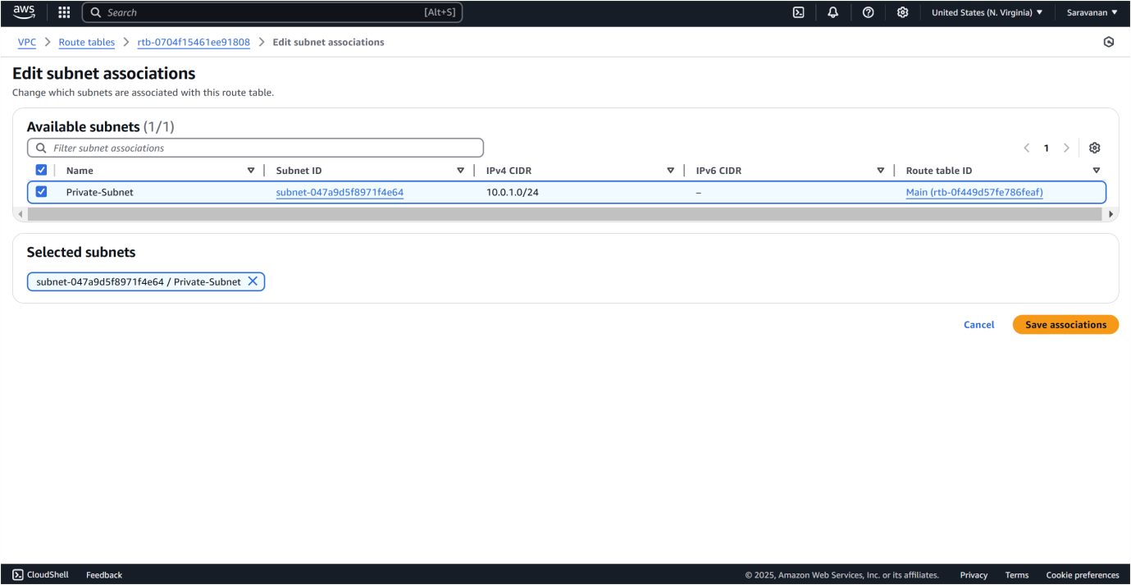

To launch a new EC2 instance in your private subnet, go to the EC2

Dashboard, click **Launch Instance**, and fill in the details: Name it "Private-Instance", choose an Amazon Linux 2 AMI (or another freetier eligible image), select the **t2.micro** instance type, and either choose an existing key pair or create a new one for SSH access. Under **Network settings**, select your **MyVPC** and **Private-Subnet**, and make sure **Auto-assign Public IP** is disabled to keep it private. Leave all other settings as default, then click **Launch Instance**.

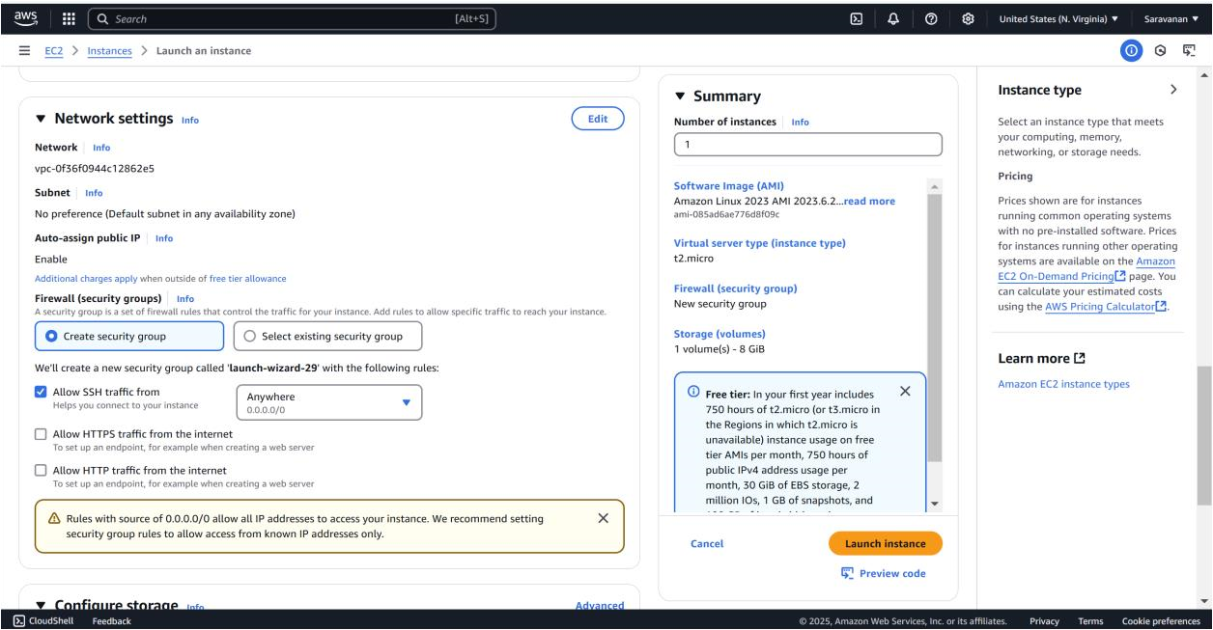

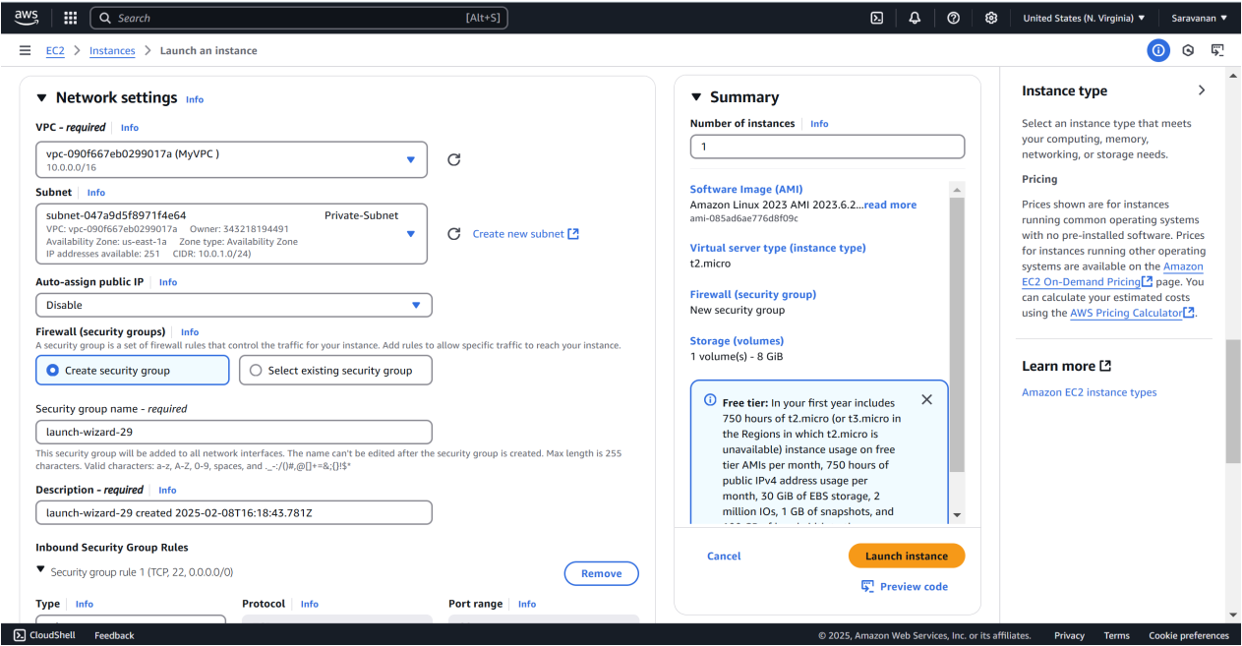

# Step 8: Verify Internal Communication

1. **Find the private IP of your instance**:

Go to the **EC2 Dashboard**.

Select your instance in Private-Subnet.

Note the **Private IPv4 address** (e.g., 10.0.1.x).

1. **Ping the Private IP**:

If you have only one instance, you can skip this. If you have multiple instances in the private subnet, SSH into one instance and try pinging the private IP of the other instance.