**Placement Empowerment Program**

***Cloud Computing and DevOps Centre***

Secure Access with a Bastion Host : Set up a bastion host in a public subnet to securely access instances in a private subnet.

Name: SHARUKA S Department: ADS

**Step** 1:

1. Go to [AWS Management Console.](https://aws.amazon.com/console/)
2. Enter your username and password to log in.

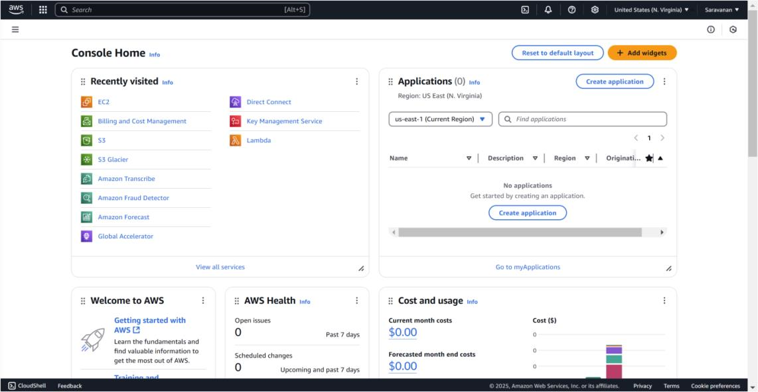

Step 2:

Search for **VPC** in the AWS search bar and click on it.

Click on **Create VPC**.

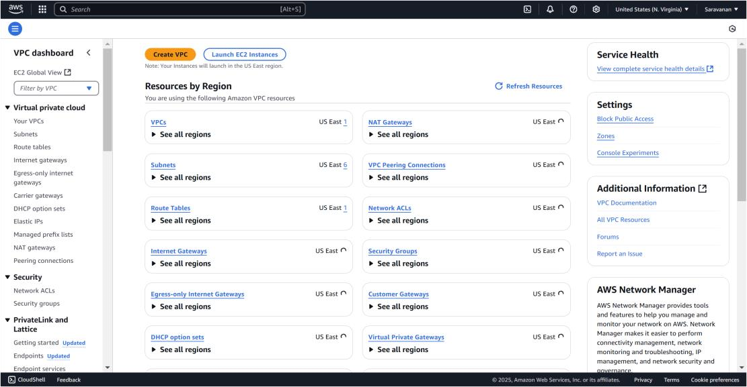

Step 3:

Create a new VPC by selecting **VPC only** and filling in the following details: set the **Name Tag** as *MyBastionVPC* and the **IPv4 CIDR**

**Block** as *10.0.0.0/16*. Leave all other settings as default, then click

**Create VPC**. Once created, the new VPC will appear in the VPC list.

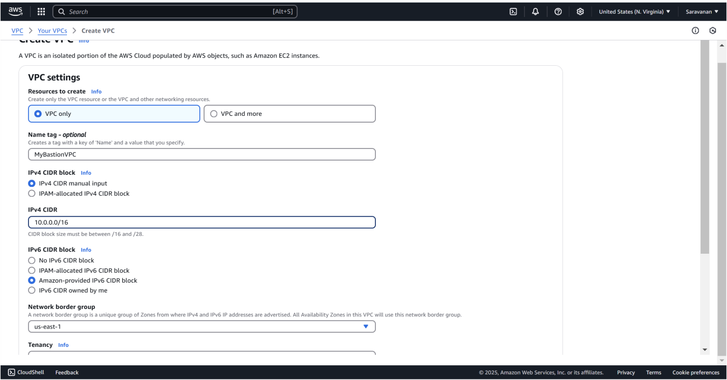

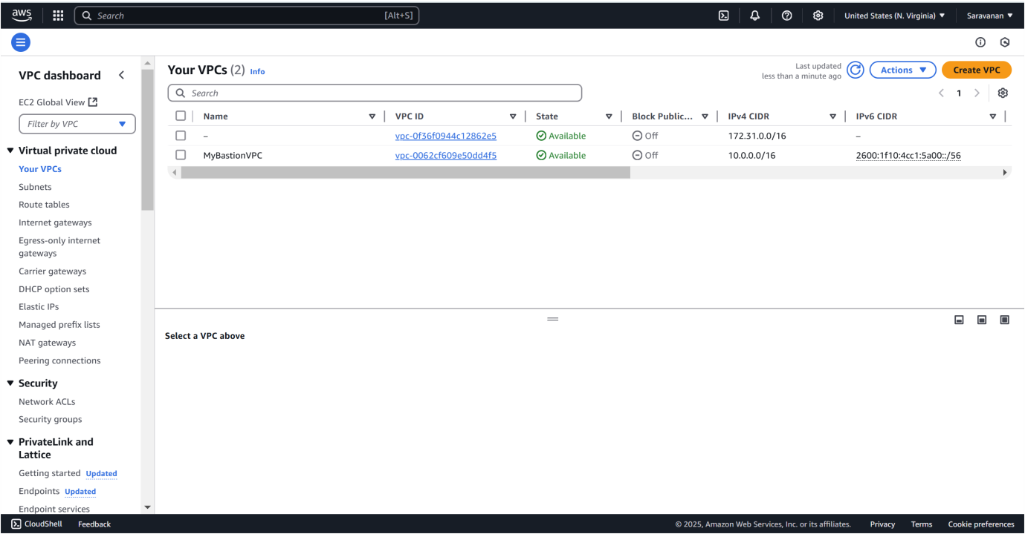

Step 4:

In the **VPC Dashboard**, go to **Subnets** and click **Create Subnet**.

Select the **VPC ID** of the VPC you created earlier (*MyBastionVPC*). Enter the **Subnet Name** as *PublicSubnet*, choose an **Availability Zone** (e.g., *us-east-1a*), and set the **IPv4 CIDR Block** as *10.0.1.0/24*. Click **Create Subnet**.

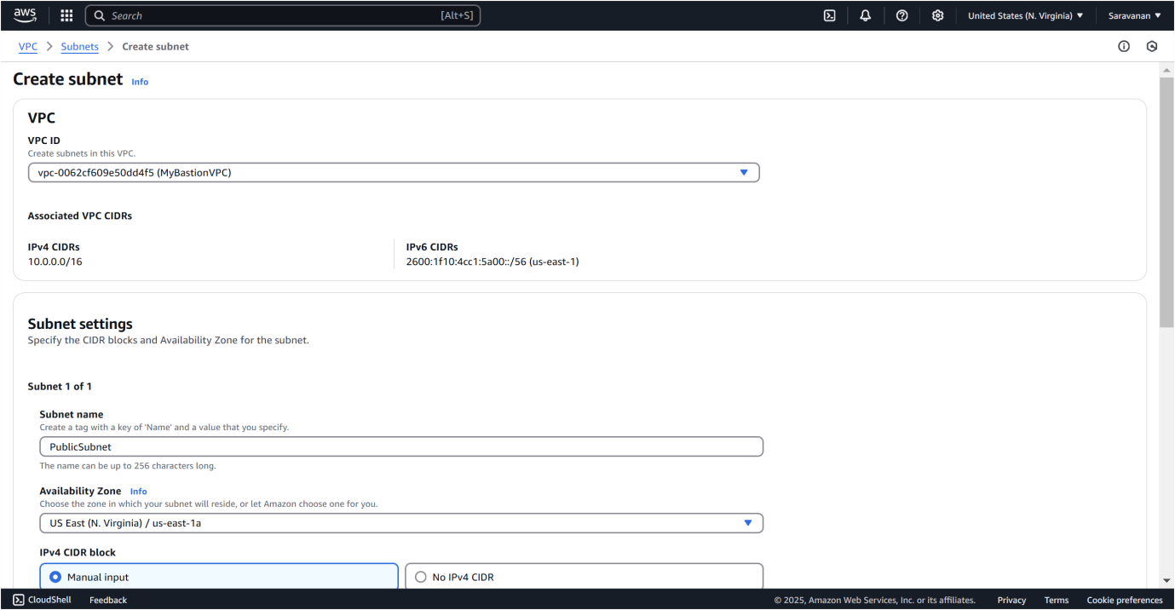

Step 5:

Select your **PublicSubnet** from the list, click **Actions → Modify auto-assign IP settings**, check **Enable auto-assign public IPv4 address**, and click **Save**.

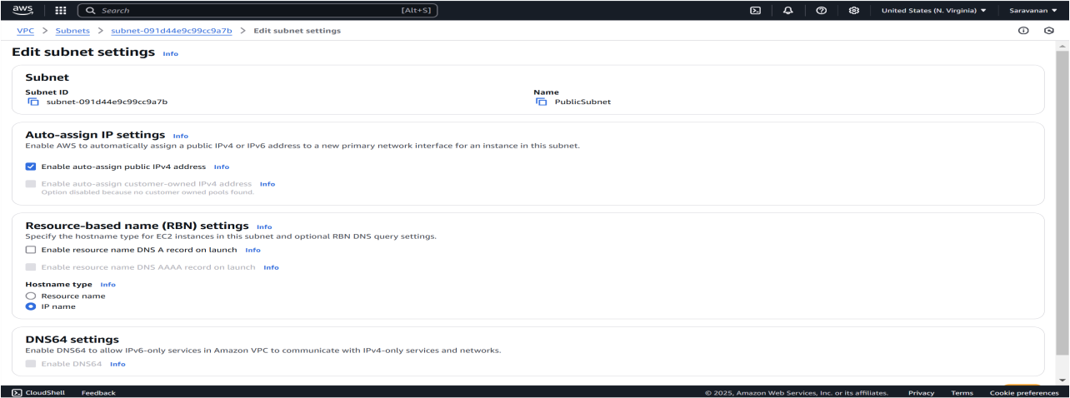

Click **Create Subnet** again and fill in the details: select the same **VPC ID** (*MyBastionVPC*), set **Subnet Name** to *PrivateSubnet*, use the same **Availability Zone** as the public subnet (e.g., *us-east-1a*), and set the **IPv4 CIDR Block** to *10.0.2.0/24*. Leave **auto-assign public IP** disabled and click **Create Subnet**.

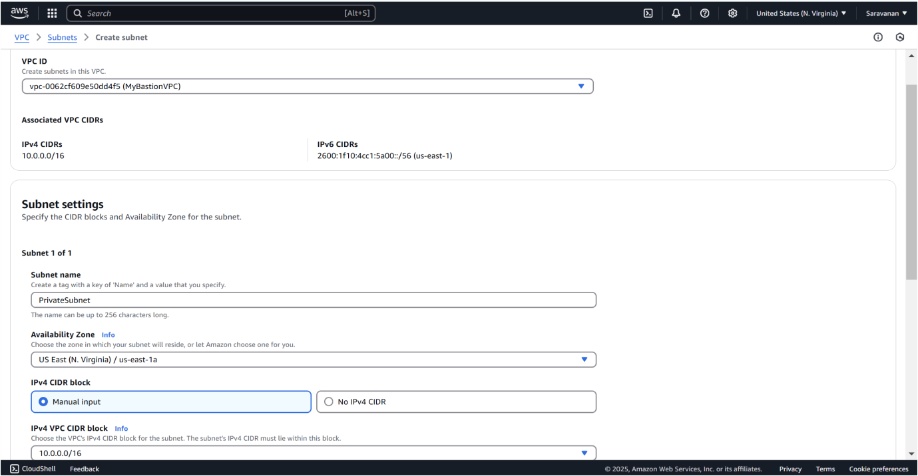

Step 7:

In the **VPC Dashboard**, go to **Internet Gateways** and click **Create**

**Internet Gateway**. Name it *MyInternetGateway* and click **Create**

**Internet Gateway**. Select your new gateway, click **Actions → Attach to VPC**, choose your VPC (*MyBastionVPC*), and click **Attach Internet Gateway**.

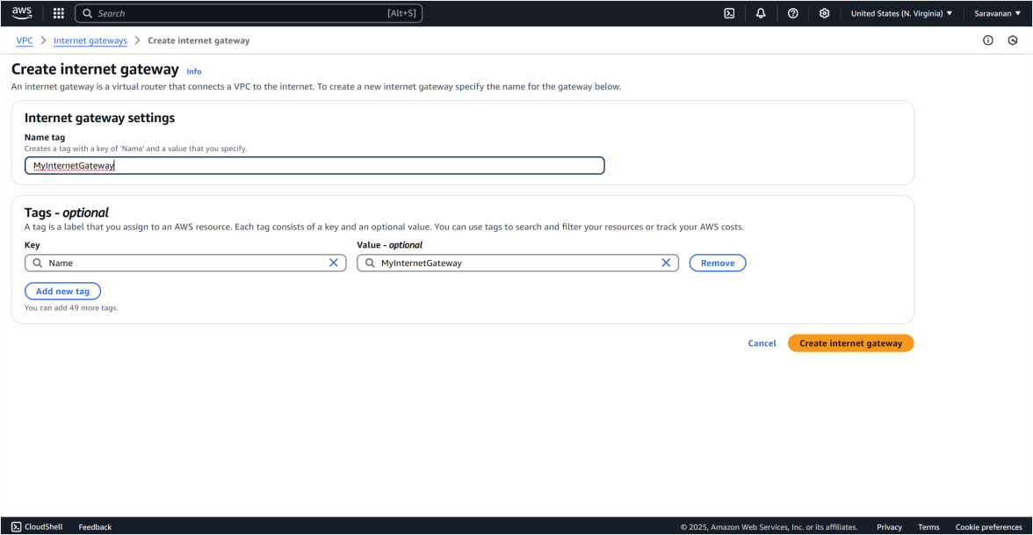

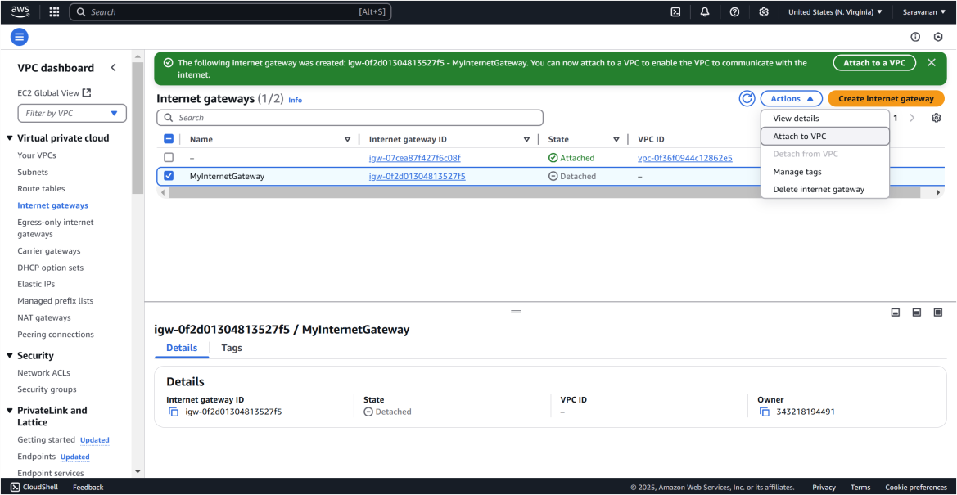

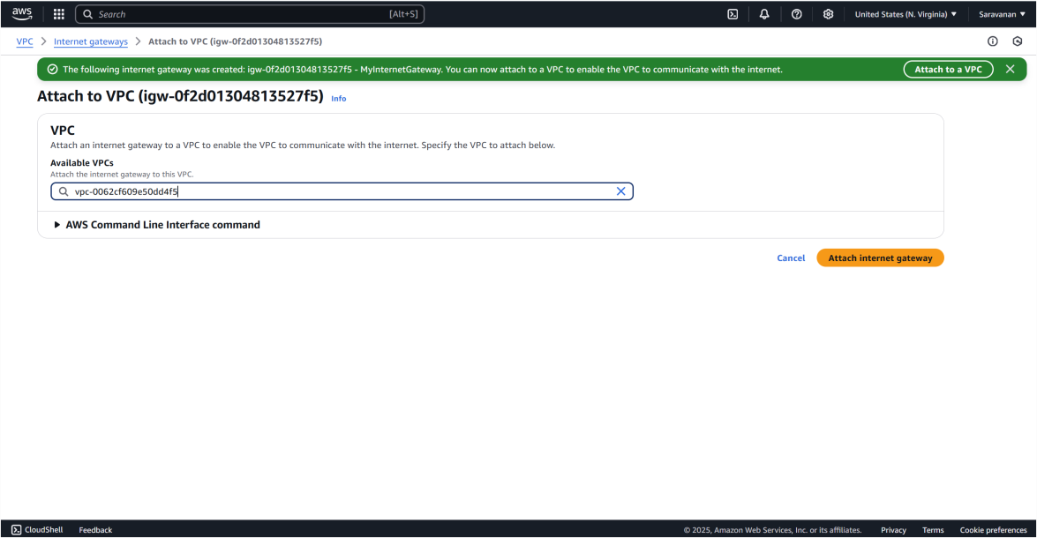

In the **VPC Dashboard**, go to **Route Tables** and click **Create Route Table**. Name it *PublicRouteTable*, select your VPC (*MyBastionVPC*), and click **Create Route Table**. Then, select *PublicRouteTable*, go to the **Routes** tab, click **Edit routes**, and add a route with **Destination** as *0.0.0.0/0* and **Target** as *MyInternetGateway*. Click **Save changes**.

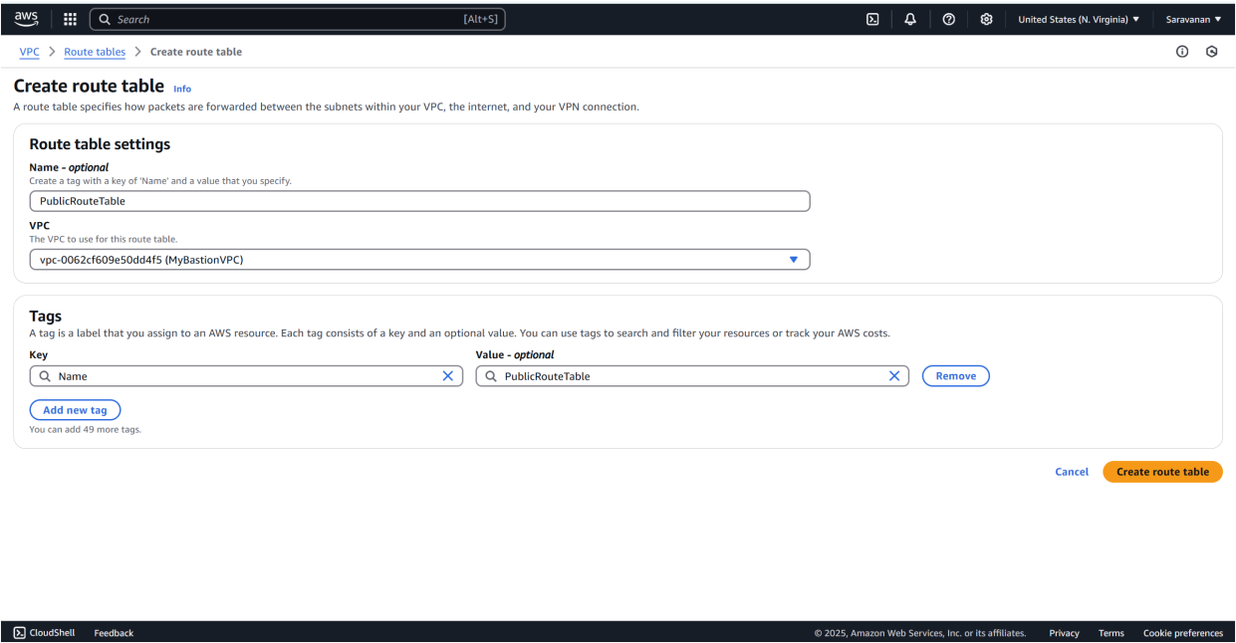

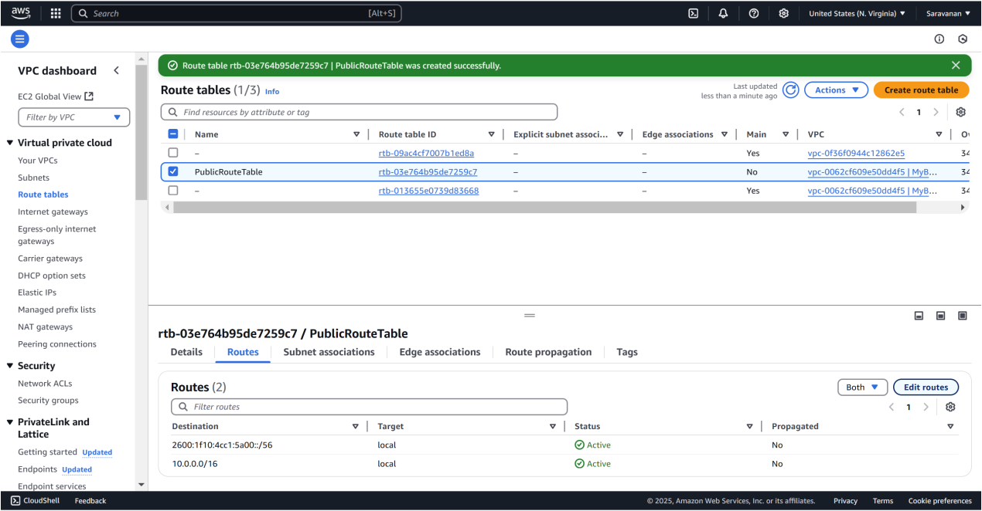

Next, go to the **Subnet associations** tab of *PublicRouteTable*, click **Edit subnet associations**, check the box for *PublicSubnet*, and click **Save associations**.

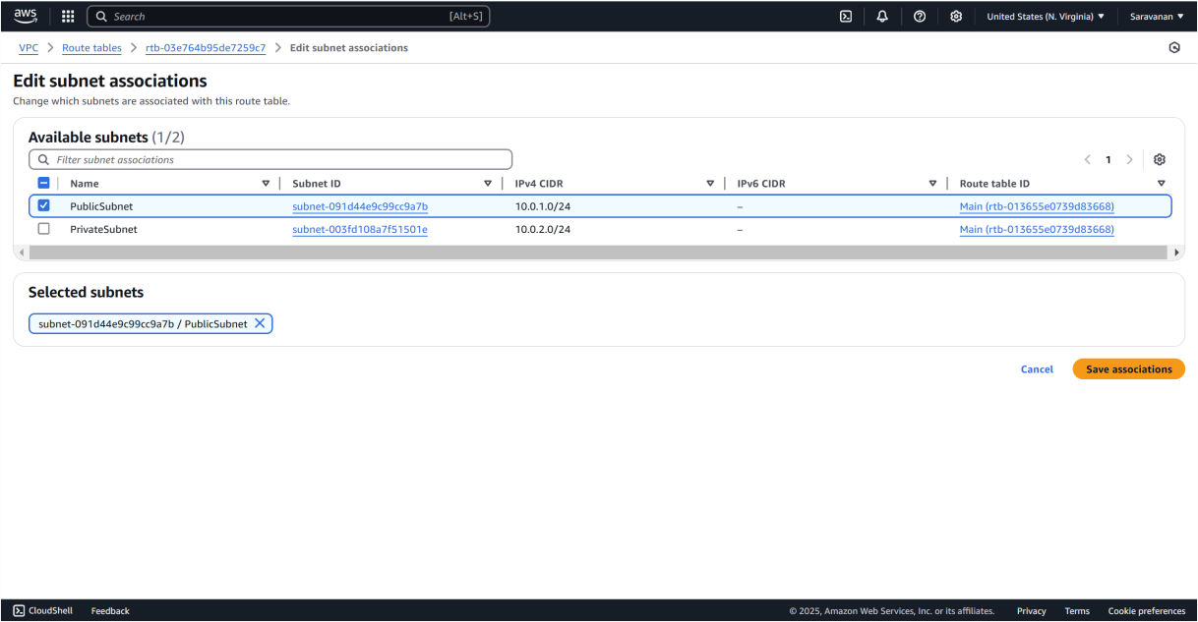

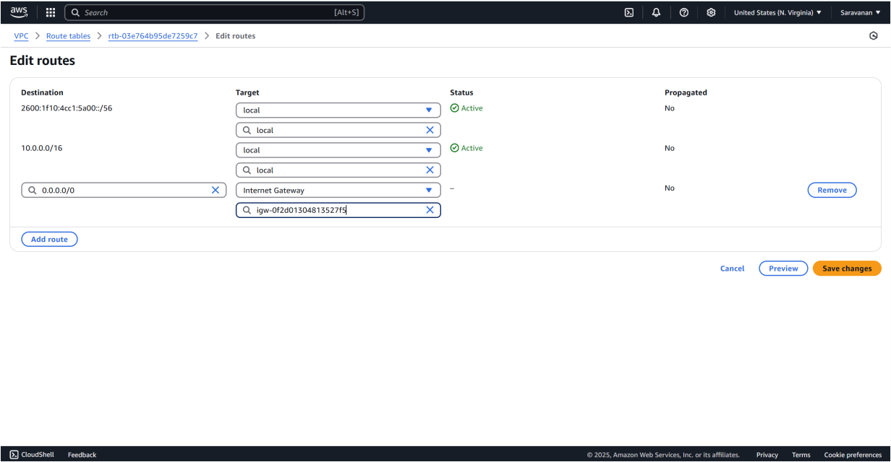

In the **EC2 Dashboard**, click **Launch Instance** and configure: set **Name** as *BastionHost*, select *Amazon Linux 2 AMI (HVM)* - Free Tier eligible, and choose **t2.micro** as the **Instance Type**. For **Key Pair**, create or select one, downloading the .pem file if creating. Under **Network Settings**, select *MyBastionVPC* for the **VPC**, *PublicSubnet* for the **Subnet**, and ensure **Auto-assign Public IP** is enabled. Create a **Security Group** to allow SSH (port 22) access, setting **Source** to *MyIP*. Use the default storage of 8 GiB, click **Launch Instance**, and wait for it to initialize.

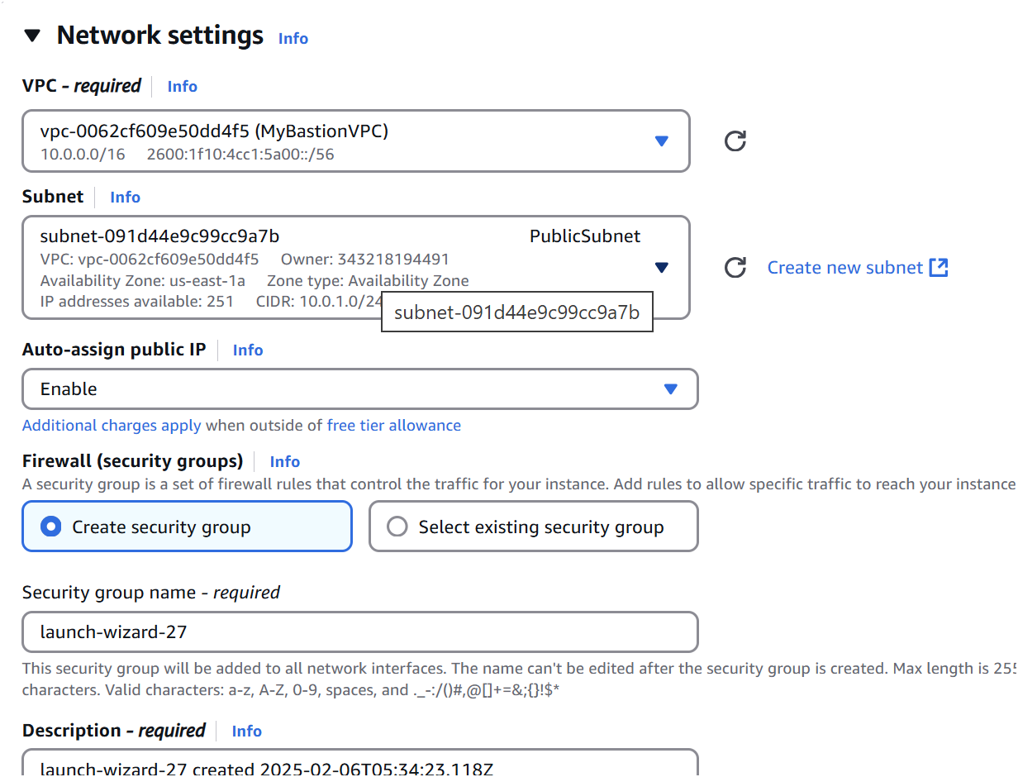

Step 10:

Connect with your PowerShell terminal by copying the ssh command in the SSH client of the *BastionHost(Ec2).*

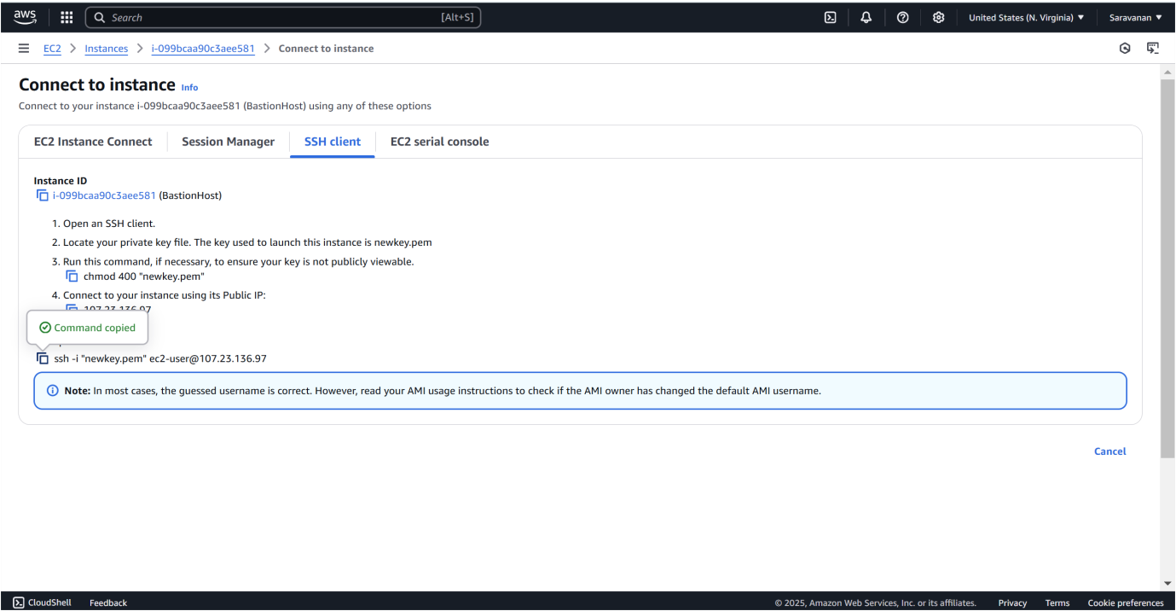

Step 11:

Paste the command copied in the SSH client and connect it by using your key pair.

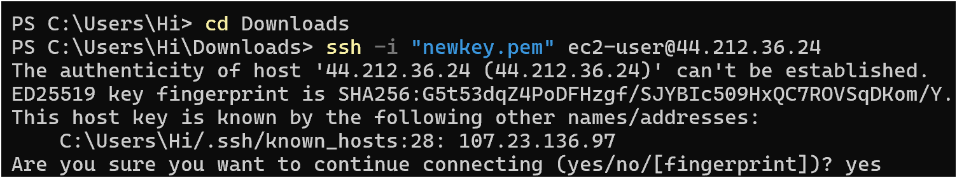

While connected to the bastion host, run this command to create a .ssh folder:



Step 13:

On your local machine, upload the key file to the bastion host

**scp -i /path/to/your-key.pem /path/to/your-key.pem ec2user@<BastionHost-Public-IP>:~/.ssh/**



Step 14:

On the bastion host, run the following command to secure the key:



Step 15:

Use the private IP of the private instance (e.g., 10.0.2.x) and run: **ssh -i ~/.ssh/your-key.pem ec2-user@<PrivateInstance-PrivateIP>**

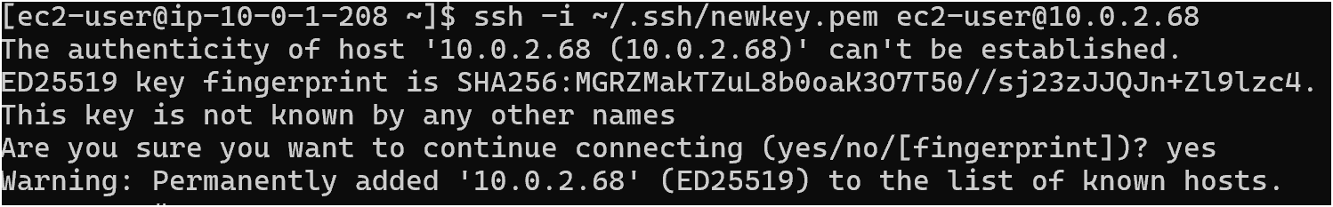

Step 16:

To verify network access and security, follow these steps:

1. **Check Internet Connectivity (Optional)**: If your private instance has internet access via a NAT gateway or instance, verify by running ping google.com. If there's no internet, it's fine as long as the private instance can communicate with the bastion host.
2. **Inspect Instance Details**: Connect to your private instance and run:

ohostname to check the instance hostname. oifconfig to verify the private IP address.

