**PLACEMENT EMPOWERMENT PROGRAM**

**CLOUD COMPUTING AND DEVOPS CENTRE**

Create a storage bucket in Cloud, upload and download files

NAME: SHARUKA S

DEPT: ADS-ENGG

STEPS:

Step1:

Create an S3 bucket

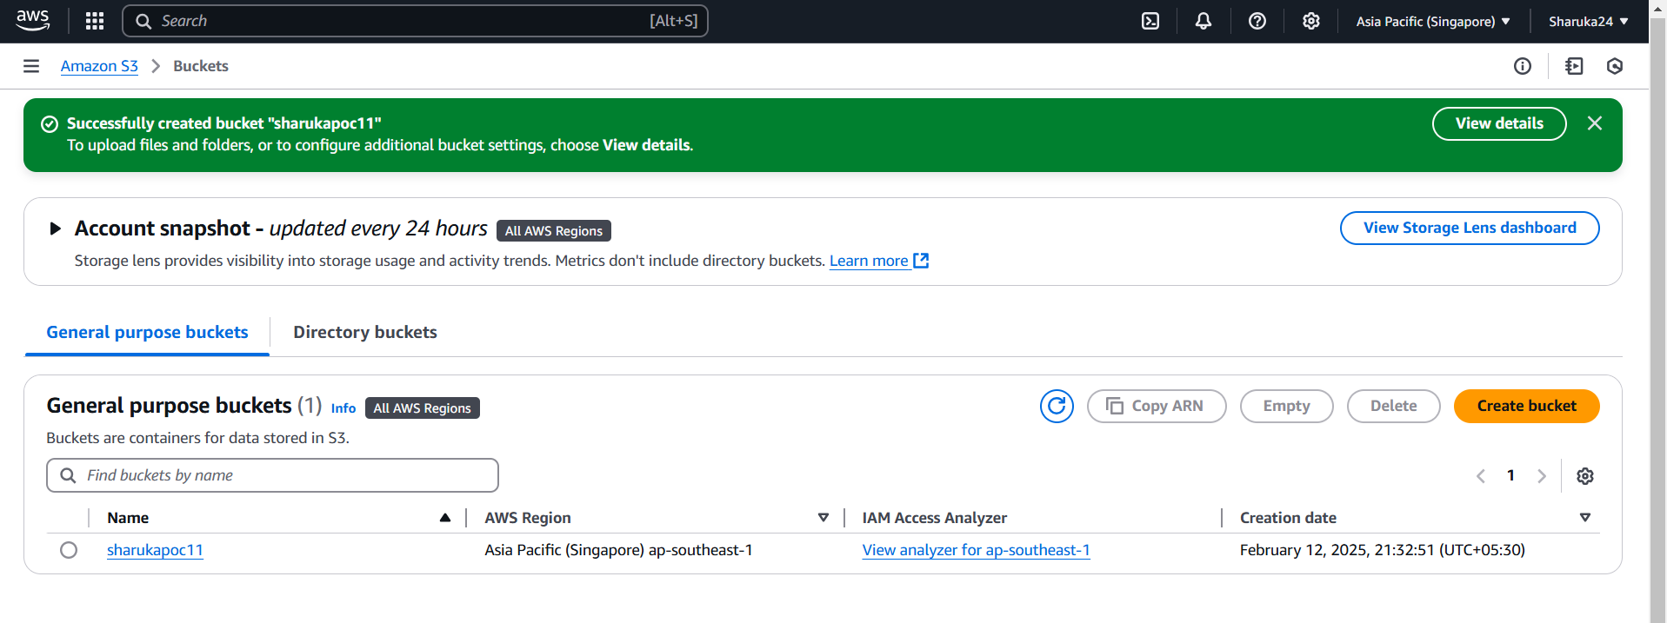

Step 2:

Select the bucket > Click upload > click add files > add a file and click upload

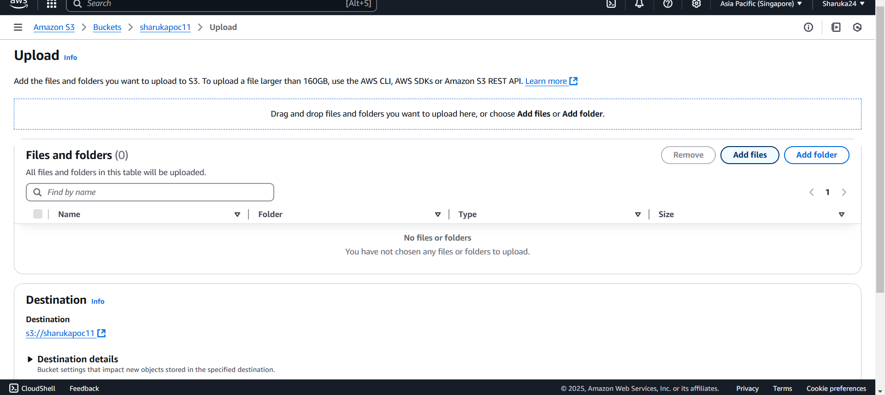

Step 3:

Navigate to the uploaded file > select it > click download

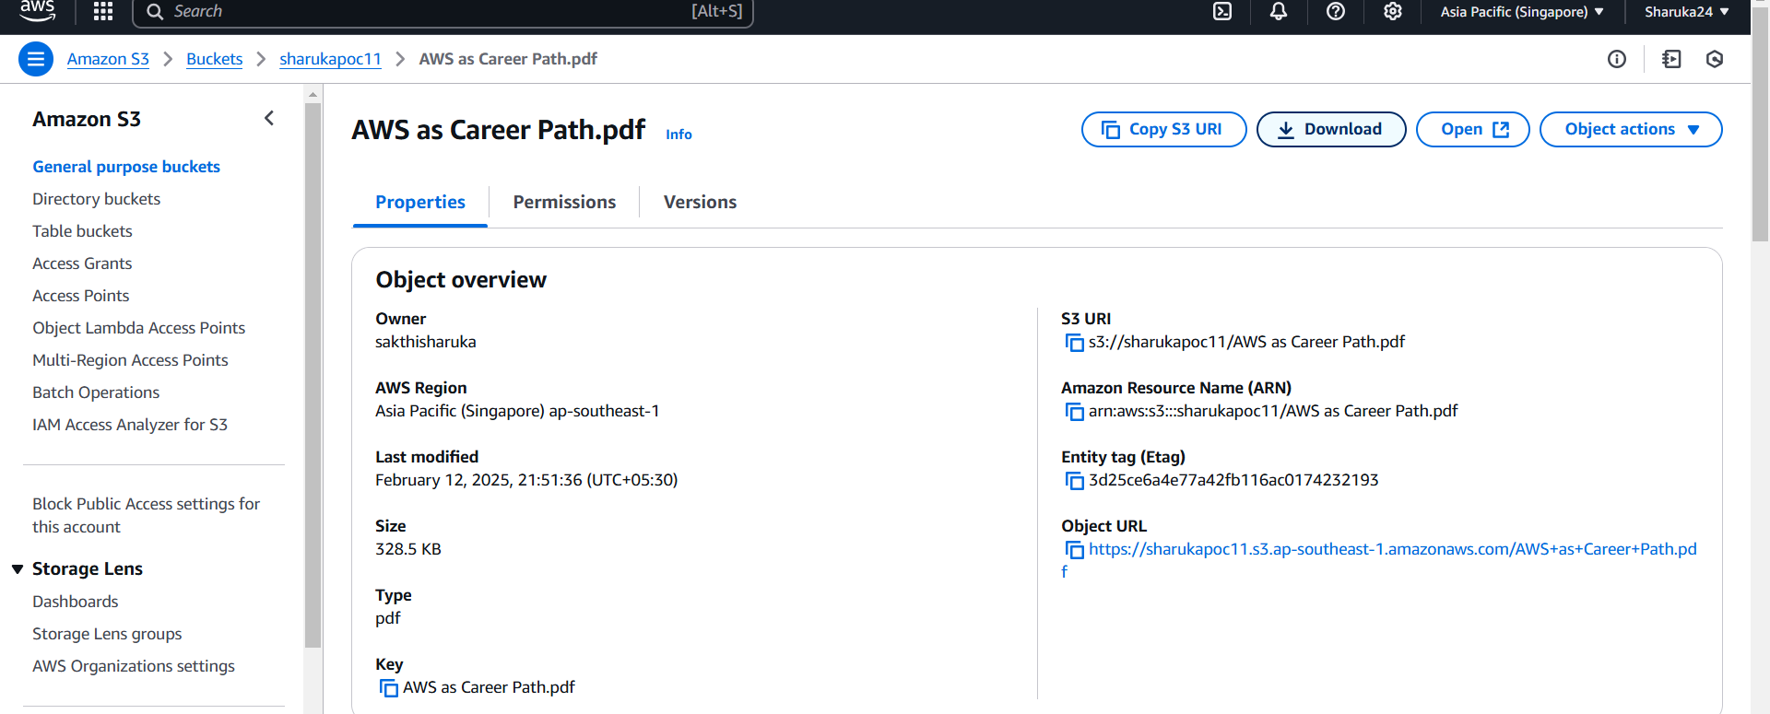

Step 4:

Navigate to the bucket and go to permissions. Edit public access and enable all public access permissions.

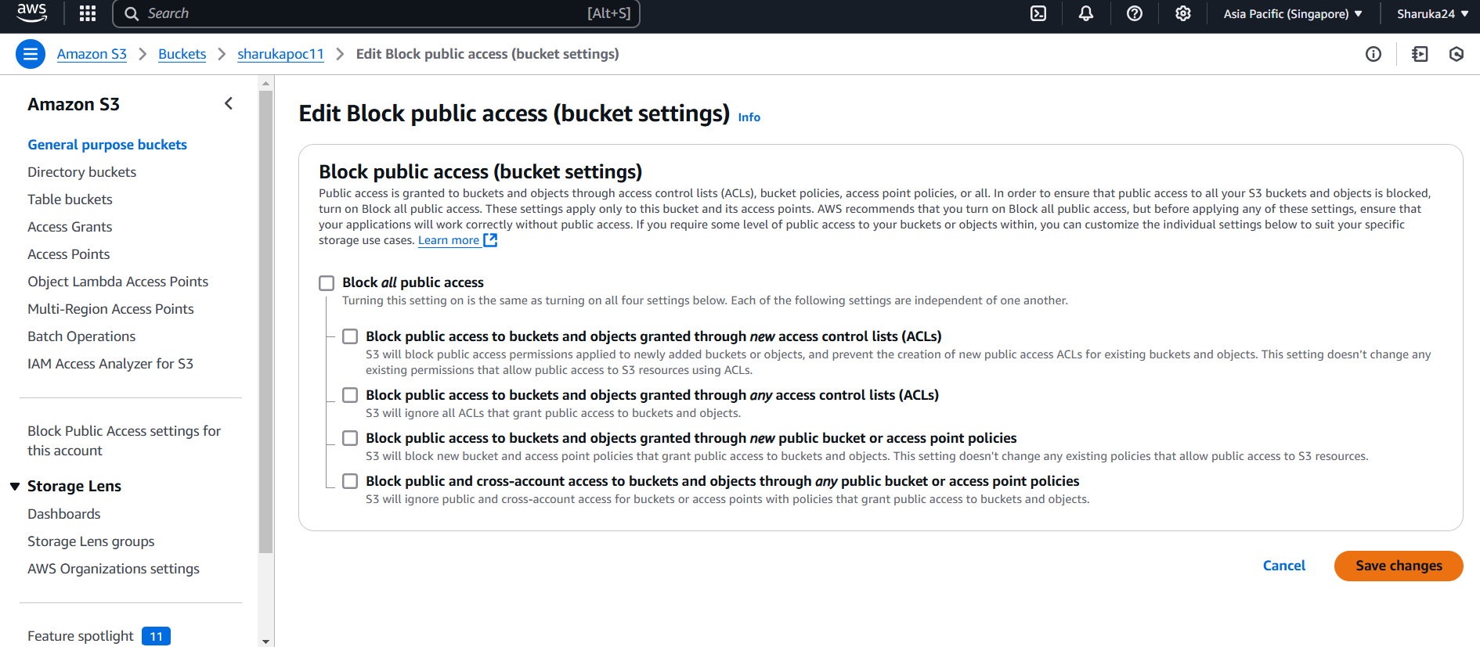

Step 5:

Now scroll down and edit the bucket policy as given below:

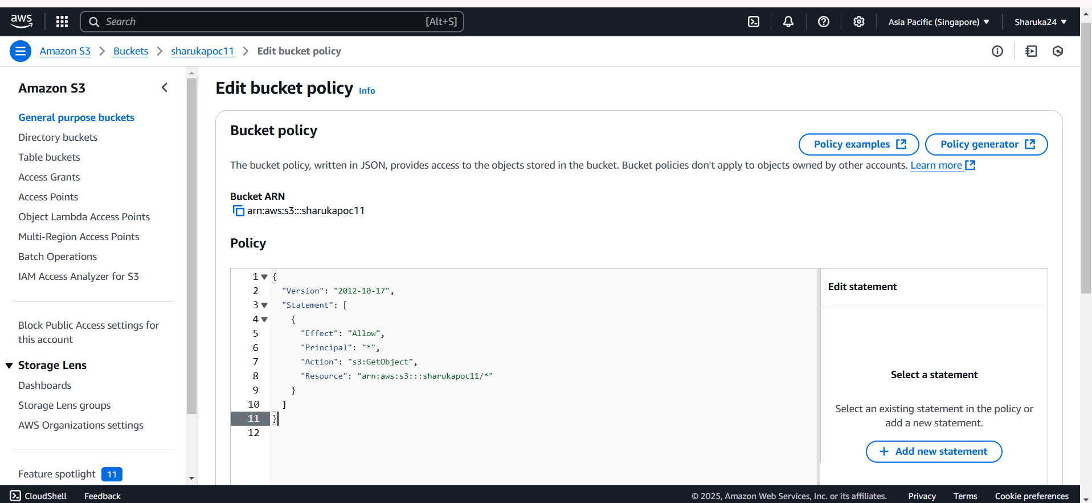

Step 6:

Navigate back to the bucket and copy the url . Paste the url in a new tab.

