**PLACEMENT EMPOWERMENT PROGRAM**

**CLOUD COMPUTING AND DEVOPS CENTRE**

Setup a cloud based monitoring service(Cloudwatch in AWS ) View metrics like CPU usage.

NAME: SHARUKA S

DEPT: ADS-ENGG

STEPS:

Step 1:

Launch an EC2 instance

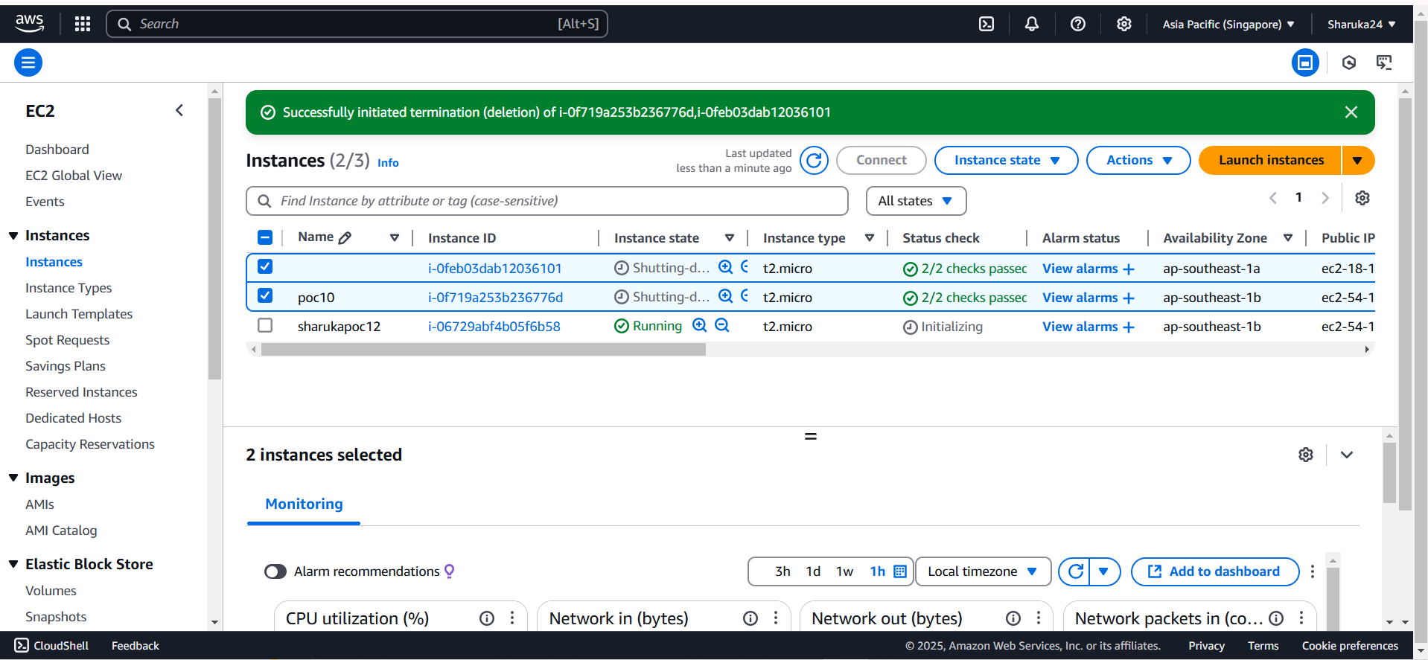

Step 2:

Go to Volumes in the EC2 dashboard below elastic block store. Create a volume

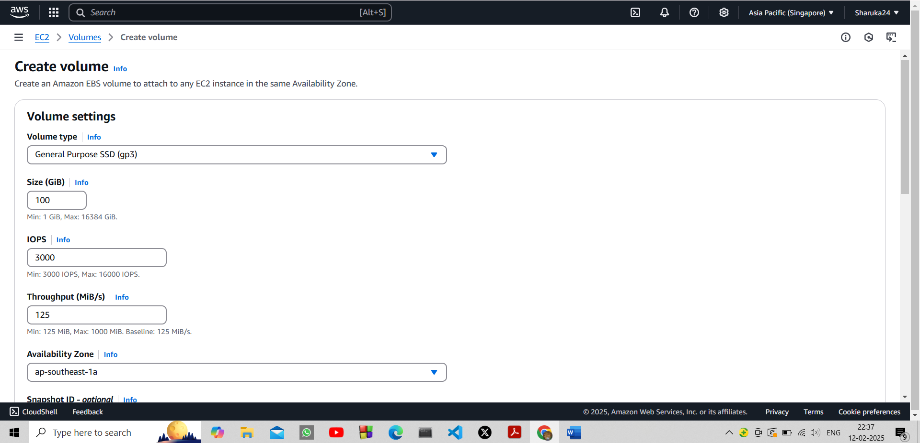

Step 3:

Navigate t the newly created volume and click attach volumes. Refer below:

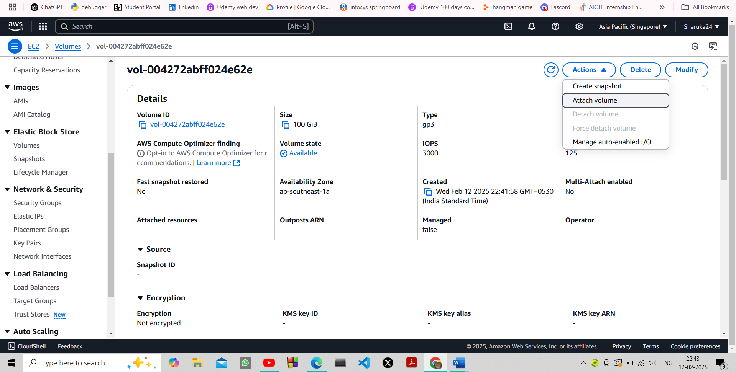

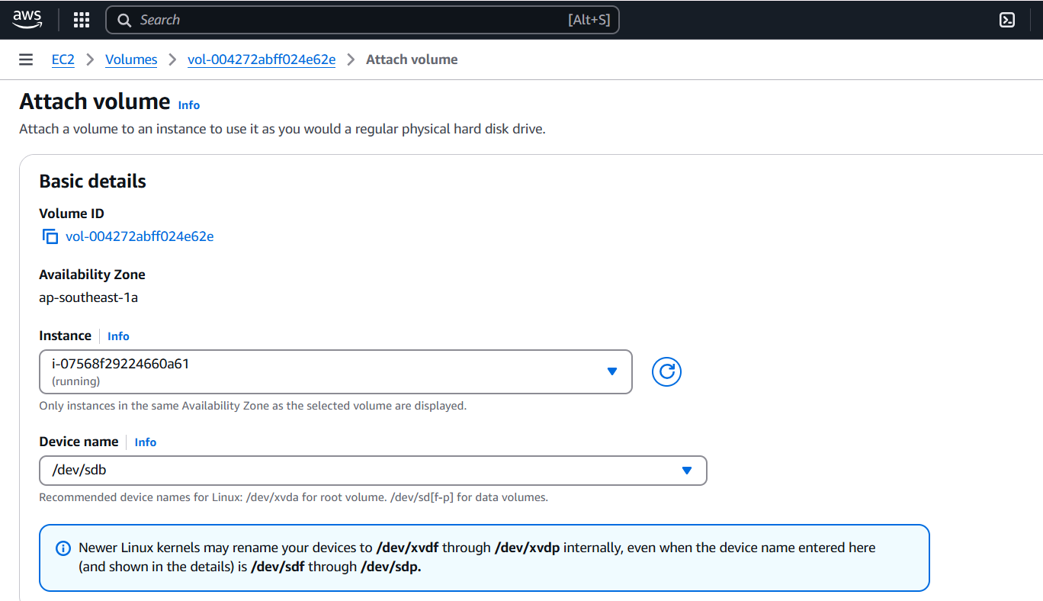

Step 4:

Search for cloudwatch > go to metrics > all metrics > select EC2 > per instance metrics.

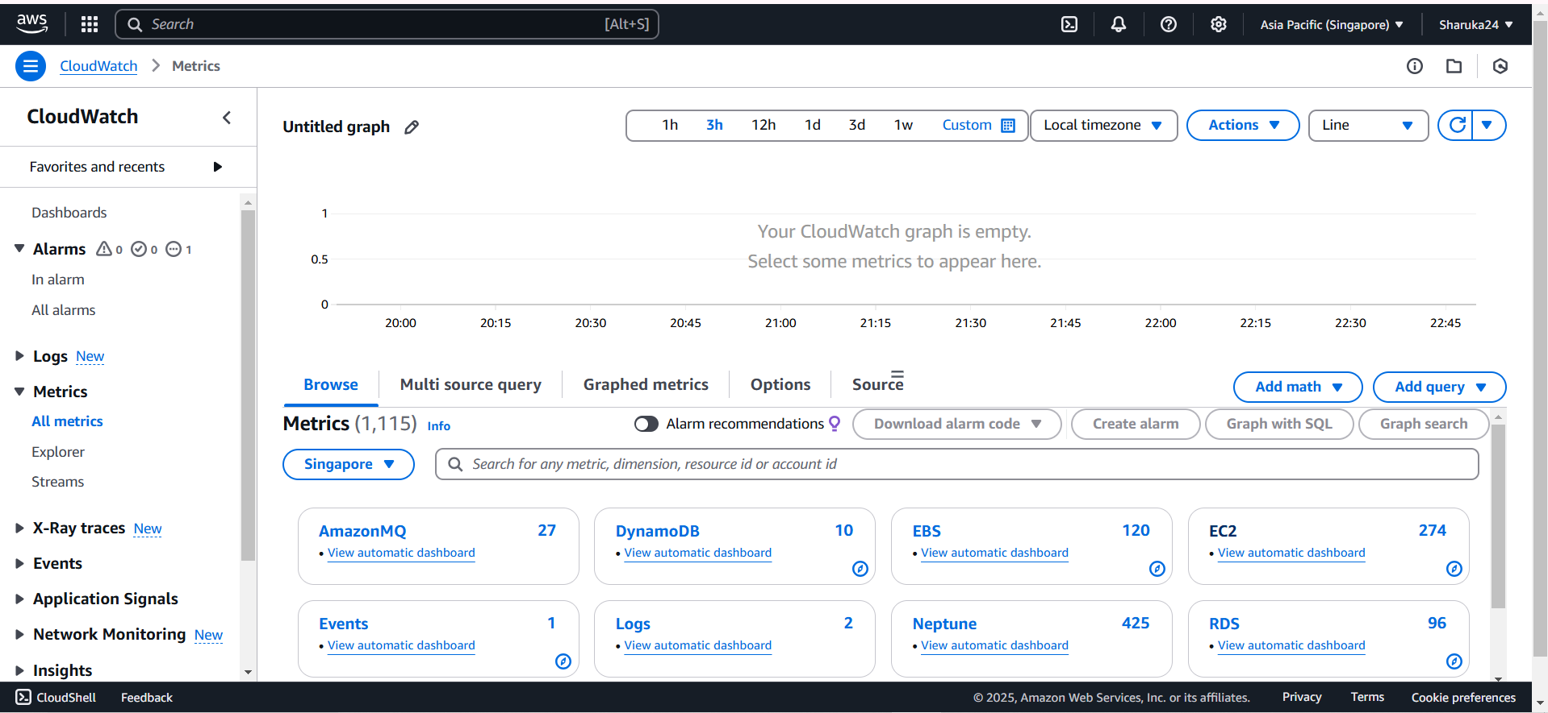

Step 5:

You should now see the list of metrics of all ec2 instances.

