**PLACEMENT EMPOWERMENT PROGRAM**

**CLOUD COMPUTING AND DEVOPS CENTRE**

Deploy a webapp in cloud. Write a flask app and deploy it in your cloud VM.

NAME: SHARUKA S

DEPT: ADS-ENGG

STEPS:

Step 1:

Launch an EC2 instance.

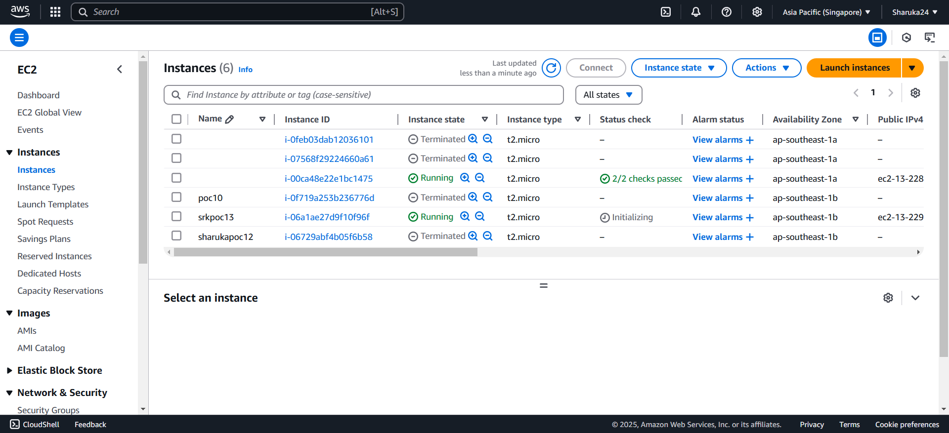

Step 2:

Select the instance > connect > copy the link given in example of ssh client.

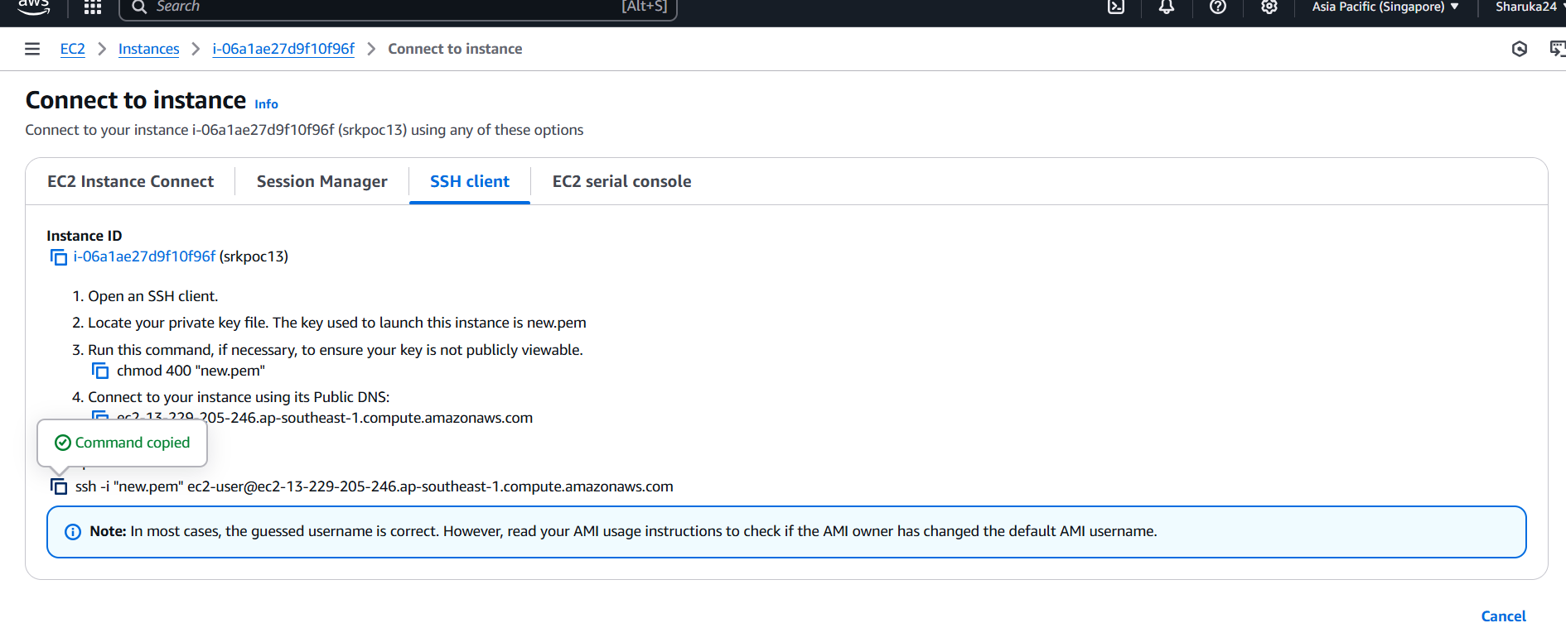

Step 3:

Open Powershell > navigate to downloads > paste the link > enter > type “yes” > enter.

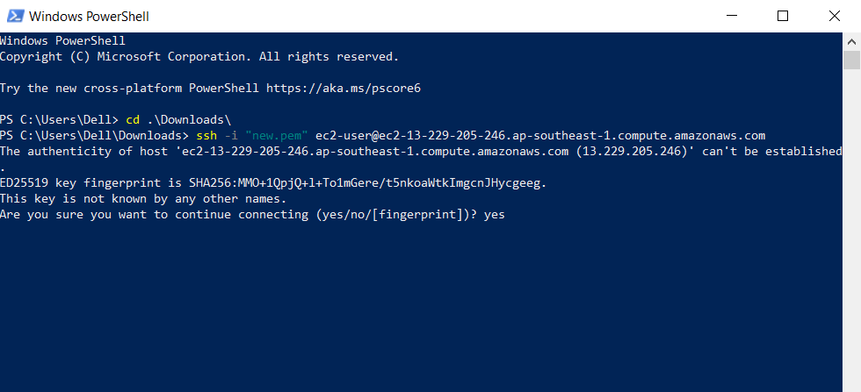

Step 4:

Follow the below commands:







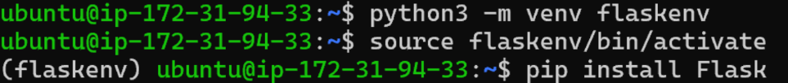



Step 5:

Write this code in to the editor . press ctrl + o to write out. Ctrl + x to exit

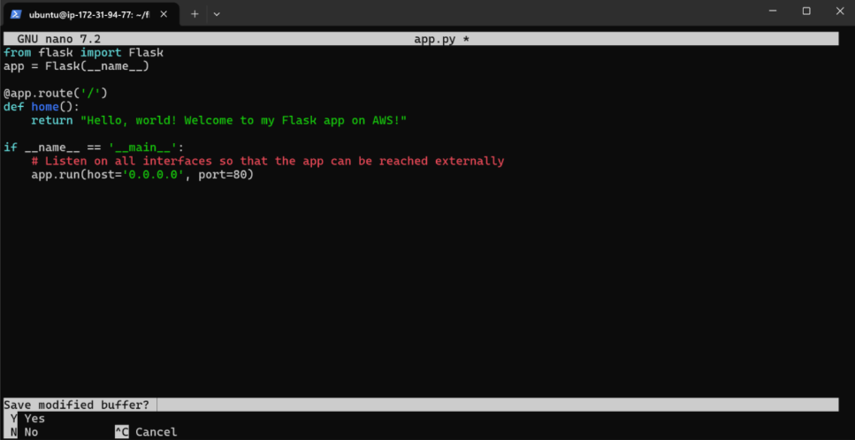

Step 6:

Add your venv path to sudo command and run the application





Your app is now running.

Step 7:

Open a new tab in browser and navigate to http://<ur instance public address>/

