**PLACEMENT EMPOWERMENT PROGRAM**

**CLOUD COMPUTING AND DEVOPS CENTRE**

Set up local Git repository:

Initialise git repo locally and version control static website

NAME: SHARUKA S

DEPT: ADS-ENGG

STEP 1:

Download git by searching in chrome. Download the latest version.

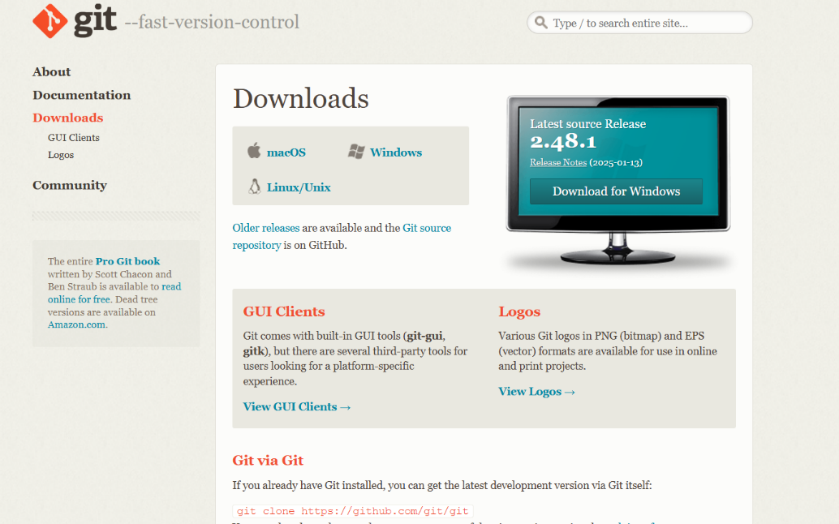

Step 2:

Open the command prompt, create a new folder and navigate to the folder and open it in vs code using the commands given in the below image

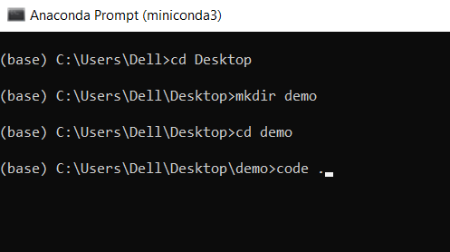

Step 3:

Create a simple html file in the folder

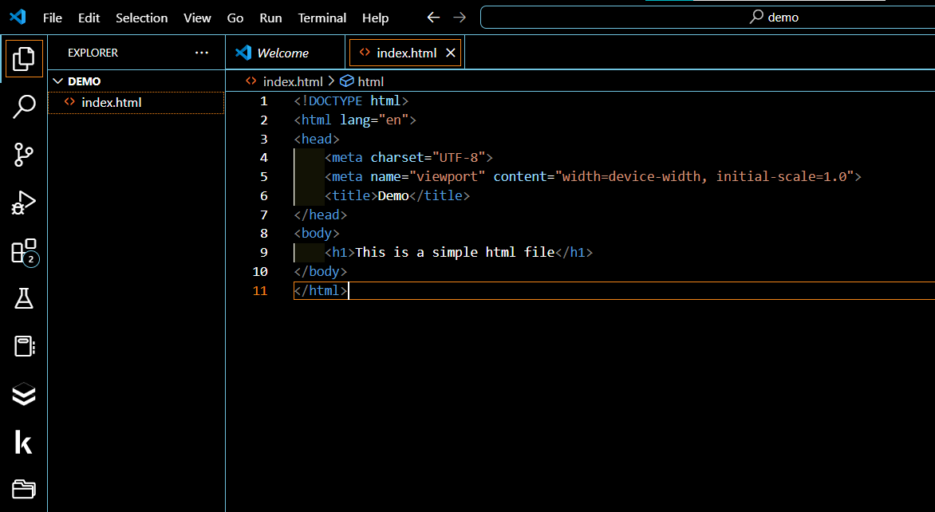

Step 4:

In the command prompt , navigate to the folder,

Initialise git and add the files to the local repo.

To do this follow the commands as given below

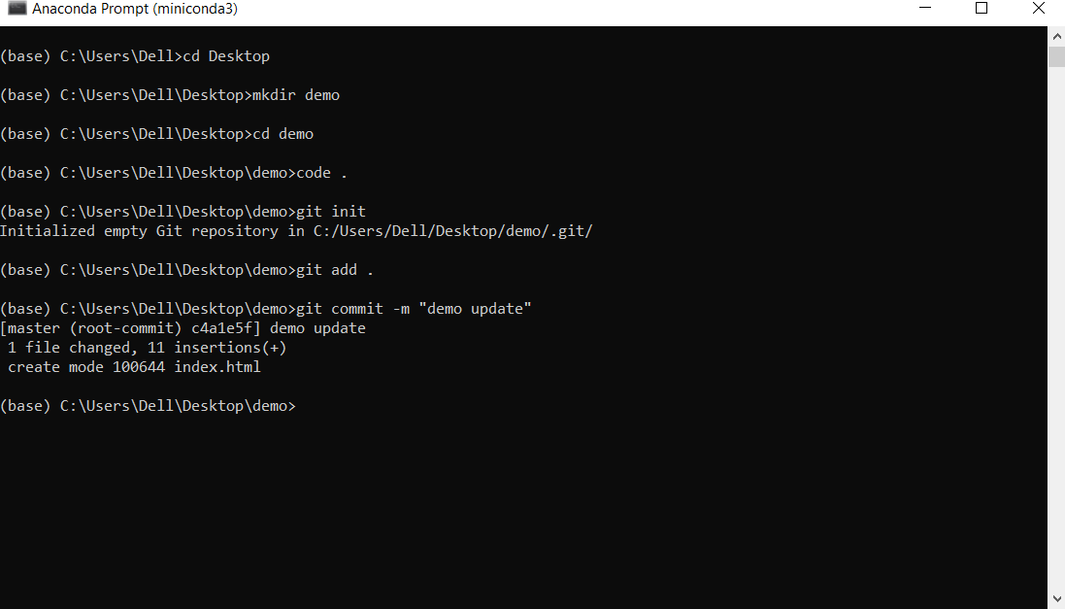

Step 5

Open Github and create a new repository

Copy its link

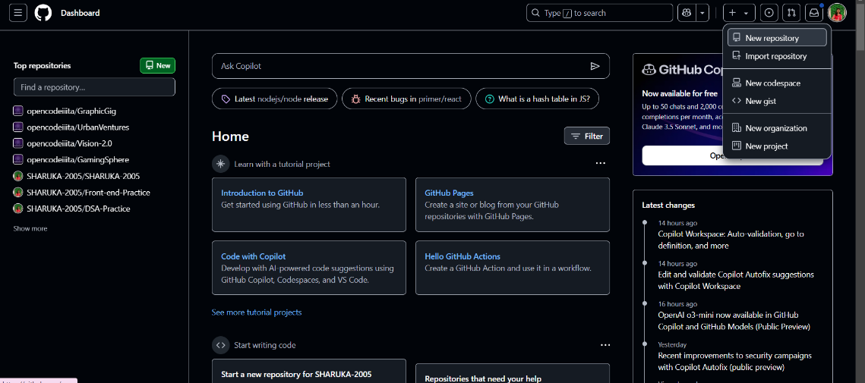

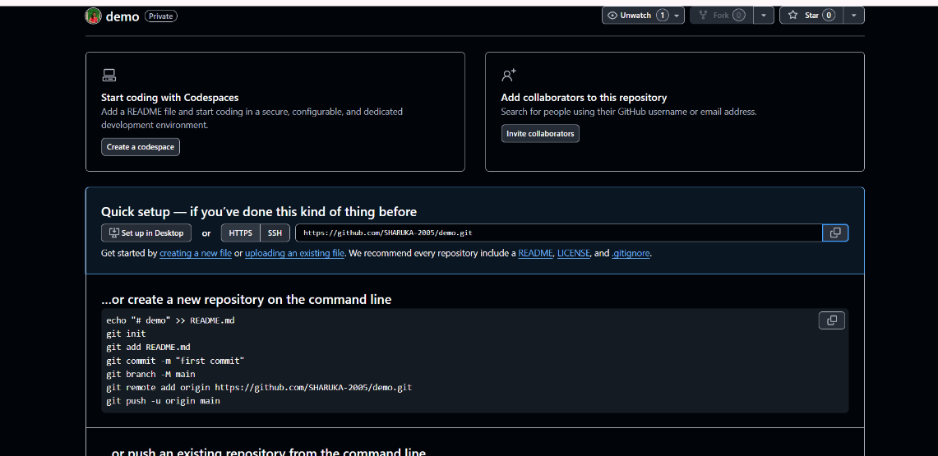

Step 6

Paste the link in the command line.

Follow the below commands.

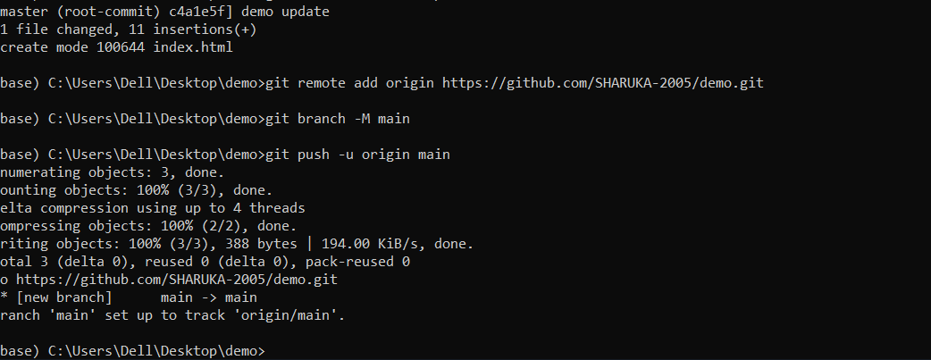

Step 7:

Refresh the github repo, the files would have been uploaded in the github repo successfully.

