**PLACEMENT EMPOWERMENT PROGRAM**

**CLOUD COMPUTING AND DEVOPS CENTRE**

Set up a Virtual Machine in the Cloud. Launch a VM and SSH into it.

NAME: SHARUKA S

DEPT: ADS-ENGG

STEPS:

Step1:

Open AWS Console and search for EC2

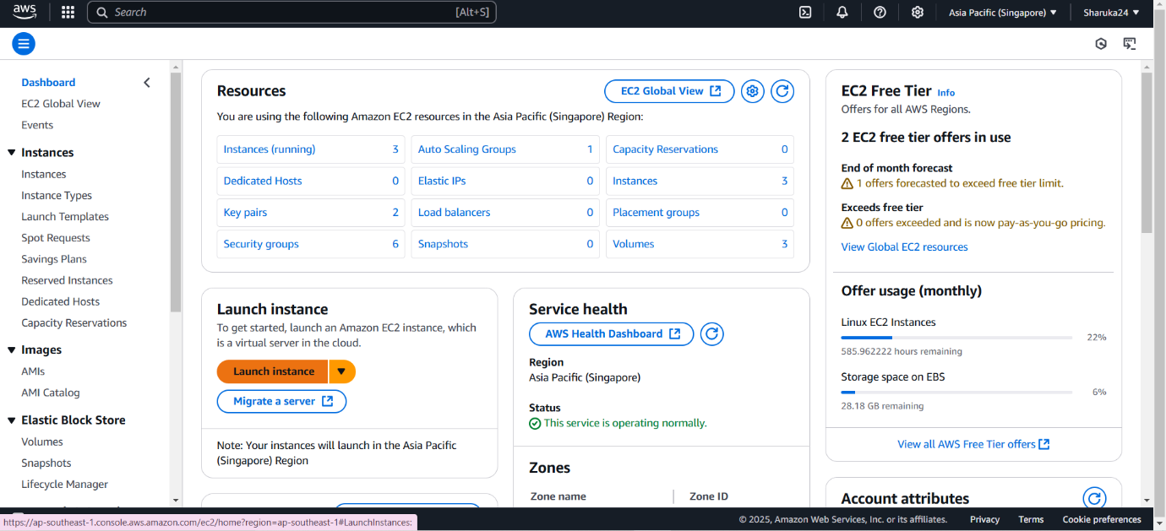

Step 2:

Launch an EC2 instance, ensure to choose Amazon Linux or Ubuntu free tier, choose a key-pair (if you don’t have create one ex: new.pem).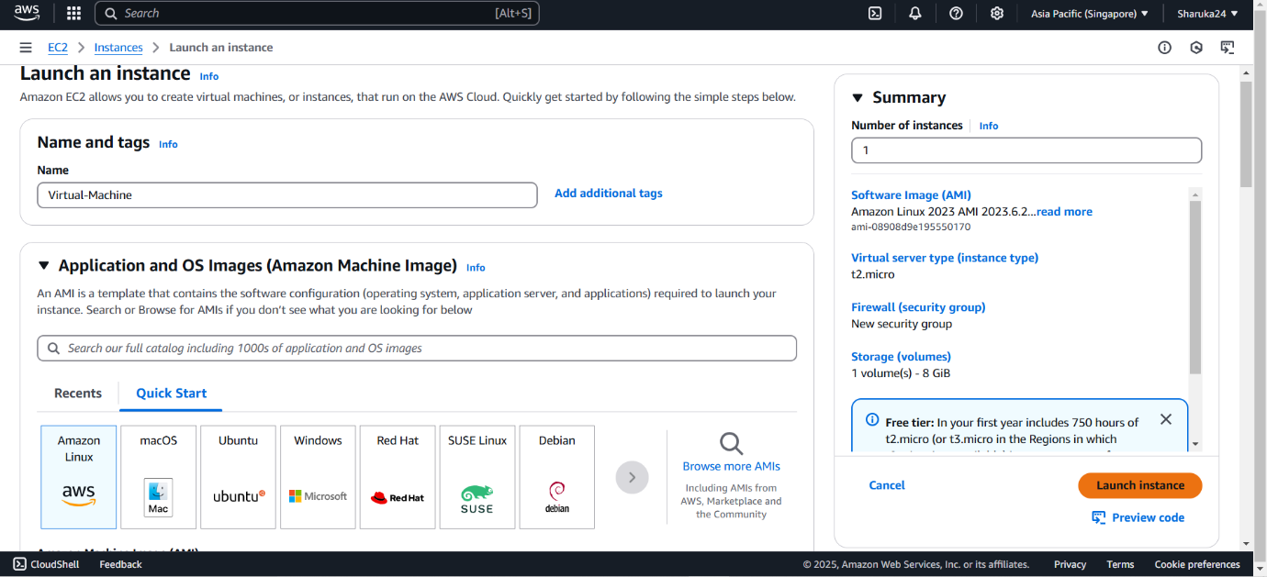

Step 3:

Select the instance and choose the “Connect” button

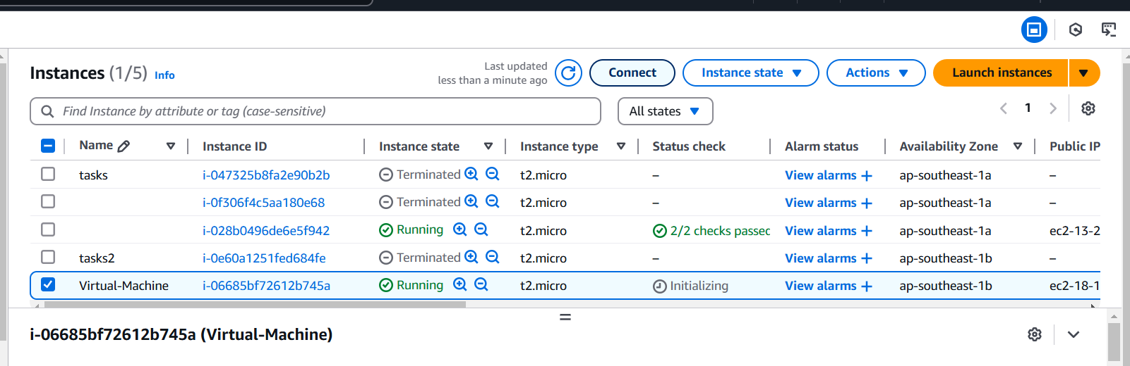

Step 4:

Copy the command provided in the example

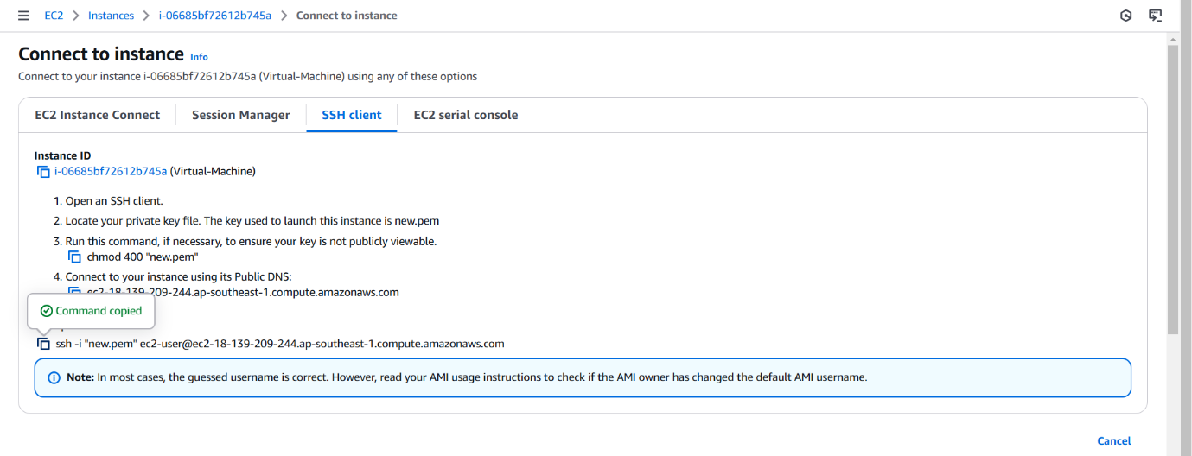

Step 5:

Open powershell , Navigate to downloads, paste the command and replace the key pair with the one you created.

