**PLACEMENT EMPOWERMENT PROGRAM**

**CLOUD COMPUTING AND DEVOPS CENTRE**

Implement DNS for your Application : Set up a DNS record to map your web application’s IP or load balancer to a domain name.

NAME: SHARUKA S

DEPT: ADS-ENGG

Steps:

Step 1:

Open Route 53 in AWS console

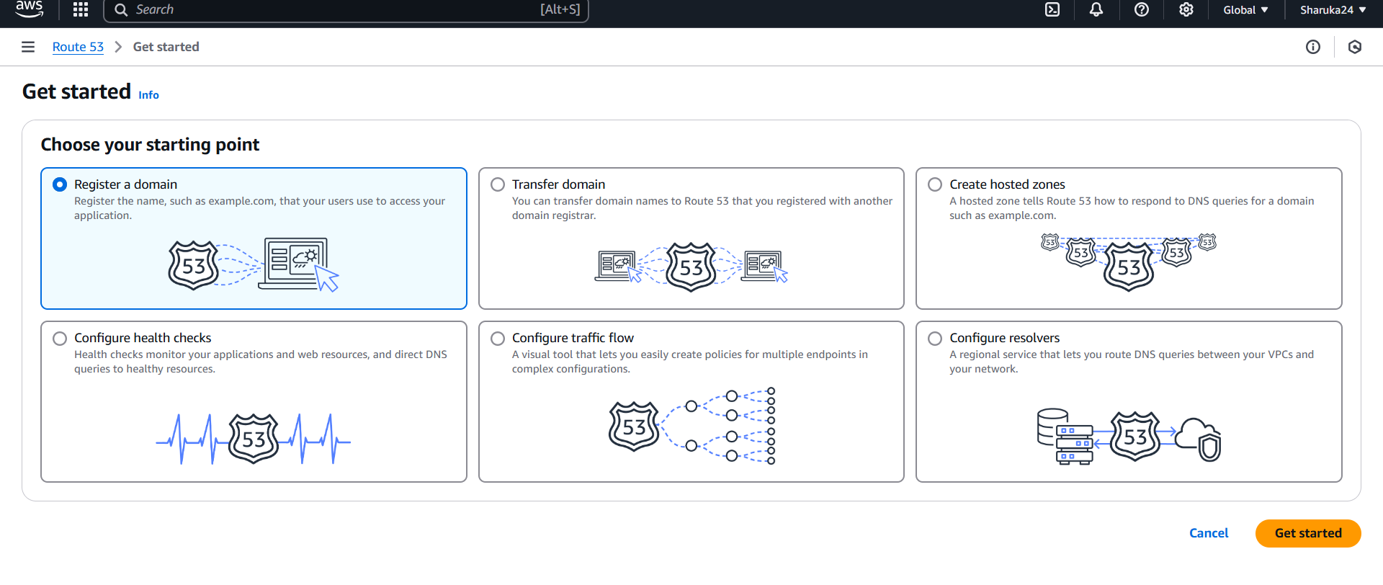

Step 2:

Go to Register a domain > type a domain name > search

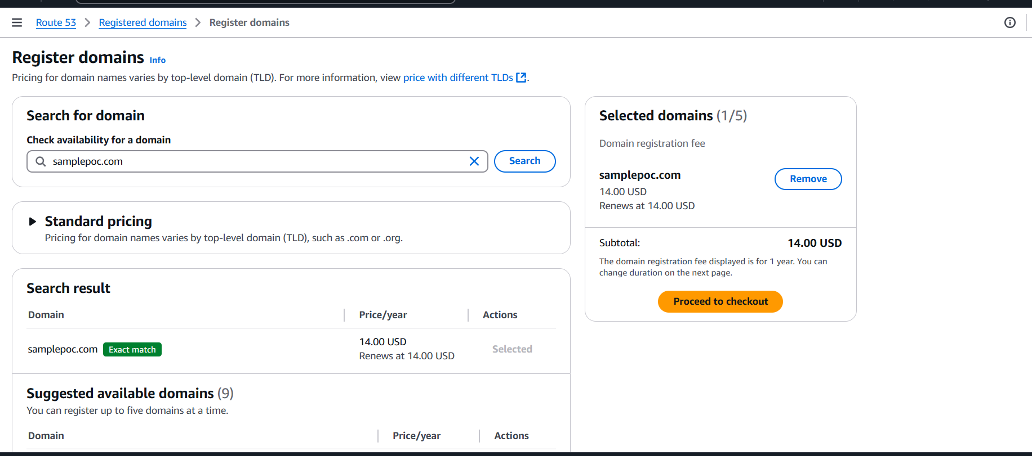

Step 3:

Launch an EC2 instance

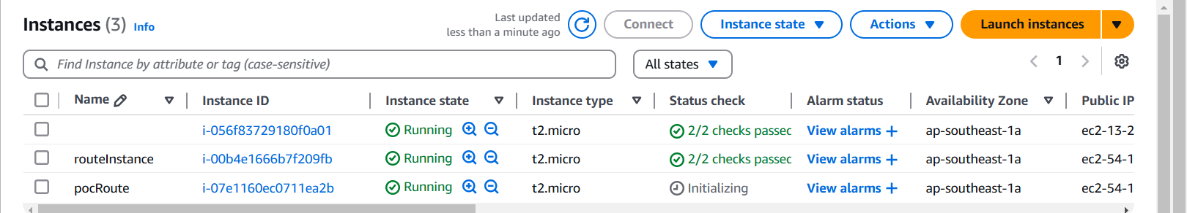

Step 4:

Copy the Public IPv4 Address

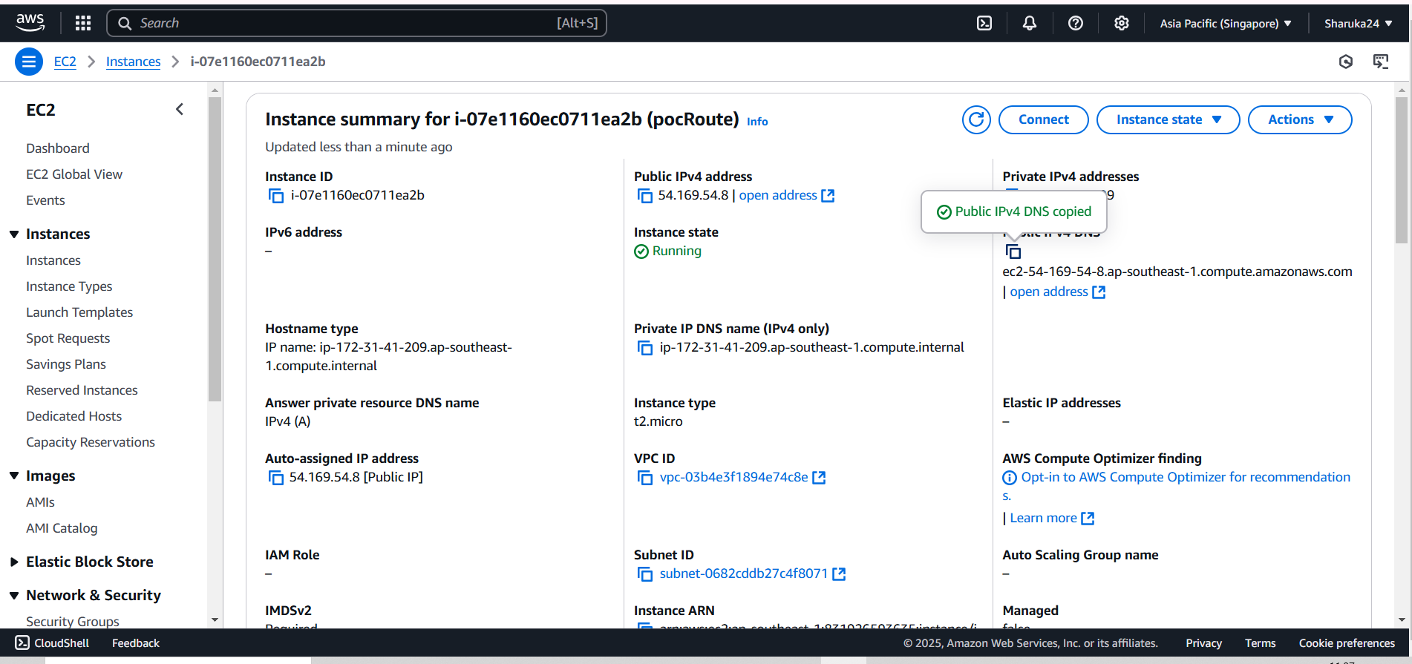

Step 5:

Using nslookup <domainname.com> you can test the config of you ec2 instance

