**Batch:__________ Roll No.:______________**

**Experiment No.**

|  |
| --- |
| **Title:** Implement following Edge detection operators (Prewitt, Sobel, Robert, and Laplacian). |

**Objective:** To learn and understand different edge detection operators.

**Expected Outcome of Experiment:**

|  |  |
| --- | --- |
| **CO** | **Outcome** |
| **CO4** | Design & implement algorithms for digital image enhancement, segmentation & restoration. |

**Books/ Journals/ Websites referred:**

1. http://www.mathworks.com/support/
2. www.math.mtu.edu/~msgocken/intro/intro.html.
3. R. C.Gonsales R.E.Woods, “Digital Image Processing”, Second edition, Pearson Education
4. S.Jayaraman, S Esakkirajan, T Veerakumar “Digital Image Processing “Mc Graw Hill.
5. S.Sridhar,”Digital Image processing”, oxford university press, 1st edition."

**Pre Lab/ Prior Concepts:**

Image segmentation can be achieved in two ways,

1. Segmentation based on discontinuities of intensity.
2. Segmentation based on similarities in intensity.

Edge information in an image is found by looking at the relationship a pixel has with its neighbourhoods. If a pixel’s gray-level value is similar to those around it, there is probably not an edge at that point. If a pixel’s has neighbors with widely varying gray levels, it may present an edge point.

**Edge Detection Methods:**

Many are implemented with convolution mask and based on discrete approximations to differential operators. Differential operations measure the rate of change in the image brightness function.Some operators return orientation information. Other only return information about the existence of an edge at each point.

**Sobel Operator**

The operator consists of a pair of 3×3 convolution kernels as shown in Figure 1. One kernel is simply the other rotated by 90°.

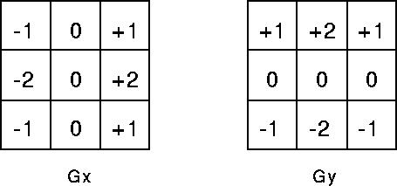

These kernels are designed to respond maximally to edges running vertically and horizontally relative to the pixel grid, one kernel for each of the two perpendicular orientations. The kernels can be applied separately to the input image, to produce separate measurements of the gradient component in each orientation (call these *Gx* and *Gy*). These can then be combined together to find the absolute magnitude of the gradient at each point and the orientation of that gradient. The gradient magnitude is given by:



Typically, an approximate magnitude is computed using:



which is much faster to compute. The angle of orientation of the edge (relative to the pixel grid) giving rise to the spatial gradient is given by:



**Robert’s cross operator:**

The Roberts Cross operator performs a simple, quick to compute, 2-D spatial gradient measurement on an image. Pixel values at each point in the output represent the estimated absolute magnitude of the spatial gradient of the input image at that point. The operator consists of a pair of 2×2 convolution kernels as shown in Figure. One kernel is simply the other rotated by 90°. This is very similar to the Sobel operator.

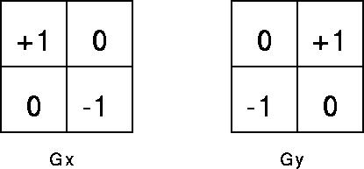

These kernels are designed to respond maximally to edges running at 45° to the pixel grid, one kernel for each of the two perpendicular orientations. The kernels can be applied separately to the input image, to produce separate measurements of the gradient component in each orientation (call these *Gx* and *Gy*). These can then be combined together to find the absolute magnitude of the gradient at each point and the orientation of that gradient. The gradient magnitude is given by:



An approximate magnitude is computed using:



Which is much faster to compute? The angle of orientation of the edge giving rise to the spatial gradient (relative to the pixel grid orientation) is given by:



**Prewitt’s operator:**

Prewitt operator is similar to the Sobel operator and is used for detecting vertical and horizontal edges in images.

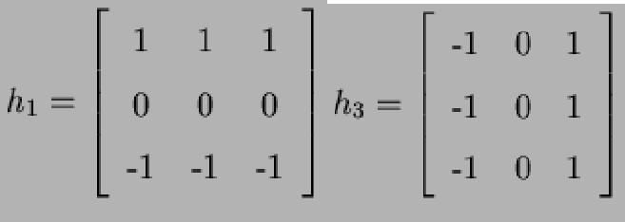

**Laplacian of Gaussian:**

The Laplacian is a 2-D isotropic measure of the 2nd spatial derivative of an image. The Laplacian of an image highlights regions of rapid intensity change and is therefore often used for edge detection. The Laplacian is often applied to an image that has first been smoothed with something approximating a  [Gaussian Smoothing filter](http://homepages.inf.ed.ac.uk/rbf/HIPR2/gsmooth.htm) in order to reduce its sensitivity to noise. The operator normally takes a single gray level image as input and produces another gray level image as output.



The Laplacian *L(x,y)* of an image with pixel intensity values *I(x,y)* is given by:



Since the input image is represented as a set of discrete pixels, we have to find a discrete convolution kernel that can approximate the second derivatives in the definition of the Laplacian. Three commonly used small kernels are shown in Fig below

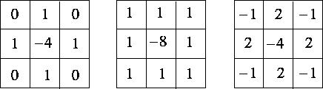

Because these kernels are approximating a second derivative measurement on the image, they are very sensitive to noise. To counter this, the image is often Gaussian Smoothed before applying the Laplacian filter. This pre-processing step reduces the high frequency noise components prior to the differentiation step.

**_____________________________________________________________________**

**Implementation Details:**

**Write Algorithm and Matlab commands used:**

**Code**

**Output**

**Conclusion:-**

**Date: _____________ Signature of faculty in-charge**

**Post Lab Descriptive Questions**

1. Explain the need of LOG operator.   
   Ans.: Common Names: Pixel Logarithm, Dynamic Range CompressionThis has the effect that  
   low intensity pixel values are enhanced.Since the logarithm is not defined for 0 ,  
   many implementations of this operator add the value 1 to the  
   image before taking the logarithm.That means if R is the  
   value with the maximum magnitude in the input image, c is given  
   byDue to the large dynamic range, we can only  
   recognize the largest value in the center of the image.The logarithmic operator enhances the low intensity pixel values,  
   while compressing high intensity values into a relatively small  
   pixel range.Hence, if an image contains some important high intensity  
   information, applying the logarithmic operator might lead to loss of  
   information.is the linearly scaled Fourier Transform ofApplying the logarithmic transform to the Fourier image  
   yieldsThe dynamic range of the film material is  
   too small, so that the graylevels on the subject's face are clustered in  
   a small pixel value range.
2. Explain the technique of thresholding for segmentation.   
   Ans.: Example of a threshold effect used on an image The simplest thresholding methods replace each pixel in an image with a black pixel if the image intensity Ii,j{\displaystyle I_{i,j}} is less than some fixed constant T (that is, Ii,j<T{\displaystyle I_{i,j}<T}), or a white pixel if the image intensity is greater than that constant.In the example image on the right, this results in the dark tree becoming completely black, and the white snow becoming completely white.To make thresholding completely automated, it is necessary for the computer to automatically select the threshold T. Sezgin and Sankur (2004) categorize thresholding methods into the following six groups based on the information the algorithm manipulates (Sezgin et al., 2004) :Spatial methods [that] use higher-order probability distribution and/or correlation between pixels Local methods adapt the threshold value on each pixel to the local image characteristics.It is also possible to use the CMYK colour model (Pham et al., 2007) .Divide the original image into two portions; Pixel values that are less than or equal to the threshold; background Pixel values greater than the threshold; foregroundFind the average mean values of the two new images Calculate the new threshold by averaging the two means.However, it is also possible to pick out the starting threshold values based on the two well separated peaks of the image histogram and finding the average pixel value of those points.ISBN 0-13-030796-3 Mehmet Sezgin and Bulent Sankur, Survey over image thresholding techniques and quantitative performance evaluation, Journal of Electronic Imaging 13(1), 146–165 (January 2004).Digital Image Processing and Analysis, pp 93-96.