Answer the questions below. Submit answers to 4 and 5 to Udacity, the others to T-square.

1a) Show that the following linear program is infeasible.

min $3x_{1}-2x_{2}$

s.t. $x_{1}+x_{2}≤ 2$

$$-x_{1} + -2x_{2} ≤ -6$$

$x_{1},x_{2}≥0$.

See the figure below. The first inequality f(x) is in dark blue. Its solution is colored (paired with the restraint that x1 and x2 are positive) is colored in dark blue. The second inequality g(x) is colored in light blue and its solution is colored similarly. The two solutions never intersect, and so this linear program is infeasible.

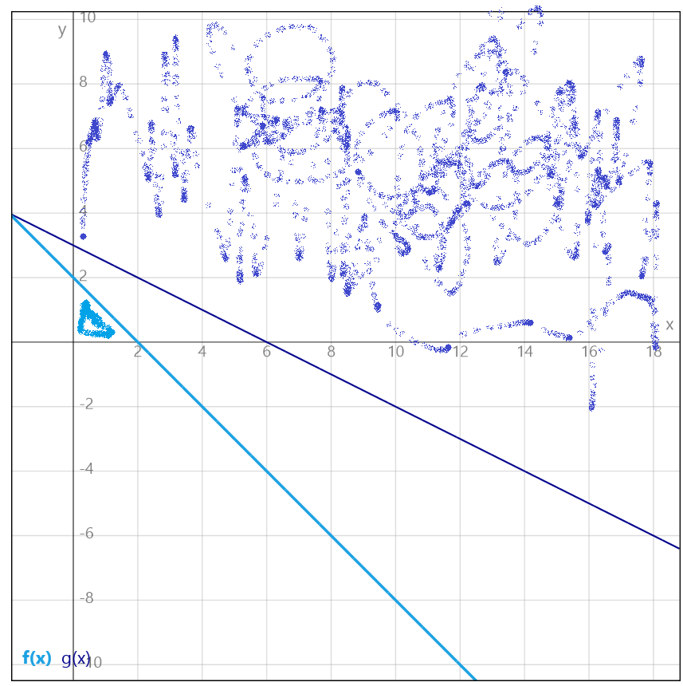

1b) Show that the following linear program is unbounded.

max ${2x}_{1}+{5x}_{2}$

s.t. ${-2x}_{1}+x_{2}≤ -1$

$$-x_{1} -2x_{2} ≤ 2$$

$x_{1},x_{2}≥0$.

See the graph below. The shaded region in red (it was the best I could do in paint) represents the feasible region. As can be seen, it is unbounded.

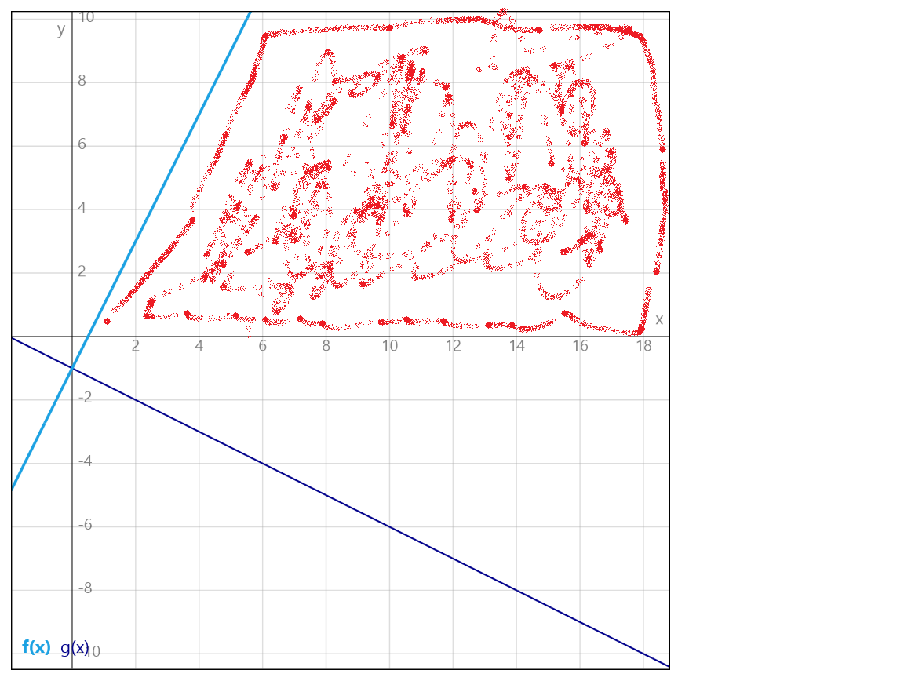

2a) Give an example of a linear program for which the feasible region is not bounded but the optimal value is finite.

One example where the feasible region is unbounded but the optimum value is finite is the following:

max x2

s.t. x2 <=5

x­1,x2 >= 0

In this case, the feasible region extends from x2 = 0 to x2 = 5 and from x1 = 0 to x1 = infinity. So the feasible region is unbounded, but the optimum value cannot exceed 5.

2b) Construct an example of a primal problem that has no feasible solutions and whose dual problem also has no feasible solutions.

As discussed in the forums, it appears that one such class of problems where both the primal and the dual solutions are infeasible is when the matrix A is symmetric. Take the following:

max $x_{1}$

s.t. $-x_{1}+x_{2}≥5$

$x_{1}-x_{2}≥5$

$x_{1},x_{2}≥0$

In matrix form, this becomes

max $\left[1 0\right] \left[\begin{aligned}x_{1} \\ x_{2}\end{aligned}\right]$

s.t $\left[\begin{matrix}-1 & 1 \\ 1 & -1\end{matrix}\right]\left[\begin{aligned}x_{1} \\ x_{2}\end{aligned}\right]≥\left[\begin{aligned}5 \\ 5\end{aligned}\right]$

$\left[\begin{aligned}x_{1} \\ x_{2}\end{aligned}\right]≥0$

which is infeasible. The dual of the problem is

max $\left[5 5\right] \left[\begin{aligned}y_{1} \\ y_{2}\end{aligned}\right]$

s.t $\left[\begin{matrix}-1 & 1 \\ 1 & -1\end{matrix}\right]\left[\begin{aligned}y_{1} \\ y_{2}\end{aligned}\right]≥\left[\begin{aligned}1 \\ 0\end{aligned}\right]$

$\left[\begin{aligned}y_{1} \\ y_{2}\end{aligned}\right]≥0$

which is also infeasible.

I conducted some further research and found the document at the location below that corroborates the thinking on the forum, specifically Table 4.2. <http://web.mit.edu/15.053/www/AMP-Chapter-04.pdf>

3. Consider the following optimization problem

min $|u|+|v|+|w|$

s.t. $u+v≤ 1$

$2u + w = 3$.

and convert it into a linear program of the form

min $c^{T}x$

s.t. $Ax=b$

$x≥0$.

(Hint: you will want to introduce two new non-negative variables for each of $u,v,w$.)

I found the document at the location below helpful:

<http://www.aimms.com/aimms/download/manuals/aimms3om_linearprogrammingtricks.pdf>

As stated in the hint, each variable must be replaced by to new variables in the following way:

$$\left|x_{j}\right|=x_{j}^{+}+x_{j}^{-}$$

$$x_{j}=x_{j}^{+}-x_{j}^{-}$$

$$x_{j}^{+},x_{j}^{-}≥0$$

When these substitutions are made, we have

min $x_{u}^{+}+x_{u}^{-}+x_{v}^{+}+x_{v}^{-}+x_{w}^{+}+x_{w}^{-}$

s.t. $x_{u}^{+}-x_{u}^{-}+x_{v}^{+}-x_{v}^{-}≤ 1$

$2x_{u}^{+}-2x_{u}^{-} + x_{w}^{+}-x_{w}^{-} = 3$.

$$x≥0$$

To eliminate the inequality, we must add one additional slack variable.

min $x_{u}^{+}+x_{u}^{-}+x_{v}^{+}+x_{v}^{-}+x_{w}^{+}+x_{w}^{-}$

s.t. $x_{u}^{+}-x_{u}^{-}+x_{v}^{+}-x_{v}^{-}+x_{7}= 1$

$2x_{u}^{+}-2x_{u}^{-} + x_{w}^{+}-x_{w}^{-} = 3$. $$x≥0$$

In matrix form, this becomes

min $1^{T}x$

s.t. $\left[\begin{aligned}1 \\ 2\end{aligned}\begin{aligned}-1 \\ -2\end{aligned} \begin{aligned}1 \\ 0\end{aligned} \begin{aligned}-1 \\ 0\end{aligned} \begin{aligned}0 \\ 1\end{aligned} \begin{aligned}0 \\ 1\end{aligned} \begin{aligned}1 \\ 0\end{aligned}\right]\left[\begin{aligned}x_{1} \\ x_{2} \\ x_{3} \\ x_{4} \\ x_{5} \\ x_{6} \\ x_{7}\end{aligned}\right]=\left[\begin{aligned}1 \\ 3\end{aligned}\right]$

$x≥0$

Which is in the form

min $c^{T}x$

s.t. $Ax=b$

$x≥0$.

1. Express the following problem as a linear program. Given an $m×n$ matrix $A$ and a vector b of length $m,$ find a vector $x$ such that $\left|\right|Ax-b{\left|\right|}_{1}$ is minimized. In other words, find $x_{1}…x_{n}$ such that $\sum_{i=1}^{m}{}|b_{i }-\sum_{j=1}^{n}{}a_{ij}x_{j}|$ is minimized. Implement your solution here.m

<https://www.udacity.com/course/viewer#!/c-ud557/l-1209378918/m-2871868559>

1. Let $A=(a_{ij})$ for $1≤i≤m$ and $1≤j≤n$ be a matrix with $m$ rows and $n$ columns. Such a matrix defines a two-person game as follows. Two players, Row and Column play a game where Row selects a row $i$ and Column selects a column $j$. If $a_{ij}>0$ Row receives a payoff amount of $a_{ij}$ from Column. If $a_{ij }<0$, Row pays an amount of $-a_{ij}$ to Column. The payoff matrix A is known to both players.

Suppose Row picks the i-th row with probability $p_{i}$ and announces this vector $p$. Knowing this vector, Column will choose column j that minimizes Row’s expected payout. Thus, the expected payout is $z = \min_{j}\sum_{i=1}^{m}{}p_{i}a_{ij}.$ Naturally, Row then will want to choose the vector $(p_{1},…,p_{m})$ so as to maximize this quantity. Express Row’s problem as a linear program. (Of course $p_{1},…p_{m}≥0$ and $\sum_{i=1}^{m}{}p_{i} = 1$.)

Implement your procedure here

<https://www.udacity.com/course/viewer#!/c-ud557/l-1209378918/m-3379798710>

1. Prove that for any $m×n$ matrix $A$ and vector $b$ of length $m$, exactly one of the following holds.
2. There is a vector $x≥0$ such that $Ax=b$.
3. There is a vector $y$ such that $y^{T}A≥0$ and $y^{T}b < 0$.

Hint: Use substitution to show both statements cannot be true for the same matrix $A$. To show that at least one must be true, consider the following linear program.

min $b^{T}y$

s.t. $A^{T}y≥0$

and find its dual. Use the Duality Theorem to complete the result.

First I will show that (a) and (b) cannot hold for the same matrix A by contradiction. Assume (a) and (b) are true. In that case, by substitution we have

$y^{T}b=y^{T}Ax <0$ (1)

But since (a) and (b) are both true, we also have that $x≥0$ and $y^{T}A≥0$. Thus it can’t be true that both (a) and (b) are true because either $x$ or $y^{T}A$ would have to have negative entries in order to satisfy (1).

Now to show that exactly one always holds. The dual of the given hint is

max $0^{T}x$

s.t. $Ax=b$

$x≥0$

If we take (a) to be true, this dual program is satisfied with an optimal value of 0. Applying the weak duality lemma, we have that the feasible solution for the primal must satisfy this inequality:

$$b^{T}y ≥c^{T}x=0$$

However, this violates the conditions of (b), so we have shown that if (a) is true, then (b) cannot be true.

Now let’s take (a) to be false and show that (b) must be true. If (a) is false, the dual linear program is infeasible. The primal however is feasible since y = 0 satisfies the condition. The primal is unbounded, however, by the duality theorem, and so $y^{T}b < 0$ will always have a solution. Thus, we have proved that exactly one of (a) or (b) holds.

This is better known as Farkas Lemma.