|  |
| --- |
| CS7647 Computer Vision |
| Assignment 2 |
| Edges and Lines |

|  |
| --- |
| Kilver, Jacob R  9-7-2015 |

# Question 1



Figure 1: ps2-1-a-1.png

# Question 2

# Hough Accumulator



Figure 2: ps2-2-a-1.png

## Hough Peaks

## Hough lines

## Questions

# Adding noise

## Smoothed image

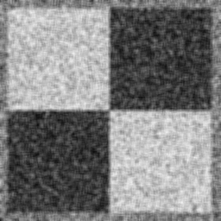

Figure 3: ps2-3-a-1.png

## Edge images

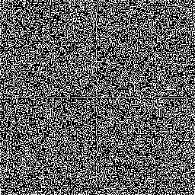

Figure 4: ps2-3-b-1.png (Noisy lines)

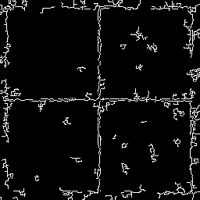

Figure 5: ps2-3-b-2.png (Lines on smoothed image)

## Hough lines

# More difficult lines

## Smoothed image

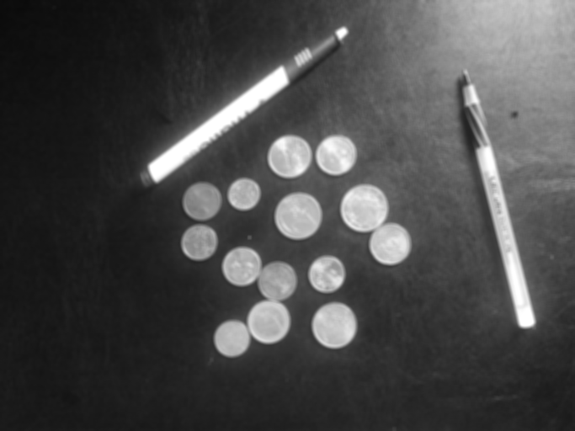

Figure 6: ps2-4-a-1.png

## Line image

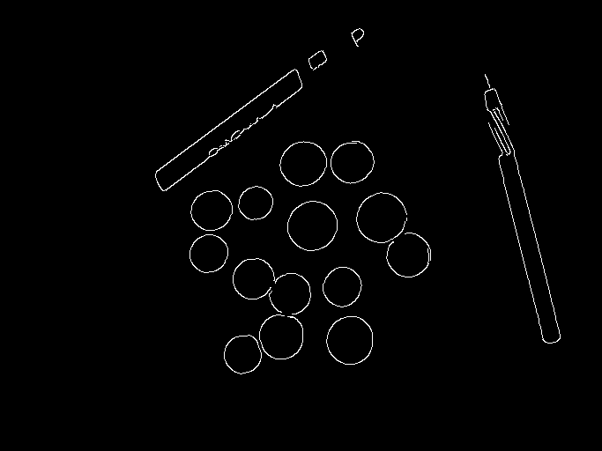

Figure 7: ps2-4-b-1.png

## Hough lines

# Hough circles

## Smoothed image



Figure 8: ps2-5-a-1.png

## Finding circles

# Finding lines with clutter

## Finding lines

## Discussion

## Looking for better results

# Finding circles with clutter

## Finding circles

## Discussiong

# Distortion

## Finding lines and circles

## Fixing problems