CV Assignment 4

Geometry

Jacob Kilver

Jkilver3

# Question 1 – Calibration

## Finding Projections

The M matrix that was output for the set of normalized points was:

$$M=\left[\begin{matrix} 0.7678 & -0.4938 & -0.0233 & 0.0067 \\ -0.0852 & -0.0914 & -0.9065 & -0.0877 \\ 0.1826 & 0.2988 & -0.0741 & 1\end{matrix} \right]$$

The projection of the last 3D point to the normalized 2D coordinates was

$$〈u,v〉= \left[\begin{matrix}0.1419 & -0.4518\end{matrix}\right]$$

Finally, L2 distance between the final projected coordinated and the actual coordinate was 0.001563 or 1.569*10-3.

## Camera Calibration

Table : Average L2 error for various sizes of constraining points

|  |  |  |  |
| --- | --- | --- | --- |
| Iteration | K=8 | K=12 | K=16 |
| 1 | 0.9491 | 2.1337 | 1.5922 |
| 2 | 2.0937 | 1.3393 | 1.2362 |
| 3 | 6.3917 | 0.5525 | 0.6622 |
| 4 | 2.4446 | 1.2759 | 1.1603 |
| 5 | 1.3047 | 1.0214 | 1.3820 |
| 6 | 2.6850 | 1.9794 | 0.9188 |
| 7 | 2.0407 | 1.2996 | 1.1568 |
| 8 | 1.5077 | 1.4639 | 1.9969 |
| 9 | 1.6526 | 1.2504 | 1.2734 |
| 10 | 1.5828 | 0.2649 | 0.8545 |
| Sum | 22.6526 | 12.581 | 12.2333 |

There is a significant drop in the error between the k=8 case and the k=12 and k=16 cases. It seems that over constraining the equation reduces the error. However, once the equation is over constrained, the gains in error are not as pronounced. While there is a decrease in the error going from 12 to 16 points, it is only a fraction of that from going from 8 to 12 points.

The best M was

## Camera Center

The camera center was computed to be

$$C= \left[\begin{matrix}303.1 & 307.1 & 30.41\end{matrix}\right]$$

# Fundamental Matrix Estimation

## Computing fundamental matrix

The fundamental matrix output using least squares was

## Reducing Rank

Using singular value decomposition to reduce the rank resulted in the fundamental matrix below. It is not very different from the original.

## Drawing Epipolar lines

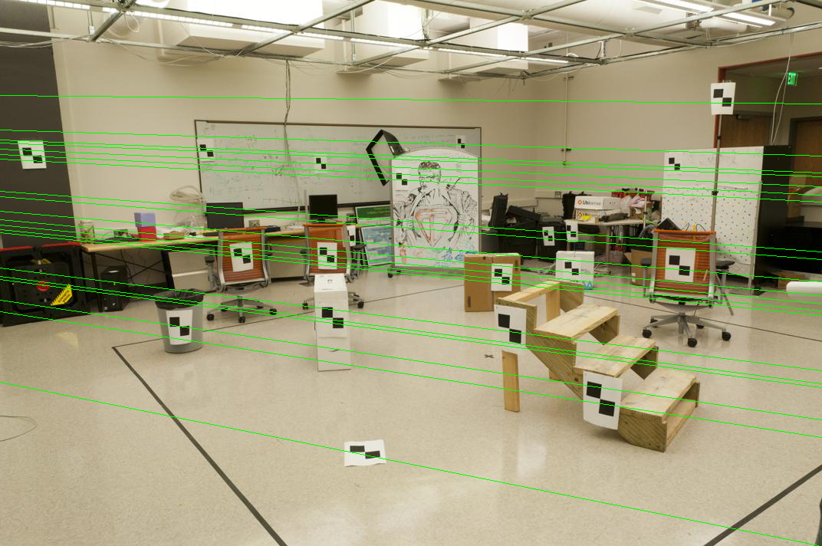

Figure : ps4-2-c-1.png

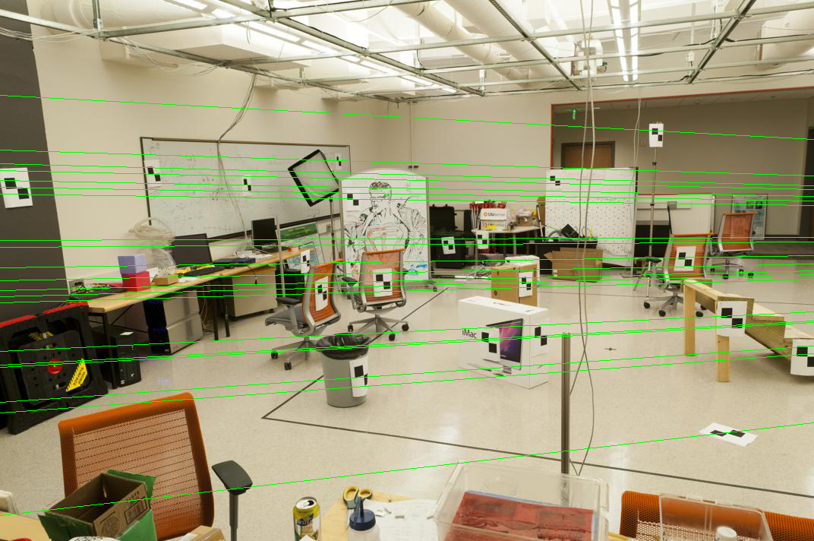

Figure : ps4-2-c-2.png

## Transformation matrices

The transformation matrices were, respectively,

The fundamental matrix after normalizing the points was found to be

After reducing the rank of the fundamental matrix using SVD, the result was

## Better epipolar lines

Using the equation in the problem write-up, the best fundamental matrix was found to be

Using this fundamental matrix, the epipolar lines were recomputed as below.

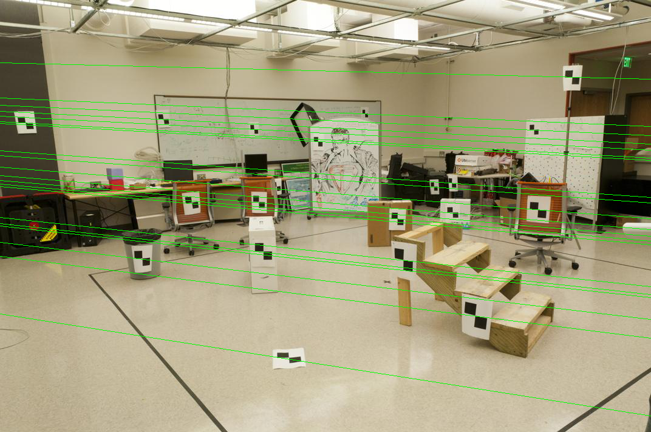

Figure : ps4-2-e-1.png

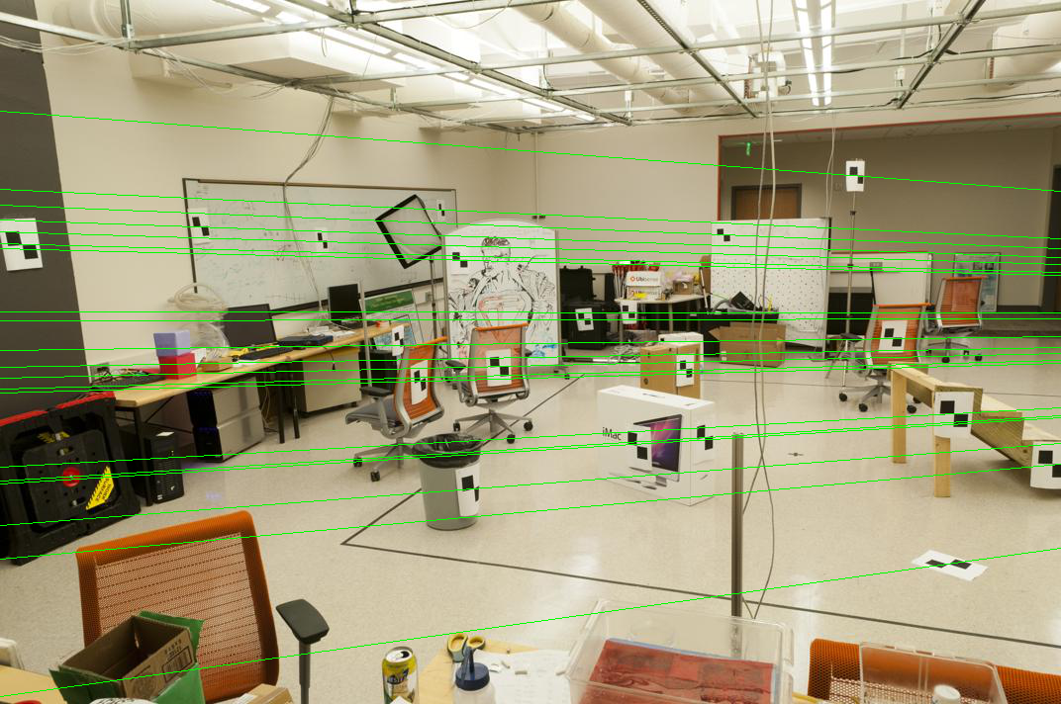

Figure : ps4-2-e-2.png