Assignment 6

Optic flow

Jacob Kilver

Jkilver3

# Lucas Kanade Optic Flow

## Small motion

I used a Gaussian filter of size 25-by-25 pixels with a sigma of 15.

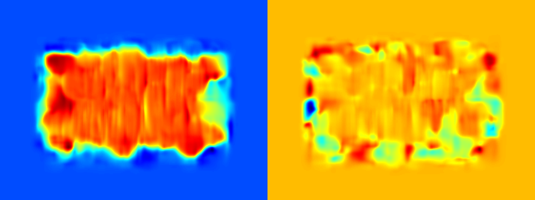

Figure : ps6-1-a-1.png

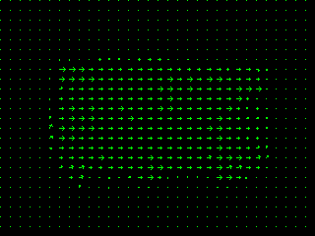

Figure : ps6-1-a-1 quiver plot

I had to use a pretty large window size (61) to get the smooth results below.

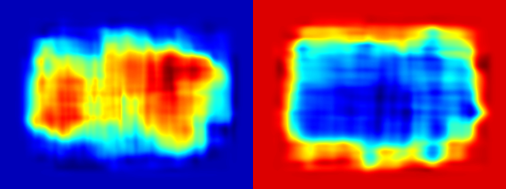

Figure : ps6-1-a-2.png

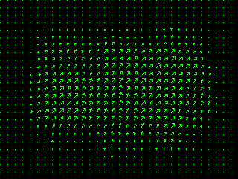

Figure : ps6-1-a-2 quiver plot

## Large motion

For the smaller motion displacement (see Figure 5 and Figure 6) the results are as expected. The flow is consistent within the motion region.

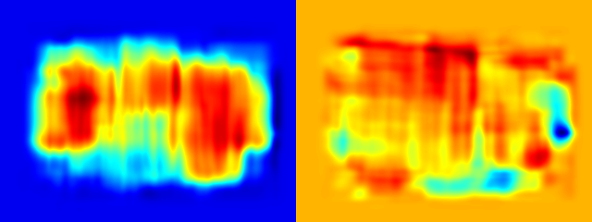

Figure : ps6-1-b-1.png

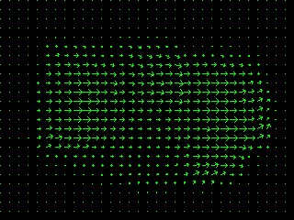

Figure : ps6-1-b-1 quiver plot

As the size of the motion increases, the results become increasingly noisy. For the displacement of 20 pixels (Figure 7 and Figure 8) the flow is still consistent in the motion region, but boundary effects start to come into play.

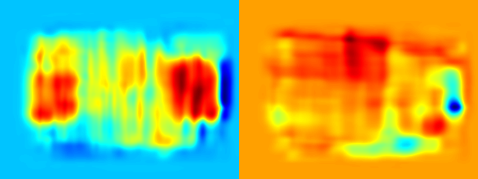

Figure : ps6-1-b-2.png

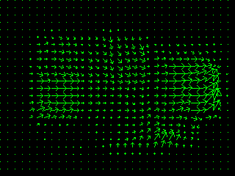

Figure : ps6-1-b-2 quiver plot

For the displacement of 40 pixels (Figure 9 and Figure 10) the results are almost entirely dictated by the boundary effects. There is almost none of the actual displacement captured in the output.

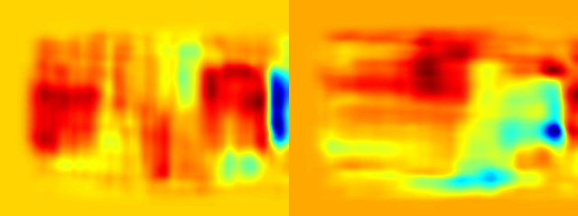

Figure : ps6-1-b-3.png

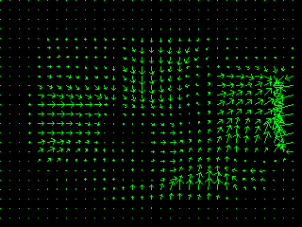

Figure : ps6-1-b-3 quiver plot

# Gaussian and Laplacian Pyramids

## Reduce

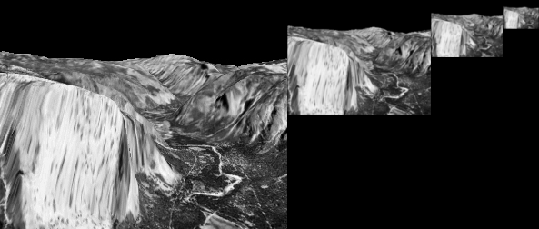

Figure : ps6-2-a-1.png

## Expand

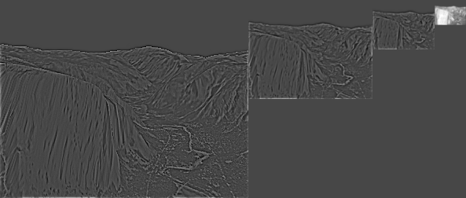

Figure : ps6-2-b-1.png

# Warping by flow

## Single level

# Hierarchical LK Optic Flow

## First sequence

## Second sequence

## Third sequence

# Juggle sequence