November 23, 2015

Jacob Kilver

jkilver3

Assignment 8

Motion History Images

# Frame Differenced MHI

## Binary images

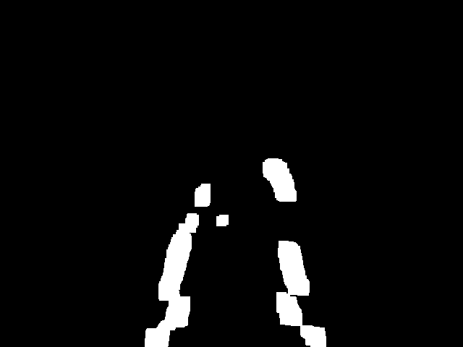

Figure : ps8-1-a-1.png

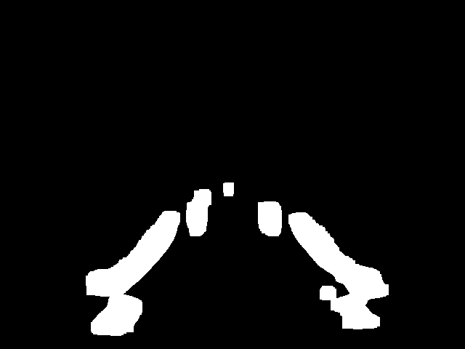

Figure : ps8-1-a-2.png



Figure : ps8-1-a-3.png

## Motion history images

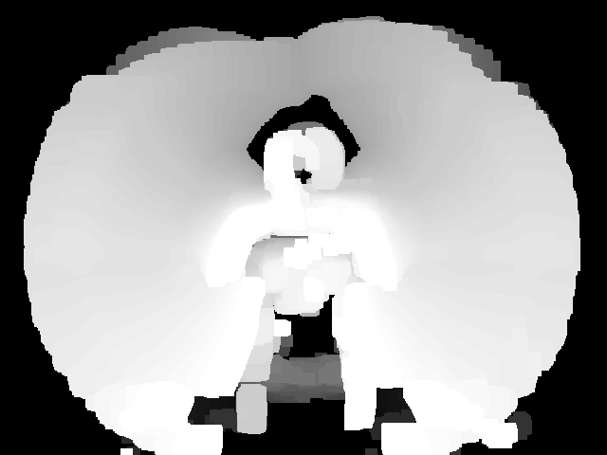

Figure : ps8-1-b-1.png

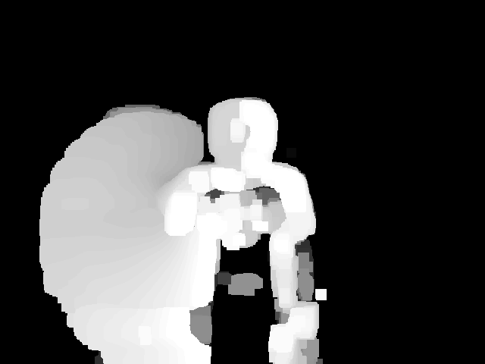

Figure : ps8-1-b-2.png

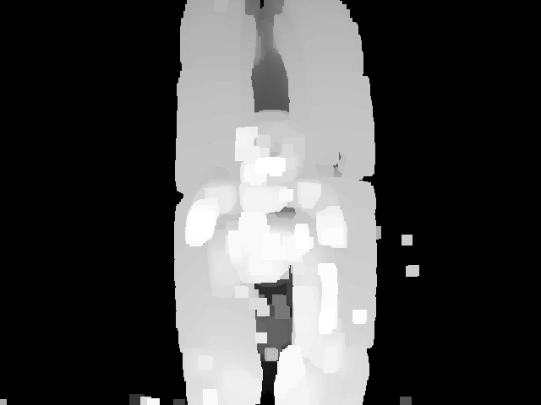

Figure : ps8-1-b-3.png

τ = 100

Table : τ Values

|  |  |
| --- | --- |
|  | τ Value |
| Action 1 | 90 |
| Action 2 | 70 |
| Action 3 | 100 |

# Recognition using MHIs

## “Cheating” version

I normalized the MHIs to have a consistent maximum value. To have a good confusion matrix I had to modify the custom parameters to include custom values for where to take the history frame and τ values. I also had to significantly blur the images to get decent results. At first I used a simple Euclidean distance. This is the confusion matrix that resulted with this distance metric and unscaled central moments:

This is the confusion matrix using scaled central moments and Euclidean distance:

## Non cheating version

At first I used the non-Euclidean distance. These are the results.

For participant 1:

For participant 2:

For participant 3:

I could not find any way to produce better MHI images, so I focused on finding a different distance method.