Assignment 10

Photos of Space

Jkilver3

# Panorama

I used the Image Composite Editor from Microsoft (<http://research.microsoft.com/en-us/um/redmond/projects/ice/>). I took a picture of a wide open field in Waynesburg, OH.

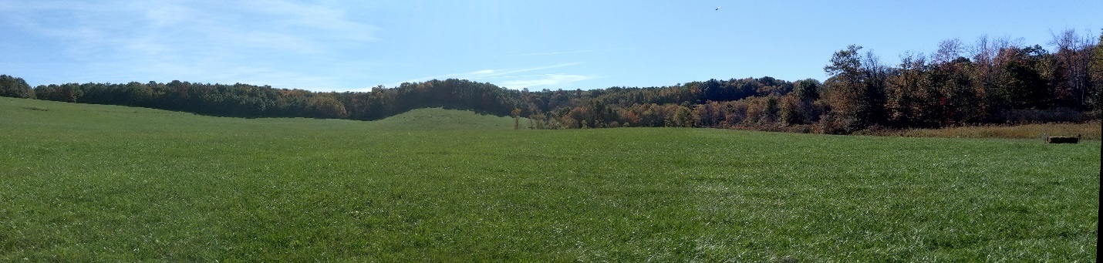

Here is a link to a higher resolution version:

<https://drive.google.com/file/d/0Bxai7xH5CdlSM0cwQzRaVXY0NGs/view?usp=sharing>

I thought that the stitching went very well. The blending could have been a little better, but I think it was the case that the wind changed direction, causing the grass color to change towards the right of the image.

# Photosynth

This was my first attempt at a Photosynth. It is of the McKinley Monument in Canton, OH. I walked around the monument attempting to get a 360° view, but it couldn’t match well enough to do so. The software reported only 51% “synthy” and they aren’t all connected. I found that by going to a different view, like point cloud, could get you more different perspectives than just going through on 3D view.

<https://photosynth.net/view.aspx?cid=a94c3215-308f-444c-8d6e-198a7ad26b44&m=false&i=0:0:1&c=0.0574028:0.069858:-0.0232599&z=495.515745707109&d=0.470433489404798:-1.6145713334215:-3.23681336844673&p=0:0&t=False>