November 16, 2015

Jacob Kilver

Assignment 11

Video Textures

# Candle Images

For the candle images, I used the default alpha of **1.5*106**. The GIF output can be viewed at the following link: <http://makeagif.com/i/9ESgxt>. These were the difference images that were output as part of the assignment11_test.py script:

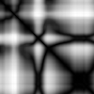

Figure : Difference image 1

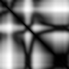

Figure : Difference image 2

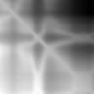

Figure : Difference image 3

The video texture code found a start and end frame of 37 and 89 respectively.

# Student video texture – dog wagging tail

Admittedly there is some art to this, so choosing a subject as unpredictable as a young dog probably was not the best choice. However, you can see the output here: <http://makeagif.com/i/_sQmz8>. The worst is that I did not hold the camera steady, so when the loop ends there is the jump due to the camera moving. However, the code does a good job of finding a loop. I know that you can’t really tell here, but when you look at the extracted frames, the final frame and the first frame have the tail at basically the same position. There might be a small dynamics problem here too – the tail seems to change directions quickly, but dog tails do that in real life too!

I did have to change the alpha value for these videos. When I used the default from before, only a single frame was output. I changed the alpha to **3*106** and got this output. This produced a starting frame of 9 and an ending frame of 139 (out of 206 possible frames). Here are the difference images that were produced:

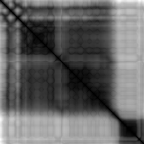

Figure : Difference image 1

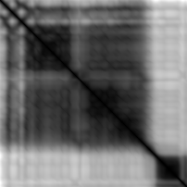

Figure : Difference image 2

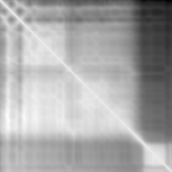

Figure : Difference image 3

These difference images are very different from the ones in the candle above. Unlike the candle video, where a number of frames can look similar to each other, my video seemed to have to distinct regions, each dissimilar to the other. There is a significant change in the difference images in what corresponds to the end of the input video. The images go from black to white or white to black. It appears that the code selected a start frame towards the beginning of the video (upper left) and selected an end frame close to this distinct boundary.