Assignment 8

Panorama

Jacob Kilver

jkilver3

# Input and Output Panorama Images

Usually you take a panorama of a wide scene, like a landscape. I decided to take a different approach and do a panorama of something up close. Here are three pictures I took of a shelf of books on a bookcase of mine.

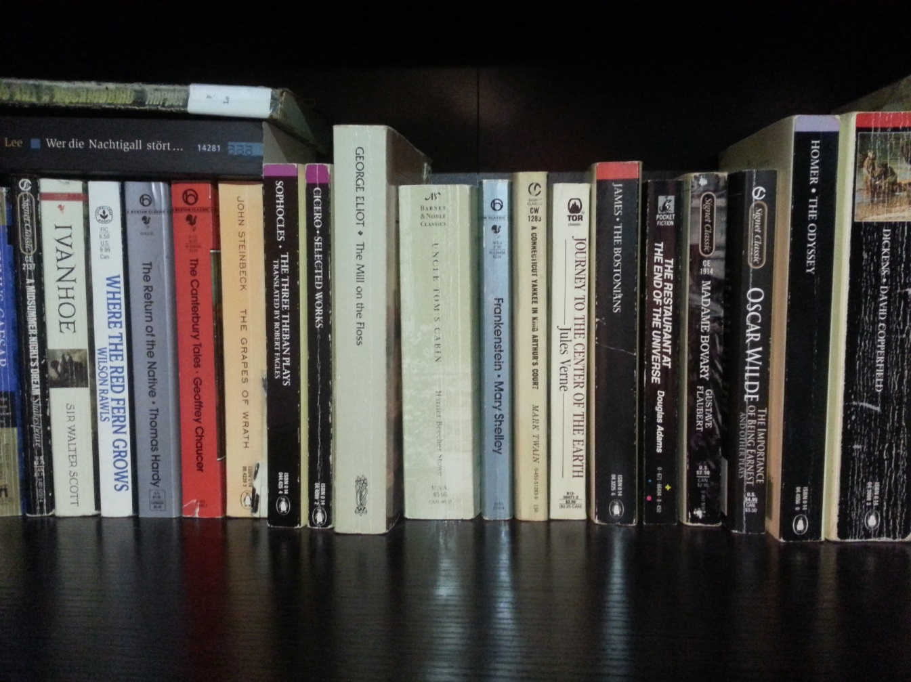

Figure : Input image 1

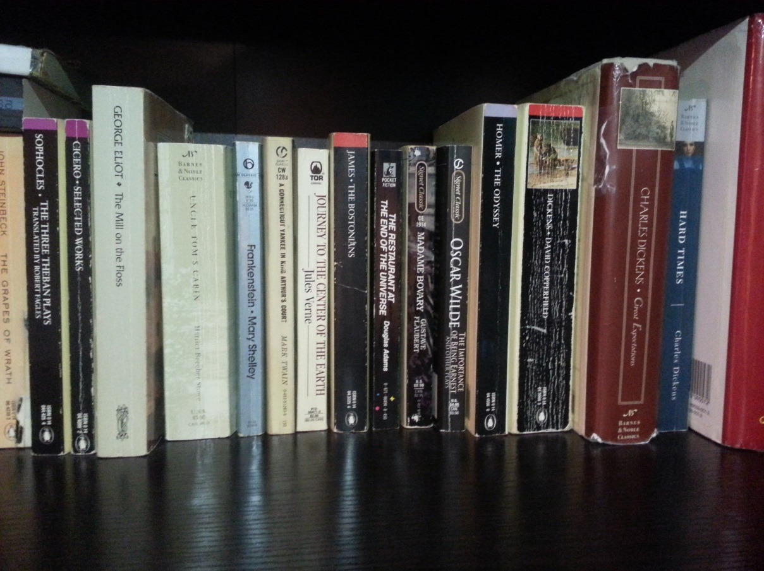

Figure : Input image 2

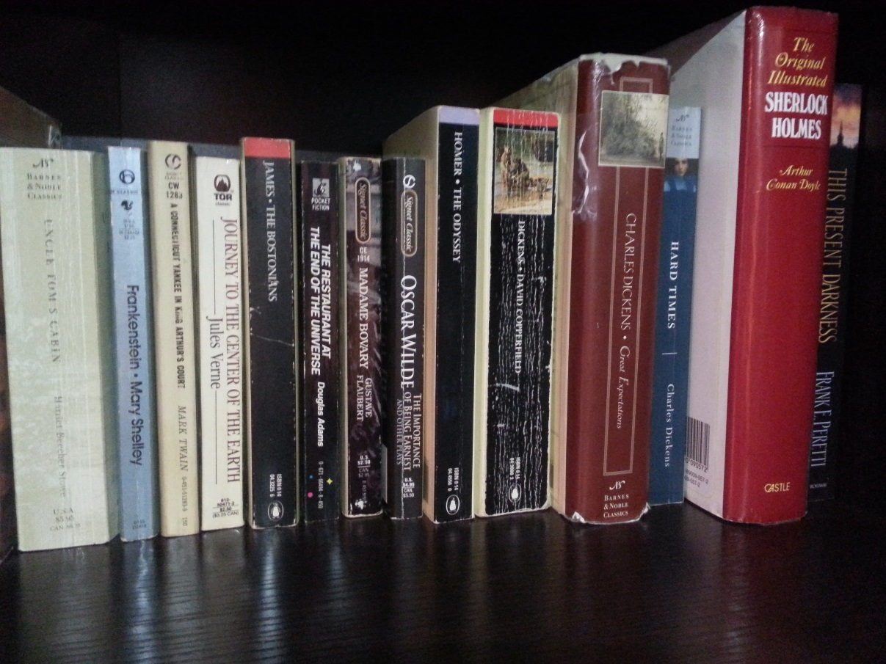

Figure : Input image 3

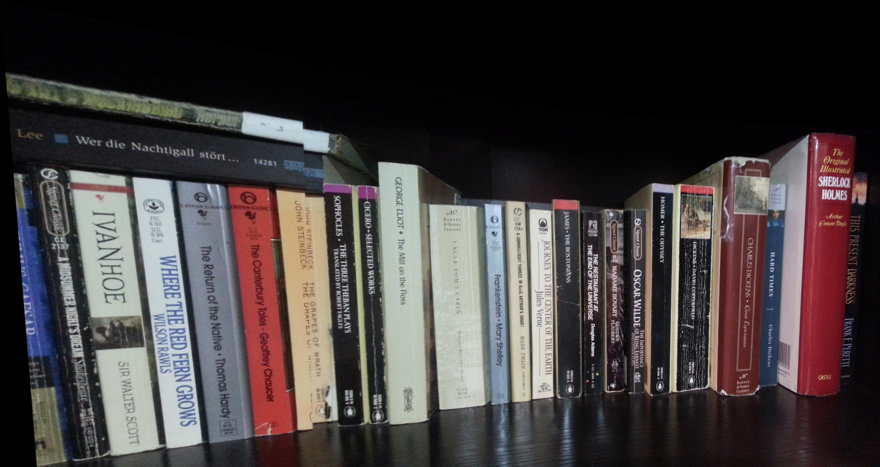

Figure : Output panorama image

# Discussion

While I was unable to get one of the image pairs to line up properly (image 1 and image 2), the other image pair lined up nearly perfectly. I found that I had to use 100 matches to get the results I did. Fewer points got worse results and more matches did not produce better results.

I tried to create a planar panorama, but the results were worse than when I did a rotational panorama. I was very confused by this. I don’t know if the images I was taking were poor candidates for panoramas or if the matched points were poor, though RANSAC should have been able to handle this case.

To implement the blending function, I copied the code from Assignment 6 where we did blending with pyramids. Since this was done with the instructor provided code previously, I had to put the driver code together myself. I took as the two input images a small region around the vertical line where the two images (the warped and non-warped images) meet, i.e., the vertical line defined by the point passed to the blend function. The mask I split right down the middle, taking half from the warped image and half from the non-warped image. I then ran this through the pyramid blending. I then placed the blended image at the proper location in the output (warped) image and placed the rest of the non-warped image into the output image. Since I only took the region around the intersection as the area to blend, the blending did not take very long.

Overall I am fairly happy with the results. The instructor provided images look great, and there is virtually no line between the second and third images I made. I am still not satisfied with the disjoint between the first and second of my images. However, I know that the code is functional because the results elsewhere seem correct. The blending also wasn’t quite as fine as I had hoped. However, I don’t know of a better way to blend the images nicely from one to the other.