Assignment 9

HDR Photography

Jacob Kilver

Jkilver3

# Output from provided images

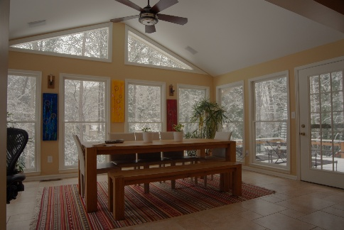

Figure : Output generated from HDR code

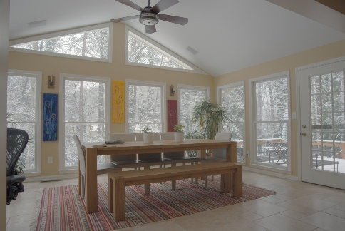

Figure : Provided example image

As can be see above the answer provided by the instructors is much more white looking than that output from the HDR code. However, this is to be expected since tone mapping was not performed on the output from the HDR code. Tone mapping was more than likely done for the instructor provided output.

# Student provided images

# Output using student provided images