Jacob Kilver

jkilver3

Final Project Report

Video Stabilization

# Introduction

# Theory of Operation

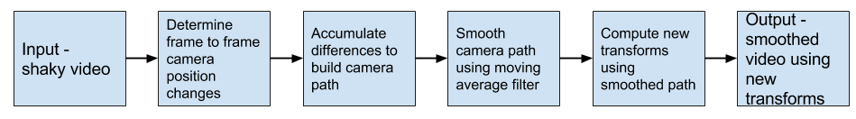

Figure : Flowchart (pipeline) for video smoothing

# Implementation

# Results

The code was tested on several different videos. The first was a rather simple and static scene to simply test the functionality of the code. Here is a link to the input video: <https://youtu.be/GdfwyoTvi-w>. The output video can be viewed here: <https://youtu.be/OsuuwgqYysk>.

The code was also tested on a more real-life video. Here is the input video: <https://youtu.be/Ww953wOwPGg>. The video stabilized by this code can be viewed here: <https://youtu.be/g2mowfhrnSI>.

Figure : Camera paths - x axis

Figure : Camera paths - y axis

Figure : Frame to Frame deltas - x axis

Figure : Frame to Frame deltas - y axis

# Comparison to existing tools

The video output using the software developed here was compared to existing tools already in the field. One popular tool is the suite built into Youtube. Here is a link to the video above stabilized by Youtube: <https://youtu.be/FpXs4LAMoo4>.

# Conclusion and Future Work