Jacob Kilver

Knowledge Based Artificial Intelligence

Assignment 1

5/29/2016

# Introduction

This assignment attempts to describe the means by which the transformations between images can be determined both verbally and visually. These methods can then be used to solve tests of intelligence such as the Raven’s Progressive Matrices (RPMs). While such a task can be simple for humans it can be quite a challenge for computers. Humans have an amazing ability to process both verbal and visual data and infer relationships. Computers need to have all these relationships explained; they are not able to infer these relationships as easily as humans. Production systems are one method that computer scientists use to endow computer with some of the intelligence of humans to infer these relationships. The remainder of this paper describes how Production Systems (and its related techniques) can be used to solve RPMs.

# Problem Description

For an example of an RPM see Figure 1. As a human we can easily tell that the correct answer to this problem is answer #2, the solid square. But how do we explain this pattern to a computer, especially when the problems become more difficult, like in Figure 2?

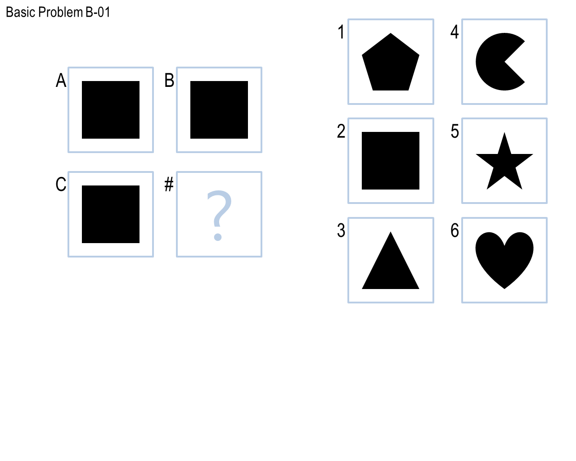

Figure 1: Example of a basic Raven's Progressive Matrix

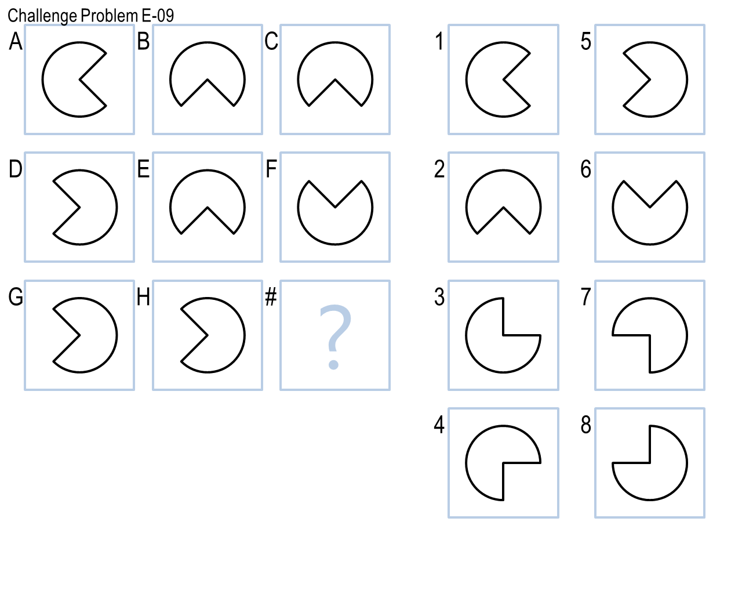

Figure : Example of a challenging Raven's Progressive Matrix

Here are some of the nuances that the humans can easily identify that we use to solve these types of problems:

* Shapes
  + Sizes
  + Whether shape is filled
* Relationships between shapes in a single cell
  + Relative locations
  + Similarities
  + Differences
* Relationship between shapes in other cells
  + What shapes are different?
  + What shapes are similar?

Solving these problems with just the visual description can be difficult. It is difficult to take the vast input space of an image and quantify the similarities and differences. Fortunately some RPMs have verbal descriptions that describe the RPMs in a more limited but more tractable input space.

# Approach

As mentioned previously, a production system is one tool that can be used to solve the RPMs. One such widely used production system is known as SOAR. A production system is, as the name implies, a system, and like most systems it has an architecture. See Figure 1 for the architecture of SOAR which consists of a long term memory, each with its own set of knowledge, and a working memory for “scratch work.” The procedural knowledge is essentially a set of *if-then* rules that describe how to do certain tasks. Certain percepts in the world lead to certain actions to be taken. The semantic knowledge contains models and views of the world. The episodic knowledge contains particular instances of events, a means of keeping track of what has happened in the past. All these pieces working together can be a very powerful problem solving tool.

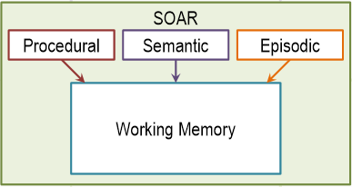

Figure 3: Production System Architecture

Applying the production system to RPMs, we will assume that we have semantic knowledge about the RPMs – how the elements of an RPM relate to each other for the various size (2x2 and 3x3). The episodic knowledge would store RPMs that have been encountered in the past along with the solution (if it is present). The procedural knowledge would take information about the RPM and determine what the answer should be. For example, one of the easiest and most important distinctions to make would be the size of the RPM. Solving a 2x2 matrix involves different techniques than solving a 3x3 matrix.

The procedural knowledge is the most interesting portion of the production system. Here is one way it could be used to solve an RPM. (See pseudocode in ____). The first several rules would involve determining what class of RPM is currently in use, and the class of problem would be stored in the working memory.

Next the RPM could be queried for whether there is a verbal description of the problem. If so, the production system could construct a semantic network and store that in working memory. This semantic network could then be applied to the missing image to solve the RPM.

If there is no verbal description the production system should attempt to solve the problem visually. This would involve a series of rules that would run transformations on the images (rotation, reflection, scaling, etc.) and compare them. For example, for a 2x2 matrix we know that A is to B as C is to D. Thus, we would need to identify what transformation connects A and B. Once this is known the same transformation can be applied to C. The resultant image can then be compared to the given answer choices and the closest match can be selected as the answer. This method includes some concepts of generate and test. The potential answers are generated and then these solutions are tested and unacceptable answers are pruned.

When solving these problems it is reasonable to include some form of a confidence rating – a measure of how closely the generated answer matches the answer that is selected (1, 2, 3,...). If this confidence value is below a certain threshold or if there are multiple answers that have the same maximum confidence rating, the production system needs some method of selecting an answer. The process whereby a production system does this is known as chunking. The production system essentially learns a new rule and adds it to its procedural knowledge by searching for previous similar events in its episodic knowledge where the selected answer was correct. Note: this assumes that this system has some knowledge of whether previous answers were correct or not. If the system has no knowledge of whether past answers were correct than chunking cannot be effective.

# Conclusion