CS7641

Problems Set 2

Jacob Kilver

6 Dec 2014

1. An appropriate encoding would be to have A have its own bit and then B and C to share a bit.

|  |  |
| --- | --- |
| A | 0 |
| B | 00 |
| C | 10 |

The entropy would be .5(1) + .5(2) = 1.5 bits

1. Skip

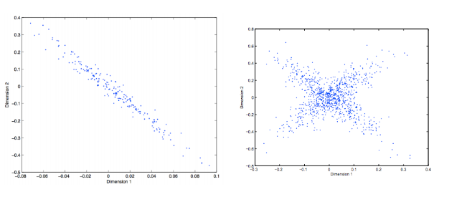

PCA has the principle component in the direction of maximum variance. For the figure on the left, that would be the line following the general trend of the data. For the figure on the right, that is less obvious, but I believe it is the same direction as before, from bottom right to upper left. The second component is perpendicular to the first, regardless of the variance in this second direction.

1. Clustering
   1. Single link clustering would produce this clustering. The distances between the closest points in the two clusters are much less than the distances between the points in the other clusters. This is how single link clustering would treat the gap between the two clusters.
   2. K means could produce this cluster assuming that the initial points are on either side of the distribution
   3. EM could produce this cluster. EM does not have hard clustering, so this clustering is trying to represent that some points belong to both clusters. In fact, since Gaussian distributions have infinite extent, all points belong at least in part to both clusters.
2. Skip
3. Q values
   1. Total exploration

$$Q\left(s, a_{1}\right)=0+ γQ\left(s_{1}^{'}, a^{'}\right)$$

where actions in s’_1 are chosen with equal probability

$$Q\left(s_{1}^{'}, a^{'}\right)=1+ γ\left(0.5*1.5+0.5*1.5\right)$$

$$Q\left(s,a_{1}\right)=γ+{1.5γ}^{2}$$

$$Q\left(s, a_{2}\right)=0+ γQ\left(s_{2}^{'}, a^{'}\right)$$

Where actions in s’_2 are chosen with equal probability

* 1. Greedy exploration

$$Q\left(s, a_{1}\right)=0+ γQ\left(s_{1}^{'}, a_{1}^{'}\right)$$

$$Q\left(s_{1}^{'}, a_{1}^{'}\right)=1+ γ\left(0.5*1+0.5*2\right)$$

$$Q\left(s,a_{1}\right)=γ+{1.5γ}^{2}$$

$$Q\left(s, a_{2}\right)=0+ γQ\left(s_{2}^{'}, a_{3}^{'}\right)$$

$$Q\left(s_{2}^{'}, a_{3}^{'}\right)=0+ γ\left(0.5*0+0.5*6\right)$$

$$Q\left(s, a_{2}\right)={3γ}^{2}$$

1. Grid world
   1. MDP

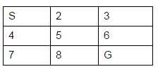

* 1. Value iteration

|  |  |  |
| --- | --- | --- |
| S (5.12) | 6.4 | 8 |
| 6.4 | 8 | 10 |
| 8 | 10 | G (0) |

1. Nash Equilibrium
   1. Case 1

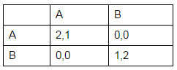

* 1. Case 2

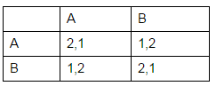

No Nash equilibrium

* 1. Case 3

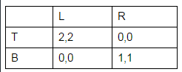

The largest that either player can get is 2