MC-2 Project 2

Trading Strategies

Jacob Kilver (jkilver3@gatech.edu)

28 Mar 2016

# Bollinger Bands®

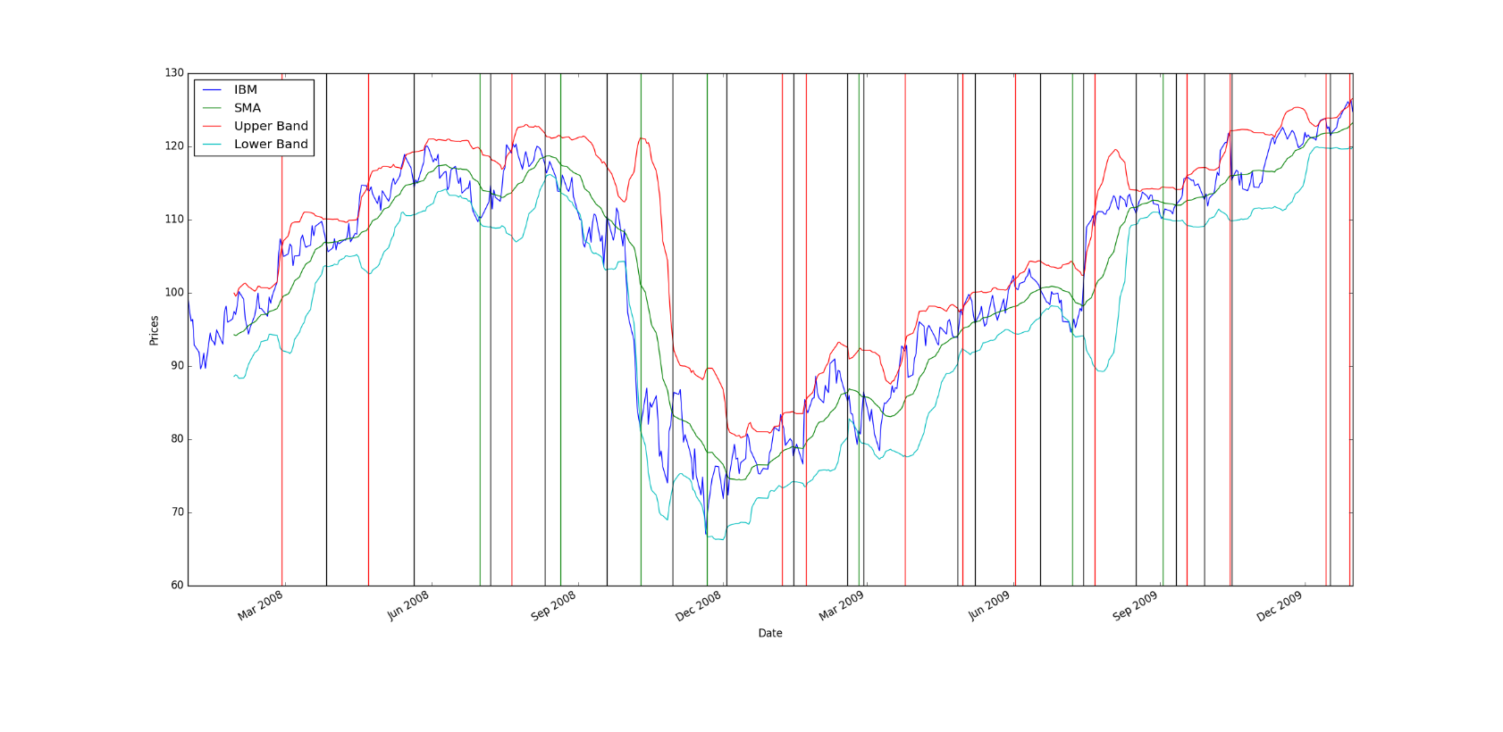

Figure : Trading strategy using Bollinger Bands

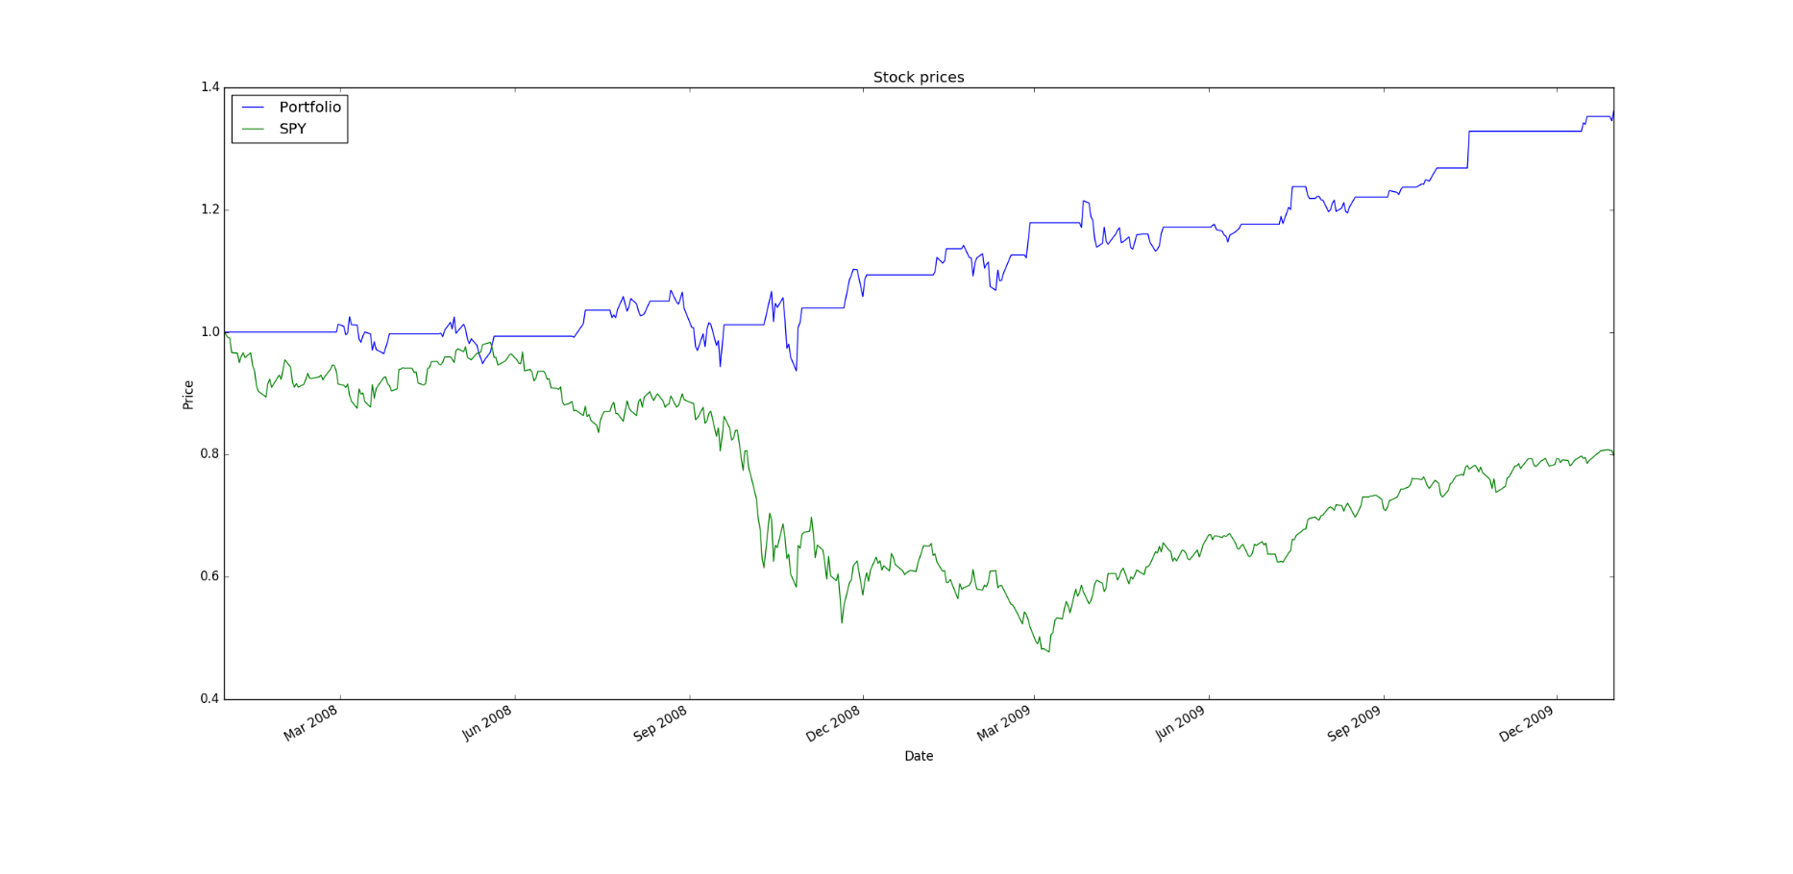

Figure : Performance of Bollinger Band trading strategy versus SPY

|  |  |  |
| --- | --- | --- |
|  | Bollinger Band portfolio | SPY |
| Sharpe Ratio | 0.97745615082 | -0.149575888341 |
| Cumulative return (%) | 0.3614 | -0.201395139514 |
| Standard Deviation of daily return | 0.0108802922269 | 0.0219136847778 |
| Average Daily Return (%) | 0.000669942567631 | -0.000206479400499 |

# Personal strategy

My strategy built upon the idea of market momentum. If the stock moved in the same direction two days in a row, then that prompted an order. Here are the two cases:

1. If the stock moved down a certain percentage 2 days in a row, that prompts a sell order because the stock is likely to continue moving downward.
2. If the stock moved up a certain percentage 2 days in a row, that prompts a buy order because the stock is likely to continue moving upward.

While delaying the buying and selling means you lose some of the potential gain from making the trade the extra day earlier, it also means that you trade less often and are not likely to simply be reactionary. Smaller changes in price are “evened out” so that trading is only done when there are major changes in the price.

Over the specified time period, here are the trades that this strategy performed:

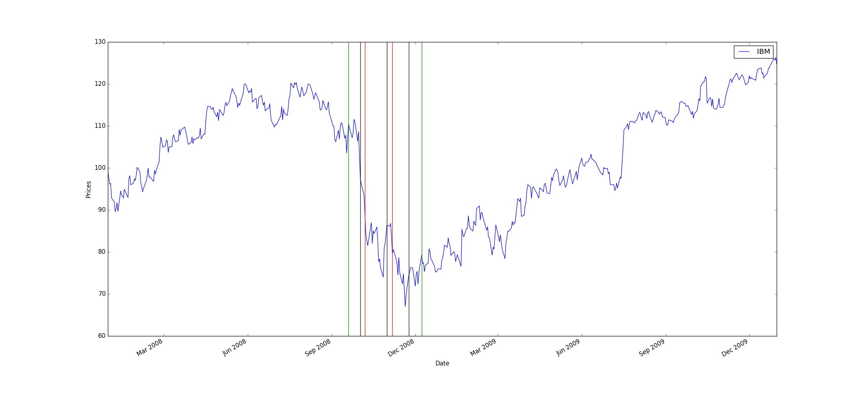

Figure : Trades selected by personal strategy

You can see that the trading is mostly performed in the middle where the stock price changed drastically. This is exactly what this strategy was intended to do – only make trades when the price changes significantly.

Here is the performance of this strategy version the S&P 500 over the same time period:

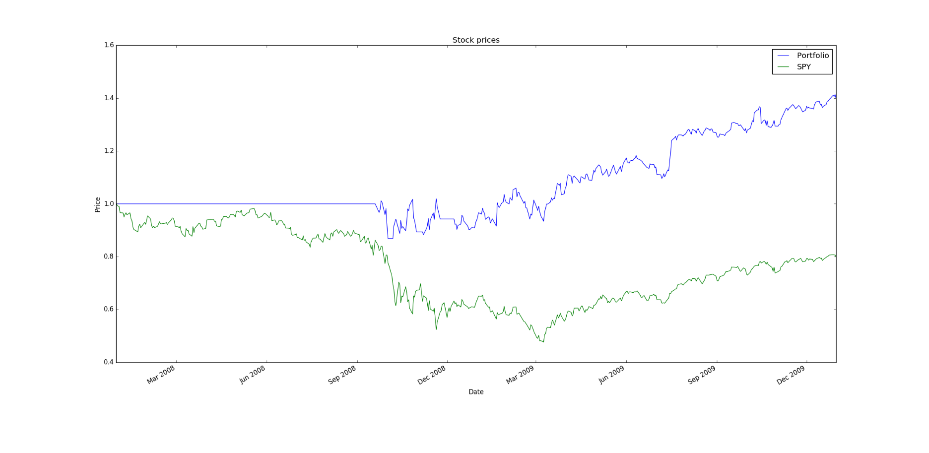

Figure : Performance of personal strategy versus S&P 500

Here are the statistics for this portfolio over the time period above.

|  |  |  |
| --- | --- | --- |
|  | My portfolio | SPY |
| Sharpe Ratio | 0.835425219517 | -0.149575888341 |
| Cumulative return (%) | 0.3976 | -0.201395139514 |
| Standard Deviation of daily return | 0.0146198167736 | 0.0219136847778 |
| Average Daily Return (%) | 0.000769394789444 | -0.000206479400499 |

This performance is very similar to the Bollinger Bands strategy. While greater risk (lower Sharpe Ratio) is carried, a higher cumulative return is achieved, showing that there is a balance between risk and reward.