MC3 Projec 2

KNN Trader

Jacob Kilver (jkilver3)

18 April 2016

# Indicators

The indicators used in this project were the ones mentioned in the project description, namely Bollinger Band© value, momentum, and volatility. Here is how each was computed:

## Bollinger Band

$$bbValue[t]=(price\left[t\right]-SMA\left[t\right])/(2*stdev[t])$$

Where SMA is the 20 day simply moving average of the stock’s adjusted close price at time t and stdev is the standard deviation of the stock adjusted close over the last 20 days.

## Momentum

The 5 day momentum of the adjusted close price was used as defined by:

$$momentum\left[t\right]=\left(\frac{price\left[t\right]}{price\left[t-5\right]}\right)-1$$

## Volatility

Five day volatility of the adjusted close price was the final feature. This was just the standard deviation of the stock price over the previous 5 days.

# Trading Policy

The trading policy recommended in the project description was used here. If the 5 day return was predicted to go up 1% or more, a buy order was placed. If the 5 day return was predicted to go down 1% or more a sell order was placed. After 5 days, the opposite of the initial order was made. Thus, if a buy order was placed, 5 days later a sell order was placed. If a sell order was placed, 5 days later a buy order was made.

The learner used as a KNN learner with a k value of 3.

# Sine data

## In Sample

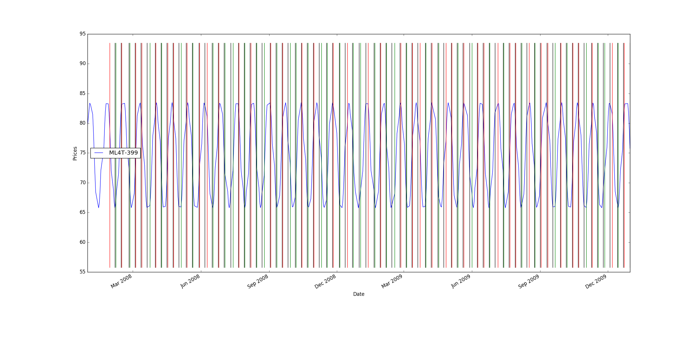

Figure : Sine data in-sample trading

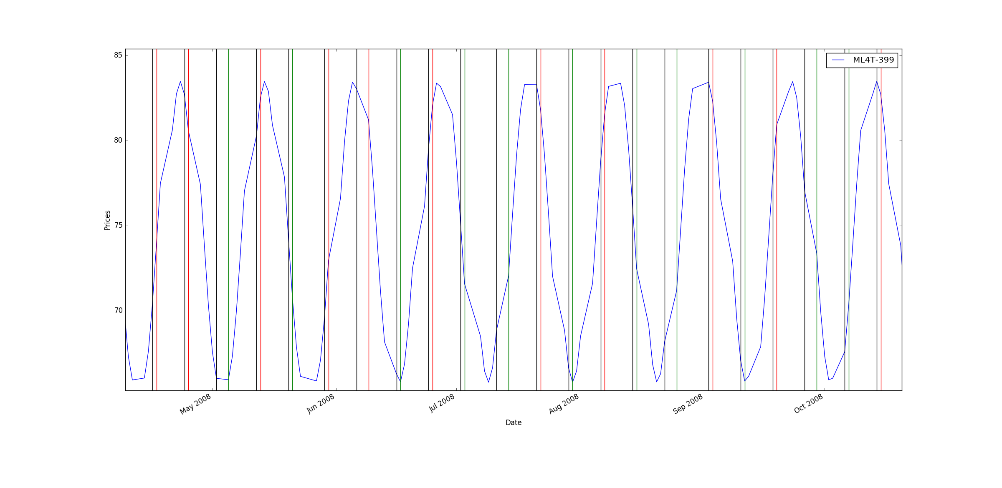

Figure : Sine data in-sample trading - zoomed view

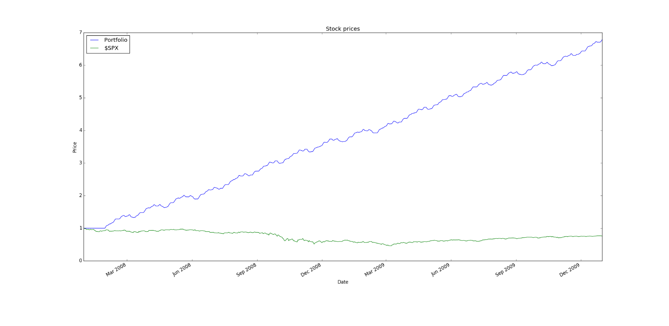

Figure : Sine data in-sample backtest performance

Table : Sine data in-sample backtest statistics

|  |  |  |
| --- | --- | --- |
|  | KNN Portfolio | $SPX |
| Sharpe Ratio | 7.60384327713 | -0.21996865409 |
| Cumulative Return | 5.78168311 | -0.240581328829 |
| Standard Deviation | 0.00799470507881 | 0.0219524869863 |
| Avg. Daily Return | 0.00382944057087 | -0.000304189525556 |

## Out of Sample

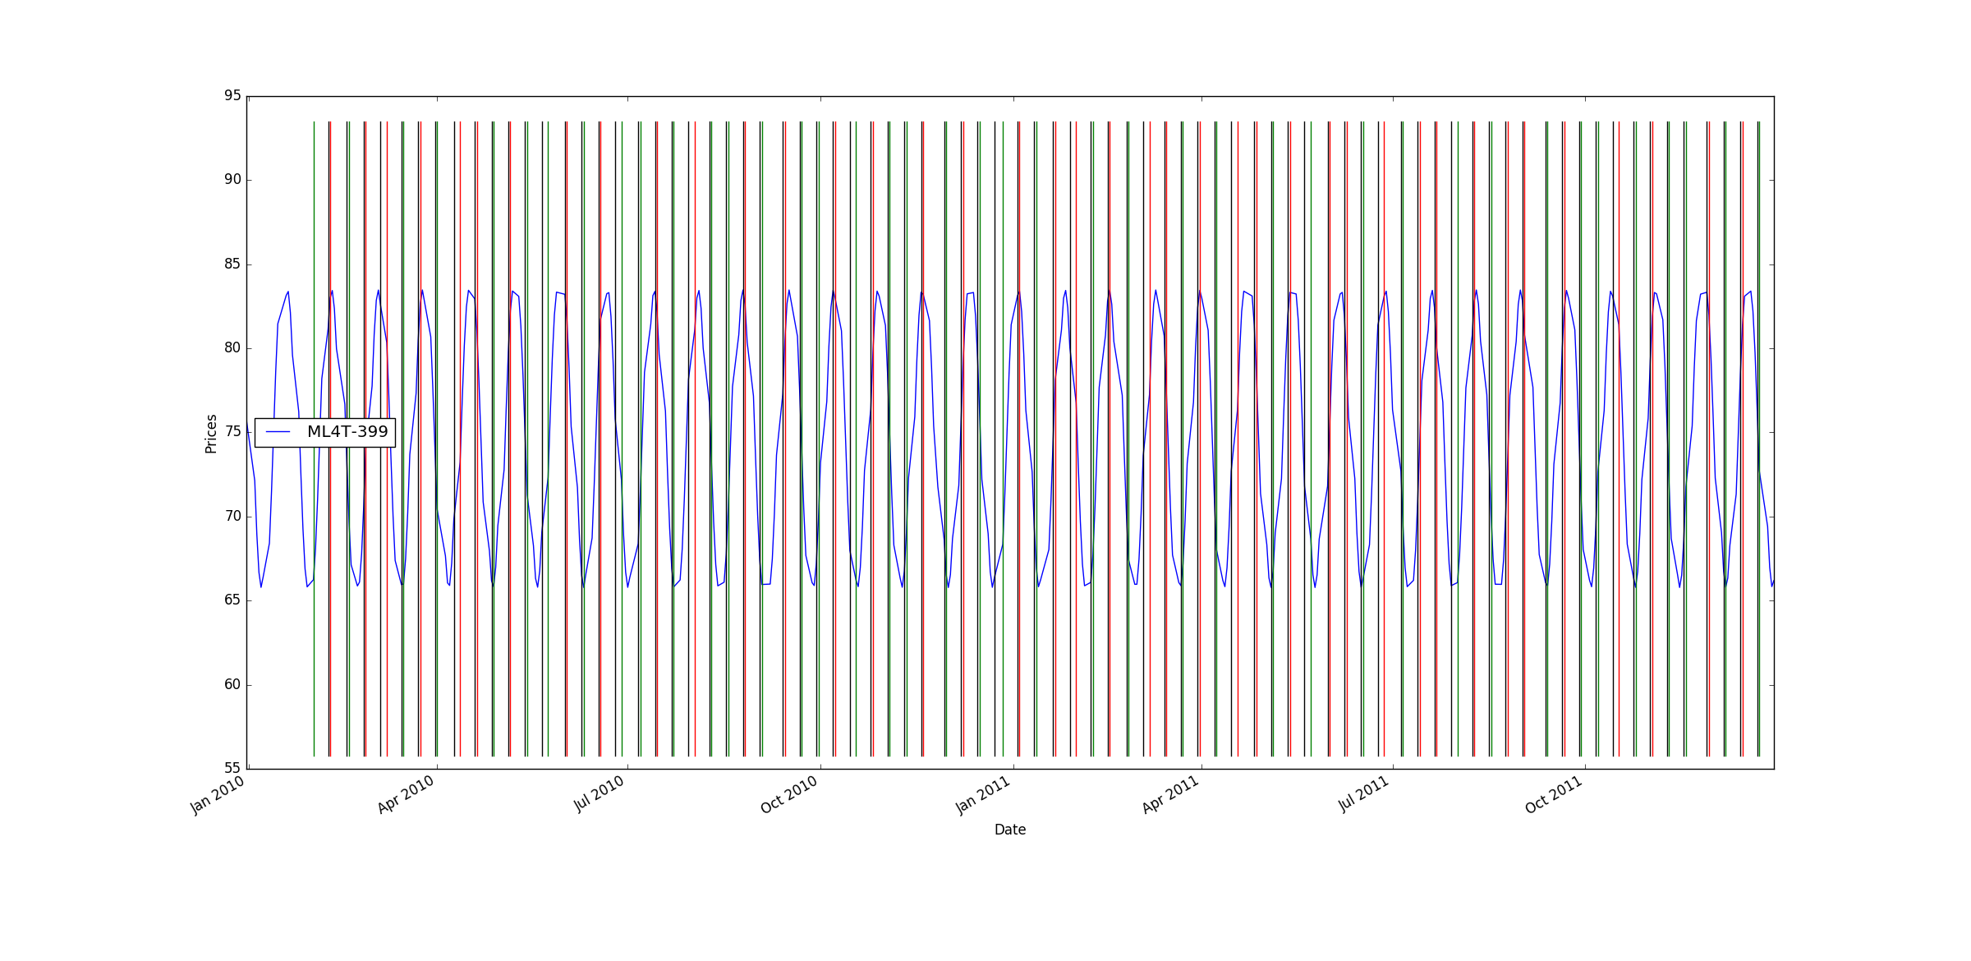

Figure : Sine data out-of-sample trading

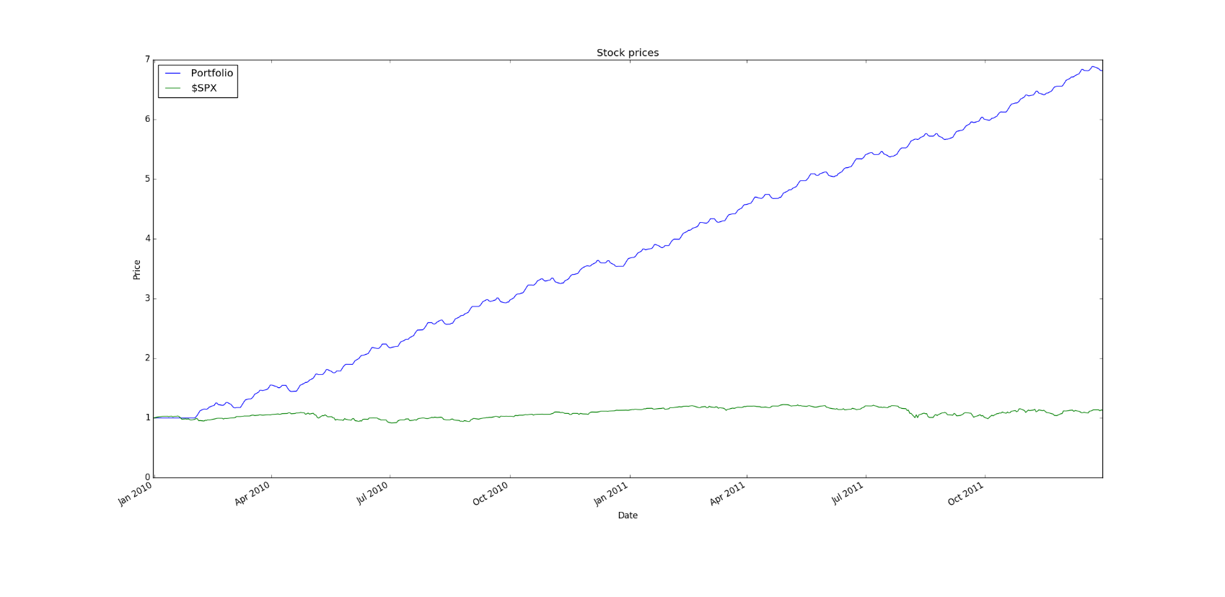

Figure : Sine data out-of-sample backtest performance

Table : Sine data out-of-sample backtest statistics

|  |  |  |
| --- | --- | --- |
|  | KNN Portfolio | $SPX |
| Sharpe Ratio | 7.48519458772 | 0.393165319464 |
| Cumulative Return | 5.82018287 | 0.127791229486 |
| Standard Deviation | 0.00816426802962 | 0.0131086008359 |
| Avg. Daily Return | 0.00384963964756 | 0.000324661859049 |

## Analysis of Results

The results for the in-sample test were exactly as expected. The KNN learner was able to predict the 5 day return very accurately. The backtest performance for the in-sample set was amazing because the behavior of the stock was very predictable and the KNN learner was able to capitalize on this behavior.

Most of the analysis above also applies to the out-of-sample backtest.

# IBM Data

## In Sample

|  |  |  |
| --- | --- | --- |
|  | KNN Portfolio | $SPX |
| Sharpe Ratio | 3.37293130035 | -0.21996865409 |
| Cumulative Return | 1.8047 | -0.240581328829 |
| Standard Deviation | 0.00984754069168 | 0.0219524869863 |
| Avg. Daily Return | 0.00209235325655 | -0.000304189525556 |

## Out of Sample

|  |  |  |
| --- | --- | --- |
|  | KNN Portfolio | $SPX |
| Sharpe Ratio | -0.0358579773671 | 0.393165319464 |
| Cumulative Return | -0.0911 | 0.127791229486 |
| Standard Deviation | 0.0173479262842 | 0.0131086008359 |
| Avg. Daily Return | -3.9186194199e-05 | 0.000324661859049 |

## Analysis of Results