UI/UX DESIGN · LAB ASSIGNMENT
Experiment 4
Interface Screenshots

GeM — Government e-Marketplace
Tractors category: search, bid detail, participation and bid tracking
Student | Shashwat Nande
Roll No. | 1032232121
Course | UI/UX Design (CSE4PE43A)
System | GeM — Government e-Marketplace (Tractors category)
Domain | Vehicles — agricultural machinery procurement
Date | 24 October 2026
Contents
Section | What it covers
Screen index | Role of each of the seven captured screens in the buying flow
Figures 1–7 | Home, listing, bid detail, specifications, My Bids and Help Centre with captions

Experiment 4 — Interface Screenshots

This section documents the interface of the GeM Tractors category as implemented for the tractor buying flow. The screenshots were captured on a desktop browser while signed in as a buyer, and follow the journey a buyer takes: discovering tractors on the home page, filtering the listing, reviewing a bid, participating, and tracking the result.

Screen index
No. | Screen | Role in the buying flow
1 | Home page — hero and entry points | Entry point of the portal; communicates the offer and routes buyers to tractors.
2 | Home page — popular tractor category | Lets buyers jump straight into live tractor bids from the homepage.
3 | Tractors listing with filters | Narrow active tractor bids by budget, power and drive type, then shortlist or compare.
4 | Bid detail page | Gives the full summary a buyer needs to decide whether to participate.
5 | Bid detail — technical specifications | Presents detailed specifications and buyer context for the bid.
6 | Participation confirmation and My Bids | Confirms participation and lets the buyer track progress without manual checking.
7 | Help Centre | Plain-language support for first-time bid participants.

Figure 1 — Home page — hero and entry points
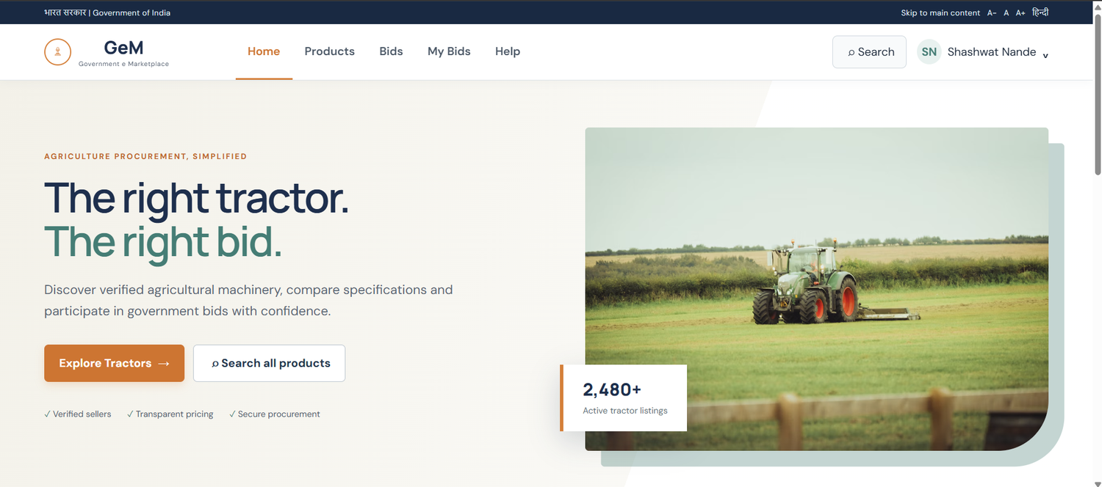
Purpose | Entry point of the portal; communicates the offer and routes buyers to tractors.
Key elements | Government of India identity bar with Skip to main content, A− / A / A+ text size and Hindi toggle; global navigation (Home, Products, Bids, My Bids, Help); headline “The right tractor. The right bid.”; primary CTA Explore Tractors and secondary Search all products; trust cues (Verified sellers, Transparent pricing, Secure procurement); “2,480+ active tractor listings” stat card.

Figure 2 — Home page — popular tractor category
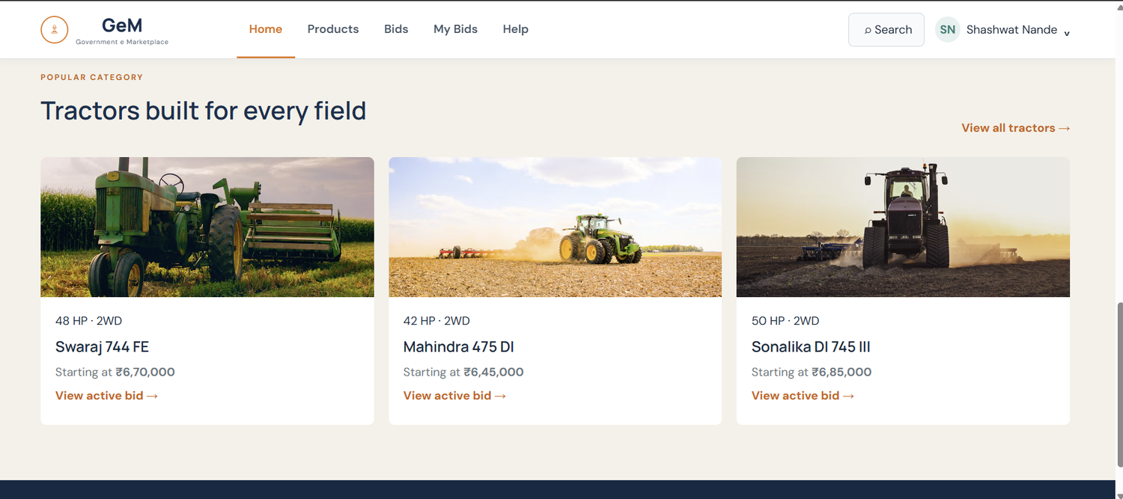
Purpose | Lets buyers jump straight into live tractor bids from the homepage.
Key elements | “Tractors built for every field” section; three model cards (Swaraj 744 FE, Mahindra 475 DI, Sonalika DI 745 III) each showing HP, drive type and starting price; View active bid links; View all tractors link.

Figure 3 — Tractors listing with filters
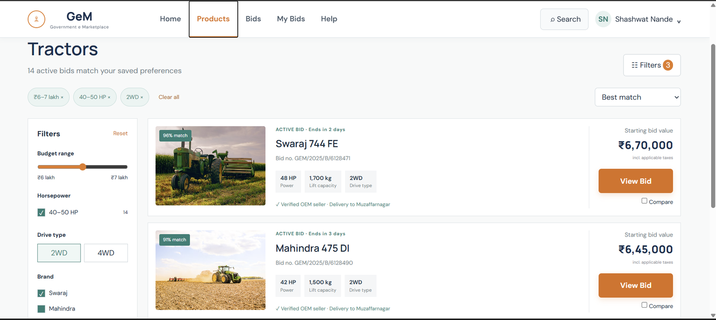
Purpose | Narrow active tractor bids by budget, power and drive type, then shortlist or compare.
Key elements | 14 matching bids; applied-filter chips (₹6–7 lakh, 40–50 HP, 2WD) with Clear all; Filters panel (budget, horsepower, drive type, brand); % match badge; bid number and closing time; spec tiles (HP, lift capacity, drive); verified OEM seller and delivery location; starting bid value; View Bid and Compare.

Figure 4 — Bid detail page
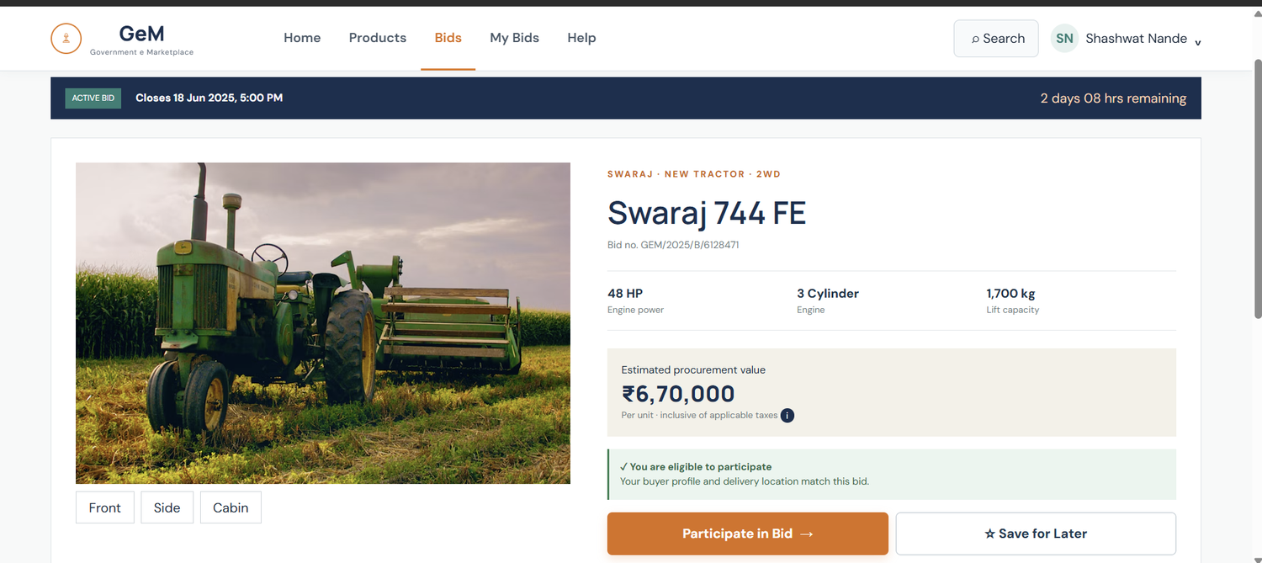
Purpose | Gives the full summary a buyer needs to decide whether to participate.
Key elements | Active bid banner with closing date and countdown; model title, bid number and category tags; key specs (48 HP, 3 cylinder, 1,700 kg); estimated procurement value with tax note; eligibility confirmation; Participate in Bid and Save for Later; Front / Side / Cabin views.

Figure 5 — Bid detail — technical specifications
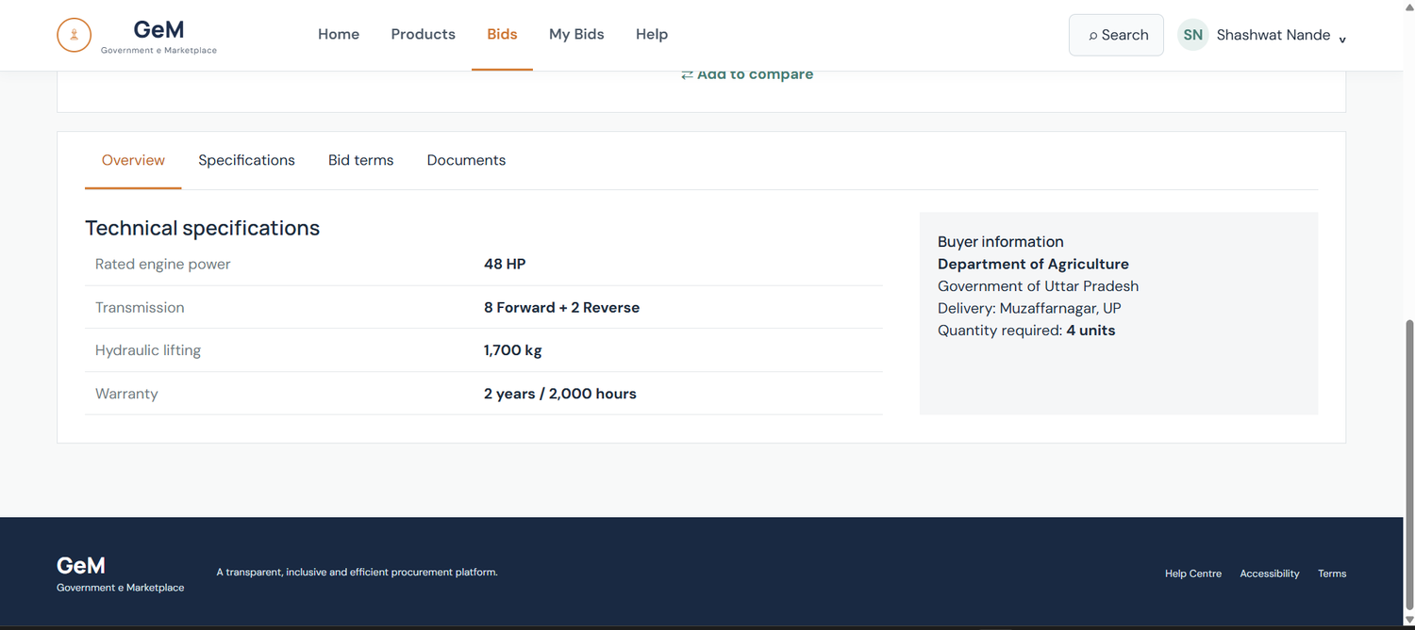
Purpose | Presents detailed specifications and buyer context for the bid.
Key elements | Tabs (Overview, Specifications, Bid terms, Documents); technical specifications table (rated engine power, transmission, hydraulic lifting, warranty); Buyer information panel (department, delivery location, quantity required); Add to compare; footer with Help Centre, Accessibility and Terms.

Figure 6 — Participation confirmation and My Bids
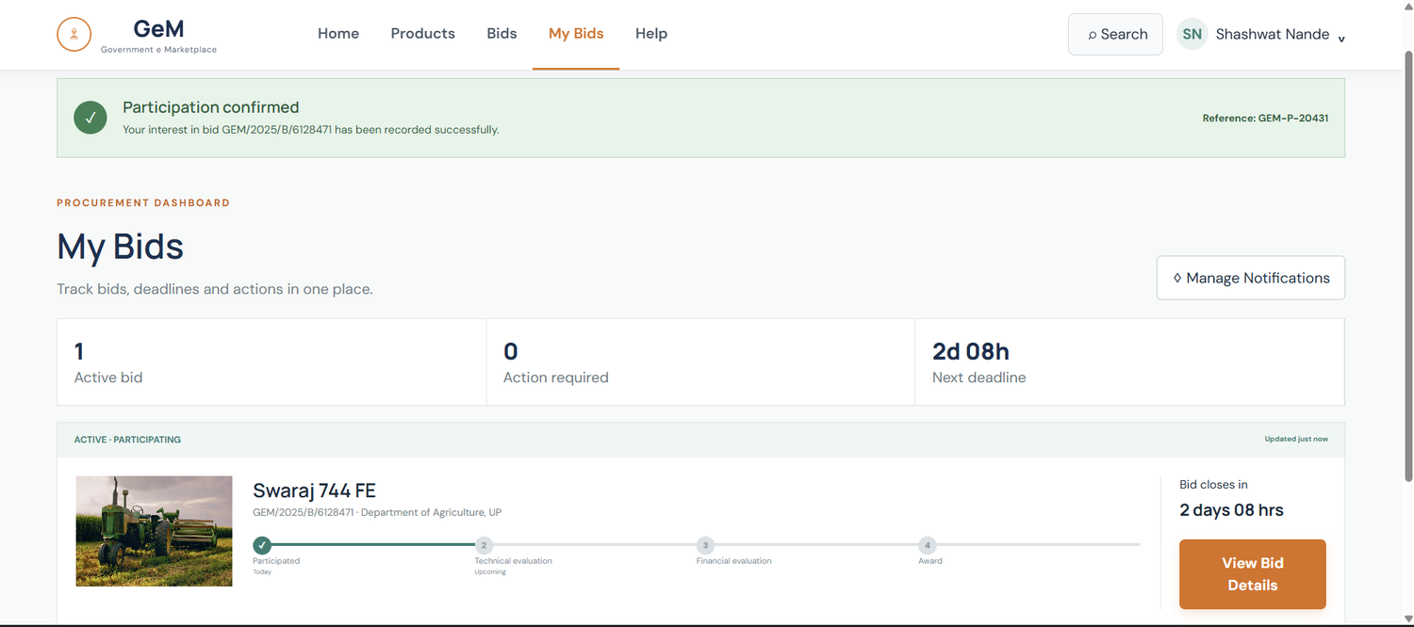
Purpose | Confirms participation and lets the buyer track progress without manual checking.
Key elements | “Participation confirmed” banner with reference GEM-P-20431; dashboard counters (1 active bid, 0 action required, 2d 08h next deadline); Manage Notifications; participating bid card with four-stage tracker (Participated, Technical evaluation, Financial evaluation, Award); View Bid Details.

Figure 7 — Help Centre
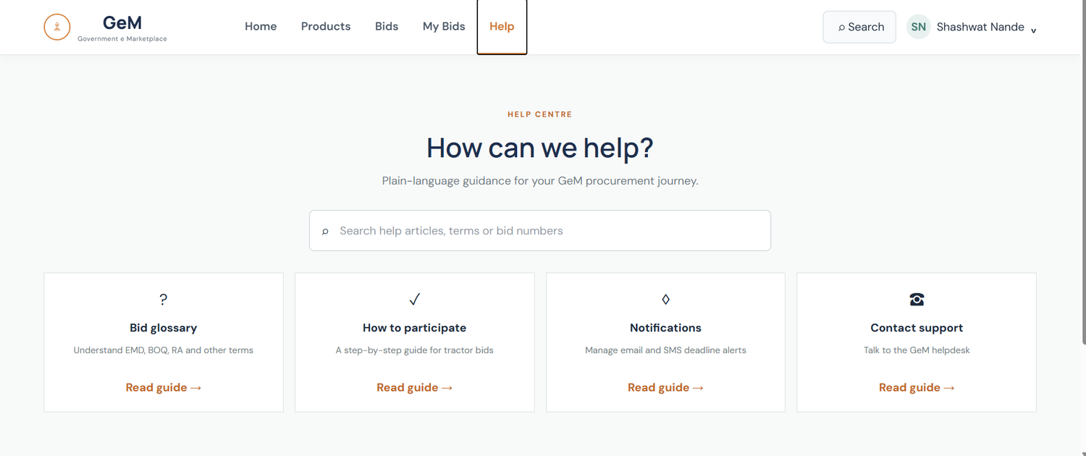
Purpose | Plain-language support for first-time bid participants.
Key elements | “How can we help?” search box; four guide cards — Bid glossary (EMD, BOQ, RA), How to participate, Notifications and Contact support; Read guide links.

