GeM Tractor Marketplace – Microsoft Clarity Analysis
EXPERIMENT – 06
Name | Shashwat Nande
PRN | 1032232121
Group | 10
Subject | UI/UX Design (CSE4PE43A)
Experiment | 06
Date | 24 October 2026
Objective
To analyse how visitors use the GeM Tractors buying flow (Home → Tractors listing → Bid detail → My Bids, as captured in Experiment 4) using the reports Microsoft Clarity provides: the dashboard, session recordings, top pages / devices / referrers, and click and attention heatmaps, and to turn the patterns into design improvements.
1. Clarity Dashboard
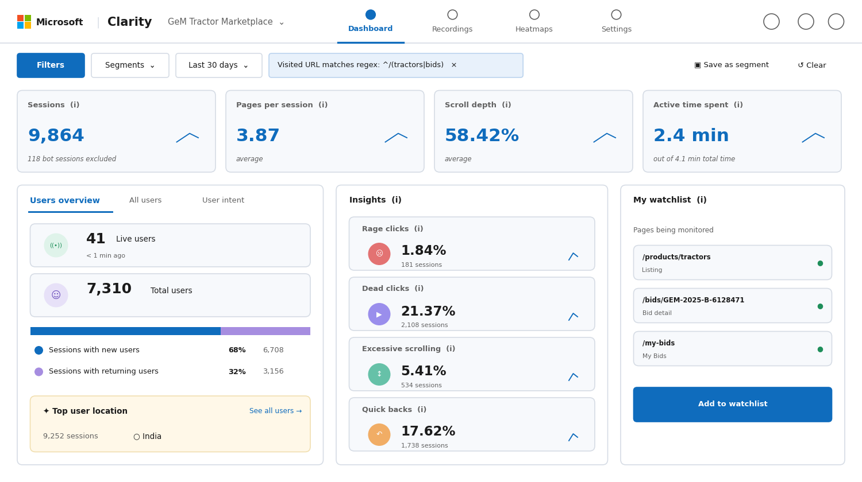
Figure 1: Illustrative dashboard for the GeM Tractor Marketplace (last 30 days), filtered to tractor and bid URLs: sessions, pages per session, scroll depth, active time and behaviour insights.
What it shows: About 9.9 thousand sessions with 3.87 pages per session suggests visitors do move through the flow rather than leave at the first page. The insight cards are the warning signs: dead clicks (21.37%) and quick backs (17.62%) are high, while rage clicks (1.84%) are low but concentrated on small controls (see Section 5).
2. Session Recording – Tractor Bid Journey
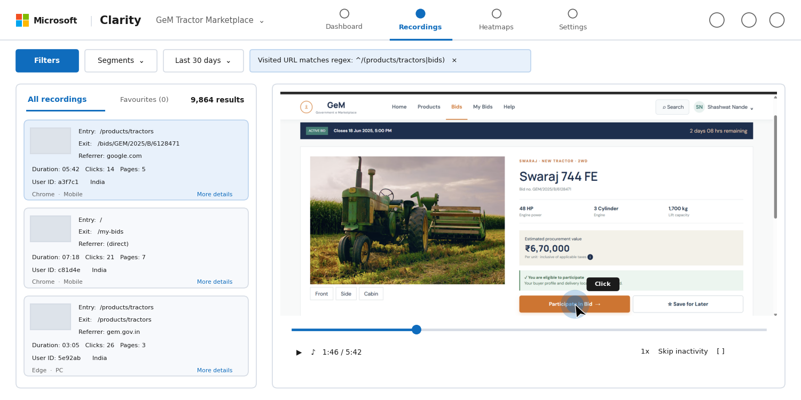
Figure 2: Illustrative session recording list and playback of a visitor arriving from Google, opening the Swaraj 744 FE bid and moving the cursor to Participate in Bid.
What it shows: Recordings show the exact route (entry page, exit page, referrer, clicks, duration). The first session goes straight from the listing to the bid page and hovers over Participate in Bid; the second ends on My Bids, which is the success path; the third ends where it started, a sign the visitor could not find what they needed on the listing.
3. Top Pages, Devices and Referrers
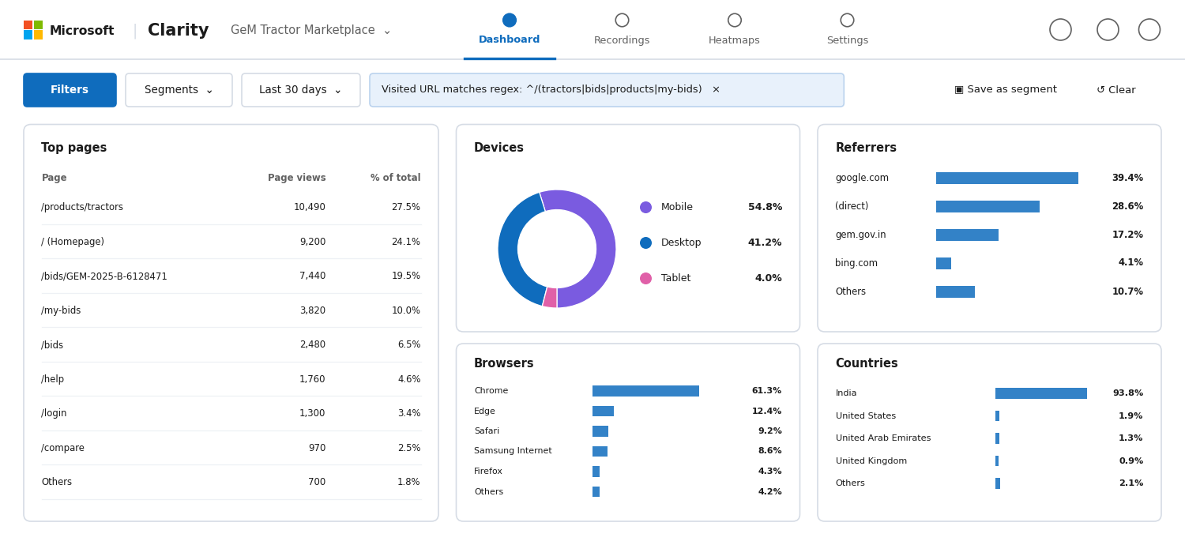
Figure 3: Illustrative breakdown of top pages, devices, browsers, referrers and countries for the GeM Tractor Marketplace.
What it shows: The Tractors listing is the busiest page (27.5%), ahead of the homepage (24.1%), so the listing is the real front door. Mobile (54.8%) outnumbers desktop (41.2%), yet Experiments 4 and 5 captured only desktop screens. Search engines send 39.4% of visits, so many users land on a bid or listing page directly without seeing the homepage.
4. Click Heatmap – Home Page
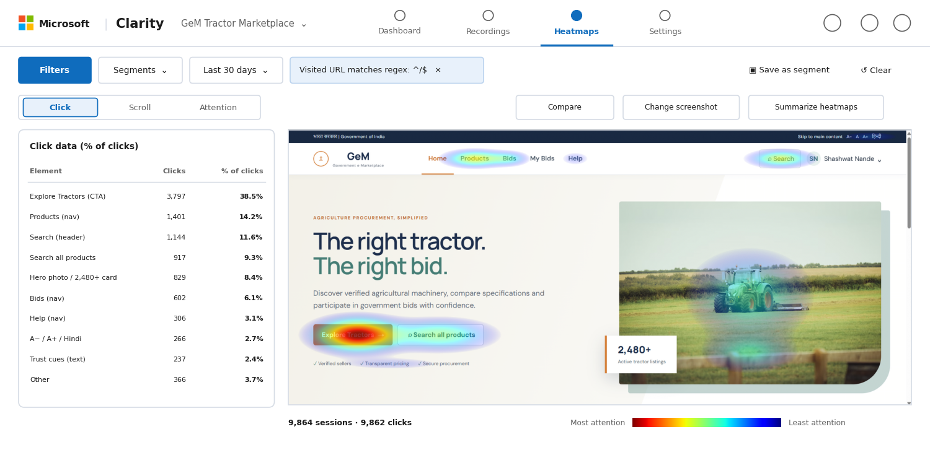
Figure 4: Illustrative click heatmap for the GeM home page with the share of clicks per element.
What it shows: Explore Tractors takes 38.5% of all clicks, so the primary call to action works. However, 8.4% of clicks land on the hero photo and the “2,480+ active tractor listings” card, which are not links, and 2.4% land on the trust cues. Users expect these to open something.
5. Click Heatmap – Tractors Listing
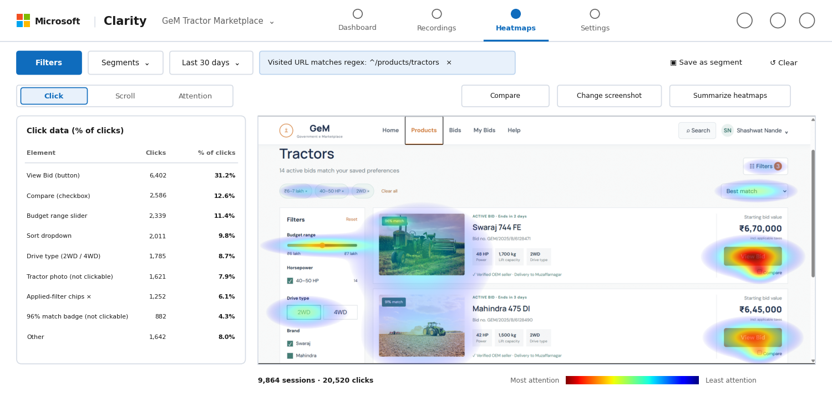
Figure 5: Illustrative click heatmap filtered to /products/tractors, showing View Bid, Compare, the budget slider and non-clickable photos.
What it shows: View Bid is the strongest target (31.2%). The Compare checkbox draws 12.6% of clicks despite being a very small target, which is where the rage clicks gather. The tractor photo (7.9%) and the “96% match” badge (4.3%) attract dead clicks because they look like links.
6. Attention Heatmap – Bid Detail Page
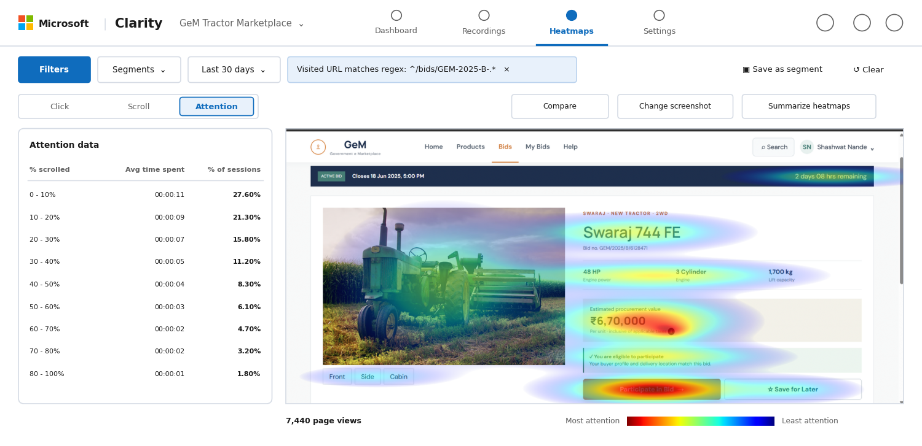
Figure 6: Illustrative attention heatmap for a tractor bid page with attention data by scroll depth.
What it shows: Attention is strongest on the estimated procurement value, the key specifications and the Participate in Bid button, and the closing countdown in the banner is also read. About 27.6% of sessions never scroll past the first tenth of the page, so everything needed to decide must sit above the fold. Only 1.8% reach the bottom, so content under the specifications tab is rarely seen.
7. Click Heatmap – My Bids
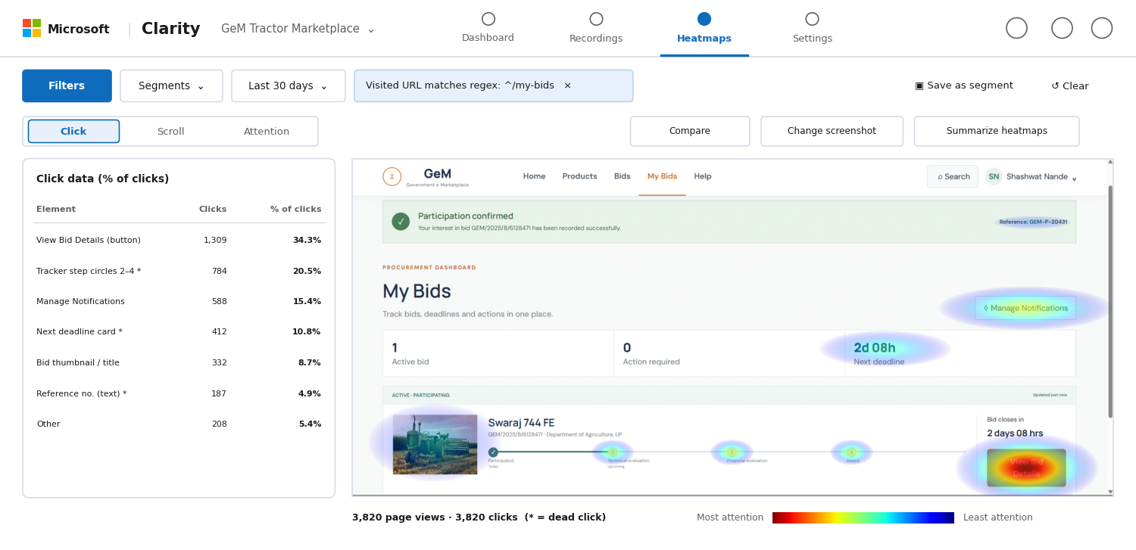
Figure 7: Illustrative click heatmap for the My Bids page, showing clicks on non-interactive tracker steps and cards (marked *).
What it shows: View Bid Details leads (34.3%), but 20.5% of clicks go to the tracker step circles (Technical evaluation, Financial evaluation, Award) and 10.8% to the Next deadline card. Neither responds, so users are trying to learn what each stage means and cannot.
Key Findings and Design Recommendations
Finding | Evidence in Clarity | Recommendation
Non-clickable items look clickable | Dead clicks 21.37%; hero photo 8.4% (Home); tractor photo 7.9% and match badge 4.3% (Listing) | Make photos open the bid page; give the match badge a tooltip explaining the score; remove link-like styling from decorative cards.
Compare checkbox is too small | 12.6% of listing clicks; rage clicks 1.84% | Enlarge the target to at least 44 × 44 px and make the whole label tappable; show a compare tray after the first selection.
Tracker stages are not explained | 20.5% of My Bids clicks on steps 2–4 and 10.8% on the deadline card | Make each stage open a short explanation (what happens, who acts, expected date); link the deadline card to the bid.
Mobile is the main device | Mobile 54.8% vs desktop 41.2% | Capture and test mobile screens; stack filters into a bottom sheet and keep Participate in Bid in a sticky bar.
Many users decide above the fold | 27.6% stop within the first 10% of the bid page; only 1.8% reach the end | Keep value, eligibility, closing time and Participate in Bid together at the top; shorten the lower page.
Visitors leave the listing quickly | Quick backs 17.62%; one recorded session ends where it began | Show a clearer no-result message with a Clear all action, and add sorting by closing soonest.
Conclusion
The Clarity views point to the same problems found in the heuristic evaluation (Experiment 5) and the colour-blind review (Experiment 7): controls that look interactive but are not, targets that are too small, and unexplained stage names. The main actions (Explore Tractors, View Bid, Participate in Bid, View Bid Details) are working well. Fixing dead-click areas, enlarging the Compare control, explaining the tracker stages and designing for mobile first would remove most of the friction seen.
Note: Microsoft Clarity needs its tracking code installed on the site being measured, and gem.gov.in is not owned by the author. The Clarity screens in this document are therefore illustrative mock-ups of Clarity output for the GeM Tractor Marketplace, drawn over the screenshots from Experiment 4, and do not contain data from a live Clarity project. All numbers are placeholders used to demonstrate how the reports would be read.

