EXPERIMENT 07
Colour Blind Mode for the GeM Tractors Website

Experiment No. | 07
Name | Shashwat Nande
PRN | 1032232121
Group | 10
Experiment Title | Added Colour Blind option to optimize the GeM Tractors website for colour-blind people
Objective
To optimize the GeM Tractors website for colour-blind users by adding a Colour Blind Mode option in the header and ensuring that important information (bid deadlines, verification, selection, bid status and actions) is conveyed through text, icons and contrast rather than colour alone.
Website Screenshots
Figure 1: Home page – header and hero
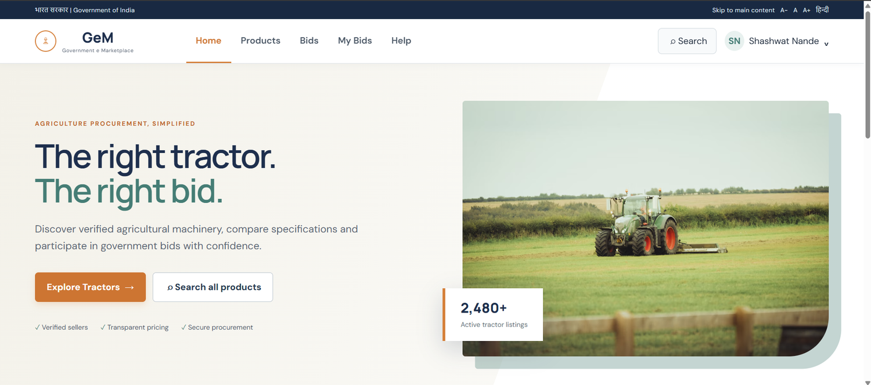
The header offers Skip to main content, A− / A / A+ and a Hindi toggle in text, which is where the Colour Blind Mode selector sits. The headline uses dark navy and green on a cream background, and Explore Tractors and Search all products are labelled in words, with trust cues (Verified sellers, Transparent pricing, Secure procurement) written out beside their ticks.
Figure 2: Home page – popular tractor category
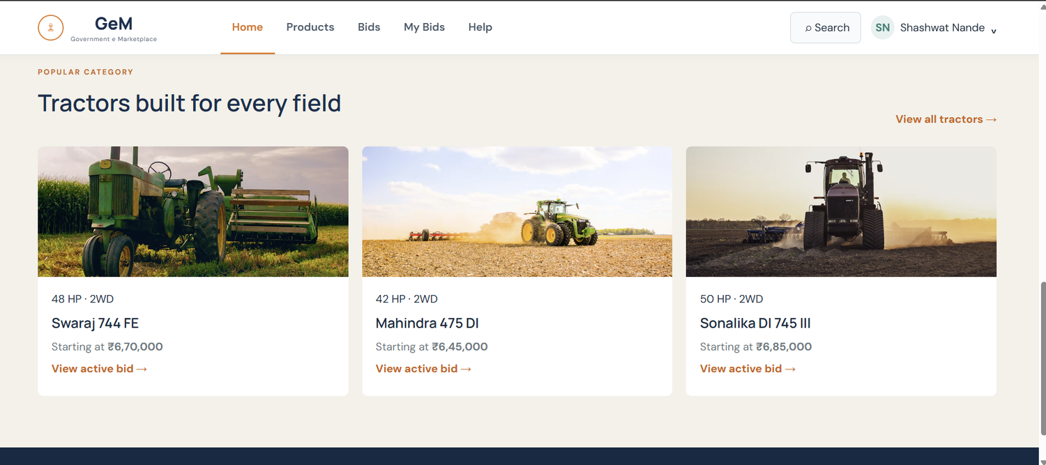
Each tractor card states HP, drive type, the starting price and “View active bid →” as text, so meaning never depends on the orange link colour. The arrow adds a second cue.
Figure 3: Tractors listing – filters, badges and match score
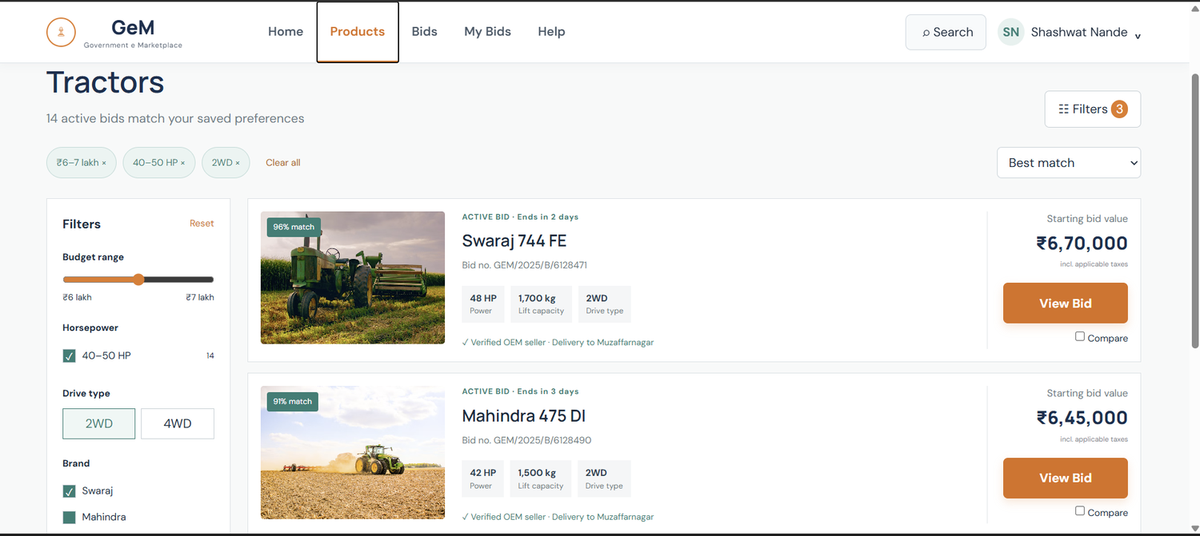
Applied filters are shown as labelled chips with a × (₹6–7 lakh, 40–50 HP, 2WD). “96% match” carries a number, “ACTIVE BID · Ends in 2 days” is written text, and “✓ Verified OEM seller” pairs a tick with words, so none relies on green or orange alone. The selected 2WD option, however, is shown mainly by a tinted fill.
Figure 4: Bid detail – status banner and eligibility
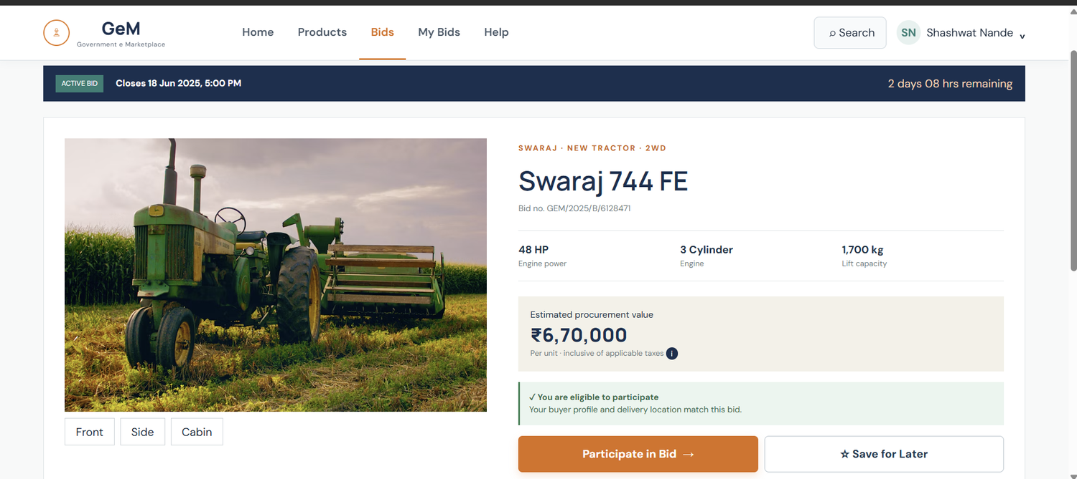
“ACTIVE BID” and the closing date and time are written in the dark banner with “2 days 08 hrs remaining”. The eligibility panel uses a tick and the sentence “You are eligible to participate”, so the green tint is only a reinforcement.
Figure 5: Bid detail – tabs and specifications
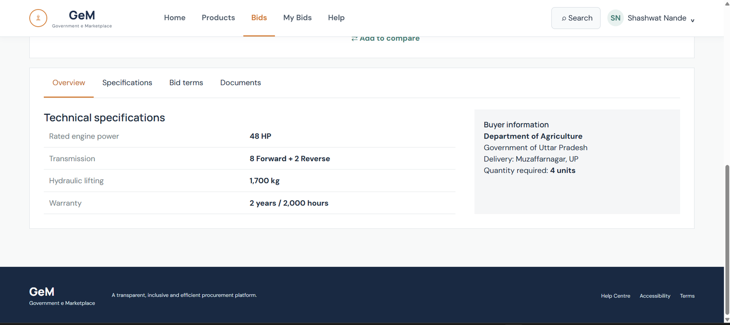
The selected tab (Overview) is marked by orange text with an underline. The underline helps, but orange against dark grey text is easy to confuse, so weight and a thicker underline are added in Colour Blind Mode.
Figure 6: Participation confirmation and My Bids
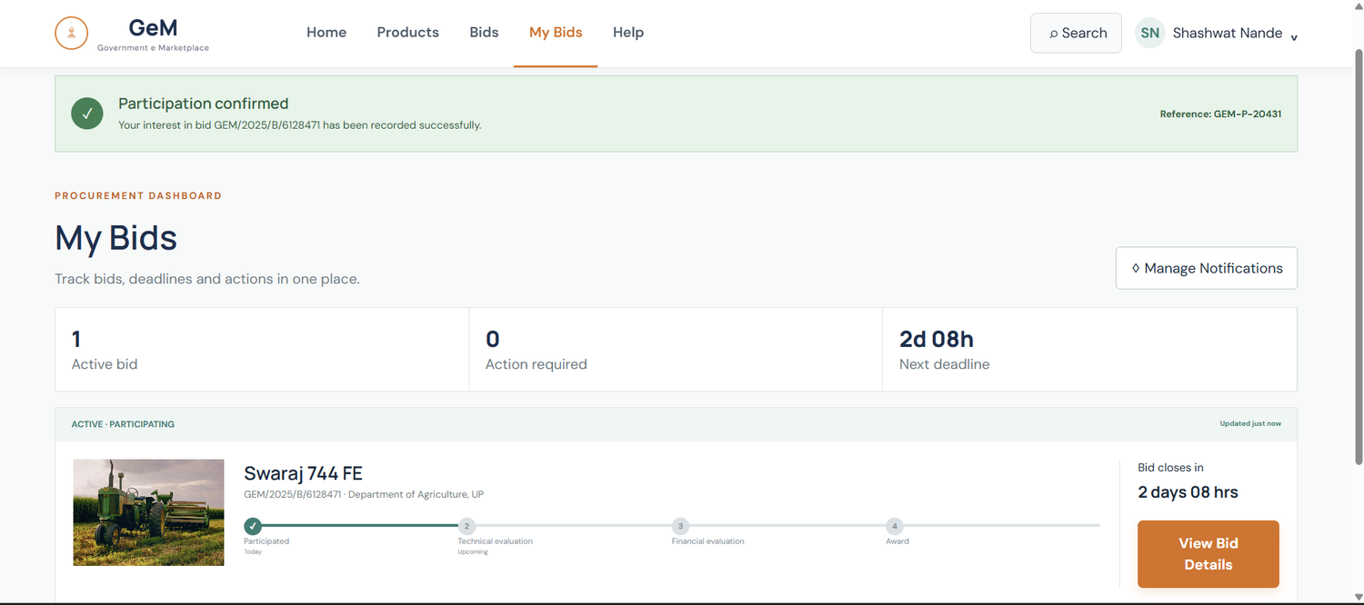
Success is shown by a tick and the words “Participation confirmed”, plus a reference number. In the tracker, the completed step shows a tick and the pending steps show the numbers 2, 3 and 4 with the labels “Today” and “Upcoming”, so progress is readable without colour.
Figure 7: Help Centre
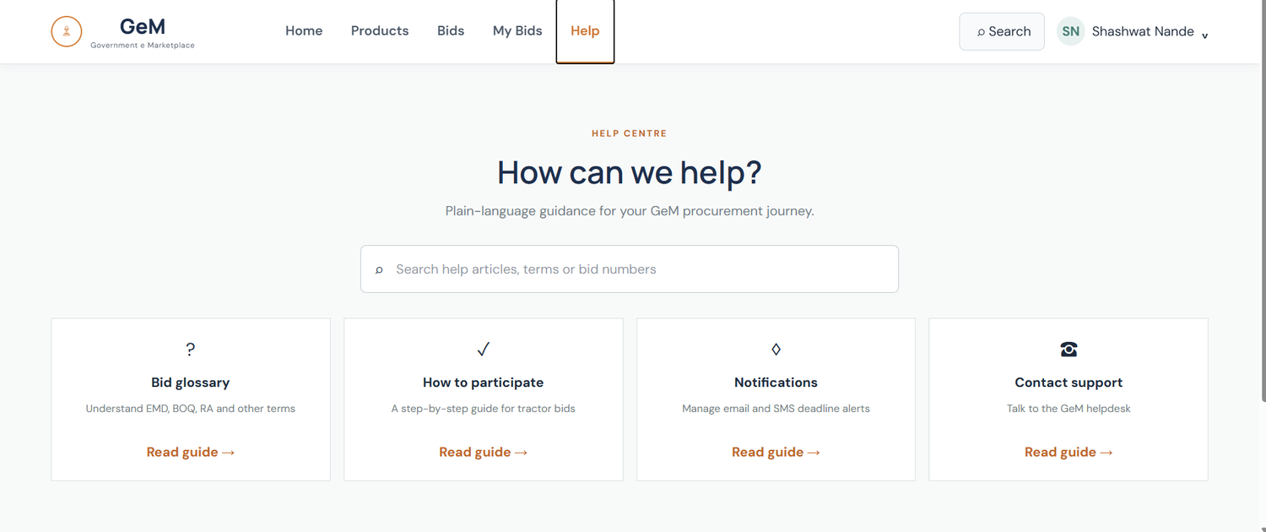
Each help card has an icon, a bold title, a description and a “Read guide →” link. Text and icons identify the cards; the orange link colour is not needed to tell them apart.
What Colour Blind Mode Changes
The selector offers Normal, Protanopia, Deuteranopia and Tritanopia options and sits in the top bar beside the A− / A / A+ text-size controls and the Hindi toggle. The chosen mode is applied across the whole site and remembered for the next visit. The changes below apply when a mode is chosen.
Element | Colour-only risk | Colour Blind Mode change
Active tab and selected states (Overview tab, 2WD option, checkboxes) | Selection is shown by an orange or teal tint, which can look the same as the unselected state | Dark fill with a tick mark and a thick border; bold tab text with a 3 px underline; filled dot for radio options
Match score badge (green “96% match”) | Green on a photo can fade into the background | Keep the percentage text and add a solid dark background with a white outline
Eligibility and success banners (“You are eligible…”, “Participation confirmed”) | A green panel suggests success only by colour | Keep the tick icon and heading words, and add a thick left border and bold heading
Progress tracker (completed vs pending steps) | Teal and grey circles look alike | Keep the tick and step numbers; add the words “Completed” / “Upcoming” and a solid vs dashed connector line
Closing-time cues (“Ends in 2 days”, “2 days 08 hrs remaining”) | Urgency is carried by plain text with no icon | Add a clock icon and the word “Urgent” with a heavier border for bids closing within 24 hours
Orange buttons and links (Participate in Bid, View Bid, Read guide →) | Orange on cream can lose contrast for some users | Bold text, underline links on hover and focus, contrast of at least 4.5:1
Palette in Colour Blind Mode | Red / green and orange / teal pairs | Use the colour-blind-safe Okabe–Ito palette: blue, orange, sky blue, yellow and vermillion
How to Verify
- Open the site in Chrome, press F12, then open Rendering and choose “Emulate vision deficiencies”.
- Check protanopia, deuteranopia and tritanopia with Colour Blind Mode off and then on.
- Confirm that each badge, selection and status can still be told apart by its icon, text or border.

