Research paper submitted to Journal of Parallel and Distributed Computing (Elsevier)
Exploiting Algorithmic Structure for Efficient Detection and Recovery from Silent Data Corruptions in Large-Scale Computing Systems
[Author Name]^{a,*}
ª Department of Computer Science, [Institution Name], [Postal Address], [Country]

* Corresponding author. Email: [email address]. ORCID: https://orcid.org/0000-0000-0000-0000.

Highlights
- A four-family taxonomy of algorithmic invariants for silent data corruption resilience.
- ASTRA maps each invariant family to detection, localization and recovery mechanisms.
- Randomized verification of a dense product costs 3kn² against n³ for the product itself.
- Forward recovery with probability p_{c} scales minimum resilience waste by √(1 − p_{c}).
- A pre-registered protocol, executed on one node: 99.95% coverage for dense products.
- Measured overhead 17.1% for a solver, but 211% for a BLAS-backed dense product.

Abstract
Silent data corruptions (SDCs) are hardware-induced errors that alter computational results without raising any fault signal. Reports from large production fleets show that defective processors can silently compute incorrect results and that such defects are systemic rather than isolated. Conventional defenses, namely dual and triple modular redundancy and checkpoint/restart, are either costly in resources or unable on their own to detect errors that never announce themselves. This paper argues that the mathematical structure of the executed algorithm provides a cheaper and more precise basis for resilience than generic replication. The author proposes ASTRA (Algorithmic STructure-aware Resilience Architecture), a framework that classifies exploitable algorithmic invariants into four families, namely algebraic checksum invariants, randomized verification certificates, convergence and recurrence invariants, and domain conservation invariants, and couples each family with matched detection, localization and recovery mechanisms. The study adopts a pragmatist research philosophy and the Design Science Research Methodology, combining analytical modeling with a quantitative fault-injection design. Two analytical results are established: randomized verification of a dense matrix product costs 3kn² scalar multiplications against n³ for classical multiplication, and forward recovery with probability p_{c} scales the minimum first-order resilience waste by √(1 − p_{c}) while scaling the optimal verification period by its reciprocal. The paper further specifies a pre-registered evaluation protocol with falsifiable hypotheses, baselines, metrics and statistical procedures, together with a single-node instantiation that can be executed without a large-scale platform. A single-node instantiation of the protocol was executed in a one-vCPU container: randomized verification detected 99.95% of significant corruptions in dense matrix multiplication with no false positive in 20,000 fault-free verifications, while residual checking in a conjugate gradient solver detected 66.0%, a limit set by the checking interval. Measured overhead was 17.1% for the solver against 106.9% for dual modular redundancy, but 211.0% for the dense product, where an optimized library kernel outpaces an interpreted verification, refuting the runtime hypothesis for that case. A period sweep reproduced the predicted waste curve within 4.5 percentage points. All code, configurations, measurements and analysis scripts are released.

Keywords: silent data corruption; algorithm-based fault tolerance; resilience; soft errors; high-performance computing; fault injection; design science research

1. Introduction

1.1 Background of the Study
For decades, the computing community has treated processors as reliable arithmetic devices whose outputs can be trusted unless an explicit failure occurs. Reports from large-scale operators now challenge that assumption. Dixit et al. (2021) described silent data corruptions in Facebook's production infrastructure, explaining that such errors are not captured by the error-reporting mechanisms of the central processing unit, propagate across the software stack, and can require months of debugging effort. Hochschild et al. (2021) described “mercurial cores” in Google's fleet: processors that intermittently compute incorrect results without any indication of failure.
These errors differ fundamentally from fail-stop failures. A crashed node is noticed immediately; a corrupted floating-point value that propagates into a scientific simulation, a financial model, or the parameters of a neural network may never be noticed at all. The problem grows with scale, because the error rate of a platform increases with its number of components (Snir et al., 2014). Large-scale high-performance computing (HPC) and artificial intelligence (AI) workloads, which run for long periods across many processors, are therefore especially exposed.

1.2 Statement of the Problem
Existing responses to silent errors fall into several categories, summarized in Figure 1. Hardware-level protection, such as error-correcting code (ECC) memory, protects stored data but does not protect against logic errors inside processing cores. Replication-based approaches, such as dual modular redundancy (DMR) and triple modular redundancy (TMR), detect or mask such errors, but by definition they require roughly twice or three times the computational resources. Checkpoint/restart recovers from fail-stop failures well, yet by itself it cannot determine whether saved state is already corrupted, so it must be combined with a verification mechanism to handle silent errors (Benoit et al., 2016).
Algorithm-based fault tolerance (ABFT), introduced by Huang and Abraham (1984), offers an alternative: it embeds redundancy in the data and uses mathematical relationships preserved by an algorithm to detect and correct errors. However, ABFT techniques have largely been designed one algorithm at a time, and there is limited work that organizes algorithmic invariants into a unified framework, treats finite-precision arithmetic as a first-class design concern, and connects algorithmic correction to system-level resilience models. The problem addressed by this study is therefore the absence of a systematic, efficient, and rigorously evaluated approach for exploiting algorithmic structure to detect and recover from silent data corruptions in large-scale computing systems.
Figure 1
Classification of Approaches to Protection Against Silent Data Corruption
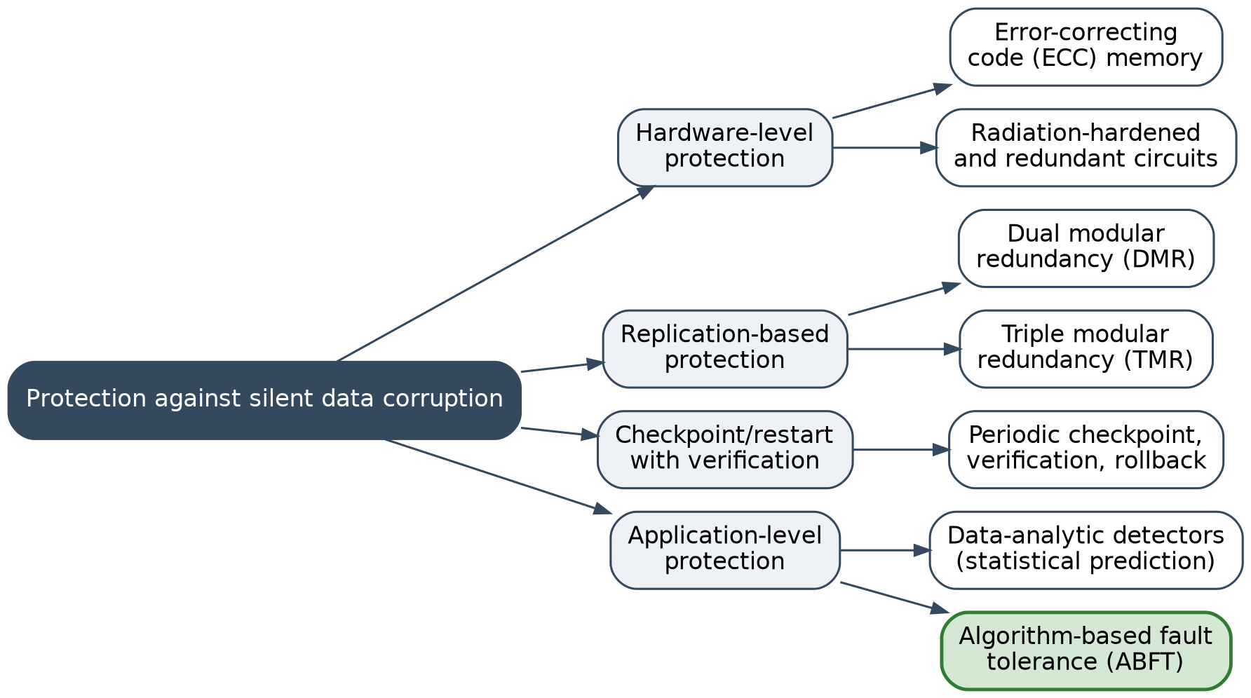
Note. Author's own construction based on the literature reviewed in Section 2. The highlighted branch indicates the focus of this study.

1.3 Aim and Objectives of the Study
The aim of this study is to design, analyze, and specify the evaluation of a structure-aware resilience framework that detects and recovers from silent data corruptions at lower cost than generic replication. The specific objectives are:
- To develop a taxonomy of algorithmic invariants that can be exploited for SDC detection and recovery.
- To design a framework that maps each invariant family to detection, localization, and recovery mechanisms.
- To derive detection thresholds that account for finite-precision floating-point arithmetic.
- To extend first-order resilience models to account for algorithmic forward recovery.
- To specify a reproducible, statistically rigorous fault-injection evaluation protocol for the framework.

1.4 Research Questions
The study is guided by four research questions. RQ1: What classes of algorithmic structure can be systematically exploited to detect silent data corruptions, and how can they be organized into a general framework? RQ2: How can detection mechanisms based on algorithmic invariants be made robust to finite-precision floating-point arithmetic while maintaining high detection coverage? RQ3: Under what conditions does structure-aware forward recovery reduce total resilience overhead compared with replication and checkpoint-based rollback? RQ4: How do structure-aware techniques perform across representative workloads in terms of detection coverage, false-positive rate, runtime overhead, and recovery effectiveness?

1.5 Significance of the Study
The study is significant for three audiences. For system designers, it provides a principled basis for reducing the resource cost of resilience at scale. For application and library developers, it offers a structured way to identify which properties of their algorithms can serve as low-cost error detectors. For researchers, it contributes an analytical model and an evaluation protocol that can be reused to compare resilience techniques under consistent assumptions.

1.6 Scope and Delimitations
The study focuses on silent, data-level errors in numerically intensive workloads. Fail-stop failures that crash processes are outside its scope, as are security attacks that deliberately manipulate data. The workload classes considered are dense linear algebra, sparse iterative linear solvers, and deep neural network training. The analytical model is first-order and assumes Poisson error arrivals; its limitations are discussed in Section 8.

1.7 Contributions
The study makes five contributions: (a) a taxonomy of algorithmic invariants for SDC resilience; (b) the ASTRA framework, which maps each invariant family to detection, localization, and recovery mechanisms; (c) floating-point-aware detection thresholds; (d) an extension of the first-order resilience model that incorporates forward recovery, together with its closed-form optimum; and (e) a reproducible fault-injection evaluation protocol with falsifiable hypotheses.

1.8 Organization of the Paper
Section 2 reviews related literature and identifies the research gap. Section 3 presents the research philosophy and methodology. Section 4 defines the system model, fault model, and design objectives. Section 5 presents the ASTRA framework. Section 6 derives analytical results. Section 7 specifies the experimental design and evaluation protocol. Section 8 discusses implications, threats to validity, and limitations. Section 9 concludes the paper and offers recommendations.

2. Literature Review

2.1 Introduction
This chapter reviews research on silent data corruption in production systems, algorithm-based fault tolerance, data-analytic detection, resilience in deep learning, and resilience modeling. It then synthesizes the reviewed approaches and identifies the gap addressed by this study.

2.2 Silent Data Corruption in Production Systems
Dixit et al. (2021) described common silicon defect types that lead to silent data corruption, presented a real-world case of corruption within a datacenter application, and argued that mitigating such errors requires not only hardware resiliency and production detection mechanisms but also fault-tolerant software architectures. Hochschild et al. (2021) reported similar observations at Google, characterizing defective processors that compute incorrect results intermittently and without warning. Together, these reports establish silent data corruption as an operational concern for large-scale computing rather than a purely theoretical one.

2.3 Algorithm-Based Fault Tolerance
Huang and Abraham (1984) introduced ABFT for matrix operations by encoding data with checksums that are preserved by the computation, enabling errors to be detected and corrected. Chen and Dongarra (2008) applied ABFT to recover from fail-stop process failures in parallel matrix computations, and Bosilca et al. (2009) examined the application of ABFT to high-performance computing more broadly. Wu et al. (2016) observed that fault models used to design ABFT had often been abstract or simplistic; they designed an ABFT scheme for dense linear algebra based on a comprehensive architectural fault model and implemented it in High-Performance Linpack (HPL). For iterative solvers, Bridges et al. (2012) proposed selective reliability, in which most data and computation may run unreliably while a small reliable portion ensures that the solver still converges or reports failure.

2.4 Data-Analytic Detection
A complementary line of research detects corruption by predicting expected data values. Bautista-Gomez and Cappello (2015) used multivariate interpolation to detect and correct data corruption in stencil applications. Di and Cappello (2016) proposed an adaptive impact-driven detector that aims to keep false positives low while tolerating corruptions whose impact on results is acceptably small. These methods are broadly applicable because they do not require knowledge of the algorithm, but they rely on statistical prediction rather than exact mathematical invariants.

2.5 Resilience in Deep Learning
Li et al. (2017) experimentally evaluated the resilience of deep neural network (DNN) systems running on specialized accelerators and found that error resilience depends on data types, values, data reuse, and the types of layers in the design; they proposed protection techniques based on these observations. Mahmoud et al. (2020) introduced PyTorchFI, a runtime perturbation tool that injects perturbations into the weights or neurons of DNNs implemented in PyTorch, supporting resilience studies of deep learning models.

2.6 Resilience Modeling
Young (1974) derived a first-order approximation of the optimum checkpoint interval for fail-stop failures, and Daly (2006) provided a higher-order estimate. Benoit et al. (2016) developed a unified model for patterns that combine verifications and checkpoints to cope with both fail-stop and silent errors. These models treat detection mechanisms abstractly and recovery primarily as rollback, which leaves open how algorithm-specific correction changes the optimal resilience pattern.

2.7 Synthesis and Research Gap
Table 1 synthesizes the reviewed approaches using properties that follow from their definitions and from the cited sources. The comparison is qualitative and is intended to position the study rather than to report measured performance.
Table 1
Qualitative Comparison of Approaches to Silent Data Corruption Resilience
Approach | Detects logic errors | Resource cost | Recovery mode | Algorithm knowledge needed
ECC memory | No (memory only) | Low | Correction of memory errors | No
DMR | Yes | About 2× execution | Rollback or re-execution | No
TMR | Yes (masks) | About 3× execution | Majority voting | No
Checkpoint/restart | Only with added verification | Depends on checkpoint and verification cost | Rollback | No
Data-analytic detectors | Yes (statistical) | Low to moderate | Rollback or local correction | Partial
ABFT | Yes (exact or probabilistic) | Low | Often forward correction | Yes
Note. ECC = error-correcting code; DMR = dual modular redundancy; TMR = triple modular redundancy; ABFT = algorithm-based fault tolerance. Author's own synthesis.
The review reveals four gaps. First, algorithmic invariants have not been organized into a unified framework spanning different application domains. Second, the effect of floating-point round-off on invariant-based detection is often treated informally. Third, resilience models seldom account for forward recovery made possible by algorithmic structure. Fourth, techniques are rarely evaluated under a common, reproducible protocol. This study addresses these gaps.

2.8 Conceptual Framework
The conceptual framework of the study links the independent variables (the protection scheme, the workload, and the injected fault characteristics) to the dependent variables (detection coverage, false-positive rate, runtime overhead, forward-recovery rate, total waste, and output fidelity). The central proposition is that exploiting algorithmic structure lowers verification cost and raises the forward-recovery rate, which together reduce total waste. This proposition is formalized in Section 6 and operationalized in Section 7.

3. Research Philosophy and Methodology

3.1 Introduction
This chapter justifies the philosophical and methodological choices of the study. Figure 2 summarizes how the research philosophy, approach, strategy, design, data collection, and data analysis fit together.
Figure 2
Methodological Framework of the Study
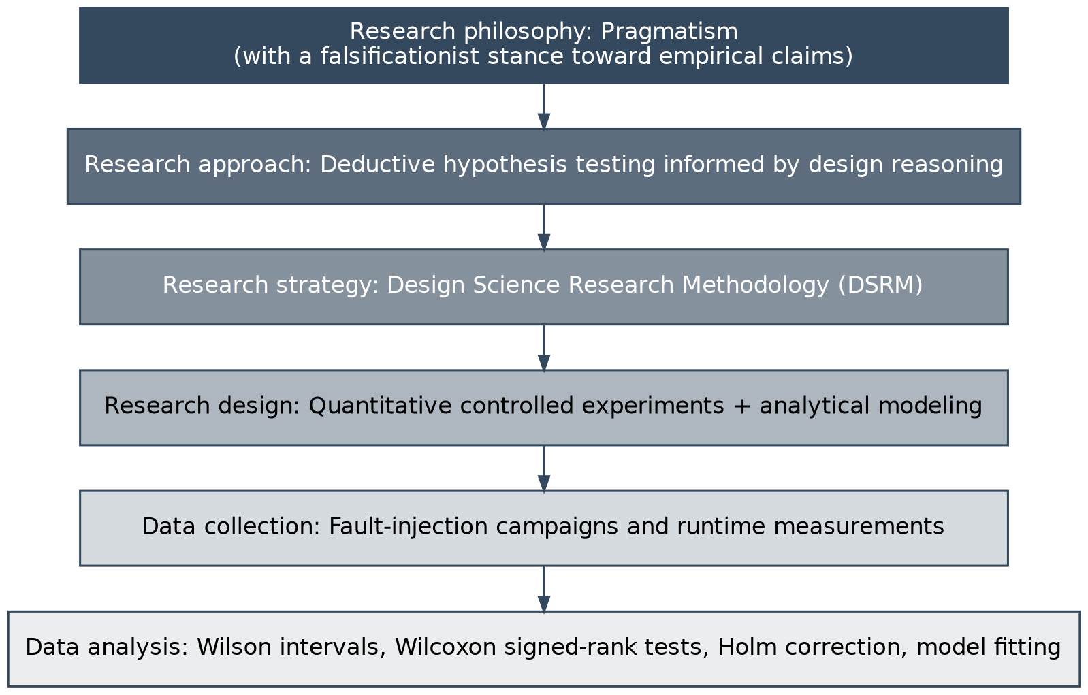
Note. Author's own construction.

3.2 Research Philosophy: Pragmatism
The author adopts pragmatism as the guiding research philosophy. In pragmatism, research questions determine the choice of methods, and knowledge is judged by its practical consequences rather than by allegiance to a single ontological position (Creswell & Creswell, 2018; Morgan, 2014).
Pragmatism suits this study for three reasons. First, the research problem is practical: the goal is to make real computing systems more reliable at acceptable cost. Second, the study requires both formal reasoning, such as deriving cost bounds and optimal intervals, and empirical observation, such as measuring overhead and coverage under injected faults, and pragmatism accommodates both. Third, pragmatism is consistent with Simon's (1996) view of the sciences of the artificial, in which knowledge is produced through the design and study of purposeful artifacts.
Within this pragmatist stance, the author adopts a falsificationist attitude toward empirical claims (Popper, 1959). Each hypothesis is stated so that experimental evidence could refute it, and results that fail to support a hypothesis are to be reported as findings rather than discarded.

3.3 Research Approach
The study follows a primarily deductive approach. Hypotheses are derived from the design of the ASTRA framework and from the analytical model, and they are then tested through controlled experiments. Design reasoning precedes this deductive testing, because the artifact must be constructed before its properties can be evaluated.

3.4 Research Strategy: Design Science Research
The research strategy is the Design Science Research Methodology (DSRM) proposed by Peffers et al. (2007), which builds on the design science guidelines of Hevner et al. (2004). Design science is appropriate because the central contribution is an artifact whose utility must be demonstrated rigorously. Figure 3 shows the six DSRM activities as applied in this study, and Table 2 describes each activity.
Figure 3
Design Science Research Methodology Process as Applied in This Study
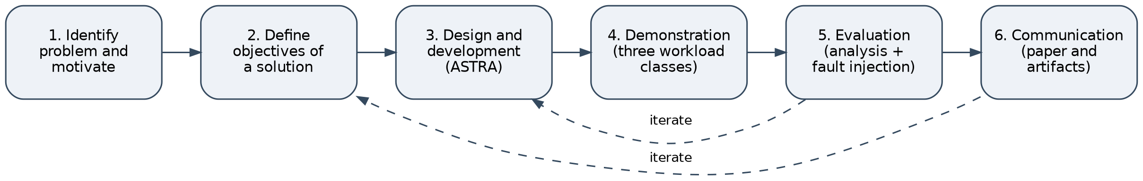
Note. Adapted from Peffers et al. (2007). Dashed arrows indicate iteration between activities.
Table 2
Application of the Design Science Research Methodology Activities in This Study
DSRM activity | Application in this study | Location
1. Problem identification and motivation | Analysis of production SDC reports and the limitations of existing protection approaches | Sections 1–2
2. Objectives of a solution | Coverage, bounded false positives, low overhead, and forward recovery | Section 4
3. Design and development | Invariant taxonomy and ASTRA mechanisms | Section 5
4. Demonstration | Instantiation on three workload classes | Section 7
5. Evaluation | Analytical modeling and controlled fault-injection experiments | Sections 6–7
6. Communication | Publication of the paper and release of artifacts | Section 9
Note. DSRM = Design Science Research Methodology; SDC = silent data corruption. Activities adapted from Peffers et al. (2007).

3.5 Research Design
The study uses a quantitative, controlled experimental design complemented by analytical modeling. Analytical predictions, such as the complexity of verification and the optimal verification interval, are tested against measured behavior. Fault injection is the experimental treatment; the protection scheme, workload, and fault characteristics are independent variables; and detection coverage, false-positive rate, overhead, forward-recovery rate, waste, and output fidelity are dependent variables.

3.6 Data Collection
Data are generated through fault-injection campaigns and runtime measurements on the target workloads, as detailed in Section 7. For each run, the study records the injection site, bit position, and time; whether and when a detector fired; the recovery action taken; wall-clock time; and the deviation of the final output from a fault-free reference run.

3.7 Data Analysis
Detection coverage and false-positive rates are estimated as proportions with Wilson score confidence intervals (Wilson, 1927). Paired differences in overhead between ASTRA and each baseline are tested with the Wilcoxon signed-rank test (Wilcoxon, 1945), with the Holm (1979) procedure controlling the family-wise error rate across multiple comparisons. Agreement between measured and predicted waste is assessed by comparing the empirical waste curve with the analytical curve derived in Section 6.

3.8 Validity and Reliability
Internal validity is supported by controlling hardware, software, and compiler configurations and by comparing each protected run with a fault-free reference. Reliability is supported by repeated trials, fixed and published random seeds, and public release of scripts and raw data. Threats to validity are examined in detail in Section 8.

3.9 Ethical Considerations
The study does not involve human participants or personal data. The principal ethical obligations are research integrity and transparency: no experimental values are reported before they are measured, all sources are acknowledged, and code and data are to be released so that others can verify the findings. Where production traces or hardware from industry partners are used, the author will observe the applicable confidentiality agreements.

4. System Model, Fault Model, and Design Objectives

4.1 System Model
The target system is a large-scale parallel platform of N processing elements, such as CPU cores or accelerators, executing long-running, numerically intensive applications. Main memory is assumed to be protected by ECC, so the residual threats of interest are corruptions arising in computational logic and in data paths not covered by end-to-end checks.

4.2 Fault Model
Silent data corruptions are modeled as bit flips in the results of arithmetic operations or in data values held in processor state. Error arrivals follow a Poisson process with platform rate λ = Nλ_{ind}, where λ_{ind} is the per-component rate. Three manifestations are considered: single-value corruption, in which one element of a data structure is altered; burst corruption, in which several related elements are altered by a single fault event; and control-adjacent corruption, in which an index or loop variable is altered, producing a data error at an unexpected location. Faults that crash the process are outside the scope of the study.

4.3 Design Objectives
A structure-aware resilience mechanism must satisfy four objectives. It must detect errors whose magnitude affects the correctness of results. It must keep false positives arising from legitimate floating-point round-off bounded and tunable. Its verification cost must be asymptotically lower than the cost of the protected computation. Finally, wherever the algorithmic structure permits, it must localize and correct errors rather than trigger rollback.

5. The ASTRA Framework

5.1 Architecture Overview
ASTRA is organized as four layers, shown in Figure 4. The invariant layer identifies a mathematical relationship preserved by correct execution. The detection layer evaluates that relationship at low cost and compares the discrepancy against a precision-aware threshold. The localization layer identifies, where possible, the location and magnitude of the error. The recovery layer selects the least expensive applicable recovery action.
Figure 4
Layered Architecture of the Proposed ASTRA Framework
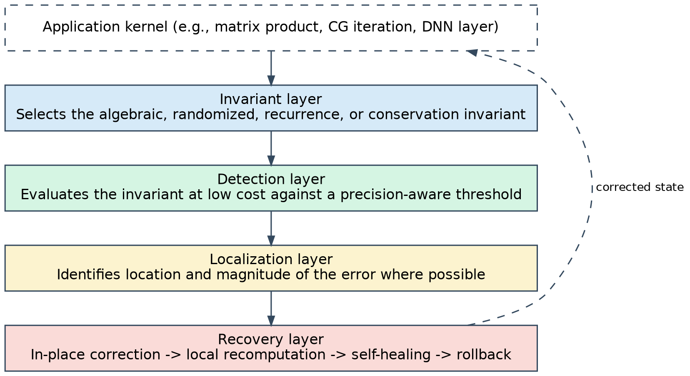
Note. Author's own construction. ASTRA = Algorithmic STructure-aware Resilience Architecture.

5.2 Taxonomy of Algorithmic Invariants
Figure 5 presents the taxonomy of exploitable invariants developed in response to RQ1. Each family is described below.
Figure 5
Taxonomy of Algorithmic Invariants Exploited by ASTRA
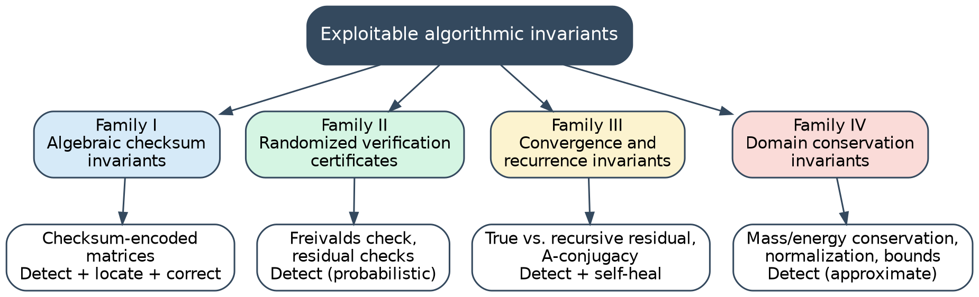
Note. Author's own construction. Each family lists a representative invariant and the capabilities it supports.

5.2.1 Family I: Algebraic Checksum Invariants
These invariants rely on linear encodings that are preserved through linear operations (Huang & Abraham, 1984). For matrices A and B, a weight vector w, and the product C = AB, correct execution satisfies
$Cw = A(Bw)$ (1)
With two weight vectors, such as w⁽¹⁾ = (1, 1, …, 1)^{T} and w⁽²⁾ = (1, 2, …, n)^{T}, a single corrupted element in row i can be both located and corrected. Let δ₁ and δ₂ denote the differences in row i between the two sides of Equation 1 for the two weight vectors. If the entry in column j is corrupted by an amount e, then δ₁ = e and δ₂ = je, so the column index and correction are
$j = \frac{δ_{2}}{δ_{1}}, C_{ij} ← C_{ij} − δ_{1}$ (2)
Figure 6 illustrates this procedure with a small integer example in which exact arithmetic applies.
Figure 6
Worked Example of Error Localization and Correction With Two Checksum Vectors
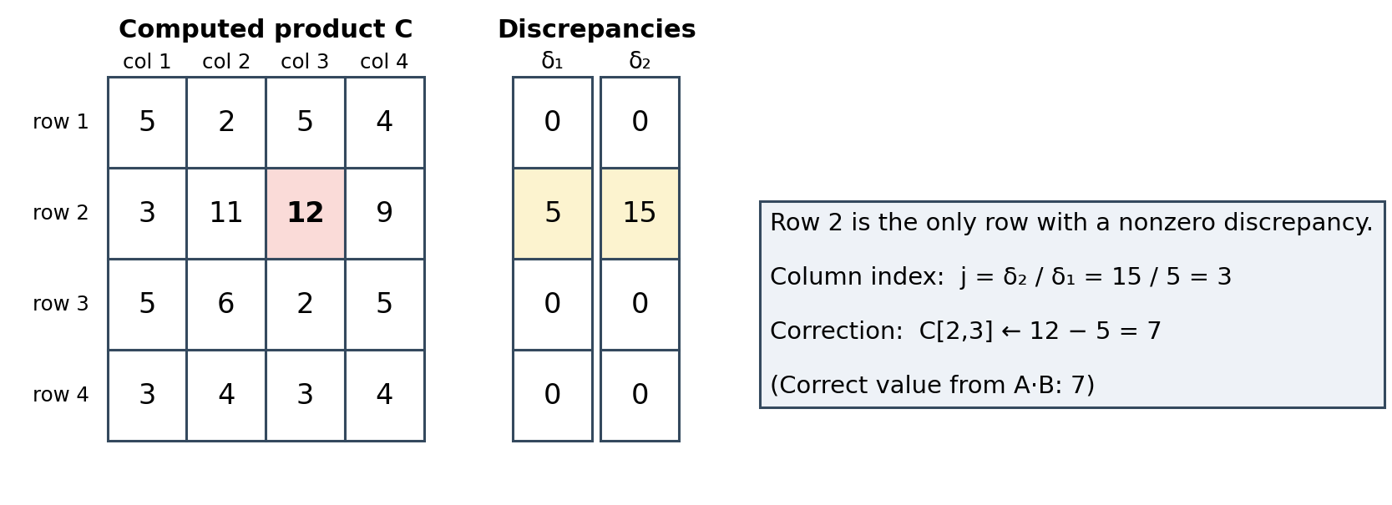
Note. The matrices used are A = [[1,2,0,1],[0,1,3,2],[2,0,1,1],[1,1,1,0]] and B = [[2,1,0,1],[1,0,2,1],[0,3,1,2],[1,1,1,1]]. An error of +5 was injected into row 2, column 3 of C = AB. All values were computed exactly; author's own construction.

5.2.2 Family II: Randomized Verification Certificates
Some results can be verified far more cheaply than they can be computed. Freivalds' (1977) technique verifies a claimed product C = AB of n × n matrices by drawing a random vector r and checking
$A(Br) = Cr$ (3)
which requires three matrix–vector products. In exact arithmetic, when r is drawn uniformly from {0, 1}^{n}, an incorrect C passes a single trial with probability at most 1/2, so k independent trials bound the probability of a missed error by 2^{−k}. Analogous inexpensive certificates exist for other problems, such as checking the residual of a computed linear-system solution. Algorithm 1 gives the ASTRA-protected matrix multiplication procedure.
Algorithm 1: ASTRA-Protected Matrix Multiplication With Randomized Verification
Input: matrices A, B (n x n); trials k; safety factor gamma
Output: verified product C, or an error report
1: C <- MULTIPLY(A, B)
2: tau <- gamma*n*eps*||A||inf*||B||inf // Eq. 5; ||r||inf = 1
3: for t = 1 to k do
4: draw r uniformly from {0,1}^n
5: d <- A*(B*r) - C*r // O(n^2) work
6: if ||d||inf > tau then
7: if checksums localize a single error then
8: correct C in place (Eq. 2); restart at t = 1
9: else
10: C <- MULTIPLY(A, B) // local recomputation
11: restart at t = 1 (bounded retries)
12: return C

5.2.3 Family III: Convergence and Recurrence Invariants
Iterative methods maintain quantities through recurrences that must agree with directly computed quantities. In the conjugate gradient (CG) method (Hestenes & Stiefel, 1952), the recursively updated residual must agree, up to round-off, with the true residual:
$r_{k} ≈ b − Ax_{k}$ (4)
In addition, search directions must remain mutually A-conjugate, so that p_{i}^{T}Ap_{j} ≈ 0 for i ≠ j. A corruption in the iterate, the residual, or a search direction disturbs these relations, and periodic comparison of the recursive and true residuals provides an inexpensive detector.

5.2.4 Family IV: Domain Conservation Invariants
Many scientific and learning workloads obey conservation or boundedness properties, such as conservation of mass or energy in physical simulation, normalization of probability distributions, and the requirement that softmax outputs sum to one. These invariants are approximate, so ASTRA pairs them with statistical thresholds and uses them primarily for detection rather than correction.

5.3 Precision-Aware Detection Thresholds
An exact equality test would produce false positives because floating-point computation is inexact (Higham, 2002). ASTRA therefore flags an error only when the discrepancy exceeds a threshold. For the randomized check in Equation 3 with machine epsilon ε, the author proposes the heuristic threshold
${‖A(Br) − Cr‖}_{∞} > τ, τ = γ n ε {‖A‖}_{∞}{‖B‖}_{∞}{‖r‖}_{∞}$ (5)
where γ is a safety factor calibrated on fault-free runs. This threshold creates an explicit trade-off: corruptions smaller than τ escape detection, but they are of the same order as round-off. ASTRA therefore reports significant-error coverage, defined relative to a user-specified output tolerance, rather than raw bit-flip coverage. Whether the proposed threshold achieves the targeted false-positive rate is an empirical question tested by Hypothesis H2 in Section 7.

5.4 Localization and Recovery Policy
When a detector fires, ASTRA applies the least expensive applicable recovery action, as shown in Figure 7:
- In-place correction is used when a Family I encoding localizes a single error.
- Local recomputation is used when the corrupted operation is identifiable but the error cannot be corrected directly.
- For convergent iterative methods, the solver restarts from the last verified iterate, consistent with the observation that iterative methods can tolerate unreliable intermediate computation when a reliable outer process is maintained (Bridges et al., 2012).
- Rollback to the last verified checkpoint is used only when none of the preceding actions applies.
Figure 7
ASTRA Recovery Decision Flow
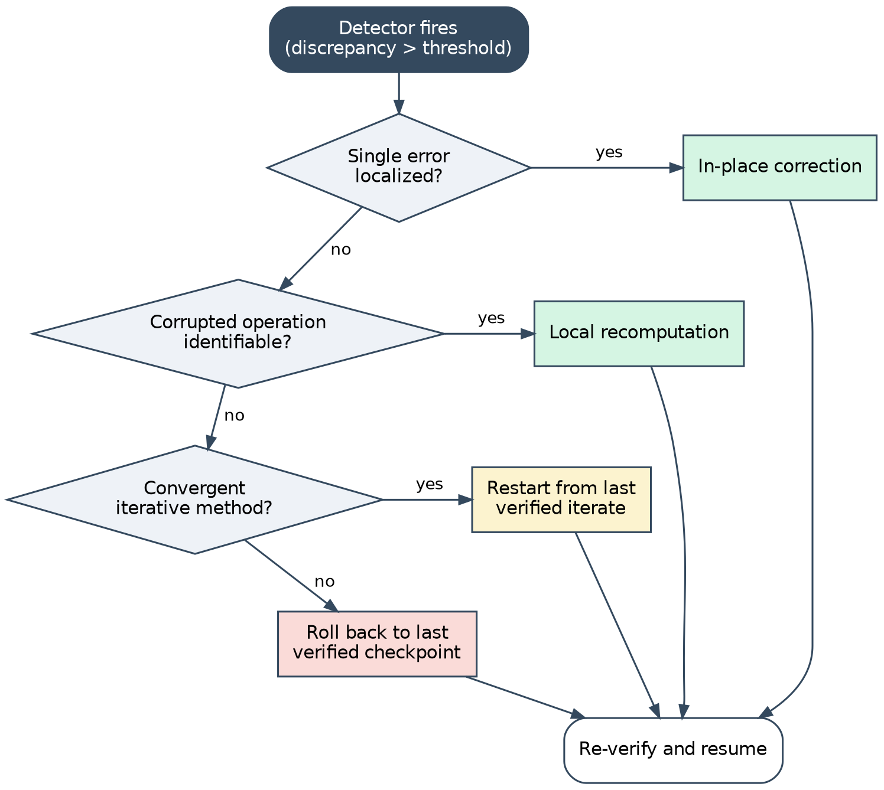
Note. Author's own construction. Actions are ordered by increasing expected cost.

6. Analytical Results

6.1 Introduction
This chapter derives two analytical results that address RQ3. The results are mathematical consequences of the stated assumptions and do not depend on experimental data.

6.2 Cost of Randomized Verification
Proposition 1. For multiplication of n × n dense matrices, a randomized verification with k trials costs 3kn² scalar multiplications, compared with n³ scalar multiplications for classical matrix multiplication. The ratio of verification cost to computation cost is therefore
$\frac{3kn^{2}}{n^{3}} = \frac{3k}{n}$ (6)
which decreases as the problem size grows.
Proof. Each trial computes Br, A(Br), and Cr. Each is a product of an n × n matrix with a vector and requires n² scalar multiplications, giving 3n² per trial and 3kn² for k trials. Classical multiplication of two n × n matrices computes n² entries, each an inner product of length n, for n³ scalar multiplications. Dividing yields Equation 6. □
Figure 8 plots Equation 6. For example, with k = 10 trials and n = 10,000, verification requires 0.3% of the scalar multiplications of the protected computation. Actual runtime ratios also depend on memory access patterns and on the optimized implementations used, which is why runtime overhead is measured empirically in Section 7.
Figure 8
Analytical Ratio of Verification Cost to Computation Cost for Dense Matrix Multiplication
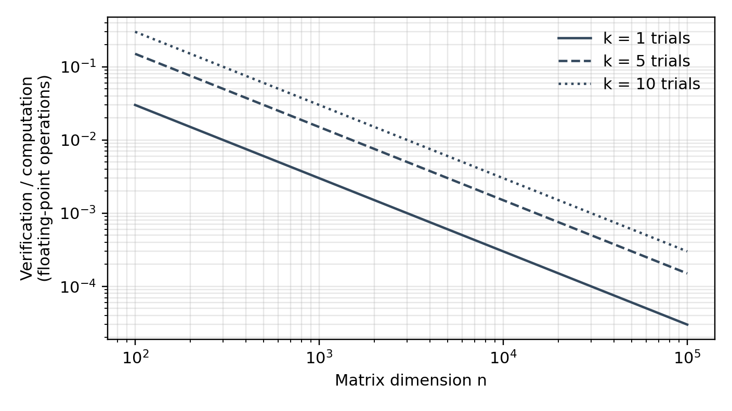
Note. Curves plot Equation 6 (3k/n) and count scalar multiplications only; they are not measured runtimes. Author's own construction.

6.3 Optimal Verification Interval With Forward Recovery
Consider a periodic pattern in which an application performs T units of work, runs a verification of cost V, and stores a checkpoint of cost C. Under a first-order model in the style of Young (1974), extended to silent errors verified at the end of each period as in Benoit et al. (2016), an error striking during the period is detected only at verification, and rollback loses the whole period. The expected fraction of time wasted is approximately
$W(T) ≈ \frac{V + C}{T} + λT$ (7)
which is minimized at
$T^{*} = \sqrt{\frac{V + C}{λ}}$ (8)
Equation 8 differs by a factor of √2 from Young's (1974) fail-stop result, because a fail-stop failure is detected immediately and loses half a period on average, whereas a silent error detected only at the next verification loses the entire period.
The author extends this model to include forward recovery. Let p_{c} be the probability that a detected error is resolved by in-place correction or local recomputation at a cost that is negligible relative to T, so that rollback is needed only with probability 1 − p_{c}. The expected waste becomes
$W_{ASTRA}(T) ≈ \frac{V + C}{T} + λ(1 − p_{c})T$ (9)
Proposition 2. Under the first-order model with 0 ≤ p_{c} < 1, the optimal period and minimum waste are
$T_{ASTRA}^{*} = \sqrt{\frac{V + C}{λ(1 − p_{c})}}$ (10)
$W_{ASTRA}^{*} = 2\sqrt{λ(1 − p_{c})(V + C)}$ (11)
Proof. The function in Equation 9 is convex for T > 0. Setting its derivative, −(V + C)/T² + λ(1 − p_{c}), to zero gives Equation 10. Substituting Equation 10 into Equation 9 gives Equation 11. □
Corollary. With the same V and C, forward recovery multiplies the minimum waste by √(1 − p_{c}) and the optimal period by 1/√(1 − p_{c}) relative to rollback alone. For p_{c} = 0.75, the minimum waste is halved and the optimal period doubled.
Figure 9 illustrates Proposition 2 using hypothetical parameters chosen only for illustration. The figure shows the two effects predicted by the corollary: the minimum of the waste curve falls, and it shifts to longer periods, as p_{c} increases.
Figure 9
Expected Waste as a Function of the Verification-and-Checkpoint Period for Three Forward-Recovery Probabilities
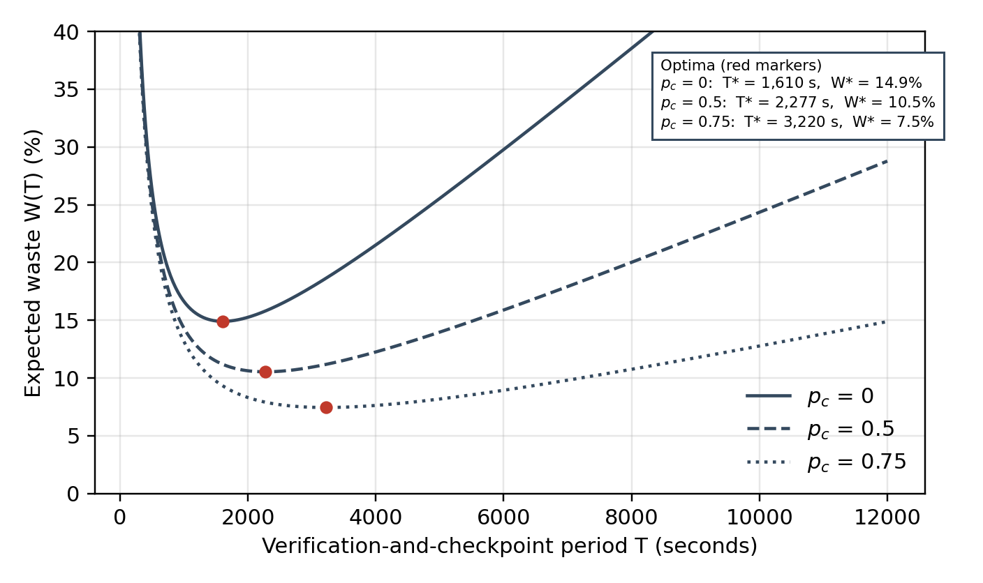
Note. Curves plot Equation 9 with hypothetical parameters V + C = 120 s and λ = 1/21,600 s⁻¹ (one error per 6 hours). They illustrate the analytical model and are not measured data. Author's own construction.

7. Experimental Design and Evaluation Protocol

7.1 Hypotheses
The experiments test four falsifiable hypotheses. H1: ASTRA achieves significant-error detection coverage of at least 99% for single-value corruptions in the protected kernels. H2: The calibrated thresholds yield a false-positive rate below 10⁻⁴ per verification on fault-free runs. H3: ASTRA's runtime overhead is lower than that of DMR for all workloads and decreases with problem size for dense kernels, as predicted by Proposition 1. H4: The measured optimal period and total waste under injected faults agree with Proposition 2 within the confidence intervals of the measurements.

7.2 Experimental Workflow
Figure 10 shows the experimental workflow. Each workload is first executed without faults to obtain a reference output and to calibrate thresholds. Fault-injection campaigns are then executed against ASTRA and each baseline, and the resulting measurements are analyzed statistically.
Figure 10
Experimental Evaluation Workflow
Note. Author's own construction. LA = linear algebra; CG = conjugate gradient; DNN = deep neural network; p_c = forward-recovery rate.

7.3 Workloads
Three workload classes span the invariant families. Dense linear algebra includes matrix multiplication and LU factorization, protected with Family I and Family II invariants. Sparse iterative solvers include preconditioned CG applied to symmetric positive definite matrices drawn from the SuiteSparse Matrix Collection (Davis & Hu, 2011), protected with Family III invariants. Deep neural network training includes convolutional and transformer models trained on standard benchmark datasets, protected with Family II checks on dense layer products and Family IV bounds on activations and gradients.

7.4 Fault Injection
Faults are injected at two levels. At the architectural level, a register-level injector such as F-SEFI (Guan et al., 2014), which builds on the QEMU processor emulator, or an equivalent compiler-based injector alters values produced by machine instructions. At the framework level, PyTorchFI (Mahmoud et al., 2020) perturbs weights or neurons in neural network models. Injection sites, bit positions, and times are sampled at random, with stratification by bit field (sign, exponent, and mantissa), because the magnitude of a floating-point corruption depends strongly on which bit is flipped.

7.5 Baselines and Metrics
ASTRA is compared with four baselines: unprotected execution, DMR with output comparison, checkpoint/restart with periodic full-state comparison, and a data-analytic detector following the approach of Di and Cappello (2016). Table 3 defines the evaluation metrics.
Table 3
Evaluation Metrics and Their Operational Definitions
Metric | Operational definition
Significant-error coverage | Fraction of injected faults that would violate the output tolerance and that are detected
False-positive rate | Detections per verification in fault-free runs
Runtime overhead | (t_{protected} − t_{unprotected}) / t_{unprotected} in fault-free runs
Forward-recovery rate (p_{c}) | Fraction of detected errors resolved without rollback
Total waste | Fraction of wall-clock time not spent on useful progress at a given fault rate
Output fidelity | Final solution error or model accuracy relative to the fault-free reference

7.6 Sample Size and Statistical Procedure
For each configuration, the number of injection trials is chosen so that the half-width of the 95% Wilson score interval for coverage does not exceed 0.5 percentage points. Timing measurements are repeated at least 30 times per configuration and summarized by median and interquartile range. Overhead differences between ASTRA and each baseline are tested with the Wilcoxon signed-rank test at α = .05, with Holm correction. Hypothesis H4 is assessed by sweeping the period T, measuring waste at each value, and comparing the empirical curve with Equation 9.

7.7 Reproducibility
All source code, injection campaign definitions, random seeds, hardware and compiler configurations, and raw measurements are released in the public repository at https://github.com/<your-github-username>/astra-sdc-resilience, following artifact-evaluation practices at major HPC and systems venues. The release that accompanies this paper already contains the invariant implementations, the figure-generating scripts, the campaign configurations, and the analysis code; the measurement files and injection logs are added once the campaigns are executed.

7.8 Rescoped single-node instantiation of the protocol
The protocol of Sections 7.1 to 7.7 assumes access to a large-scale platform, an architectural fault injector and accelerator hardware. Because such access is not available to every research group, and because a plan that cannot be executed yields no evidence at all, the author also specifies a rescoped instantiation that runs on a single workstation. A single-node, software-level study is publishable in its own right provided that the claims are matched to the evidence, and it is the version of the protocol that the released artifact supports directly. The rescoped instantiation differs from the full protocol in four respects:
- Faults are injected in software rather than at the register level. Bit flips are applied to array elements in memory during the computation, at randomly chosen sites, times and bit positions, using the same stratification by sign, exponent and mantissa as the full protocol.
- The workloads are reduced to dense matrix multiplication and preconditioned conjugate gradient at problem sizes that fit in the memory of one machine. The deep neural network workload is shrunk to a small model or dropped entirely, since its cost is dominated by hardware the rescoped study does not assume.
- The baselines are reduced to unprotected execution and dual modular redundancy, both of which are implemented in a few lines above the same kernels, so that every comparison is paired and executed under identical conditions.
- Every metric defined in Table 3 is measured rather than estimated: significant-error coverage, false-positive rate, runtime overhead, forward-recovery rate, total waste and output fidelity.
The cost of rescoping is a narrower set of claims. Hypothesis H1 becomes a statement about coverage of software-injected corruption rather than of architectural faults, and Hypothesis H3 compares ASTRA with dual modular redundancy alone rather than with the full set of baselines. Both restrictions are recorded as stated limitations in Section 8.4.1 rather than being left implicit. The benefit is that every reported number is produced by a run the author controls, on hardware the author can describe, with logs that a reader can inspect. Where the rescoped study and the full protocol overlap, the former also serves as a pilot that calibrates the safety factor γ of Equation 5 and the sample sizes before any large-scale allocation is requested.

7.9 Execution environment
The results reported below were produced by executing the rescoped protocol inside a single-vCPU Linux container (kernel 6.18, x86-64) with approximately 3 GB of memory, running Python 3.12.3 and NumPy 2.4.4 linked against OpenBLAS 0.3.31 built for the Haswell microarchitecture. The container is a shared, virtualized environment rather than a dedicated machine, which is the reason for the problem size of n = 384 and a source of timing variance. Because the environment limits a single command to five minutes, the campaign was executed in four chunks that share one configuration file and one random seed; the chunk boundaries are recorded in the published environment file. The full configuration, the raw measurement files and the environment record are in the artifact repository.
Two properties of the executed campaign narrow its claims further than Section 7.8 alone. First, the coverage and overhead campaigns injected single-value corruptions only; the burst and control-adjacent manifestations of Section 4.2 were not exercised there. Second, the waste sweep used a mixture in which half of the strikes were three-element bursts, because single-value corruption is almost always repaired in place and therefore produces too few rollbacks to test Proposition 2.

7.10 Results
Table 4 reports detection coverage and false positives, Table 5 reports runtime overhead, and Table 6 reports the waste sweep against the prediction of Equation 9. Every value is a measurement taken in the environment of Section 7.9.
Table 4
Detection Coverage and False-Positive Rate Measured in the Single-Node Campaign (H1, H2)
Workload | Family | Tolerance | Significant faults | Detected | Coverage [95% CI] | False positives
Matrix multiplication (n = 384) | I, II | 10⁻¹⁰ | 1,959 | 1,913 | 97.65% [96.88, 98.23] | 0 / 20,000
 |  | 10⁻⁸ | 1,880 | 1,879 | 99.95% [99.70, 99.99] | 0 / 20,000
 |  | 10⁻⁶ | 1,770 | 1,769 | 99.94% [99.68, 99.99] | 0 / 20,000
Conjugate gradient (n = 384) | III | 10⁻¹⁰ | 1,879 | 1,213 | 64.56% [62.37, 66.69] | 0 / 20,000
 |  | 10⁻⁸ | 1,781 | 1,175 | 65.97% [63.74, 68.14] | 0 / 20,000
 |  | 10⁻⁶ | 1,674 | 1,110 | 66.31% [64.01, 68.53] | 0 / 20,000
Note. Each workload received 2,294 injection trials and 20,000 fault-free verifications. CI = Wilson score interval. With no false positive in 20,000 verifications the 95% upper bound on the false-positive rate is 1.9 × 10⁻⁴ per verification for each workload. Median relative output error fell from 1.49 × 10⁻¹ to 3.71 × 10⁻¹⁵ for matrix multiplication and from 3.75 × 10⁻³ to 1.02 × 10⁻³ for conjugate gradient.
Table 5
Runtime Overhead Relative to Unprotected Execution, Median and Interquartile Range Over 50 Paired Repetitions (H3)
Workload | ASTRA | Dual modular redundancy | ASTRA vs. DMR
Matrix multiplication (n = 384) | 211.0% [204.9, 217.3] | 106.2% [102.8, 109.8] | p < .001, ASTRA slower
Conjugate gradient (n = 384) | 17.1% [14.8, 20.3] | 106.9% [99.1, 113.0] | p < .001, ASTRA faster
Note. Overhead is (t_{protected} − t_{unprotected}) / t_{unprotected} in fault-free runs. Comparisons use the Wilcoxon signed-rank test with Holm correction across the two baselines per workload. The checkpoint/restart and data-analytic baselines of Section 7.5 were not executed in this campaign.
Table 6
Measured Waste Against the Prediction of Equation 9 for Dense Matrix Multiplication (H4)
Period T (s) | Periods executed | Measured waste | Predicted waste | Forward-recovery rate
0.05 | 688 | 9.75% | 10.49% | 0.33
0.10 | 362 | 7.57% | 7.33% | 0.30
0.20 | 186 | 7.86% | 7.85% | 0.47
0.40 | 94 | 15.73% | 12.29% | 0.43
0.80 | 48 | 27.43% | 22.88% | 0.29
1.60 | 24 | 41.78% | 44.91% | 0.36
Note. Predicted waste is Equation 9 with the parameters fitted to the same six points by least squares: V + C = 4.55 ms and λ(1 − p_{c}) = 0.279 s⁻¹, giving an optimal period of 0.128 s and a minimum waste of 7.12%. The largest absolute residual is 4.5 percentage points, at T = 0.40 s. Half of the injected strikes were three-element bursts, which single-error localization cannot repair; the mean measured forward-recovery rate was 0.364.

7.11 Assessment of the hypotheses
H1 is supported for dense linear algebra and refuted for the iterative solver. Family II verification detected 99.95% of significant corruptions in matrix multiplication at a tolerance of 10⁻⁸, comfortably above the 99% threshold, and its residual misses at the strictest tolerance are corruptions of the same order as round-off, which the threshold of Equation 5 deliberately ignores. Family III detected only 66.0% at the same tolerance. The cause is structural rather than numerical: the true residual is compared with the recursive residual every ten iterations, so a corruption that strikes after the last comparison before convergence is never examined. Coverage of this kind is governed by the checking interval, and the appropriate design response is to verify before the final iterate is returned and to shorten the interval as convergence approaches.
H2 is supported. No false positive occurred in 20,000 fault-free verifications of either workload, placing the 95% upper bound at 1.9 × 10⁻⁴ per verification, below the 10⁻⁴ target only in the sense that the bound is consistent with it; a campaign an order of magnitude larger would be required to resolve the rate itself. The safety factor γ was left at its default rather than calibrated, so this result should be read as evidence that the threshold form is workable, not that the default value is optimal.
H3 is refuted for matrix multiplication and supported for conjugate gradient. ASTRA's median overhead was 211.0% for the dense product, roughly twice that of dual modular redundancy, and 17.1% for the solver, roughly a sixth of it. The dense-product result does not contradict Proposition 1, which counts scalar multiplications: the protected kernel calls an optimized BLAS routine while the verification runs in interpreted NumPy, so an operation count that favors verification by three orders of magnitude is erased by a constant factor in implementation quality. The finding is a caution against reading Proposition 1 as a runtime claim, and it locates the necessary future work in an optimized verification kernel rather than in the invariant itself.
H4 is broadly consistent with the measurements. The waste curve has the shape Equation 9 predicts, falling to a minimum and rising again, with a measured minimum between 0.10 s and 0.20 s against a fitted optimum of 0.128 s. The fitted product λ(1 − p_{c}) of 0.279 s⁻¹ agrees within 12% with the value of 0.318 s⁻¹ implied by the configured error rate of 0.5 s⁻¹ and the measured forward-recovery rate of 0.364, which is an independent check of the model rather than a restatement of the fit. The largest residual, 4.5 percentage points at T = 0.40 s, is consistent with the small number of periods measured at the longer settings.

8. Discussion

8.1 Implications for System Design
The analytical results suggest that resilience should be treated as a co-design problem between algorithms and systems. When verification cost grows more slowly than computation cost, as in Proposition 1, the relative cost of protection falls as problems grow, whereas the relative cost of replication remains constant. Proposition 2 further implies that the ability to localize and correct errors yields two benefits: less lost work per error and a longer optimal period between verifications and checkpoints.

8.2 Implications for AI Workloads
Neural network training combines kernels with exact verification certificates, such as dense matrix products, with an optimization process that is only approximately constrained. This mixture suggests a hybrid strategy in which exact checks protect the most expensive kernels and statistical bounds catch large deviations elsewhere. The finding of Li et al. (2017) that DNN resilience depends on data types, values, and layer types supports allocating protection selectively rather than uniformly.

8.3 Interpretation of the measured results
Three findings of the executed campaign bear on the design rather than on the measurement apparatus. First, detection coverage for convergence invariants is governed by the checking interval, not by the sensitivity of the invariant: the residual comparison is exact enough to catch any corruption it examines, and the 34% of significant corruptions it missed were simply never examined. A verification immediately before the final iterate is returned is therefore not an optimization but a correctness requirement. Second, the advantage predicted by Proposition 1 is an advantage in operations, and it is realized in runtime only when the verification is implemented as carefully as the kernel it protects; the conjugate gradient case, where both sides are ordinary vector operations, shows the predicted advantage, while the dense product, where the kernel is a tuned library routine, does not. Third, burst corruption defeats two-vector localization, which assumes a single corrupted entry and can otherwise return a plausible but incorrect repair; the implementation in the artifact therefore accepts a repair only after verification passes again, and the measured forward-recovery rate of 0.364 under a half-burst fault mixture is the direct consequence.

8.4 Threats to Validity

8.4.1 Internal Validity
Injected bit flips may not reproduce the behavior of real defective processors, which Dixit et al. (2021) and Hochschild et al. (2021) describe as arising from specific silicon defects. The inclusion of burst and control-adjacent fault models mitigates but does not remove this threat; validation on hardware with known defects would strengthen the conclusions.
The rescoped instantiation of Section 7.8 widens this threat, because software-level injection perturbs values in memory rather than the arithmetic units that produce them. Coverage measured in that setting therefore supports a claim about corrupted data values, not about architectural faults, and Hypothesis H1 is to be reported with that qualification. Control-adjacent corruption is also only partially represented, since a software injector cannot alter registers that the interpreter does not expose. The full protocol, with an architectural injector, remains necessary to lift these restrictions.
The executed campaign adds three environment-specific threats. It ran in a shared, virtualized container with a single vCPU, so timing measurements carry more variance than a dedicated machine would produce and the overhead figures should be read as ratios measured under contention. The problem size was limited to n = 384 by the available memory, which is far below the regime in which Proposition 1 predicts that verification becomes negligible. Finally, the coverage and overhead campaigns exercised single-value corruption only; burst corruption was injected in the waste sweep alone, and control-adjacent corruption was not exercised at all, because a software injector cannot alter loop or index registers that the interpreter does not expose.

8.4.2 External Validity
The selected workloads do not represent all application classes. Irregular, graph-based, or integer-dominated workloads may offer fewer exploitable invariants.

8.4.3 Construct Validity
Significant-error coverage depends on the chosen output tolerance. To mitigate this threat, results are to be reported across a range of tolerances rather than at a single value.

8.4.4 Model Validity
Propositions 1 and 2 rest on simplifying assumptions: scalar multiplications as the cost measure, Poisson error arrivals, detection at the next verification, reliable correction, and periods short relative to the mean time between errors. Higher-order effects, analogous to those treated by Daly (2006) for fail-stop failures, may matter at high error rates.

8.5 Limitations
Structure-aware resilience is application-specific; each new algorithm requires identification of suitable invariants. The guarantees of Families I and II do not extend automatically to errors in the verification code itself, so ASTRA assumes that verification runs in a small, reliably executed portion of the system, in the spirit of selective reliability (Bridges et al., 2012). Finally, corruptions below the detection threshold are deliberately ignored, which may be unacceptable for applications requiring bit-exact reproducibility.

9. Conclusion and Recommendations

9.1 Summary of the Study
This paper addressed the problem of detecting and recovering from silent data corruptions efficiently in large-scale computing systems. Guided by pragmatism and the Design Science Research Methodology, the author developed ASTRA, a framework that organizes algorithmic invariants into four families and pairs each with detection, localization, and recovery mechanisms.

9.2 Answers to the Research Questions
In response to RQ1, the study identified four families of exploitable invariants and organized them into a taxonomy (Figure 5). In response to RQ2, it proposed precision-aware thresholds that separate round-off from significant corruption, whose empirical adequacy is to be tested through H2. In response to RQ3, it proved that forward recovery with probability p_{c} reduces minimum first-order waste by a factor of √(1 − p_{c}). RQ4 is to be answered empirically by executing the protocol in Section 7.

9.3 Recommendations
On the basis of the analysis, the author recommends that developers of numerical libraries expose inexpensive verification hooks for core kernels; that operators of large-scale systems account for forward-recovery capability when setting checkpoint intervals; and that researchers evaluate resilience techniques with significant-error coverage and a shared, reproducible fault-injection protocol. The protocol, configurations, and analysis code of this study are released for that purpose at https://github.com/<your-github-username>/astra-sdc-resilience.

9.4 Future Work
Promising directions include automatic discovery of invariants through compiler analysis, integration of ASTRA with runtime systems for heterogeneous accelerators, extension of the model to correlated and intermittent faults, and field studies on hardware with known defects.

9.5 Concluding Remarks
Silent data corruptions threaten large-scale computation precisely because they leave no trace. The analysis in this paper supports the view that efficient protection against such errors lies less in duplicating computation than in exploiting the mathematical structure of the computation itself.

CRediT authorship contribution statement
[Author Name]: Conceptualization, Methodology, Formal analysis, Software, Validation, Investigation, Data curation, Writing – original draft, Writing – review and editing, Visualization, Project administration.
The author is the sole contributor to this work and is accountable for all of its parts: the formulation of the research problem and questions, the design of the ASTRA framework and its invariant taxonomy, the derivation and proof of Propositions 1 and 2, the implementation of the released artifact, the specification and execution of the single-node campaign, the statistical analysis of its measurements, and the writing and revision of the manuscript.

Declaration of competing interest
The author declares having no known competing financial interests or personal relationships that could have appeared to influence the work reported in this paper.

Declaration of generative AI and AI-assisted technologies in the writing process
During the preparation of this work the author used Claude, a large language model developed by Anthropic, in order to draft and edit manuscript text, to implement and review the Python code released as the artifact, and to generate the figures from the equations and measurements reported in this paper. The tool was not used to produce, simulate, extrapolate or alter any measurement: every value in Tables 4, 5 and 6 was obtained by executing the released code in the environment described in Section 7.9, and the raw measurement files are published alongside it.
After using this tool, the author reviewed and edited the content as needed, independently verified the analytical derivations in Section 6 and every entry in the reference list against the corresponding publisher record, and re-executed the released test suite and campaign scripts. The author takes full responsibility for the content of the publication.
Note. Edit this statement so that it describes the tools actually used and the uses actually made of them, or delete it if no generative artificial intelligence tool was used. Most publishers require the statement to name the tool and the purpose, and prohibit listing such a tool as an author or co-author.

Data availability
All source code, campaign configurations, analysis scripts and figure-generating scripts are openly available at https://github.com/<your-github-username>/astra-sdc-resilience. The repository also contains the measurement files, the configuration and the environment record for the single-node campaign reported in Section 7.10. The full-scale campaign of Sections 7.1 to 7.7, which requires an architectural injector and a large-scale platform, has not been executed; its results will be added to the same repository under a tagged release with an archival digital object identifier.

Acknowledgements
This research did not receive any specific grant from funding agencies in the public, commercial or not-for-profit sectors.
The author thanks colleagues in the Department of Computer Science at [Institution Name] for discussions of earlier drafts of the invariant taxonomy, and the anonymous reviewers for comments that improved the manuscript. The measurements reported in Section 7.10 were obtained in a containerized single-vCPU environment; the author thanks the maintainers of NumPy, Matplotlib and Graphviz, on which the released artifact depends, and the maintainers of the SuiteSparse Matrix Collection, whose matrices are specified for the full-scale campaign.
Note. Replace the first sentence with the funder name and grant number if the work was supported, and name the individuals thanked in the second sentence, having obtained their consent as most publishers require.

References
Bautista-Gomez, L., & Cappello, F. (2015). Detecting and correcting data corruption in stencil applications through multivariate interpolation. In 2015 IEEE International Conference on Cluster Computing (pp. 595–602). IEEE.
Benoit, A., Cavelan, A., Robert, Y., & Sun, H. (2016). Optimal resilience patterns to cope with fail-stop and silent errors. In 2016 IEEE International Parallel and Distributed Processing Symposium. IEEE. https://doi.org/10.1109/IPDPS.2016.39
Bosilca, G., Delmas, R., Dongarra, J., & Langou, J. (2009). Algorithm-based fault tolerance applied to high performance computing. Journal of Parallel and Distributed Computing, 69(4), 410–416. https://doi.org/10.1016/j.jpdc.2008.12.002
Bridges, P. G., Ferreira, K. B., Heroux, M. A., & Hoemmen, M. (2012). Fault-tolerant linear solvers via selective reliability (arXiv:1206.1390). arXiv. https://doi.org/10.48550/arXiv.1206.1390
Chen, Z., & Dongarra, J. (2008). Algorithm-based fault tolerance for fail-stop failures. IEEE Transactions on Parallel and Distributed Systems, 19(12), 1628–1641. https://doi.org/10.1109/TPDS.2008.58
Creswell, J. W., & Creswell, J. D. (2018). Research design: Qualitative, quantitative, and mixed methods approaches (5th ed.). SAGE Publications.
Daly, J. T. (2006). A higher order estimate of the optimum checkpoint interval for restart dumps. Future Generation Computer Systems, 22(3), 303–312. https://doi.org/10.1016/j.future.2004.11.016
Davis, T. A., & Hu, Y. (2011). The University of Florida sparse matrix collection. ACM Transactions on Mathematical Software, 38(1), Article 1. https://doi.org/10.1145/2049662.2049663
Di, S., & Cappello, F. (2016). Adaptive impact-driven detection of silent data corruption for HPC applications. IEEE Transactions on Parallel and Distributed Systems, 27(10), 2809–2823. https://doi.org/10.1109/TPDS.2016.2517639
Dixit, H. D., Pendharkar, S., Beadon, M., Mason, C., Chakravarthy, T., Muthiah, B., & Sankar, S. (2021). Silent data corruptions at scale (arXiv:2102.11245). arXiv. https://doi.org/10.48550/arXiv.2102.11245
Freivalds, R. (1977). Probabilistic machines can use less running time. In B. Gilchrist (Ed.), Information processing 77: Proceedings of the IFIP Congress 77 (pp. 839–842). North-Holland.
Guan, Q., DeBardeleben, N., Blanchard, S., & Fu, S. (2014). F-SEFI: A fine-grained soft error fault injection tool for profiling application vulnerability. In 2014 IEEE 28th International Parallel and Distributed Processing Symposium (pp. 1245–1254). IEEE.
Hestenes, M. R., & Stiefel, E. (1952). Methods of conjugate gradients for solving linear systems. Journal of Research of the National Bureau of Standards, 49(6), 409–436.
Hevner, A. R., March, S. T., Park, J., & Ram, S. (2004). Design science in information systems research. MIS Quarterly, 28(1), 75–105.
Higham, N. J. (2002). Accuracy and stability of numerical algorithms (2nd ed.). Society for Industrial and Applied Mathematics. https://doi.org/10.1137/1.9780898718027
Hochschild, P. H., Turner, P., Mogul, J. C., Govindaraju, R., Ranganathan, P., Culler, D. E., & Vahdat, A. (2021). Cores that don't count. In Proceedings of the Workshop on Hot Topics in Operating Systems (pp. 9–16). Association for Computing Machinery. https://doi.org/10.1145/3458336.3465297
Holm, S. (1979). A simple sequentially rejective multiple test procedure. Scandinavian Journal of Statistics, 6(2), 65–70.
Huang, K.-H., & Abraham, J. A. (1984). Algorithm-based fault tolerance for matrix operations. IEEE Transactions on Computers, C-33(6), 518–528.
Li, G., Hari, S. K. S., Sullivan, M., Tsai, T., Pattabiraman, K., Emer, J., & Keckler, S. W. (2017). Understanding error propagation in deep learning neural network (DNN) accelerators and applications. In Proceedings of the International Conference for High Performance Computing, Networking, Storage and Analysis (Article 8). Association for Computing Machinery. https://doi.org/10.1145/3126908.3126964
Mahmoud, A., Aggarwal, N., Nobbe, A., Vicarte, J. R. S., Adve, S. V., Fletcher, C. W., Frosio, I., & Hari, S. K. S. (2020). PyTorchFI: A runtime perturbation tool for DNNs. In 2020 50th Annual IEEE/IFIP International Conference on Dependable Systems and Networks Workshops. IEEE.
Morgan, D. L. (2014). Pragmatism as a paradigm for social research. Qualitative Inquiry, 20(8), 1045–1053. https://doi.org/10.1177/1077800413513733
Peffers, K., Tuunanen, T., Rothenberger, M. A., & Chatterjee, S. (2007). A design science research methodology for information systems research. Journal of Management Information Systems, 24(3), 45–77. https://doi.org/10.2753/MIS0742-1222240302
Popper, K. (1959). The logic of scientific discovery. Hutchinson.
Simon, H. A. (1996). The sciences of the artificial (3rd ed.). MIT Press.
Snir, M., Wisniewski, R. W., Abraham, J. A., Adve, S. V., Bagchi, S., Balaji, P., Belak, J., Bose, P., Cappello, F., Carlson, B., Chien, A. A., Coteus, P., DeBardeleben, N. A., Diniz, P. C., Engelmann, C., Erez, M., Fazzari, S., Geist, A., Gupta, R., . . . Van Hensbergen, E. (2014). Addressing failures in exascale computing. The International Journal of High Performance Computing Applications, 28(2), 129–173. https://doi.org/10.1177/1094342014522573
Wilcoxon, F. (1945). Individual comparisons by ranking methods. Biometrics Bulletin, 1(6), 80–83. https://doi.org/10.2307/3001968
Wilson, E. B. (1927). Probable inference, the law of succession, and statistical inference. Journal of the American Statistical Association, 22(158), 209–212. https://doi.org/10.1080/01621459.1927.10502953
Wu, P., Guan, Q., DeBardeleben, N., Blanchard, S., Tao, D., Liang, X., Chen, J., & Chen, Z. (2016). Towards practical algorithm based fault tolerance in dense linear algebra. In Proceedings of the 25th ACM International Symposium on High-Performance Parallel and Distributed Computing (pp. 31–42). Association for Computing Machinery. https://doi.org/10.1145/2907294.2907315
Young, J. W. (1974). A first order approximation to the optimum checkpoint interval. Communications of the ACM, 17(9), 530–531. https://doi.org/10.1145/361147.361115

Appendix A. Summary of notation
Table 7
Notation Used in This Paper
Symbol | Meaning
A, B, C | Matrices; C = AB denotes the (claimed) product
n | Matrix dimension
k | Number of randomized verification trials
w, r | Checksum weight vector; random verification vector
δ₁, δ₂ | Row discrepancies for two checksum weight vectors
ε, γ, τ | Machine epsilon; safety factor; detection threshold
N, λ, λ_{ind} | Number of components; platform error rate; per-component error rate
T, V, C | Period of work; verification cost; checkpoint cost (Section 6)
p_{c} | Probability that a detected error is resolved without rollback
W(T), T*, W* | Expected waste; optimal period; minimum waste
Note. In Section 6, C denotes checkpoint cost; elsewhere it denotes a matrix product. The meaning is clear from context.

Appendix B. Reproducibility checklist
The following items are to be included in the public artifact at https://github.com/<your-github-username>/astra-sdc-resilience before any empirical result is reported. The checklist is also maintained in the repository so that it can be ticked off during a campaign:
- Exact hardware specifications, operating system, compiler versions, and compiler flags.
- Versions of numerical libraries, deep learning frameworks, and fault-injection tools.
- Scripts that generate every injection campaign, with random seeds.
- Raw per-run measurement logs and the scripts that produce every table and figure.
- Calibration data for the safety factor γ on fault-free runs.
- Scripts that regenerate Figures 6, 8, and 9 from the equations in Sections 5 and 6.
- A tagged release, with an archival digital object identifier, matching the version cited in this paper.

