**BIODATA**

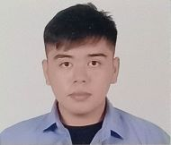**Personal Background**

**Name** : Shawn Harvey S. Otero

**Nickname** : Shawn

**Date of Birth** : March 18, 2003

**Home Address** : Poblacion, Cortes, Bohol

**Status** : Single

**Religion** : Roman Catholic

**Name of Father** : Sedrick D. Otero

**Name of Mother** : Erlinda S. Otero

**Educational Background**

**Elementary** : Cortes Central Elementary School

: Poblacion, Cortes, Bohol

**Secondary** : Infant King Academy High School

: Poblacion, Cortes, Bohol

**College** : Bohol Island State University – Balilihan Campus

: Magsija, Balilihan, Bohol

**Program** **:** Bachelor of Science in Information Technology