**helloWorld:**

**stress.cpp:**

#include <iostream>
  
#include "another.cpp"
  
#include "helloWorld.cpp"
  
using namespace std;
  
  
int main()
  
{
  
 cout << "stress Tested the application update command.";
  
}

**another.cpp:**

#include <iostream>
  
  
void greet()
  
{
  
 std::cout << "hello world";
  
}

**helloWorld.cpp:**

#include "helloWorld.h"
  
  
void doNothing()
  
{
  
 // doing nothing hahahaha
  
}

class HelloWorld
  
{
  
public:
  
 HelloWorld();
  
 void greetingUser();
  
};

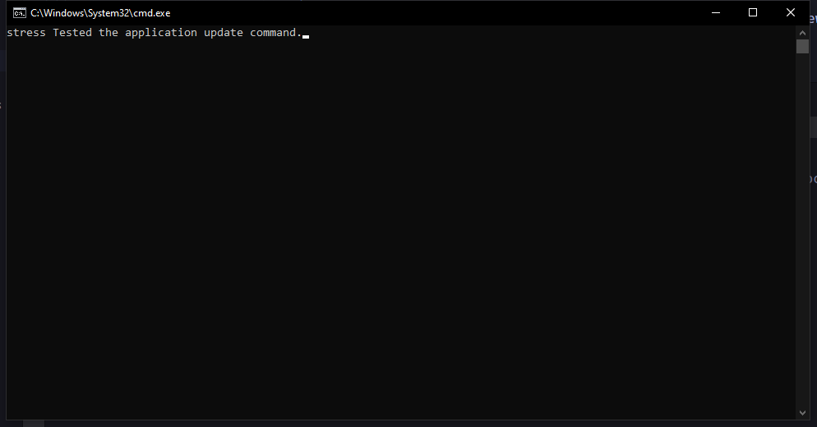

**test2.cpp:**

#include <iostream>
  
  
int main()
  
{
  
 std::cout << "Hello World";
  
 return 0;
  
}

