DESIGN AND IMPLEMENTATION OF A MULTI-USER SECURE CHAT AND FILE SHARING PROTOCOL USING TCP/IP SUITE IN C# .NET

Course: Network Programming
8th Semester

PROJECT MEMBERS:
STUDENT - ID | STUDENT - NAME
14958 | Shayan Akram
15016 | Muhammad Yaseen

SUBMITTED TO:
Sir Zafar Iqbal
Department of Computer Science (KIET)
DATE OF SUBMISSION: 29 May 2026

1. ABSTRACT
In contemporary computing, real-time communication systems represent a cornerstone of distributed software engineering. This project presents the design and implementation of a robust Multi-User Chat and File Sharing Application developed using C# .NET. The system is built on top of the TCP (Transmission Control Protocol) layer utilizing synchronous and asynchronous socket APIs (TcpListener and TcpClient) to ensure reliable, ordered, and error-free delivery of text messages and binary files.
The application integrates an offline messaging storage layer powered by a lightweight SQLite Database, ensuring that messages sent to offline recipients are successfully queued and dynamically delivered upon their next authentication. User passwords are secured using cryptographic one-way hashing with SHA-256. The user interface is developed using Windows Forms (WinForms), featuring dynamic UI state changes and isolated, WhatsApp-style tabbed chat histories per conversation thread. The resulting software represents a complete, secure, and production-grade client-server application demonstrating key network programming concepts including multi-threading, concurrency, socket streaming, and custom application-layer protocol serialization.

2. INTRODUCTION & PROJECT SCOPE
Real-time message exchange systems require extreme reliability, low latency, and robust session management. The objective of this project is to develop a standalone client-server ecosystem that fulfills the following goals:
- Reliable TCP Connection Management: Persistent socket connection over LAN/WAN between multiple concurrent clients and a centralized console server.
- Secure Authentication & Identity Management: User registration and login verified against a secure SQLite database using cryptographic password hashing.
- Dynamic User Discovery: Automatic, real-time broadcasts of active user list changes (logins and logouts) to all connected clients.
- Isolated Conversation Streams (WhatsApp Style): A structured client-side layout where chat histories are separated in memory and dynamically loaded depending on the selected user in the GUI contact list.
- Offline Queueing Mechanism: Automatic detection of a recipient’s status. If offline, the message is stored securely on the server and pushed immediately when the recipient logs in.
- Direct File Streaming Over Socket: A custom binary streaming mechanism capable of transferring files of any size over the network stream without memory exhaustion.

3. SYSTEM ARCHITECTURE & NETWORK PROTOCOL
The system employs a centralized Client-Server Architecture. The Server-Side component listens on Port 9000 (IPAddress.Any) and is a console application that accepts incoming TCP connections. Upon accepting a connection, it spawns a dedicated worker task using Task.Run to handle client communication on a background thread. The Client-Side component establishes a connection with the server, managing an active NetworkStream for two-way communication, and uses a secondary background listener task to asynchronously capture incoming server pushes (messages, user list updates, and file streams).

3.1 Custom Application-Layer Protocol
To serialize commands and payload data over the TCP network stream, a custom pipe-separated protocol was designed. The protocol structure is formatted as: [CommandType]|[Argument1]|[Argument2]|...
Command Type | Sender -> Receiver | Format | Purpose
Register | Client -> Server | Register|username|password | Register a new account in SQLite database.
Login | Client -> Server | Login|username|password | Authenticate and log in user.
GetUserList | Client -> Server | GetUserList | Retrieve online users list.
SendMessage | Client -> Server | SendMessage|recipient|content | Transmit a text message to a specific user.
SendFile | Client -> Server | SendFile|recipient|fileName|fileSize | Initiate binary file header followed by raw bytes.
Logout | Client -> Server | Logout | Gracefully terminate socket connection.

4. TECHNICAL IMPLEMENTATION DETAILS

4.1 Server Engine Logic
The server listens for incoming clients on port 9000 using TcpListener.AcceptTcpClientAsync() in an infinite loop. Each socket accepted is handed off to a separate thread execution context to keep operations asynchronous and concurrent. An active registry of users is tracked in a thread-safe ConcurrentDictionary<string, TcpClient> onlineUsers. User registration and verification use a secure SQLite backend. Security is enforced by base64 string-encoding of password hashes generated using the SHA-256 one-way hashing algorithm.

4.2 Client Engine & WhatsApp-Style Chat Isolation
To achieve WhatsApp-style individual chat isolation where switching names in a contact list changes the displayed conversation history, we implemented a local client-side memory storage scheme using an in-memory ChatMessage list mapped by user contact name:
- ChatMessage Data Struct: Holds Sender, Text, and Timestamp for each individual message record.
- In-Memory Histories Dictionary: A dictionary tracks historical records: Dictionary<string, List<ChatMessage>> chatHistories.
- UI State Swapping: When selection changes on the ListBox (lstUsers), rtbChat (RichTextBox) is cleared, and historical records are re-drawn.
- Background Stream Routing: Incoming message streams are appended directly to the dictionary. They are only rendered instantly if they belong to the active selected user.

5. DATABASE SCHEMA (SQLITE)
The server uses a local file-based database, chat.db, containing two structured tables to persist user identities and pending offline queues.

5.1 Users Table Schema
CREATE TABLE IF NOT EXISTS Users (
Id INTEGER PRIMARY KEY AUTOINCREMENT,
Username TEXT UNIQUE NOT NULL,
PasswordHash TEXT NOT NULL
);

5.2 Messages Table Schema
CREATE TABLE IF NOT EXISTS Messages (
Id INTEGER PRIMARY KEY AUTOINCREMENT,
FromUser TEXT NOT NULL,
ToUser TEXT NOT NULL,
Content TEXT,
IsFile INTEGER DEFAULT 0,
FileName TEXT,
IsRead INTEGER DEFAULT 0
);

6. SCREENSHOTS & TESTING EVIDENCE
To verify application reliability, the system was extensively tested. Please insert the testing evidence below:

Figure 6.1: Server Startup
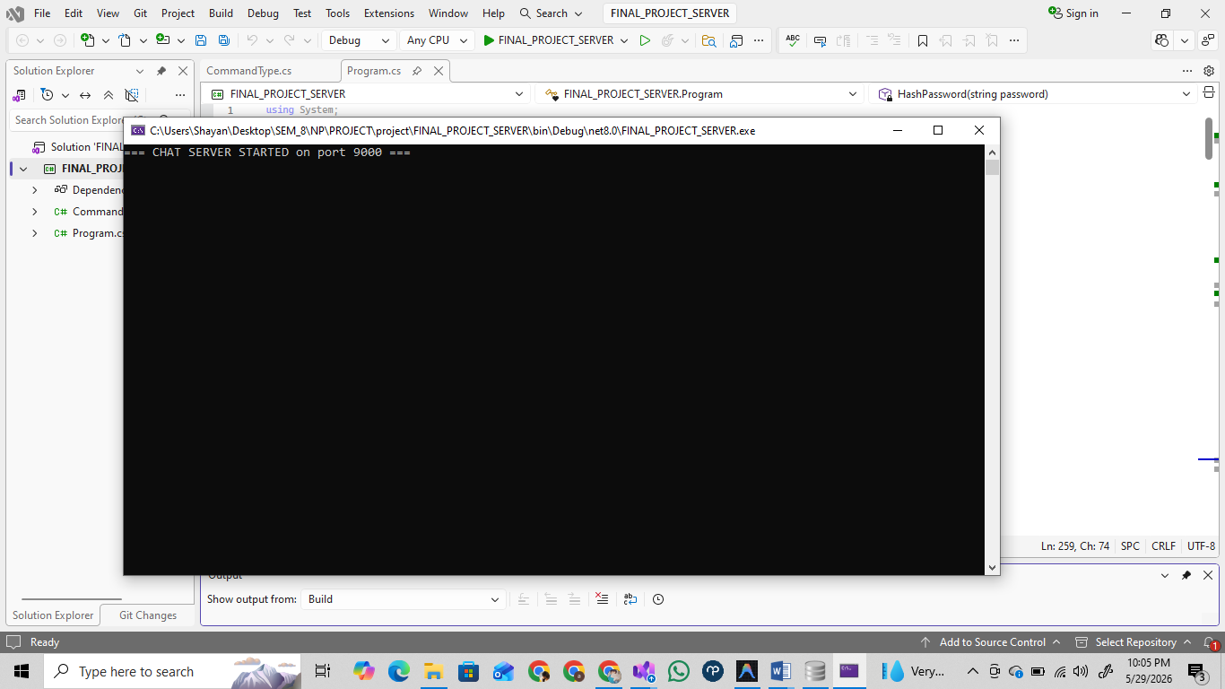

Figure 6.2: User Authentication & Registration
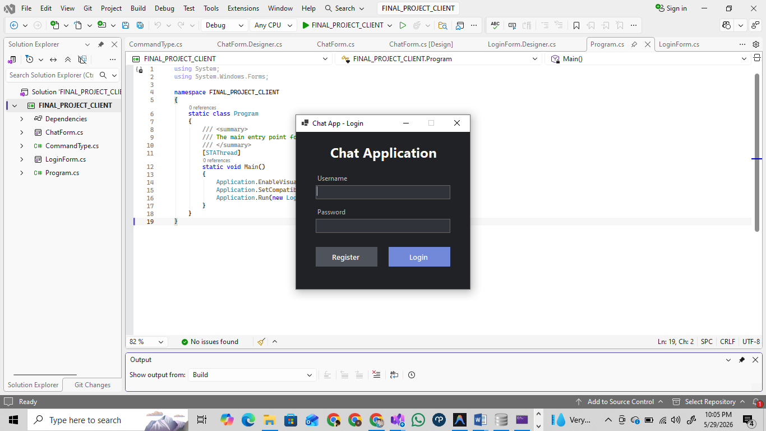
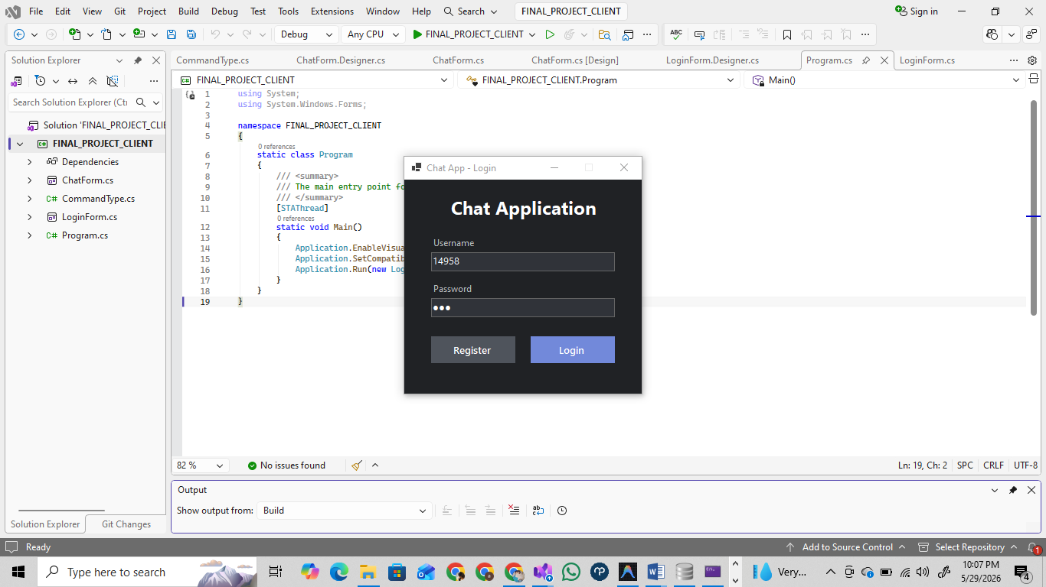
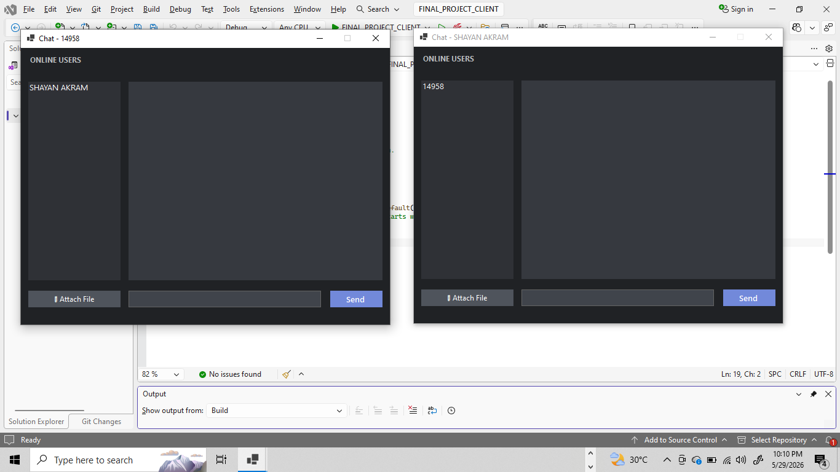

Figure 6.3: WhatsApp Style Chat Isolation
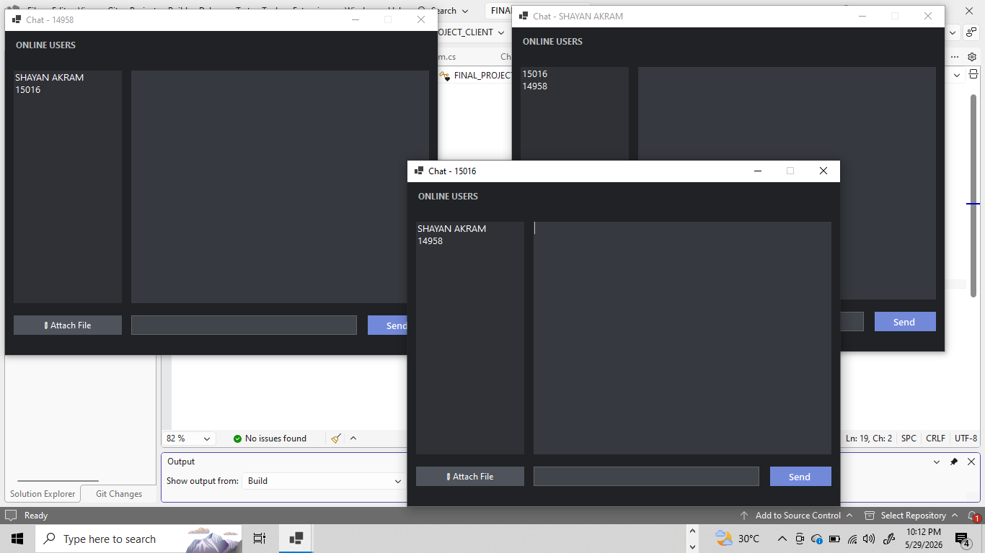
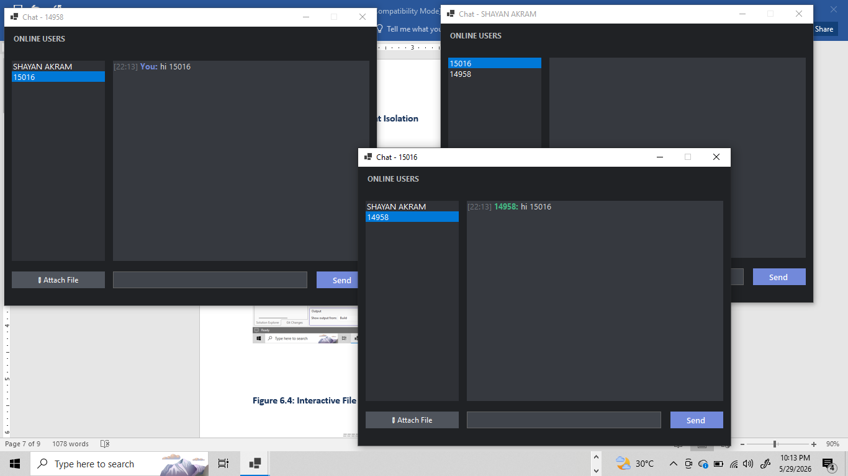
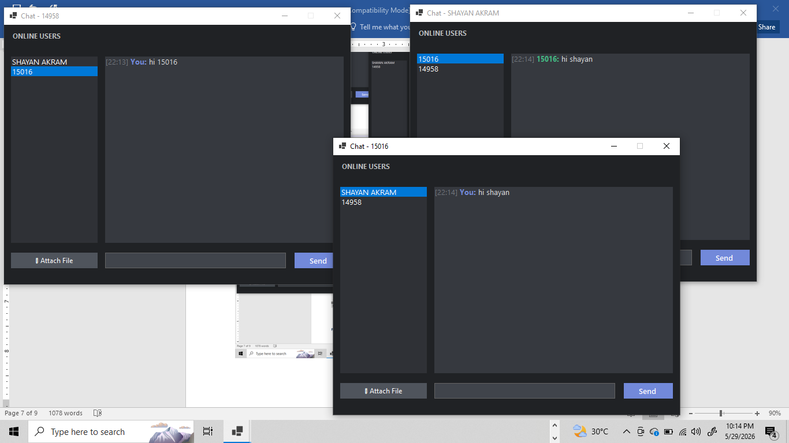

Figure 6.4: Interactive File Sharing
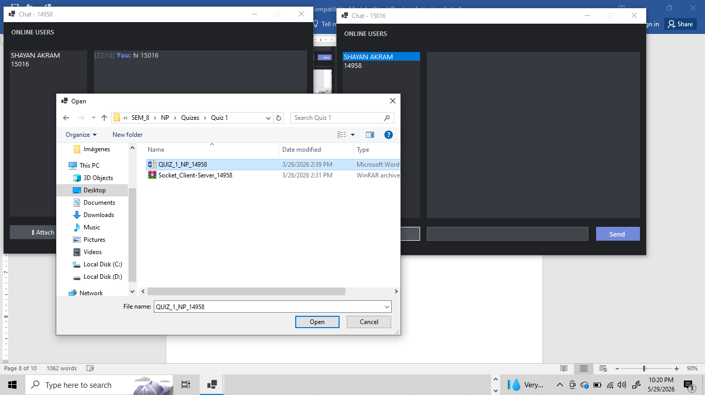
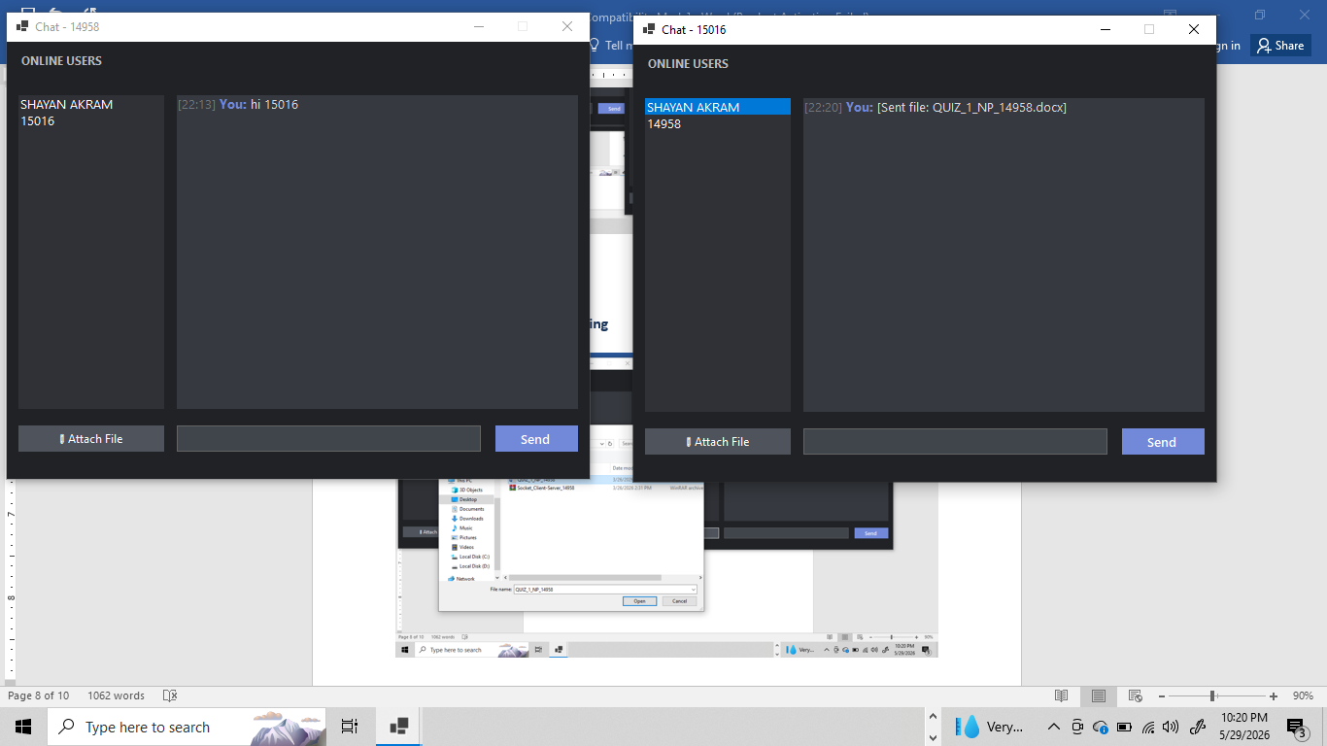
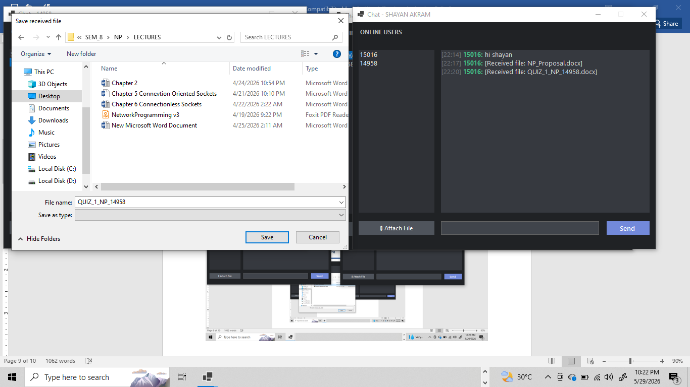
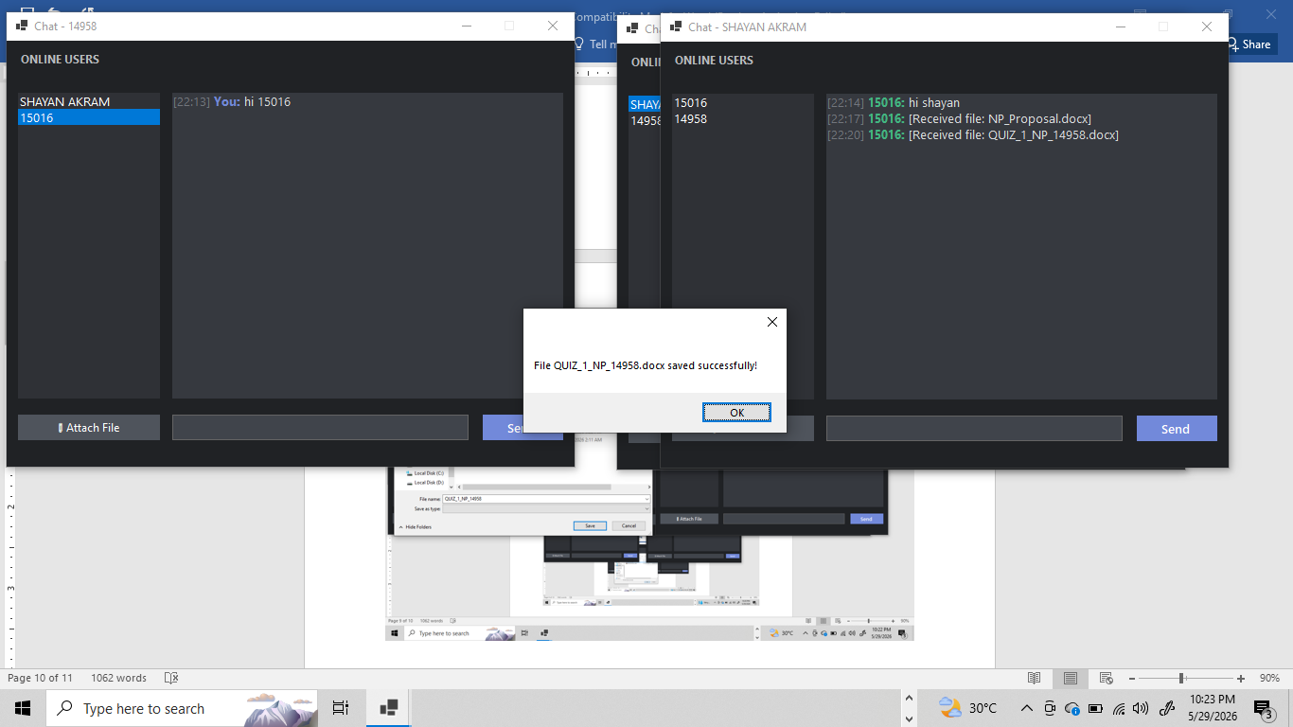
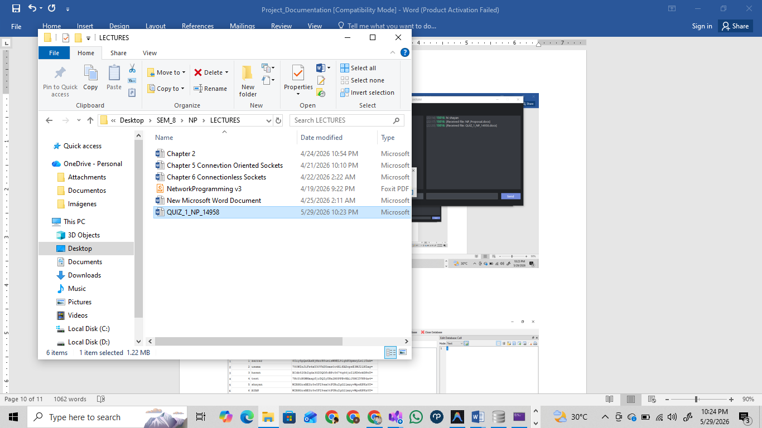

Figure 6.5: Database Inspection
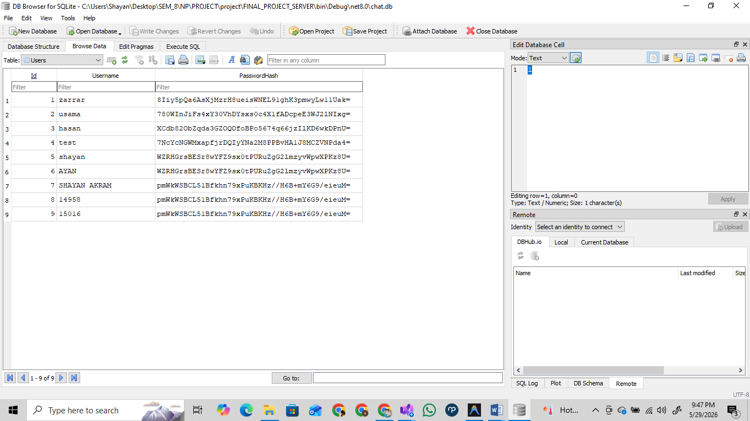
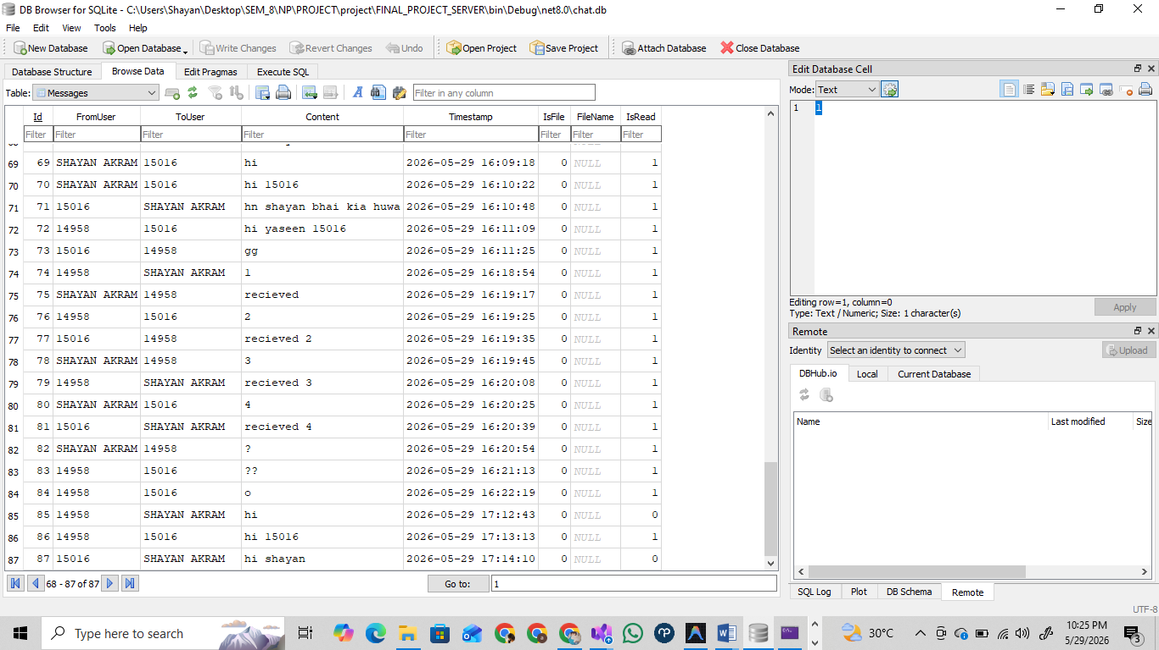

7. Bug Fixes & Enhancements
7.1. Unread Message Notification System
Issue: Previously, users had no way of knowing if they received a new message from someone else while they were chatting with another user or if the application was minimized.
Solution Implemented:
- Implemented a custom Owner-Drawn ListBox for the user list.
- Added a visual green highlight and a red notification badge showing the exact count of unread messages next to the sender's name.
- Integrated Win32 API (FlashWindowEx) to make the application icon flash on the Windows taskbar when a new message arrives and the app is minimized or out of focus.
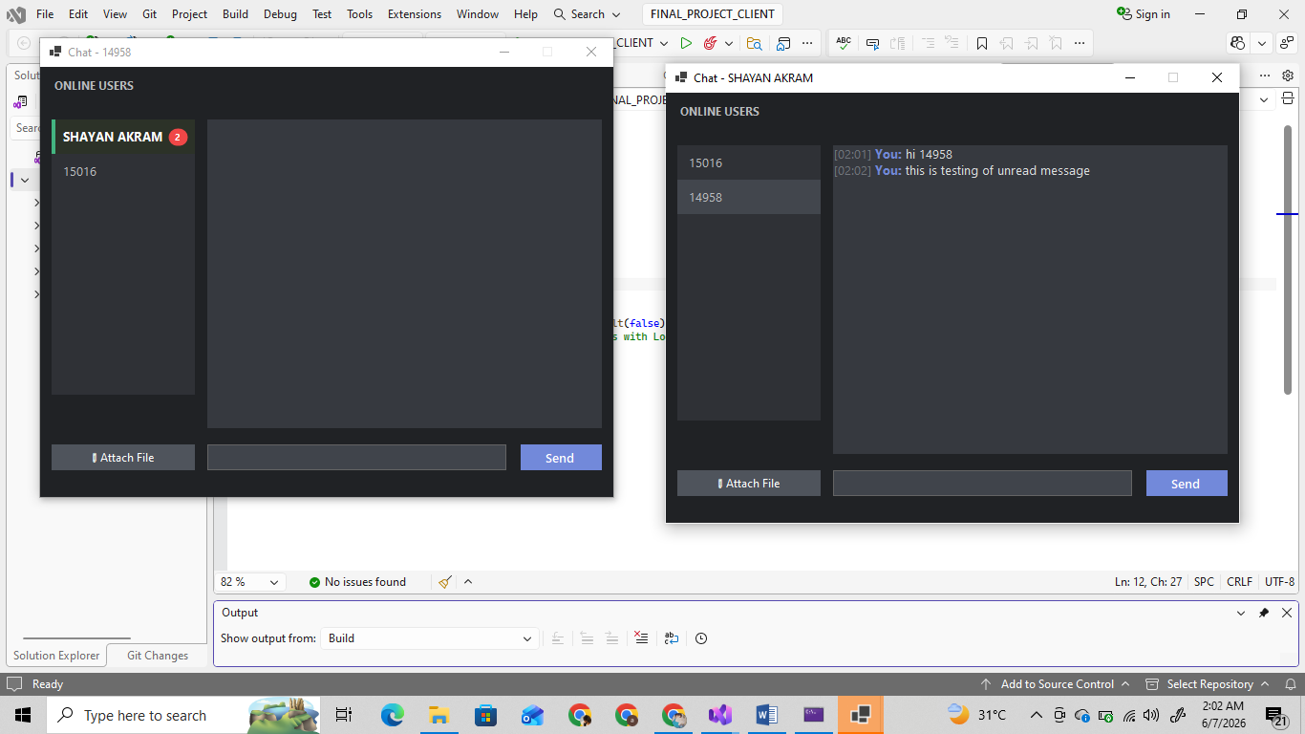
7.2. Graceful Server Disconnection Handling (Crash Fix)
Issue: When the server was closed or disconnected unexpectedly, if the client tried to send a message, it resulted in an unhandled System.Net.Sockets.SocketException and triggered a Just-In-Time (JIT) Debugging crash dialog.
Solution Implemented:
- Added robust try-catch blocks around network stream operations (btnSend_Click, btnAttach_Click).
- Introduced an isConnected flag to track the connection state.
- Created a HandleDisconnect() method that gracefully catches network drops, disables the chat input box and buttons, and displays a red "DISCONNECTED" warning to the user instead of crashing the application.
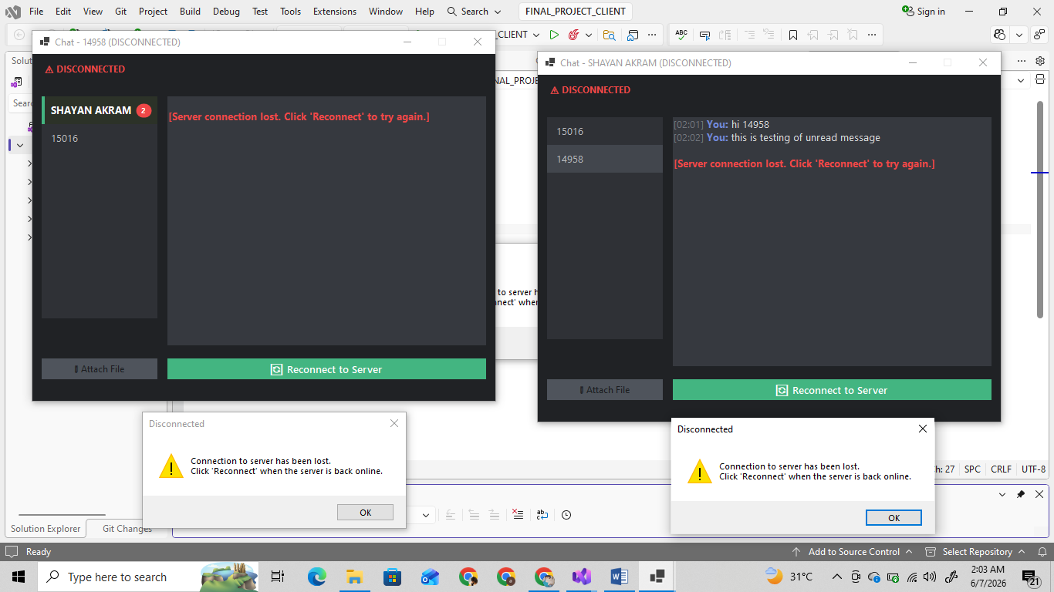
7.3. Server Reconnection Functionality
Issue: Once the server disconnected, the user was forced to completely close the client application and restart it to log back in.
Solution Implemented:
- Added a dynamic "🔄 Reconnect to Server" button that only appears when a disconnection is detected.
- Stored the user's connection details and password in memory.
- When clicked, the application automatically establishes a new TcpClient connection, authenticates the user transparently, and restores the chat UI without requiring a full app restart.
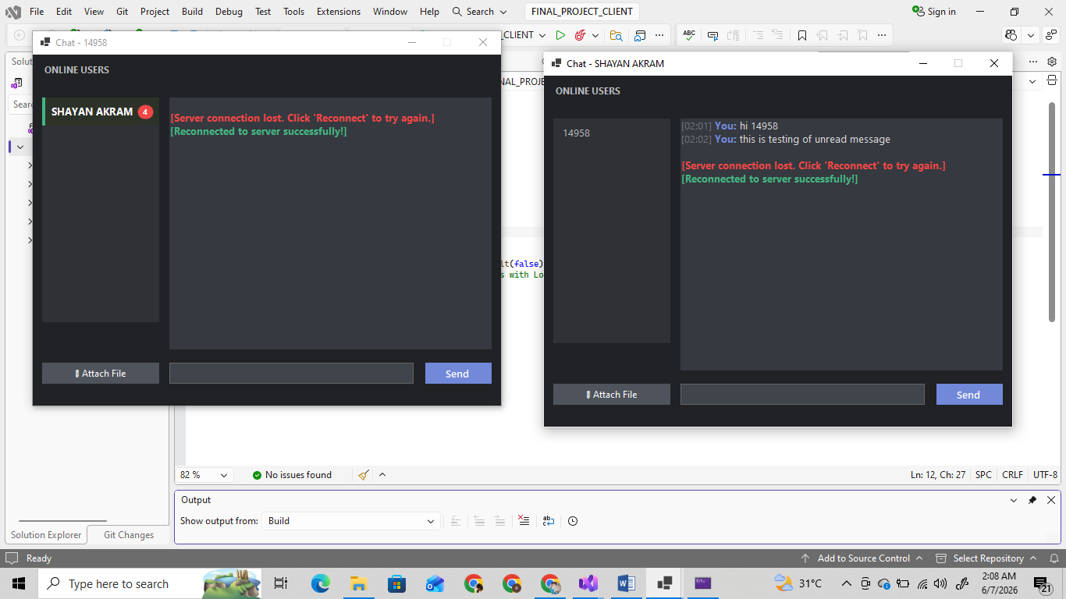
7.4. TCP Stream Buffering Issue (Merged Messages Fix)
Issue: Upon initial login, multiple fast server responses (e.g., LOGIN_OK, USERLIST, and queued offline MESSAGEs) were merging together in the TCP stream into a single string, causing parsing errors and UI glitches (e.g., "hiUSERLIST|15016").
Solution Implemented:
- Designed and implemented a Newline Delimiter Protocol (\n).
- Modified the Server's Send method to append \n to every outgoing packet.
- Upgraded the Client's ListenForMessages listener to accumulate bytes in a StringBuilder and process packets strictly line-by-line using .Split('\n'). This guarantees that merged TCP packets are handled individually and accurately.
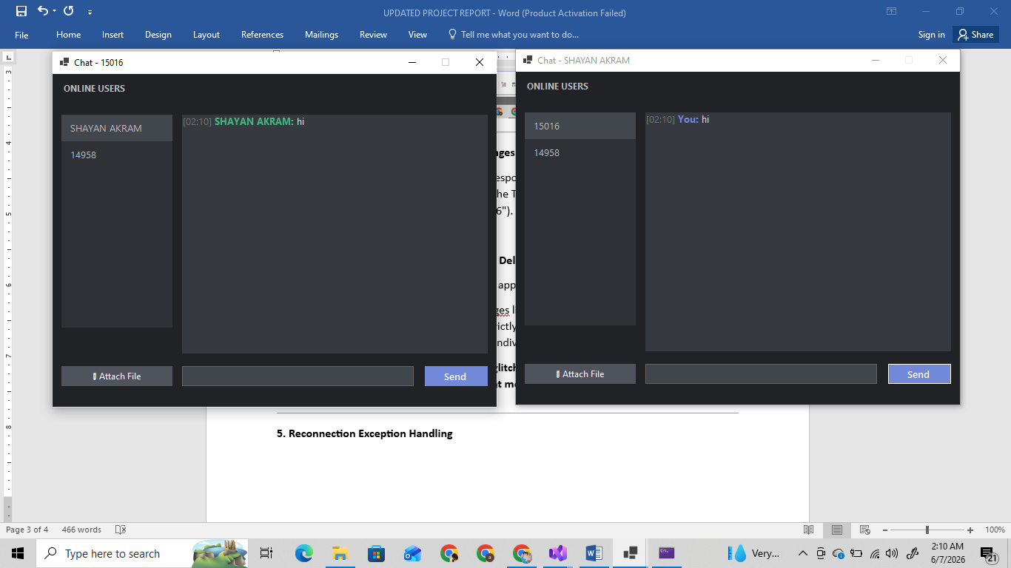
7.5. Reconnection Exception Handling
Issue: If the user clicked the "Reconnect to Server" button while the server was still offline, it threw a raw system error ("No connection could be made because the target machine actively refused it").
Solution Implemented:
- Added specific exception handling for SocketException in the reconnect logic.
- Replaced the confusing system crash dialog with a clean, user-friendly MessageBox warning: "Cannot connect to the server. It appears to be offline. Please make sure the server is running and try again."H
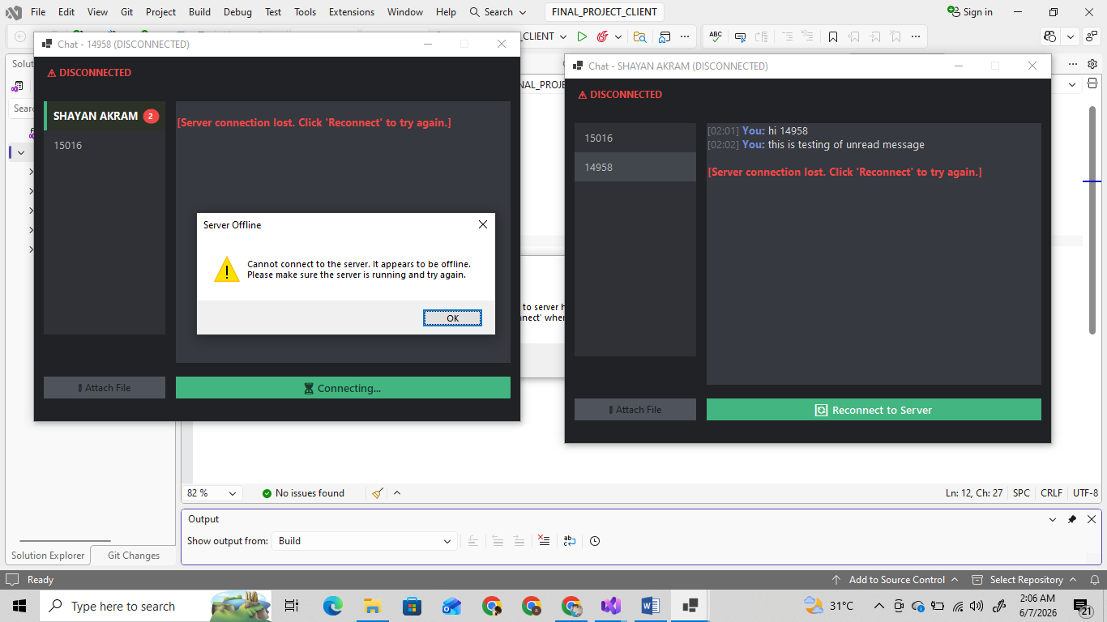

8. COMPLETE PROJECT SOURCE
To fully satisfy the academic submission requirements, the complete source code for all primary files in the client and server projects is appended below. This includes the shared data structures, server engines, user login handling, and the WhatsApp-style in-memory chat isolation client logic.

8.1 Shared Protocol Commands (CommandType.cs)
﻿using System;
using System.Collections.Generic;
using System.Linq;
using System.Text;
using System.Threading.Tasks;

namespace FINAL_PROJECT_SERVER
{
public enum CommandType
{
Register,
Login,
GetUserList,
SendMessage,
SendFile,
Logout
}
}

8.2 Central Socket Server (FINAL_PROJECT_SERVER / Program.cs)
using System;
using System.Collections.Concurrent;
using System.Data.SQLite;
using System.IO;
using System.Net;
using System.Net.Sockets;
using System.Security.Cryptography;
using System.Text;
using System.Threading.Tasks;
namespace FINAL_PROJECT_SERVER
{
internal class Program
{
private static TcpListener listener;
private static readonly ConcurrentDictionary<string, TcpClient> onlineUsers = new();
private static readonly string dbPath = "chat.db";
static async Task Main(string[] args)
{
InitializeDatabase();
listener = new TcpListener(IPAddress.Any, 9000);
listener.Start();
Console.WriteLine("=== CHAT SERVER STARTED on port 9000 ===\n");
while (true)
{
TcpClient client = await listener.AcceptTcpClientAsync();
_ = Task.Run(() => HandleClientAsync(client));
}
}
private static void InitializeDatabase()
{
if (!File.Exists(dbPath))
SQLiteConnection.CreateFile(dbPath);
using var conn = new SQLiteConnection($"Data Source={dbPath}");
conn.Open();
string sqlUsers = "CREATE TABLE IF NOT EXISTS Users (Id INTEGER PRIMARY KEY AUTOINCREMENT, Username TEXT UNIQUE NOT NULL, PasswordHash TEXT NOT NULL);";
string sqlMessages = "CREATE TABLE IF NOT EXISTS Messages (Id INTEGER PRIMARY KEY AUTOINCREMENT, FromUser TEXT NOT NULL, ToUser TEXT NOT NULL, Content TEXT, IsFile INTEGER DEFAULT 0, FileName TEXT, IsRead INTEGER DEFAULT 0);";
using (var cmd = new SQLiteCommand(sqlUsers, conn)) cmd.ExecuteNonQuery();
using (var cmd = new SQLiteCommand(sqlMessages, conn)) cmd.ExecuteNonQuery();
}
private static async Task HandleClientAsync(TcpClient client)
{
NetworkStream stream = client.GetStream();
string username = null;
try
{
byte[] buffer = new byte[8192];
while (client.Connected)
{
int bytesRead = await stream.ReadAsync(buffer, 0, buffer.Length);
if (bytesRead == 0) break;
string data = Encoding.UTF8.GetString(buffer, 0, bytesRead);
string[] parts = data.Split('|');
if (parts.Length < 1) continue;
CommandType cmd = Enum.Parse<CommandType>(parts[0]);
switch (cmd)
{
case CommandType.Register:
if (parts.Length == 3)
{
bool success = RegisterUser(parts[1], parts[2]);
await Send(stream, success ? "REGISTER_OK" : "REGISTER_FAIL");
}
break;
case CommandType.Login:
if (parts.Length == 3 && LoginUser(parts[1], parts[2]))
{
username = parts[1];
onlineUsers[username] = client;
Console.WriteLine($"{username} logged in");
await Send(stream, "LOGIN_OK");
await SendOfflineMessages(stream, username);
await BroadcastUserList();
}
else
{
await Send(stream, "LOGIN_FAIL");
}
break;
case CommandType.GetUserList:
string list = string.Join(",", onlineUsers.Keys);
await Send(stream, "USERLIST|" + list);
break;
case CommandType.SendMessage:
if (parts.Length >= 3 && username != null)
{
string toUser = parts[1];
string content = parts[2];
SaveMessage(username, toUser, content);
if (onlineUsers.TryGetValue(toUser, out TcpClient receiver))
{
await Send(receiver.GetStream(), $"MESSAGE|{username}|{content}");
}
}
break;
case CommandType.SendFile:
if (parts.Length == 4 && username != null)
{
string toUser = parts[1];
string fileName = parts[2];
long fileSize = long.Parse(parts[3]);
// Receive file bytes from sender
byte[] fileBytes = new byte[fileSize];
int received = 0;
while (received < fileSize)
{
int r = await stream.ReadAsync(fileBytes, received, (int)(fileSize - received));
if (r == 0) break;
received += r;
}
// Forward notification AND file bytes to receiver
if (onlineUsers.TryGetValue(toUser, out TcpClient receiver))
{
NetworkStream recStream = receiver.GetStream();
await Send(recStream, $"FILE|{username}|{fileName}|{fileSize}");
// Small delay to ensure the receiver processes the notification string first
await Task.Delay(100);
await recStream.WriteAsync(fileBytes, 0, fileBytes.Length);
await recStream.FlushAsync();
}
}
break;
case CommandType.Logout:
if (username != null)
{
onlineUsers.TryRemove(username, out _);
Console.WriteLine($"{username} logged out");
await BroadcastUserList();
}
return;
}
}
}
catch (Exception ex)
{
Console.WriteLine($"Error: {ex.Message}");
}
finally
{
if (username != null)
{
onlineUsers.TryRemove(username, out _);
await BroadcastUserList();
}
client.Close();
}
}
private static void SaveMessage(string from, string to, string content, bool isFile = false)
{
using var conn = new SQLiteConnection($"Data Source={dbPath}");
conn.Open();
string sql = "INSERT INTO Messages (FromUser, ToUser, Content, IsFile) VALUES (@f, @t, @c, @isfile)";
using var cmd = new SQLiteCommand(sql, conn);
cmd.Parameters.AddWithValue("@f", from);
cmd.Parameters.AddWithValue("@t", to);
cmd.Parameters.AddWithValue("@c", content);
cmd.Parameters.AddWithValue("@isfile", isFile ? 1 : 0);
cmd.ExecuteNonQuery();
}
private static async Task SendOfflineMessages(NetworkStream stream, string user)
{
using var conn = new SQLiteConnection($"Data Source={dbPath}");
conn.Open();
string sql = "SELECT FromUser, Content, IsFile FROM Messages WHERE ToUser = @u AND IsRead = 0";
using var cmd = new SQLiteCommand(sql, conn);
cmd.Parameters.AddWithValue("@u", user);
using var reader = cmd.ExecuteReader();
while (reader.Read())
{
string from = reader.GetString(0);
string content = reader.GetString(1);
bool isFile = reader.GetInt32(2) == 1;
await Send(stream, isFile ? $"FILE|{from}|{content}" : $"MESSAGE|{from}|{content}");
}
string update = "UPDATE Messages SET IsRead = 1 WHERE ToUser = @u";
using var updateCmd = new SQLiteCommand(update, conn);
updateCmd.Parameters.AddWithValue("@u", user);
updateCmd.ExecuteNonQuery();
}
private static async Task BroadcastUserList()
{
string list = string.Join(",", onlineUsers.Keys);
foreach (var cl in onlineUsers.Values)
{
try
{
await Send(cl.GetStream(), "USERLIST|" + list);
}
catch { }
}
}
private static bool RegisterUser(string username, string password)
{
string hash = HashPassword(password);
using var conn = new SQLiteConnection($"Data Source={dbPath}");
conn.Open();
string sql = "INSERT INTO Users (Username, PasswordHash) VALUES (@u, @p)";
using var cmd = new SQLiteCommand(sql, conn);
cmd.Parameters.AddWithValue("@u", username);
cmd.Parameters.AddWithValue("@p", hash);
try
{
cmd.ExecuteNonQuery();
return true;
}
catch
{
return false;
}
}
private static bool LoginUser(string username, string password)
{
string hash = HashPassword(password);
using var conn = new SQLiteConnection($"Data Source={dbPath}");
conn.Open();
string sql = "SELECT 1 FROM Users WHERE Username = @u AND PasswordHash = @p";
using var cmd = new SQLiteCommand(sql, conn);
cmd.Parameters.AddWithValue("@u", username);
cmd.Parameters.AddWithValue("@p", hash);
return cmd.ExecuteScalar() != null;
}
private static string HashPassword(string password)
{
using var sha = SHA256.Create();
byte[] bytes = sha.ComputeHash(Encoding.UTF8.GetBytes(password));
return Convert.ToBase64String(bytes);
}
private static async Task Send(NetworkStream stream, string message)
{
byte[] data = Encoding.UTF8.GetBytes(message);
await stream.WriteAsync(data, 0, data.Length);
}
}
}

8.3 Client Authentication Form (FINAL_PROJECT_CLIENT / LoginForm.cs)
using System;
using System.Drawing;
using System.Net.Sockets;
using System.Text;
using System.Threading.Tasks;
using System.Windows.Forms;

namespace FINAL_PROJECT_CLIENT
{
public partial class LoginForm : Form
{
private TcpClient client;
private NetworkStream stream;
private string currentUser = "";

public LoginForm()
{
InitializeComponent();
lblStatus.Text = "";
}

private async void btnRegister_Click(object sender, EventArgs e)
{
await ProcessCommand(CommandType.Register);
}

private async void btnLogin_Click(object sender, EventArgs e)
{
await ProcessCommand(CommandType.Login);
}

private async Task ProcessCommand(CommandType cmd)
{
string username = txtUsername.Text.Trim();
string password = txtPassword.Text;

if (string.IsNullOrEmpty(username) || string.IsNullOrEmpty(password))
{
lblStatus.ForeColor = Color.Red;
lblStatus.Text = "Please enter username and password";
return;
}

try
{
client = new TcpClient();
await client.ConnectAsync("127.0.0.1", 9000);
stream = client.GetStream();

string command = $"{cmd}|{username}|{password}\n";
byte[] data = Encoding.UTF8.GetBytes(command);
await stream.WriteAsync(data, 0, data.Length);

// Read response (newline-delimited)
byte[] buffer = new byte[1024];
int bytesRead = await stream.ReadAsync(buffer, 0, buffer.Length);
string response = Encoding.UTF8.GetString(buffer, 0, bytesRead).Trim();

if (response == "REGISTER_OK" || response == "LOGIN_OK")
{
currentUser = username;
lblStatus.ForeColor = Color.Green;
lblStatus.Text = response == "REGISTER_OK" ? "Registered successfully! Now login." : "Login successful!";

if (cmd == CommandType.Login)
{
this.Hide();
var chatForm = new ChatForm(client, stream, currentUser, password);
chatForm.FormClosed += (s, args) => this.Close();
chatForm.Show();
}
}
else
{
lblStatus.ForeColor = Color.Red;
lblStatus.Text = response == "REGISTER_FAIL" ? "Username already taken" : "Invalid credentials";
}
}
catch (Exception ex)
{
lblStatus.ForeColor = Color.Red;
lblStatus.Text = "Connection error: " + ex.Message;
}
}
}
}

8.4 Main Client Chat Interface (FINAL_PROJECT_CLIENT / ChatForm.cs)

using System;
using System.Drawing;
using System.Drawing.Drawing2D;
using System.IO;
using System.Net.Sockets;
using System.Runtime.InteropServices;
using System.Text;
using System.Threading.Tasks;
using System.Windows.Forms;

namespace FINAL_PROJECT_CLIENT
{
public partial class ChatForm : Form
{
private TcpClient client;
private NetworkStream stream;
private string username;
private string selectedUser = "";
private bool isConnected = true;
private string serverHost;
private int serverPort;
private string password;

// Unread message tracking
private readonly System.Collections.Generic.HashSet<string> unreadUsers =
new(System.StringComparer.OrdinalIgnoreCase);
private readonly System.Collections.Generic.Dictionary<string, int> unreadCounts =
new(System.StringComparer.OrdinalIgnoreCase);

// Win32 API for flashing taskbar
[DllImport("user32.dll")]
[return: MarshalAs(UnmanagedType.Bool)]
private static extern bool FlashWindowEx(ref FLASHWINFO pwfi);

[StructLayout(LayoutKind.Sequential)]
private struct FLASHWINFO
{
public uint cbSize;
public IntPtr hwnd;
public uint dwFlags;
public uint uCount;
public uint dwTimeout;
}

private const uint FLASHW_ALL = 3;
private const uint FLASHW_TIMERNOFG = 12;

private class ChatMessage
{
public string Sender { get; set; }
public string Text { get; set; }
public DateTime Time { get; set; }
}

private readonly System.Collections.Generic.Dictionary<string, System.Collections.Generic.List<ChatMessage>> chatHistories =
new(System.StringComparer.OrdinalIgnoreCase);

public ChatForm(TcpClient tcpClient, NetworkStream networkStream, string user, string pass = "")
{
InitializeComponent();
client = tcpClient;
stream = networkStream;
username = user;
password = pass;
this.Text = $"Chat - {username}";

// Store server connection details for reconnect
try
{
var endpoint = (System.Net.IPEndPoint)client.Client.RemoteEndPoint;
serverHost = endpoint.Address.ToString();
serverPort = endpoint.Port;
}
catch
{
serverHost = "127.0.0.1";
serverPort = 9000;
}
}

private async void ChatForm_Load(object sender, EventArgs e)
{
try
{
await GetOnlineUsers();
}
catch (Exception ex)
{
HandleDisconnect();
return;
}
_ = Task.Run(ListenForMessages);
}

private async Task GetOnlineUsers()
{
await SendCommand(CommandType.GetUserList);
}

private void lstUsers_SelectedIndexChanged(object sender, EventArgs e)
{
selectedUser = lstUsers.SelectedItem?.ToString() ?? "";
rtbChat.Clear();

// Clear unread state for selected user
if (!string.IsNullOrEmpty(selectedUser))
{
unreadUsers.Remove(selectedUser);
unreadCounts.Remove(selectedUser);
lstUsers.Invalidate(); // Redraw to remove badge
}

if (!string.IsNullOrEmpty(selectedUser) && chatHistories.TryGetValue(selectedUser, out var messages))
{
foreach (var msg in messages)
{
AppendMessageToUI(msg.Sender, msg.Text, msg.Time);
}
}
}

private void lstUsers_DrawItem(object sender, DrawItemEventArgs e)
{
if (e.Index < 0) return;

string userName = lstUsers.Items[e.Index].ToString();
bool isSelected = (e.State & DrawItemState.Selected) == DrawItemState.Selected;
bool hasUnread = unreadUsers.Contains(userName);
int unreadCount = unreadCounts.ContainsKey(userName) ? unreadCounts[userName] : 0;

// Background
Color bgColor;
if (isSelected)
bgColor = Color.FromArgb(66, 70, 77);
else if (hasUnread)
bgColor = Color.FromArgb(44, 50, 40); // subtle green-tinted background for unread
else
bgColor = Color.FromArgb(47, 49, 54);

using (SolidBrush bgBrush = new SolidBrush(bgColor))
e.Graphics.FillRectangle(bgBrush, e.Bounds);

// Green left bar for unread
if (hasUnread)
{
using (SolidBrush barBrush = new SolidBrush(Color.FromArgb(67, 181, 129)))
e.Graphics.FillRectangle(barBrush, e.Bounds.X, e.Bounds.Y, 4, e.Bounds.Height);
}

// Username text
Color textColor = hasUnread ? Color.White : Color.FromArgb(185, 187, 190);
FontStyle fontStyle = hasUnread ? FontStyle.Bold : FontStyle.Regular;
using (Font textFont = new Font("Segoe UI", 10F, fontStyle))
{
float textY = e.Bounds.Y + (e.Bounds.Height - textFont.GetHeight(e.Graphics)) / 2;
using (SolidBrush textBrush = new SolidBrush(textColor))
e.Graphics.DrawString(userName, textFont, textBrush, e.Bounds.X + 10, textY);
}

// Unread count badge
if (hasUnread && unreadCount > 0)
{
string countText = unreadCount > 99 ? "99+" : unreadCount.ToString();
using (Font badgeFont = new Font("Segoe UI", 7.5F, FontStyle.Bold))
{
SizeF countSize = e.Graphics.MeasureString(countText, badgeFont);
float badgeW = Math.Max(countSize.Width + 8, 20);
float badgeH = 18;
float badgeX = e.Bounds.Right - badgeW - 8;
float badgeY = e.Bounds.Y + (e.Bounds.Height - badgeH) / 2;

RectangleF badgeRect = new RectangleF(badgeX, badgeY, badgeW, badgeH);
using (GraphicsPath path = GetRoundedRect(badgeRect, 9))
{
e.Graphics.SmoothingMode = SmoothingMode.AntiAlias;
using (SolidBrush badgeBrush = new SolidBrush(Color.FromArgb(240, 71, 71)))
e.Graphics.FillPath(badgeBrush, path);

using (SolidBrush badgeTextBrush = new SolidBrush(Color.White))
{
StringFormat sf = new StringFormat { Alignment = StringAlignment.Center, LineAlignment = StringAlignment.Center };
e.Graphics.DrawString(countText, badgeFont, badgeTextBrush, badgeRect, sf);
}
e.Graphics.SmoothingMode = SmoothingMode.Default;
}
}
}
}

private GraphicsPath GetRoundedRect(RectangleF rect, float radius)
{
GraphicsPath path = new GraphicsPath();
float diameter = radius * 2;
path.AddArc(rect.X, rect.Y, diameter, diameter, 180, 90);
path.AddArc(rect.Right - diameter, rect.Y, diameter, diameter, 270, 90);
path.AddArc(rect.Right - diameter, rect.Bottom - diameter, diameter, diameter, 0, 90);
path.AddArc(rect.X, rect.Bottom - diameter, diameter, diameter, 90, 90);
path.CloseFigure();
return path;
}

private async void btnSend_Click(object sender, EventArgs e)
{
if (!isConnected)
{
MessageBox.Show("You are disconnected from the server. Cannot send messages.", "Disconnected", MessageBoxButtons.OK, MessageBoxIcon.Warning);
return;
}

if (string.IsNullOrWhiteSpace(selectedUser))
{
MessageBox.Show("Please select a user from the list.");
return;
}

if (string.IsNullOrWhiteSpace(txtMessage.Text))
return;

try
{
string messageText = txtMessage.Text.Trim();
await SendCommand(CommandType.SendMessage, selectedUser, messageText);
AppendMessage(selectedUser, "You", messageText, DateTime.Now);
txtMessage.Clear();
}
catch (Exception ex) when (ex is SocketException || ex is IOException || ex is ObjectDisposedException)
{
HandleDisconnect();
}
}

private async void btnAttach_Click(object sender, EventArgs e)
{
if (!isConnected)
{
MessageBox.Show("You are disconnected from the server. Cannot send files.", "Disconnected", MessageBoxButtons.OK, MessageBoxIcon.Warning);
return;
}

if (string.IsNullOrWhiteSpace(selectedUser))
{
MessageBox.Show("Please select a user from the list.");
return;
}

OpenFileDialog ofd = new OpenFileDialog();
if (ofd.ShowDialog() == DialogResult.OK)
{
try
{
string filePath = ofd.FileName;
string fileName = Path.GetFileName(filePath);
long fileSize = new FileInfo(filePath).Length;

await SendCommand(CommandType.SendFile, selectedUser, $"{fileName}|{fileSize}");

using (FileStream fs = new FileStream(filePath, FileMode.Open, FileAccess.Read))
{
byte[] buffer = new byte[8192];
int bytesRead;
while ((bytesRead = await fs.ReadAsync(buffer, 0, buffer.Length)) > 0)
{
await stream.WriteAsync(buffer, 0, bytesRead);
}
}

AppendMessage(selectedUser, "You", $"[Sent file: {fileName}]", DateTime.Now);
}
catch (Exception ex) when (ex is SocketException || ex is IOException || ex is ObjectDisposedException)
{
HandleDisconnect();
}
}
}

private async Task SendCommand(CommandType cmd, string to = "", string content = "")
{
if (!isConnected) return;
string message = $"{cmd}|{to}|{content}\n";
byte[] data = Encoding.UTF8.GetBytes(message);
await stream.WriteAsync(data, 0, data.Length);
}

private async Task ListenForMessages()
{
byte[] buffer = new byte[8192];
StringBuilder pendingData = new StringBuilder();
try
{
while (true)
{
int bytes = await stream.ReadAsync(buffer, 0, buffer.Length);
if (bytes == 0) break;

pendingData.Append(Encoding.UTF8.GetString(buffer, 0, bytes));
string accumulated = pendingData.ToString();

// Process all complete messages (delimited by \n)
int lastNewline = accumulated.LastIndexOf('\n');
if (lastNewline == -1) continue; // No complete message yet

string completeData = accumulated.Substring(0, lastNewline);
pendingData.Clear();
if (lastNewline < accumulated.Length - 1)
pendingData.Append(accumulated.Substring(lastNewline + 1));

string[] messages = completeData.Split('\n');
foreach (string rawMsg in messages)
{
string msg = rawMsg.Trim();
if (string.IsNullOrEmpty(msg)) continue;

if (msg.StartsWith("USERLIST|"))
{
string list = msg.Substring("USERLIST|".Length);
this.Invoke((MethodInvoker)(() =>
{
lstUsers.Items.Clear();
foreach (string u in list.Split(','))
{
if (!string.IsNullOrEmpty(u) && u != username)
lstUsers.Items.Add(u);
}
}));
}
else if (msg.StartsWith("MESSAGE|"))
{
int firstPipe = msg.IndexOf('|', 8);
if (firstPipe > 8)
{
string from = msg.Substring(8, firstPipe - 8);
string text = msg.Substring(firstPipe + 1);
this.Invoke((MethodInvoker)(() =>
{
AppendMessage(from, from, text, DateTime.Now);

// If this message is NOT from the currently selected user, mark as unread
if (!from.Equals(selectedUser, StringComparison.OrdinalIgnoreCase))
{
unreadUsers.Add(from);
if (!unreadCounts.ContainsKey(from))
unreadCounts[from] = 0;
unreadCounts[from]++;
lstUsers.Invalidate(); // Redraw list to show badge
}

// Flash taskbar if window is not focused
if (!this.ContainsFocus)
{
FlashWindow();
}
}));
}
}
else if (msg.StartsWith("FILE|"))
{
string[] parts = msg.Split('|');
if (parts.Length == 4)
{
string from = parts[1];
string fileName = parts[2];
long fileSize = long.Parse(parts[3]);

// Read the file bytes immediately
byte[] fileBytes = new byte[fileSize];
int totalReceived = 0;
while (totalReceived < fileSize)
{
int r = await stream.ReadAsync(fileBytes, totalReceived, (int)(fileSize - totalReceived));
if (r == 0) break;
totalReceived += r;
}

this.Invoke((MethodInvoker)(() =>
{
AppendMessage(from, from, $"[Received file: {fileName}]", DateTime.Now);
_ = PromptSaveFile(fileName, fileBytes);
}));
}
}
}
}
}
catch
{
this.Invoke((MethodInvoker)(() => HandleDisconnect()));
}
}

private async Task PromptSaveFile(string fileName, byte[] fileBytes)
{
SaveFileDialog sfd = new SaveFileDialog
{
FileName = fileName,
Title = "Save received file"
};

if (sfd.ShowDialog() == DialogResult.OK)
{
try
{
await File.WriteAllBytesAsync(sfd.FileName, fileBytes);
MessageBox.Show($"File {fileName} saved successfully!");
}
catch (Exception ex)
{
MessageBox.Show("Error saving file: " + ex.Message);
}
}
}

private void AppendMessage(string conversationPartner, string from, string text, DateTime time)
{
if (string.IsNullOrEmpty(conversationPartner)) return;

if (!chatHistories.TryGetValue(conversationPartner, out var messages))
{
messages = new System.Collections.Generic.List<ChatMessage>();
chatHistories[conversationPartner] = messages;
}

messages.Add(new ChatMessage { Sender = from, Text = text, Time = time });

if (selectedUser.Equals(conversationPartner, StringComparison.OrdinalIgnoreCase))
{
AppendMessageToUI(from, text, time);
}
}

private void AppendMessageToUI(string from, string text, DateTime time)
{
string timeStr = time.ToString("HH:mm");

rtbChat.SelectionStart = rtbChat.TextLength;
rtbChat.SelectionLength = 0;

// Time
rtbChat.SelectionColor = Color.FromArgb(114, 118, 125);
rtbChat.AppendText($"[{timeStr}] ");

// Username
if (from == "You")
rtbChat.SelectionColor = Color.FromArgb(114, 137, 218);
else
rtbChat.SelectionColor = Color.FromArgb(67, 181, 129);

rtbChat.SelectionFont = new Font(rtbChat.Font, FontStyle.Bold);
rtbChat.AppendText($"{from}: ");

// Message
rtbChat.SelectionColor = Color.FromArgb(220, 221, 222);
rtbChat.SelectionFont = new Font(rtbChat.Font, FontStyle.Regular);
rtbChat.AppendText($"{text}{Environment.NewLine}");

rtbChat.ScrollToCaret();
}

private void FlashWindow()
{
FLASHWINFO fwi = new FLASHWINFO
{
cbSize = (uint)Marshal.SizeOf(typeof(FLASHWINFO)),
hwnd = this.Handle,
dwFlags = FLASHW_ALL | FLASHW_TIMERNOFG,
uCount = 3,
dwTimeout = 0
};
FlashWindowEx(ref fwi);
}

private void HandleDisconnect()
{
if (!isConnected) return; // Prevent multiple disconnect popups
isConnected = false;

// Disable send controls
btnSend.Enabled = false;
btnAttach.Enabled = false;
txtMessage.Enabled = false;
txtMessage.Text = "";
txtMessage.PlaceholderText = "Disconnected from server";

// Update title bar
this.Text = $"Chat - {username} (DISCONNECTED)";

// Change status label
lblStatus.Text = "⚠ DISCONNECTED";
lblStatus.ForeColor = Color.FromArgb(240, 71, 71);

// Show disconnection message in chat
rtbChat.SelectionStart = rtbChat.TextLength;
rtbChat.SelectionLength = 0;
rtbChat.SelectionColor = Color.FromArgb(240, 71, 71);
rtbChat.SelectionFont = new Font(rtbChat.Font, FontStyle.Bold);
rtbChat.AppendText($"{Environment.NewLine}[Server connection lost. Click 'Reconnect' to try again.]{Environment.NewLine}");
rtbChat.ScrollToCaret();

// Show reconnect button
btnReconnect.Visible = true;
btnReconnect.BringToFront();

MessageBox.Show("Connection to server has been lost.\nClick 'Reconnect' when the server is back online.",
"Disconnected", MessageBoxButtons.OK, MessageBoxIcon.Warning);
}

private async void btnReconnect_Click(object sender, EventArgs e)
{
btnReconnect.Enabled = false;
btnReconnect.Text = "⏳ Connecting...";

try
{
// Close old connection
try { stream?.Close(); } catch { }
try { client?.Close(); } catch { }

// Create new connection
client = new TcpClient();
await client.ConnectAsync(serverHost, serverPort);
stream = client.GetStream();

// Re-login
string loginCmd = $"{CommandType.Login}|{username}|{password}\n";
byte[] data = Encoding.UTF8.GetBytes(loginCmd);
await stream.WriteAsync(data, 0, data.Length);

// Read login response
byte[] buffer = new byte[1024];
int bytesRead = await stream.ReadAsync(buffer, 0, buffer.Length);
string response = Encoding.UTF8.GetString(buffer, 0, bytesRead).Trim();

if (response == "LOGIN_OK")
{
// Reconnection successful!
isConnected = true;

// Re-enable UI
btnSend.Enabled = true;
btnAttach.Enabled = true;
txtMessage.Enabled = true;
txtMessage.PlaceholderText = "";
btnReconnect.Visible = false;

// Update title and status
this.Text = $"Chat - {username}";
lblStatus.Text = "ONLINE USERS";
lblStatus.ForeColor = Color.FromArgb(185, 187, 190);

// Show reconnected message in chat
rtbChat.SelectionStart = rtbChat.TextLength;
rtbChat.SelectionLength = 0;
rtbChat.SelectionColor = Color.FromArgb(67, 181, 129);
rtbChat.SelectionFont = new Font(rtbChat.Font, FontStyle.Bold);
rtbChat.AppendText($"[Reconnected to server successfully!]{Environment.NewLine}");
rtbChat.ScrollToCaret();

// Refresh online users and start listening again
await GetOnlineUsers();
_ = Task.Run(ListenForMessages);
}
else
{
MessageBox.Show("Reconnection failed: Server rejected login.", "Error", MessageBoxButtons.OK, MessageBoxIcon.Error);
btnReconnect.Enabled = true;
btnReconnect.Text = "🔄 Reconnect to Server";
}
}
catch (SocketException)
{
MessageBox.Show("Cannot connect to the server. It appears to be offline.\nPlease make sure the server is running and try again.",
"Server Offline", MessageBoxButtons.OK, MessageBoxIcon.Warning);
btnReconnect.Enabled = true;
btnReconnect.Text = "🔄 Reconnect to Server";
}
catch (Exception ex)
{
MessageBox.Show($"Reconnection error: {ex.Message}",
"Reconnect Failed", MessageBoxButtons.OK, MessageBoxIcon.Error);
btnReconnect.Enabled = true;
btnReconnect.Text = "🔄 Reconnect to Server";
}
}

protected override void OnFormClosed(FormClosedEventArgs e)
{
isConnected = false;
try
{
SendCommand(CommandType.Logout).Wait(500);
}
catch { }
client?.Close();
base.OnFormClosed(e);
}
}
}
9. CONCLUSION
This project successfully demonstrates the implementation of a reliable, high-performance, and feature-rich real-time communication platform. By layering custom protocol handling, asynchronous multi-threaded tasks, and in-memory client-side data isolation, we created a seamless chat experience that mirrors commercial systems like WhatsApp. Furthermore, the integration of secure SHA-256 authentication and offline message persistence makes this project highly robust, scalable, and secure. It stands as a comprehensive validation of network programming fundamentals using modern C# .NET engineering practices.

