Audit Points:
11. ESI Reconciliation (Books Vs returns)
12.EPF Reconciliation (Books Vs Returns)
15. Professional Tax Reconciliation (Books Vs Returns)
16. Salary Reconciliation (Books Vs Salary Register)

ESI Reconciliation (Books Vs Returns):
Description:
- ESI payable (by employer and employee) as per the provisions of Employees' State Insurance Act, 1948 (ESIC Act) is computed for those employees to whom ESI is applicable.
- After that, it is verified that whether the employee’s portion of ESI has been deducted from his / her salary.
- The total amount payable is then reconciled with both the ESI challan and ESI payment voucher downloaded from the ESIC website.

Inputs:
From Salary Sheet:
Employee Number (For Unique)
Gross Wage (Total Earnings)
ESI
From ESIC Portal:
Challan Individual:
Reason
IP Number
IP name
No. of Days
Total Wages
IP Contribution
Challan Total:
IP Contribution
Employer Contribution
Total Contribution
Total Government Contribution
Total Monthly Wages

From Receipt:
Transaction status
Employer’s Code No
Employer’s Name
Challan Created date
Challan Submitted date
Amount Paid
From Tally:
ESI - Employer Contribution
ESI – Employee Contribution Payable
ESI Payable
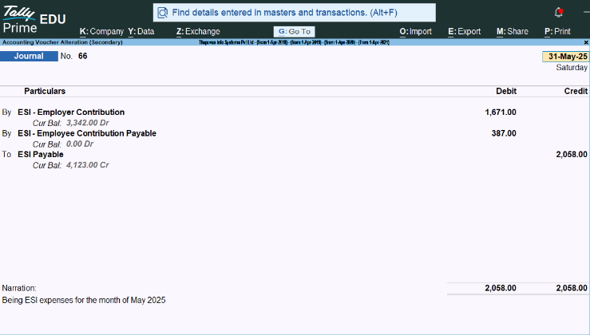
Tally:
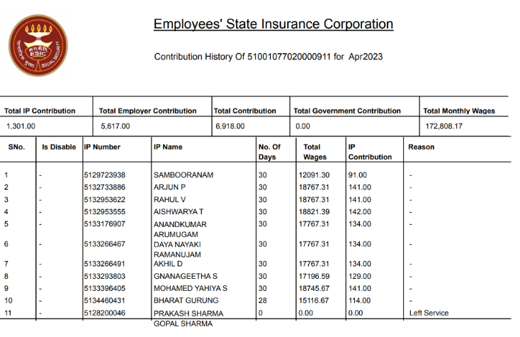
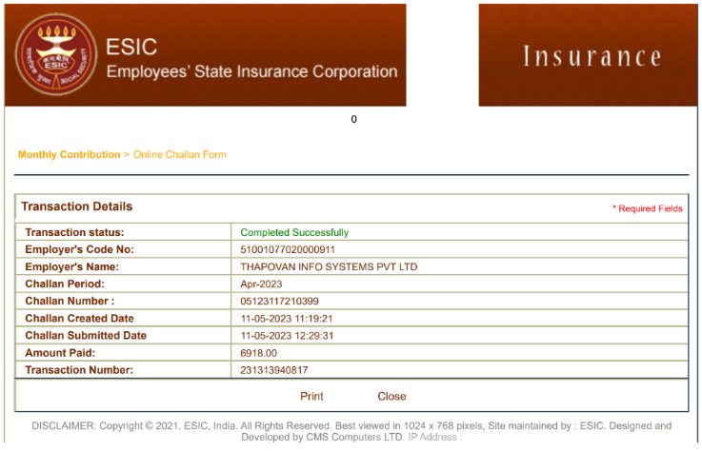
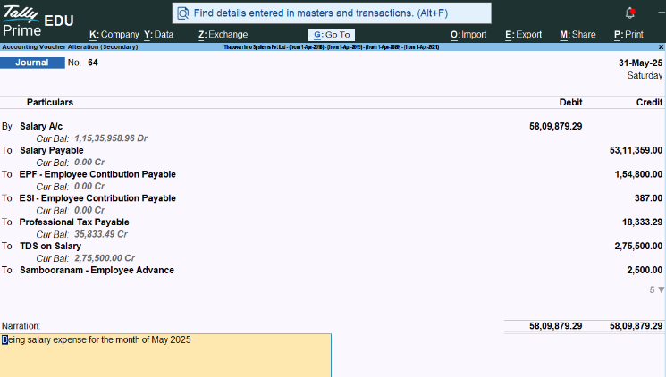

Portal Challan & Receipt:

Process:
Step 1: Employee Eligibility check:
If an employee’s gross salary is ₹21,000 or less, the employee is eligible for ESI coverage.
Agent:
Checks the salary sheet ESI column for the individual Is eligible for ESI
Step 2: Contribution Check:
Step 2.1 Employee Contribution:
Employer will deduct 0.75% from the Employee salary
Step 2.2 Employer Contribution:
Employer will Pay 3.25% of Gross Salary of the employee
Calculation:
Employee ESI = Gross Wage × 0.75%
Employer ESI = Gross Wage × 3.25%
Total of 4% of the Gross Salary from the Employee need to be paid by the Employer to the Government

Step 3: Total payable ESI:
Total ESI Payable = Employee ESI + Employer ESI (4% of Gross Salary)
Agent:
Agent will compare the Tally’s ESI payable with Challan Amount paid (by OCR Extraction)
Step4: Payment Due Date:
Payment needed to be done by Due Date (Generally 15th of the following month)
Agent:
The agent must verify that the payment date falls on or before the 15th of each month, which can be check on the challan submission date.
Step 5: Metrics:
Employee Eligibility
Employee Deduction
Employee Contribution
Book Vs Challan
Challan Vs Payment
Due Date Payment
If any of the above fails ESI Audit fails
Output:
Component | Books | ESIC Portal | Status
Employee ESI | ₹X | —
Employer ESI | ₹Y | —
Total Payable | ₹Z | ₹Z
Payment Date | — | DD/MM

Flow:
Payroll (Salary List) → ESI Eligibility → Salary Deduction → Employer Share →
Books Records → ESIC Challan → Bank Payment → Reconciliation → PASS / FAIL

EPF Reconciliation (Books Vs Returns)
Description:
- Provident fund payable (by employer and employee) as per the provisions of Employees' Provident Funds and Miscellaneous Provisions Act, 1952 is computed.
- After that, it is verified that whether the employee’s portion of PF has been deducted from his / her salary.
- The total amount payable is then reconciled with both the PF challan and PF payment voucher downloaded from the EPF website.

Input :
From the Salary Sheet:
Employee Number
PF Basic
PF wage
From Tally :
EPF – Employer Contribution
EPF Admin Charges
EPF – Employee Contribution Payable
EPF – Contribution Payable
From Challan & Receipt
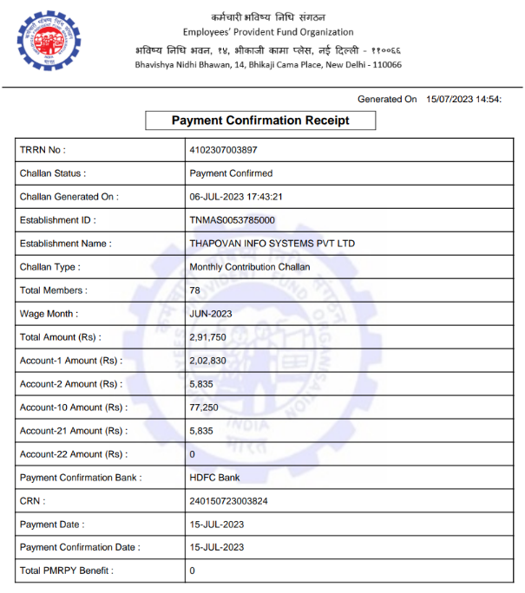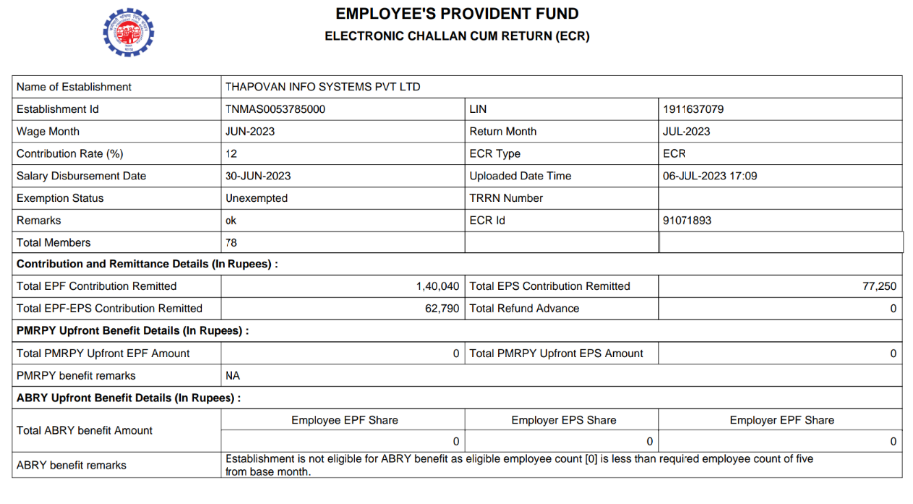
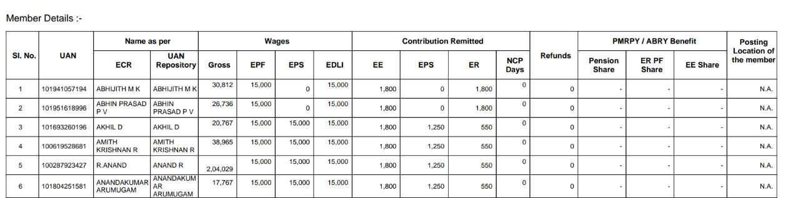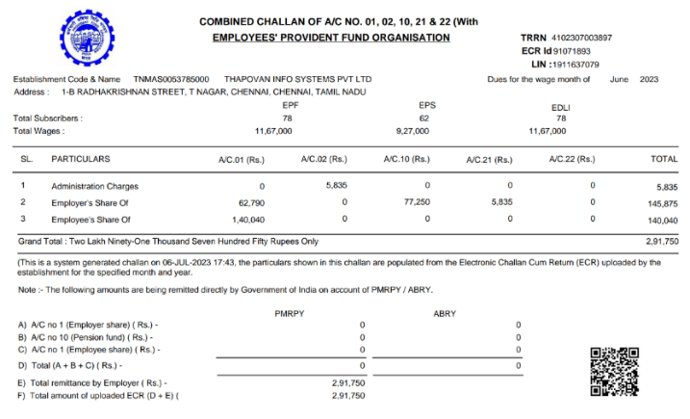
Process:
Step 1: Check If the PF is eligible for the Employee:
Scenario
Based on:
Salary Limit (15,000)
Voluntary PF option
Step 2:PF calculation based on PF wage
PF wage = Basic Salary + Dearness Allowance (DA)
Rules:
Maximum PF wage = 15,000
Even If the salary is higher PF is capped at 15000

Step 3: Calculate Employee PF (12%)
Employee contribution 12% of PF wage
Employee PF = PF Wages × 12%
This PF Is deducted from the employee salary and goes fully to EPF account (A/C 01)

Step 4: Calculate Employer contribution (12%)
This 12% will be split into EPS + EPF
Step 4A: EPS Eligibility:
EPS eligibility is decided only at the employee’s first PF joining in life.
Condition | EPS Status
First PF salary ≤ ₹15,000 | EPS Eligible
First PF salary > ₹15,000 | EPS Not Eligible

Step 5: Employer Contribution
Case 1: If the employee is EPS eligible the employer’s EPF will be split into
EPS: 8.33% Goes to Pension (A/C 10)
EPF: 3.67% Goes to PF (A/C 01)

Case 2: If the employee is not eligible for EPS, then the Entire employer contribution will go to EPF
EPF: 12% Goes to PF (A/C 01)
EPS: 0%

Step 6: Total PF per Employee
Rules:
PF is calculated on the PF Basic shown in the salary sheet.
• If the PF Basic is ₹15,000 or less, PF is 12% of that amount.
• If the PF Basic is more than ₹15,000 and the employee has opted for higher PF, then PF is 12% of the higher PF Basic shown in the salary sheet.
• If the employee has not opted for higher PF, PF is calculated only up to ₹15,000, even if the salary is higher.
The employer’s PF contribution will always be equal to the employee’s PF amount deducted in the salary sheet.
Total PF = Employee PF + Employer EPF + Employer EPS

Step 7: Records
Employee PF: This will be deducted from the salary and then recorded as PF payable in Tally
Employer PF: This will be recorded as company expense and liability until paid

Step 8: Government Portal
Employee-wise PF data uploaded through ECR and EPFO will generate challan, company pays the challan amount and the amount will be reflected in
- EPF account
- EPS account
- Employee UAN passbook

Output:
Side-by-Side Reconciliation View
Component | Books | EPF Portal | Status
Employee PF | ₹X | —
Employer PF | ₹Y | —
Total PF | ₹Z | ₹Z
Payment Date | — | DD/MM

Agentic Flow:
Payroll → Eligibility → PF Wages → Employee PF → Employer PF → Books → Challan → Payment → PASS / FAIL

Professional Tax Reconciliation
Inputs:
From Salary Sheet:
- Employee Number
- Employee Name
- Total Earnings
- PT

From Receipt:
- Receipt Number
- Name
- Address
- Payment Details
- Receipt Date
- Total amount paid
- Payment Date
From Tally:
- Professional Tax Payable

Source:
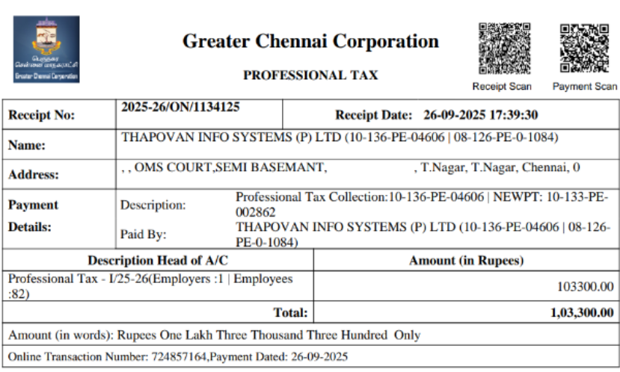
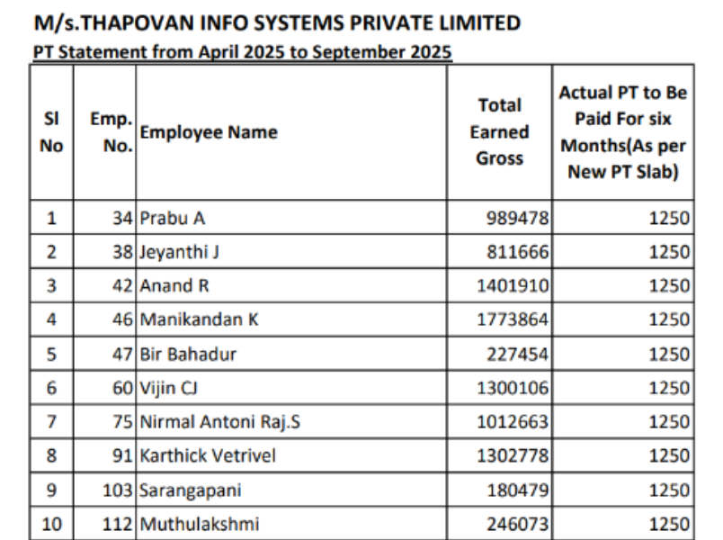

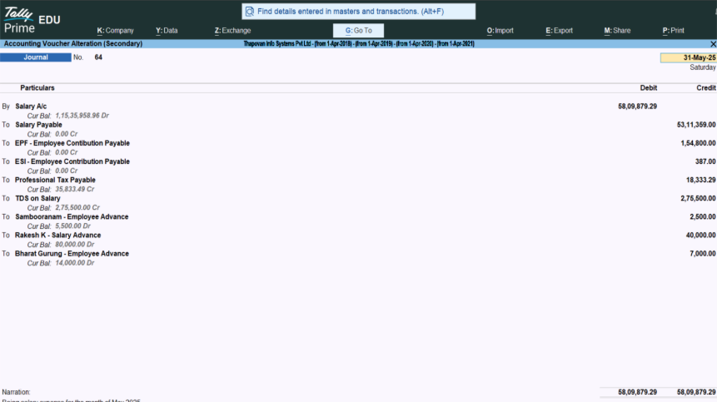

Process:
Step 1: Check the state of the employee as the PT applicability for each state differs.
Step 2: Check for the eligibility of the employee for PT deduction and ensure no deduction is missed and no ineligible employee is deducted.
Step 3: Calculate the PT amount for each employee based on their gross salary and the PT slabs of their state.
Step 4: Verify the PT deduction for each employee and ensure the correct slab is applied.
Step 5: Aggregate the employee – wise PT calculated and match it with the PT amount recorded in Tally.
Agent: Agent will compare the calculated PT with the PT recorded in the Tally.
Step 6: Compare the PT amount recorded in the Tally with the payment receipt
Agent: Agent will compare the tally with the payment receipt (OCR Extraction)
Step 7: Check the payment date and ensure that the payment was made within the due date.
Agent: Agent compares the payment date from the receipt with the due of the state.

Output:
Side by side reconciliation view
Component | Tally | Receipt
Total PT Deducted | ₹X | ₹X
Eligible Employees | N | N
Payment Date | — | DD/MM

Scenarios:
1)Employee wise exception report
Employee | Expected | Deducted | Issue
E101 | ₹200 | ₹150 | SLAB_ERROR

2)Employee-wise exception report
Employee | Expected | Deducted | Issue
E102 | ₹200 | ₹0 | PT_NOT_DEDUCTED

3)Payment-level exception report
Component | Tally | Receipt | Issue
Total PT Paid | ₹12,400 | ₹12,400 | DUE_DATE_MISSED

Salary Reconciliation
Inputs:
From Salary Sheet:
- Employee Number
- Employee Name
- EPF
- ESI
- PT
- TDS
- CTC Yearly
- CTC Monthly
- Total Earnings
- Other Deduction
- Net Payable
From Tally:
- Salary Payable
- EPF - Employee Contribution Payable
- ESI - Employee Contribution Payable
- Professional Tax Payable
- TDS on Salary

Source:
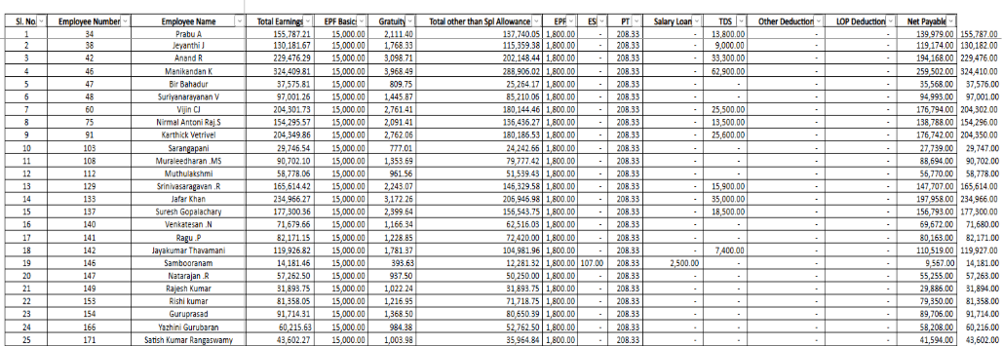
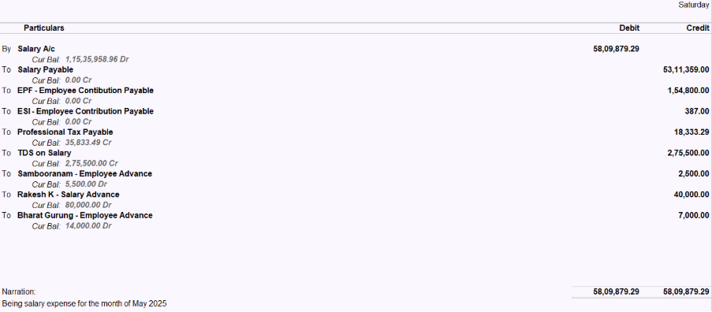
Process:
Step 1: Extract employee-wise salary details (Employee No, Name, Earnings, Deductions, Net Pay) from the Salary Sheet.
Agent: Automatically reads the salary sheet, identifies and maps employee-wise columns (Employee No, Name, Earnings, Deductions, Net Pay).
Step 2: Ensure no employee is missing or duplicated
Step 3: Check the deductions applied for each employee is applicable and there is no unusual deductions
Step 4: Aggregate the components of an employee and match it with the total earnings
Step 5: Validate employee-level calculation (Total Earnings – Total Deductions = Net Payable)
Step 6: Aggregate the component – wise totals from Salary sheet to get the total.
- Total EPF (Employee Contribution)
- Total ESI (Employee Contribution)
- Total PT
- Total TDS
- Total Net Payable
- Total Salary Expense (Total Earnings)
Step 7: Compare aggregated Salary Sheet totals with corresponding Tally ledger balances.
Agent: Matches Salary Sheet totals with Tally totals and reports differences.

Output
Side by side Reconciliation view
Component | Salary Register | Tally
Gross Salary | ₹X | ₹X
PF Deduction | ₹Y | ₹Y
TDS Deduction | ₹Z | ₹Z
Net Payable | ₹A | ₹A

Scenarios:
1)Employee exception report
Employee | Issue | Impact
E104 | PF not booked | ₹1,800

2) Salary Arithmetic Exception Report
Employee | Issue | Impact
E105 | Net pay mismatch | ₹500

3)Employee exception report
Employee | Issue | Impact
E106 | EPF not booked | ₹1,800

