TDS PartyWise Verification:

Simple flow:
Creditors list (Particulars)
↓
Extract Creditors
↓
Map to Tally Ledgers
↓
Identify Nature of Service (from Journal)
↓
Group Transactions (same creditor, same service)
↓
Map Service → TDS Section
↓
Check Threshold (amount & calculate the rate)

Explained Flow:
Step 1: Take the creditor list
Input : Creditor list given by company

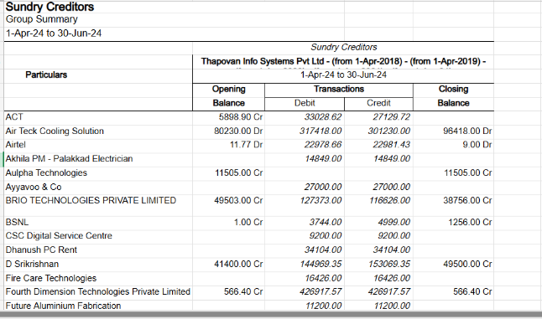

Step 2: According to the particular name take in the tally.
Input: Tally (Display more accounts/ account books/ ledger/ Name of Creditor).
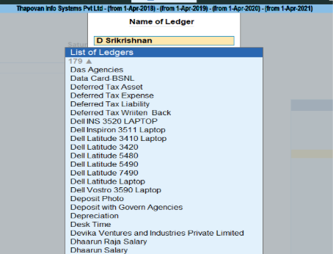

Step 3: From ledger identify the nature of the service
Input : Creditor’s Ledgers from the tally(Date, Particulars, Vch Type, Vch No., Debit, Credit).
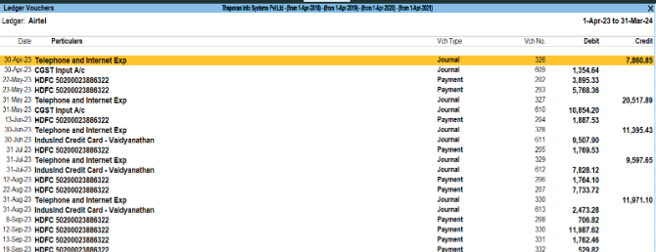

Step 4:Group the similar nature of service of the creditors and for amount of each nature take the cedited column values.
Step 5:Identify with the TDS section for the nature of the service
input : Rate chart
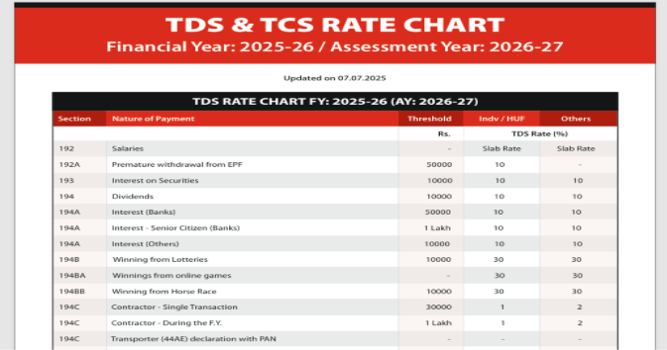
Step 6: For each creditor under the specific section check the threshold limit for amount.
Input : Rate chart.
Step 7: If the amount is above the threshold limit find the creditor’s pan number from the ledger in tally.
Input : ledger in tally
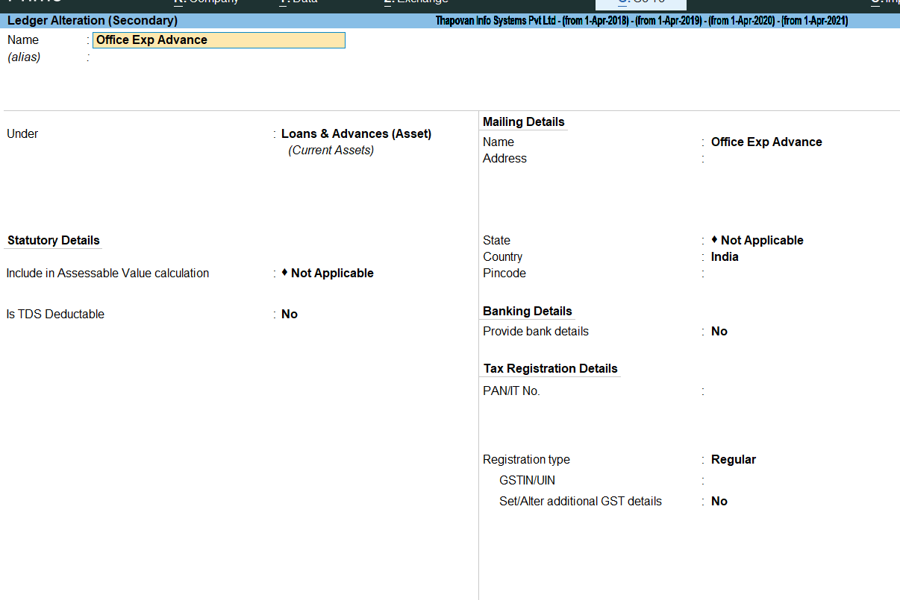

Step 8: In pan , from the last 4th place contains “P” or “H” then we should take the individual rate of percentage or else others rate of percentage should taken and the TDS amount is calculated.
Input : Rate chart

Step 9 : Compare the TDS calculated amount with deducted amount in tally under creditor’s ledger.
If the amount is Correctly deduced or deduced less in amount it should be displayed.
Input : Creditor’s Ledgers from the tally (Date, Particulars, Vch Type, Vch No., Debit, Credit).

TDS Payable:

Simple Flow:
TDS Deducted in Tally (Month-wise)
↓
Check if TDS is Payable (Before 7th of next month)
↓
Section-wise Segregation (194J / 194C / 194A)
↓
Match with TDS Challan (Payment)
↓
Group Data into 24Q & 26Q
↓
Quarterly Cumulative (3 Months Total)
↓
Match with Quarterly Return (TRACES)

Detailed Explain:
Step 1:Check whether TDS is paid before 7th of following month or if it is beyond that interest @1.5% per month or part of that month is paid.
Input : Challan/Payment receipts of TDS
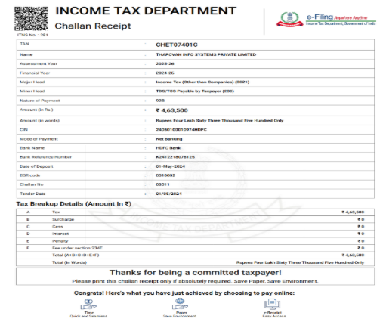
Step 2: Categorise the section wise amount and compare it with the tally
Input: Tally ledgers (Display more accounts/ account books/ ledger/ TDS on specific section) and Receipts/Challans.
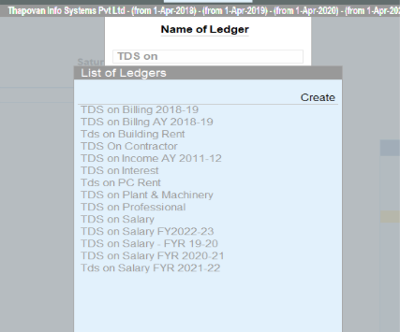

Step 3: Group the amount according to the 24Q and 26Q and returns are filed
24Q → Salary TDS
26Q → Non-salary TDS (vendors, professionals, contractors)
Input : Quarterly returns filed receipts.
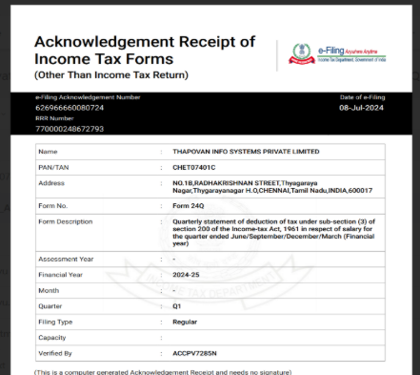
Step 4: Calculate the cumulative total amount of TDS for each month.
Input : Tally Ledger data (Display more accounts/ account books/ ledger/ TDS on specific section).
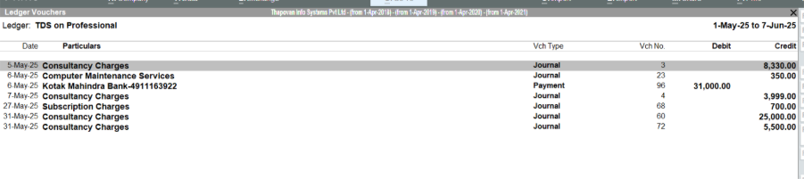
Step 5:Compare the quarterly cumulative total with 24Q and 26Q returns receipts
Input : Challan/Payment receipts of TDS
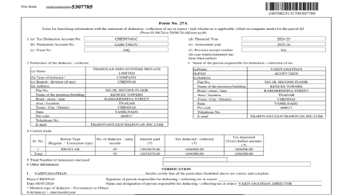
Output:
If both match → Correct
If mismatch → Error (short payment, wrong section, missing challan, etc.)

End Points :
TDS Partywise Verification :
/api/upload :
Input : the creditors list , Rate chart from the user.
text_extraction() :
If the uploaded documents are excel, pdf or image the text is extracted and stored in db using Pyplumber, OCR, Pandas.
/api/execute :
Extension : It has the required tally data fetched using extention stored in the Database.
Creditors transactions Ledger
Creditors details ledger
find_nature_of_service() :
Checks for individual creditors data from tally data and for all the transactions in that check for the Voucher type field
If the Voucher type is Journal note its Particulars field data as their Nature of service
segregate_service() :
Check under category of section in rate chart the particular nature of service falls on.
compare_threshold() :
Compare the Credits amount of that creditors with that section’s threshold limit.
If credits_amount < Threshold limit – No TDS need to be deducted and skips for the next creditor.
Else if credits amount > Threshold limit – calculate_TDS()
calculate_TDS() :
From the Creditors details stored in DB from tally,
If the Pan No. has a fourth value from it right as “P” or “H” then
TDS = creditors amount * individual rate of % / 100
or else
TDS = creditors amount * others rate of % / 100
Store that TDS amount and its section in the database.
/api/result :
compare_calcuTDS&TDSdeduced() :
From the creditors tally details under that nature of payment find the debit amount and compare it with the TDS calculated
If the TDS amount are equal then the TDS deduced is correct.
Then the mismatched Creditors are displayed
TDS Payable :
/api/upload :
Input : Challan, Payments receipts of tax on monthly basis and quaterly returns from the user.
text_extraction() :
If the uploaded documents are in pdf or image so, the text is extracted and stored in db using Pyplumber, OCR.
/api/execute :
Duedate_verification() :
From the Challans or receipts of tax paid check the date.
If the date is beyond the 7th of following month – calculate_Interest_onlatetax()
calculate_Interest_onlatetax() :
If the date is late and within the following month
late tax amount = tax amount of that month * 1.5 / 100
If the date beyond that following month then,
late tax amount = tax amount of that month * 2.5 / 100 and gradually increases.
check for the interest column in the receipt
If should be equal to that late tax amount or else mismatch of late tax amount should be displayed.
Sectionwise_grouping() :
Calculate the sum of amount deduced under each section from DB (Partywise).
Sum of amount deduced under each section = the challan and receipt amount paid under each section.
If the mismatch is found then it is displayed.
quaterly_returns() :
From that nature,Section and amount stored in DB – group them into salary taxes under 24Q and non salary taxes under 26Q.
Sum the total based on 24Q and 26Q for quarterly(3 months)
For 24Q and 26Q,
Sum calculated = Challans of quarterly returns filed = receipts of quarterly returns.
Output :
Display all the mismatches.

