**Session 5 – Data Management using R**

**Assignment - 1**

Problem Statement

1. How many vowels are there in the names of USA States?

Ans.

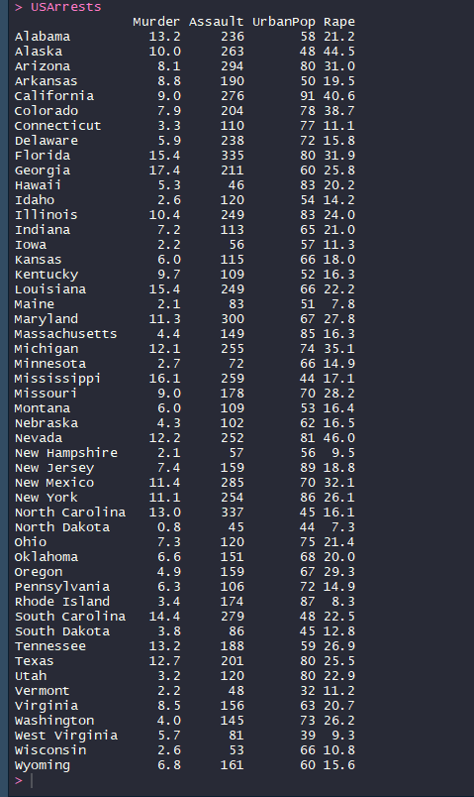

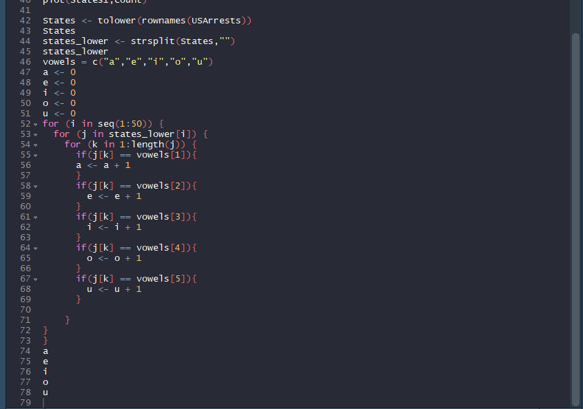

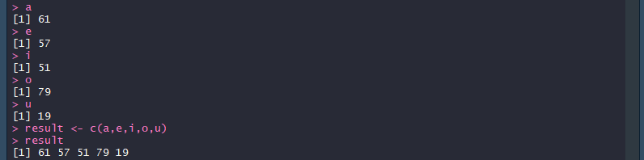

1. Visualize the vowels distribution.

Ans.

