**Session 5 – Data Management using R**

**Assignment – 2**

**Problem Statement**

**1. Obtain the elements of the union between two character vectors.**

**vec1 = c(rownames(mtcars[1:15,]))**

**vec2 = c(rownames(mtcars[10:32,]))**

**Ans .**

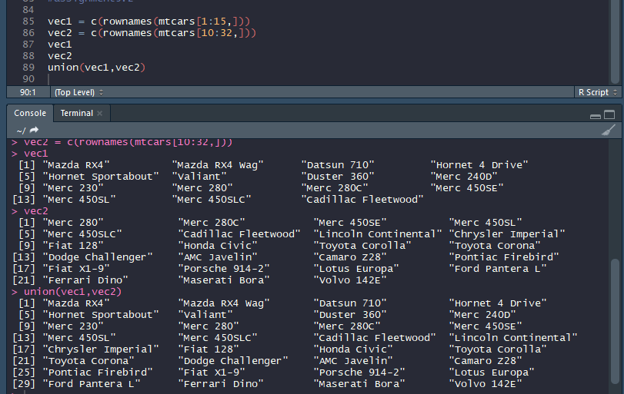

**2. Get those elements that are common to both vectors.**

**vec1 = c(rownames(mtcars[1:15,]))**

**vec2 = c(rownames(mtcars[10:32,]))**

**Ans.**

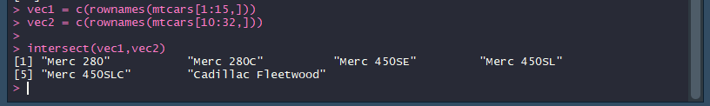

**3. Get the difference of the elements between two character vectors.**

**vec1 = c(rownames(mtcars[1:15,]))**

**vec2 = c(rownames(mtcars[10:32,]))**

**Ans.**

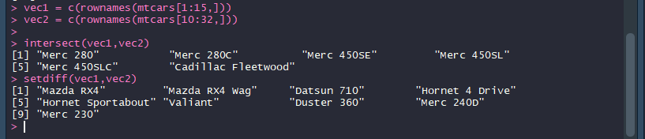

**4.** Test the quality of two character vectors.

vec1 = c(rownames(mtcars[1:15,]))

vec2 = c(rownames(mtcars[11:25,]))

Ans.

