**Session 5 – Data Management using R**

**Assignment - 3**

Problem Statement

1. Test whether two vectors are exactly equal (element by element).

vec1 = c(rownames(mtcars[1:15,]))

vec2 = c(rownames(mtcars[11:25,]))

Ans.

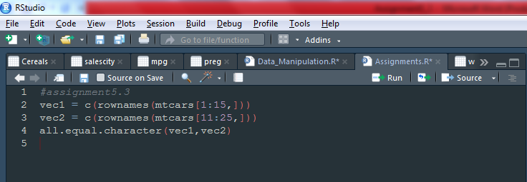

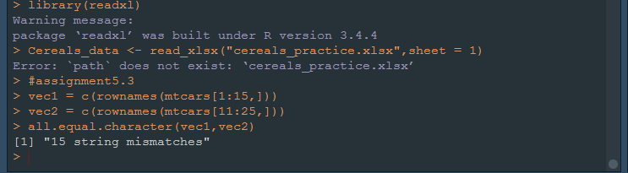

2. Sort the character vector in ascending order and descending order.

vec1 = c(rownames(mtcars[1:15,]))

vec2 = c(rownames(mtcars[11:25,]))

Ans.

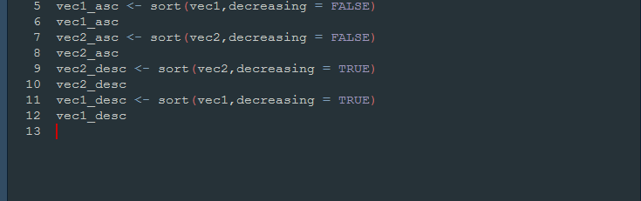

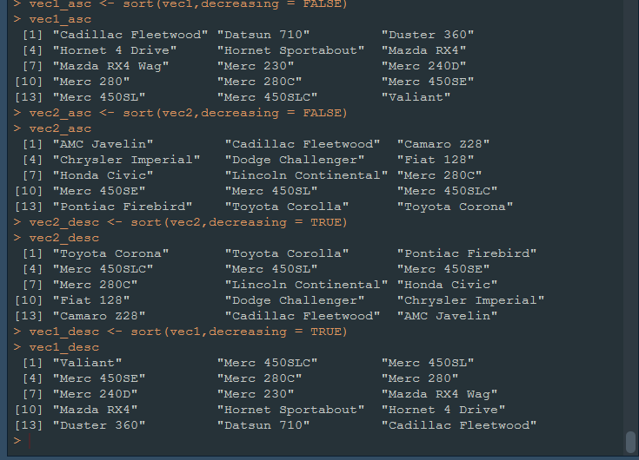

3. What is the major difference between str() and paste() show an example.

Ans.

**Paste()**

**paste converts its arguments (via [as.character](https://www.rdocumentation.org/link/as.character?package=base&version=3.5.0)) to character strings, and concatenates them (separating them by the string given by sep). If the arguments are vectors, they are concatenated term-by-term to give a character vector result. Vector arguments are recycled as needed, with zero-length arguments being recycled to "".**

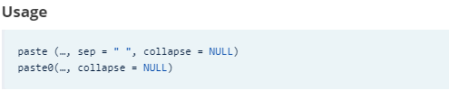

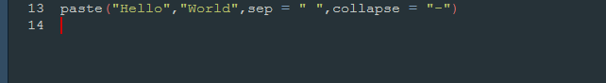



Str()

**Compactly Display The Structure Of An Arbitrary R Object**

**Compactly display the internal structure of an R object, a diagnostic function and an alternative to**[**summary**](https://www.rdocumentation.org/link/summary?package=utils&version=3.5.0)**(and to some extent, [dput](https://www.rdocumentation.org/link/dput?package=utils&version=3.5.0)). Ideally, only one line for each ‘basic’ structure is displayed. It is especially well suited to compactly display the (abbreviated) contents of (possibly nested) lists. The idea is to give reasonable output for any R object. It calls [args](https://www.rdocumentation.org/link/args?package=utils&version=3.5.0) for (non-primitive) function objects.**

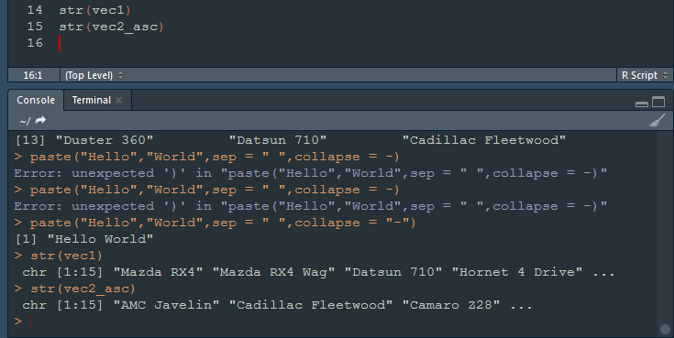

4. Introduce a separator when concatenating the strings.

Ans.

