**Problem 1 :Personal Webpage**

AIM:

## Design a sample personal web page using three separate pages such as

## Home page

## Educational Qualification

## Contact me

## PROGRAM CODE:

## 

|  |  |
| --- | --- |
| Prgrm01.html | <html><head><title> sample webpage </title></head><body><h1 style="color:black;"> <u> <b> <center> PERSONAL BIO </center> </b> </u> </h1><ul style="list-style-type:none;"><center> <img src="image.png" width="300" height="300"> </center> </br><p><b>I am Shefna Shukkur seeking a job in Software Field.I have a Bachelor's Degree in Electronics Field and a Master's Degree in Computer Application.</br>A challenging position in which my applied background in Bachelor of Electronics and Computer Skills can be well utilized.</b></p>&nbsp &nbsp &nbsp &nbsp &nbsp &nbsp &nbsp &nbsp &nbsp &nbsp &nbsp &nbsp &nbsp &nbsp &nbsp &nbsp &nbsp &nbsp &nbsp &nbsp &nbsp &nbsp&nbsp &nbsp &nbsp &nbsp &nbsp &nbsp &nbsp &nbsp &nbsp &nbsp &nbsp &nbsp &nbsp &nbsp &nbsp &nbsp &nbsp &nbsp &nbsp &nbsp &nbsp &nbsp<a href="EDU.html"><I>EDU</I></a> </br>&nbsp &nbsp &nbsp &nbsp &nbsp &nbsp &nbsp &nbsp &nbsp &nbsp &nbsp &nbsp &nbsp &nbsp &nbsp &nbsp &nbsp &nbsp &nbsp &nbsp &nbsp &nbsp&nbsp &nbsp &nbsp &nbsp &nbsp &nbsp &nbsp &nbsp &nbsp &nbsp &nbsp &nbsp &nbsp &nbsp &nbsp &nbsp &nbsp &nbsp &nbsp &nbsp &nbsp &nbsp<a href="CONTACTS.html"><I>CONTACT</I></a></body></html> |
| edu.html | <html><head><title> EDUCATIONAL QUALIFICATION </title><style>table {font-family: arial, sans-serif;border-collapse: collapse;width: 100%;}td, th {border: 1px solid #dddddd;text-align: left;padding: 8px;}tr:nth-child(even) {background-color: #dddddd;}</style></head><body><h2>EDUCATIONAL QUALIFICATION</h2><table> <tr><th>COURSE</th><th>BOARD</th><th>INSTITUTE</th> </tr><tr><td>MCA</td><td>KTU</td><td>TKM College Of Engineering,Kollam</td></tr><tr><td>BSC ELECTRONICS</td><td>Kerala University</td><td>IHRD College Of Applied Science,Adoor p.o Pathanamthitta dist.</td></tr><tr><td>+2</td><td>CBSE</td><td>All Saint's Public School & Junior College,Adoor p.o Pathanamthitta dist.</td></tr><tr><td>10</td><td>CBSE</td><td>All Saint's Public School & Junior College,Adoor p.o Pathanamthitta dist.</td></tr></table></body></html> |
| contact.html | <html><head><title>website</title></head><body><center> <img src="EMAILCALL.png"></br><table> <tr><th>NAME &nbsp &nbsp &nbsp : </th><td>SHEFNA SHUKKUR</td> </tr><tr><th>ADDRESS : </th><td>SHERIN MANZIL</td></tr><tr><td>KANNAMKODE,ADOOR P.O</td> </tr><tr><td>PATHANAMTHITTA DIST</td> </tr><tr><td>PIN:-691523</td></tr><th>MOBILE &nbsp : </th><td>7558971942</td> </tr><tr><th>EMAIL &nbsp &nbsp &nbsp: </th><td> SHEFNASHUKKUR96@GMAIL.COM</td></tr></table></center></body></html> |

## RESULT

## Personal web page using three separate pages are designed.

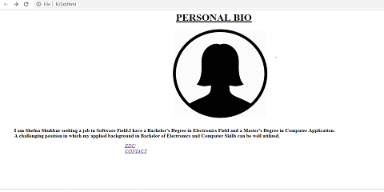r – 1pt solid

## 

## Figure 1: Home Page.

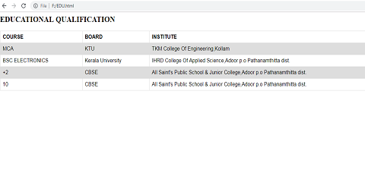

## Figure 2: Educational Qualification.

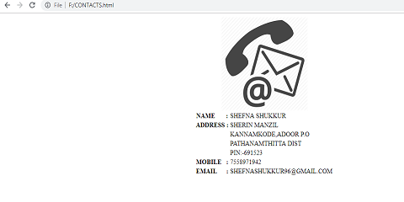

## Figure 3: Contacts.