**Problem 3 :Cascading Stylesheets**

## AIM:

## Create a web page that displays college information using various style sheets.

## Inline

## Internal

## External

## PROGRAM CODE:

## 

|  |  |
| --- | --- |
| Prgrm03.html | <html><body><h1 style="color:blue;">TKM COLLEGE OF ENGINEERING</h1><img src="tkm.jpg" width="300" height="300"><h2 style="color:brown;">History</h2><ol><h3>Thangal Kunju Musaliar College of Engineering (TKMCE), is the first government aided engineering institution in the Indian state of Kerala.<br>The foundation stone for the college was laid by Dr. Rajendra Prasad, the erstwhile President of India on 3 February 1956, making it the second <br>oldest engineering college in Kerala after College of Engineering, Trivandrum. The college is located at Karikode, 6 kilometres (3.7 mi) from the <br>city of Kollam in southern Kerala.</ol></body></html> |
| internalcss.html | <html><head><style>body {background-color: lightgreen;}h1 {color: blue;font-family: verdana;font-size: 250%;}h2 {color: rgb(11, 45, 48);}h5 {color: purple;font-family: calibri;font-size: 150%;border: 1px solid black;}</style></head><body><h1><center><u>Contact Details</u></center></h1><br><img src="tkm.jpg" width="300" height="300"><h2><b><u>Location</b></u></h2><h5>The college is located at Karicode, a suburb town of the coastal city of Kollam on the Kollam- Sengottai NH-208 road, 6 kilometres<br>away from Kollam city centre (Chinnakada), and 2.2 kilometres from Kallumthaazham junction</h5></body></html> |
| extrnal.html | <html><head><link rel="stylesheet" href="external.css"></head><body> <h1><center><u>Admission</center></h1><center><img src="tkm.jpg" width="300" height="300"></center><p> Admission to the college is based on the competitive Entrance Examination KEAM administered by the Government of Kerala, India.<br>One has to secure very high score in the examination tosecure admission here. Some seats are reserved for students from Arunachal<br>Pradesh,Andaman and Lakshadweep, and also in the management quota.<br><b><u>Postgraduatelevel </b> </u> <br>M.Tech Graduate Aptitude Test in Engineering (GATE) conducted by the Indian Institutes of Technology, IITs.<br>MCA Kerala MCA Entrance Examination, conducted by the Office of the Commissioner of Entrance Exams run by the Government of Kerala.<br>MBA Management Aptitude Test (MAT) conducted by the All India Management Association and CMAT conducted by AICTE..</p> </body> </html> |
| extrnal.css | <html>body{background-color:lightgrey;}h1{color: blue;}p{color: brown;}</html> |

## RESULT

## We can create a web page that displays college information using various style sheets are designed.

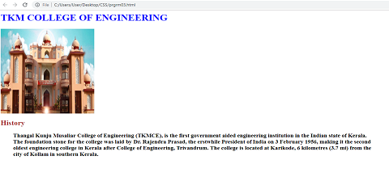

## 

## Figure 1: Home Page

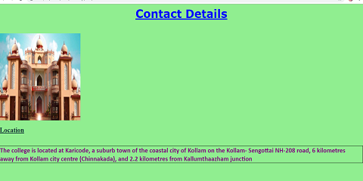

## Figure 2: Contact Details.

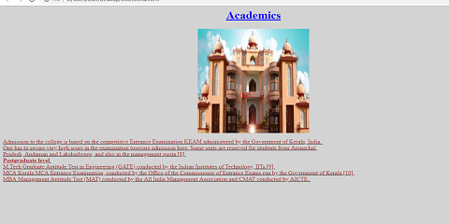

## Figure 3: Academic Details.