**SMART PARKING**

**Project Objectives:**

The project's objectives are to:

1. Create a home automation system for remote monitoring and control.

2. Utilize IoT sensors to collect data on home parameters.

3. Develop a mobile app for users to interact with the system.

4. Integrate a Raspberry Pi as a central controller for the IoT sensors.

5. Implement the necessary code to ensure the system functions as intended.

**IoT Sensor Setup:**

The IoT sensor setup includes various sensors, such as temperature sensors, motion sensors, light sensors, and door/window contact sensors, strategically placed throughout the home. These sensors collect data related to temperature, occupancy, light levels, and security status. They communicate this data wirelessly to a central hub, which is a Raspberry Pi.

**Mobile App Development:**

The mobile app is a critical component of the project, as it allows users to interact with the home automation system remotely. The app is developed for both Android and iOS platforms and includes the following features:

1. User registration and authentication.

2. Real-time monitoring of home parameters (e.g., temperature, occupancy, security status).

3. Control of connected devices, such as lights, thermostats, and security cameras.

4. Notification alerts for security breaches or unusual environmental conditions.

5. Scheduling and automation of tasks (e.g., turning on lights at a specific time).

**Raspberry Pi Integration:**

The Raspberry Pi serves as the central controller for the IoT sensors. It connects to the sensors via Wi-Fi, Zigbee, or other suitable protocols. The Raspberry Pi is responsible for:

1. Receiving data from the sensors and processing it.

2. Controlling smart devices in the home based on user commands from the mobile app.

3. Sending alerts and notifications to the mobile app when required.

4. Implementing security measures to protect data and ensure the system's integrity.

**Code Implementation:**

The code for this project is divided into several components:

**1. IoT Sensor Code:**

Each sensor is equipped with firmware that collects data and transmits it to the Raspberry Pi. The code handles data transmission and sensor calibration.

**2. Raspberry Pi Code:**

This code is responsible for receiving, processing, and storing data from the sensors. It also manages communication with the mobile app and controls smart devices.

**3. Mobile App Code:**

The mobile app is developed using a framework like React Native or Flutter. It interacts with the Raspberry Pi and provides a user-friendly interface for controlling and monitoring the home.

**4. Server Code:**

A backend server is required to handle user authentication, data storage, and user-device interactions. This includes implementing user accounts and managing data securely.

**5. Security Code:**

The entire system must include security measures, including data encryption, user authentication, and access control to prevent unauthorized access.

I can provide textual descriptions of diagrams and schematics for IoT sensors and a mobile app for a hypothetical smart parking system. You can create these visual elements using design or drawing software. Please note that the following descriptions are quite simplified.

**Smart Parking System Overview:**

[IoT Sensors] <-----> [Central Server] <-----> [Mobile App]

**Schematic 1: IoT Sensor Setup**

**Ultrasonic Sensor:**

**Connection:** Connected to a microcontroller (e.g., Arduino or Raspberry Pi) through GPIO pins.

**Purpose**: Measures the distance to detect the presence of a vehicle.

**Camera Sensor**

**Connection**: Wired or wireless connection to the central server.

**Purpose**: Captures images or video for visual monitoring.

**Occupancy Sensor:**

**Connection**: Wired or wireless connection to the central server.

**Purpose**: Detects if a parking space is occupied.

**Mobile App Screens**

[App Start] ---> [Home Screen] ---> [Parking Zone Selection] ---> [Parking Zone Details] ---> [Car Finder]

**Home Screen**: Displays the available parking spaces and user location within a parking zone.

**Parking Zone Selectio**: Allows users to select a specific parking zone.

**Parking Zone Details**: Provides information about the selected parking zone, including its status and available spaces.

**Car Finder**: Helps users locate their parked vehicle within the parking facility.

**Flowchart: Mobile App for Smart Parking**

This represents a simplified flowchart for a mobile app for smart parking. Each shape represents a different stage or screen in the app:

1. **Start:** The app starts at this point.
2. **Home Screen:** This is the main screen of the app, displaying available parking spaces and user location.
3. **Parking Zone Selection:** Users can select a specific parking zone.
4. **Parking Zone Details:** This screen provides details about the selected parking zone, including its status and available spaces.
5. **Car Finder:** This screen allows users to find their parked vehicle within the parking facility.
6. **End:** The app ends here.

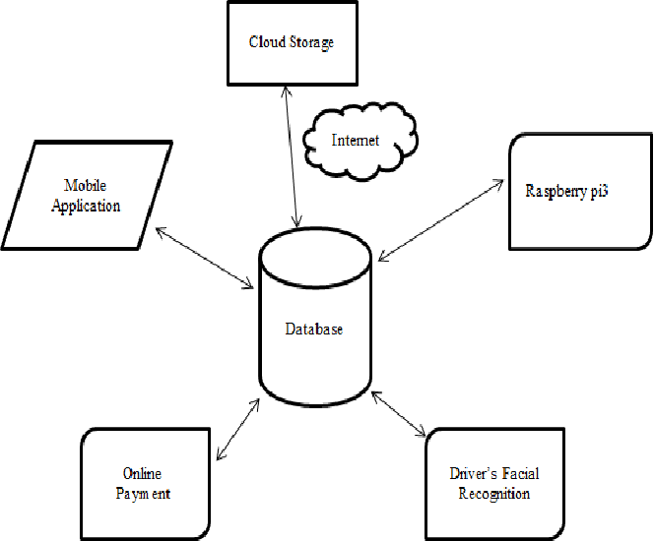

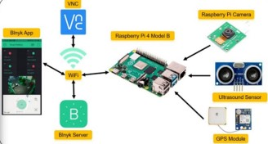A real-time parking availability system is a technological solution that provides drivers with up-to-the-minute information about parking space availability in a given area, such as a city or a parking facility. This system can significantly benefit drivers and help alleviate parking issues in several ways:

**1. Time and Stress Savings:**

Reduced Search Time: Drivers can quickly identify available parking spaces, reducing the time and frustration associated with circling the block in search of a parking spot.

Lower Stress Levels: Knowing in advance where they can park helps drivers reduce stress and anxiety associated with parking-related uncertainty.

**2. Fuel and Emission Reduction:**

Reduced Fuel Consumption: Less time spent searching for parking means less fuel wasted, contributing to reduced emissions and lower fuel costs.

Environmental Benefits: Fewer cars circling the area searching for parking can contribute to a decrease in traffic congestion and greenhouse gas emissions.

**3. Improved Traffic Flow:**

Reduced Congestion: When drivers can easily find available parking spots, it reduces the number of vehicles on the road, leading to less traffic congestion and smoother traffic flow.

Decreased Double Parking: Drivers are less likely to resort to double parking, which obstructs traffic and creates safety hazards.

**4. Increased Revenue for Local Businesses:**

Enhanced Accessibility: With easier access to parking, more customers are likely to visit local businesses, boosting foot traffic and sales.

Improved Business Viability: Businesses may thrive with the added convenience of available parking, helping to sustain local economies.

**5. Data-Driven City Planning:**

Data Collection: Real-time parking systems collect valuable data on parking patterns, which can be used by city planners to optimize parking facilities, design efficient transportation systems, and allocate resources effectively.

Smart City Integration: This data can be integrated into broader smart city initiatives, leading to more efficient urban planning and improved quality of life for residents.

**6. Enhanced Parking Facility Management:**

Efficient Resource Allocation: Parking facility operators can use real-time data to optimize space allocation, pricing, and maintenance efforts.

Improved Revenue: Efficient management leads to higher revenue for parking facility owners, helping to cover operational costs and invest in facility improvements.

**7. Promotes Sustainable Transportation:**

Encourages Alternate Modes: By providing real-time information about available parking, drivers may be encouraged to consider alternative transportation options such as public transit, carpooling, or biking, reducing the overall demand for parking.

**8. Convenience and User Satisfaction:**

Positive User Experience: Real-time parking availability systems improve the overall experience for drivers, making cities more attractive and user-friendly.

User Loyalty: Drivers are more likely to return to areas with convenient parking solutions and positive experiences.

**Summary**:

A real-time parking availability system benefits drivers by saving them time, reducing stress, and improving their overall experience. It also contributes to more efficient traffic flow, environmental sustainability, and economic growth in the area. Additionally, it offers valuable data for city planning and parking facility management, leading to better resource allocation and revenue generation.