Does GenAI Serve Educational Equity? An Evidence Map of Under-served Contexts
Li Zhou*
School of Economics, Wuhan Business University, Wuhan 430056, Hubei, China
*Corresponding author. Email: 20200122@wbu.edu.cn
ORCID: 0000-0002-4024-2552
Abstract: Whether GenAI can advance educational equity remains an open question, and the existing evidence points in no single direction. This paper searched the Web of Science Core Collection, included 68 publications issued between 2024 and 2026, and organised them into four themes according to research context. Of these, 32 studies (47.1%) addressed special education and disability, 21 (30.9%) addressed low-resource languages and non-English settings, 9 (13.2%) addressed rural and socioeconomically disadvantaged settings, and 6 (8.8%) addressed ethnic, Indigenous and culturally disadvantaged settings. Special education accounts for the largest share of the literature, yet practice guidance and design frameworks outnumber tests of effectiveness. Work on low-resource languages reports learning gains alongside stratification in model capability and tool accessibility. In rural and resource-constrained settings, the compensatory potential of GenAI depends on infrastructure, teacher competence and institutional support. Research on ethnic and Indigenous contexts is the scarcest, and its findings are largely mixed or risk-oriented. Overall, GenAI does not improve educational equity automatically; its effects are conditional on access to technology, teacher support and institutional arrangements.
Keywords: GenAI; educational equity; under-served learners; special education; low-resource languages; rural education; scoping review

1 Introduction
Since the public release of ChatGPT, GenAI has moved rapidly into educational settings such as writing feedback, lesson preparation and personalised tutoring, and the associated research literature has grown quickly (Allison et al., 2025; Lachheb et al., 2025). On the one hand, GenAI may widen access to high-quality resources and provide individualised support (Ballantyne et al., 2025). On the other hand, uneven access conditions, digital literacy and institutional support may produce a new "GenAI divide" (Beckman et al., 2025). Bias in model-generated scoring, cognitive offloading and the uncertain effects of school-level policy further suggest that adopting the technology does not necessarily produce equitable outcomes (Warr et al., 2025; Seung & Basham, 2026; Liu et al., 2026).
Although systematic reviews already exist in the field of special education (Voultsiou & Moussiades, 2025), few of them compare across groups. Following PRISMA-ScR, this paper conducts a scoping review that places rural and socioeconomically disadvantaged groups, special education and disability, low-resource languages and non-English settings, and ethnic and Indigenous groups within a single comparative frame. Two questions are addressed. First, how is the existing research distributed across the four types of under-served contexts? Second, what principal effects, risks and shared constraints are reported in each type of context?

2 Methodology & paper selection

2.1 Selection criteria
The search was completed on 26 August 2026 and drew on the Web of Science Core Collection, covering the Science Citation Index Expanded (SCIE) and the Social Sciences Citation Index (SSCI). Searches were run in parallel across three fields: title (TI), author keywords (AK) and Keywords Plus (KP).
The search strategy comprised two core concept groups. The education concept group (#1) used truncated terms including educa*, learn*, teach*, student*, school*, classroom*, pedagog* and curricul*, returning 1,709,274 records. The generative artificial intelligence concept group (#2) used terms including "generative AI", "generative artificial intelligence", GenAI, ChatGPT, "GPT-3*", "GPT-4*", "large language model*", "AI chatbot*", "conversational agent*", "AI writing tool*", Copilot and DeepSeek, returning 40,552 records. The intersection of the two groups (#3 = #1 AND #2) yielded 11,720 records.
Three further concept groups covering disadvantaged contexts were then added. Rural and socioeconomic disadvantage (#4) included rural, remote, underserved, "under-served", "low-income", "low socioeconomic", "socio-economic status", disadvantaged, marginalized, marginalised, "digital divide", equity, inequit*, "developing countr*", "low- and middle-income", LMIC and "Global South", returning 398,907 records. Special education and disability (#5) included "special education*", "special needs", "special educational needs", SEN, disabilit*, autis*, ASD, dyslexi*, "learning difficult*", "hearing impair*", "visual impair*", deaf, blind, neurodiver* and "inclusive education", returning 452,963 records. Low-resource languages and non-English settings (#6) included "low-resource language*", "minority language*", "indigenous language*", "endangered language*", "heritage language*", multilingual*, "non-English", "linguistic divers*" and "culturally responsive", returning 13,164 records.
The final search strategy was #3 AND (#4 OR #5 OR #6), which returned 332 records.

2.2 Inclusion and exclusion criteria
Publications had to satisfy four conditions simultaneously. First, the document type had to be Article or Review. Second, the Web of Science subject category had to be Education & Educational Research or Education Special. Third, the study had to concern the application of GenAI in education. Fourth, the study had to be centrally concerned with a specific under-served group or context. The initial search retrieved 332 records; 239 were excluded by subject category, 1 by document type, and a further 24 irrelevant records were excluded after screening titles, bibliographic details and abstracts, leaving 68 publications for inclusion. The screening process is shown in Fig. 1.
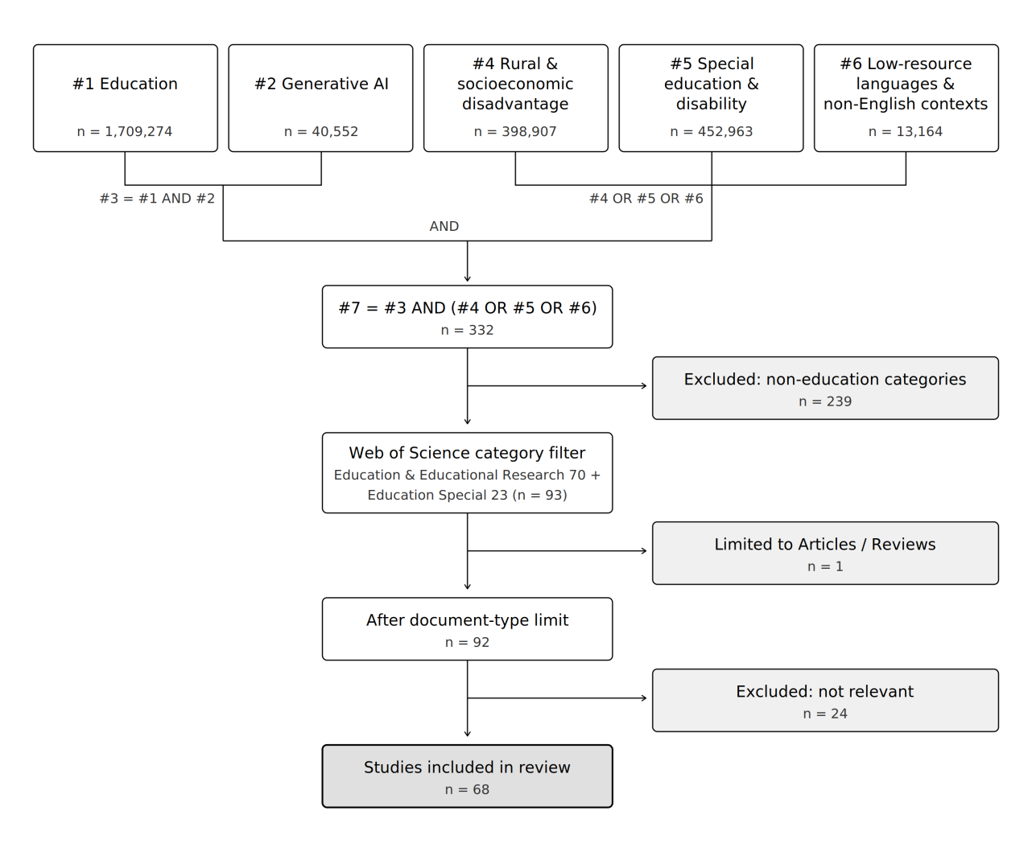
Fig. 1. PRISMA-ScR paper screening flowchart

3 Descriptive analysis

3.1 Annual publications & citations
The annual publication and citation counts for the 68 included publications are shown in Fig. 2.
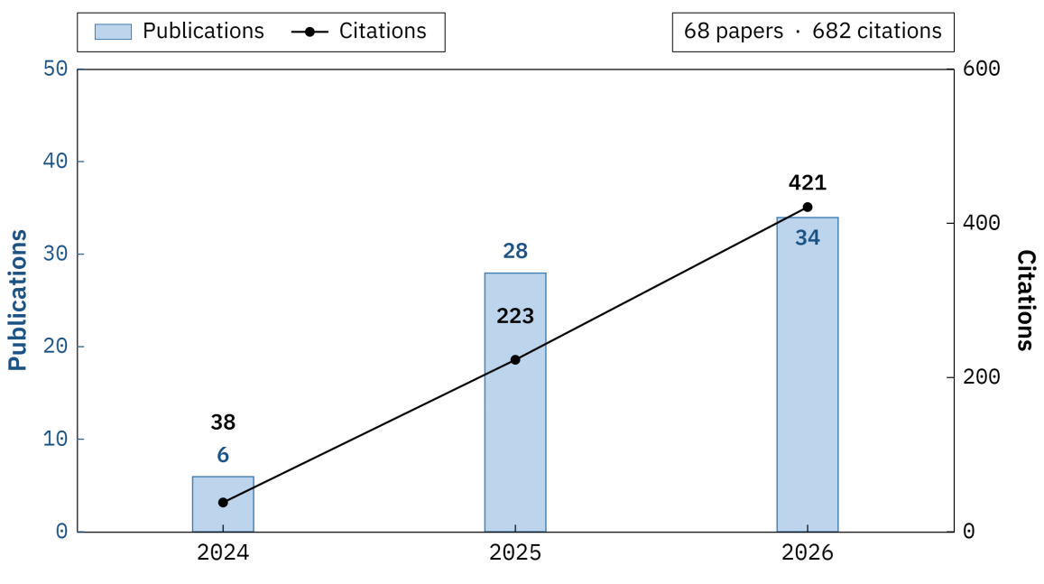
Fig. 2. Analysis of annual publications & citations
Six publications were included for 2024, 28 for 2025, and 34 for 2026 up to 26 August; the corresponding citation counts were 38, 223 and 421, giving a cumulative total of 682. This distribution indicates that scholarly attention is rising quickly, but it should not be used to compare annual impact directly. Some of the publications assigned to 2026 had already appeared online earlier, and more than twenty still lack volume, issue and page numbers, so the year of publication does not correspond exactly to the window over which citations have accumulated.

3.2 Distribution of source journals
The distribution of source journals for the included publications is shown in Table 1.
Table 1 Principal journals publishing the included studies (≥ 3 publications)
No. | Journal | Frequency
1 | Journal of Special Education Technology | 11
2 | Education and Information Technologies | 8
3 | Interactive Learning Environments | 4
4 | Internet and Higher Education | 4
5 | Learning Disability Quarterly | 4
6 | BMC Medical Education | 3

Six journals published three or more of the included studies, accounting together for 34 publications, or 50% of the total. The Journal of Special Education Technology published 11 and Education and Information Technologies published 8; the former together with Learning Disability Quarterly accounts for 15, which reflects the relative concentration of research in special education. The remaining publications are scattered across a wide range of journals, indicating that this topic has not yet established a stable core of outlets.

4 Themes from the papers
This section groups the 68 retrieved publications into four themes: special education and disability; low-resource languages and non-English settings; rural and socioeconomic disadvantage; and ethnic, Indigenous and cultural disadvantage.

4.1 Special education and disability
Thirty-two publications fall under the theme of special education and disability, and they mainly examine how the use of GenAI by teachers and students in special education affects educational equity. Studies at the teacher level are relatively numerous. Research indicates that ChatGPT can improve the quality and efficiency with which novice special education teachers formulate Individualized Education Program (IEP) goals (Rakap, 2024). However, teachers rate the technology more favourably for lesson preparation than for IEP writing, and in the IEP context the path from behavioural intention to actual use is not significant (Lin et al., 2026). Surveys show that everyday usage rates among special education teachers are low (Naatz & Ruppar, 2026), and that mainstream teachers who do use GenAI for lesson preparation rarely apply it to problems of inclusive education (Besozzi & Menon, 2026). Student-level research focuses mainly on academic writing, classroom participation and perceptions of use among university students with disabilities. A survey of 124 university students with disabilities found that chatbots and paraphrasing tools were already in widespread use (Zhao et al., 2025). At the same time, publications on instructional resources and tool design are numerous, but many of them remain at the level of practice guidance or design frameworks and have not yet tested their effects on equity. A small number of intervention studies provide more direct evidence of effectiveness. A randomised experiment by Wang and Kuo (2026) with 83 Chinese primary school students with dyslexia found that the AI chatbot group outperformed the conventional instruction group in solving arithmetic word problems, with intrinsic motivation acting as a moderator (Wang & Kuo, 2026). Nevertheless, existing reviews, policy analyses and conceptual studies repeatedly flag risks relating to bias, information accuracy, cognitive offloading and the absence of policy (Voultsiou & Moussiades, 2025; Shin et al., 2026; Seung & Basham, 2026). On the whole, the supply of tools and designs in special education exceeds the volume of research that has tested their effects.

4.2 Low-resource languages and non-English settings
Twenty-one publications fall under the theme of low-resource languages and non-English settings, and they mainly address the linguistic capability of models, learning applications and teacher readiness. Differences in model capability are the most fundamental issue. Mainstream models perform unevenly on curriculum classification and skill tagging tasks across multiple national languages (Kwak & Pardos, 2024). A pilot study involving 46 teachers shows that teachers of low-resource languages need an operational procedure for evaluating models (Swinehart et al., 2025). Wang (2025) explores how AI tools can be effectively integrated into foreign language teaching, using AI fine-tuning to improve translation quality for low-resource languages; in a Chinese–Hindi task, iterative fine-tuning of ChatGPT improved translation outcomes (Wang & Wang, 2025). Findings on language learning are broadly positive. Related research suggests that GenAI may narrow gaps by expanding access, providing personalised scaffolding and supporting multilingualism, but may equally widen them because of unequal infrastructure (Cong-Lem et al., 2025). In disciplinary-language and multilingual classrooms, studies report gains in comprehension, emotion and engagement, while also pointing to problems of assessment validity and systematic bias (Tang, 2024; Derakhshan & Wei, 2026; Ndacyayisenga et al., 2026). Teachers are the key intermediary determining whether these gains are realised. A cross-national survey reveals marked differences among second language (L2) teachers in tool access, knowledge, integration and the nature of their use (Davin et al., 2026). Taken together, GenAI can support multilingual learning, but model capability, tool accessibility and teacher readiness remain stratified along the lines of language resource conditions. This theme therefore presents learning gains and stratification risks simultaneously, indicating that language resource conditions shape how the benefits of GenAI are distributed.

4.3 Rural and socioeconomic disadvantage
Nine publications fall under the theme of rural and socioeconomic disadvantage, focusing on urban–rural resource differences, developmental conditions and socioeconomic status. Research on rural settings reveals compensatory potential and implementation barriers at the same time. A quasi-experiment with 120 rural sixth-grade students showed that, within a progressive interdisciplinary Science, Technology, Engineering and Mathematics (STEM) teaching approach embedded in the Four-Component Instructional Design (4C/ID) model, incorporating Large Language Models (LLMs) provided equitable and inquiry-oriented STEM learning support for rural learners in resource-poor conditions (Ding et al., 2026). However, an analysis of 514 K-12 English teachers in under-resourced regions identified distinct GenAI literacy profiles, with differences attributable to capabilities and conditions rather than to teacher demographics (Wu et al., 2026). Institutional conditions matter equally. University students displayed divergent understandings and intentions to use GenAI during a period of policy vacuum (Beckman et al., 2025); an analysis of ICILS 2023 data examined the relationship between school-based ChatGPT policies and gaps associated with gender, socioeconomic status and immigration background (Liu et al., 2026); and an analysis of US school district policies showed that ethical and pedagogical guidance remains weak in most districts (Mandel, 2026). In sum, research indicates that GenAI holds compensatory potential in resource-constrained settings, but realising it depends on infrastructure, teacher competence and institutional guidance.

4.4 Ethnic, Indigenous and cultural disadvantage
Six publications fall under the theme of ethnic, Indigenous and cultural disadvantage, addressing Indigenous knowledge, culturally responsive teaching and differences in use across ethnic groups. Research on Indigenous education notes that models may strip knowledge of its context, obscure its provenance and generate plausible-looking reconstructions, thereby undermining culturally responsive teaching (Alterator et al., 2025). A comparison of AI-generated and human-written vocabulary curriculum materials likewise shows that adapting tools must take account of the linguistic, cultural and historical situation of Indigenous learners (Li et al., 2025). Research on ethnicity shows that model-generated scoring may express bias in covert ways (Warr et al., 2025), and that ethnic minority students differ in their awareness of ChatGPT, their academic use of it and the instructional support they receive (Arum et al., 2025). Teacher interviews and studies of cross-linguistic knowledge collaboration further indicate that group identity is not the only explanatory factor, and that the teaching environment and relations of knowledge matter as well (Soffer-Vital et al., 2026; Tsao et al., 2025). Among the six publications included here, none reports gap reduction as its principal finding. Because this theme lacks a complete set of direct search terms, however, that result can serve only as a descriptive signal.
Two principal features of the field emerge from these four themes. First, the literature is distributed unevenly. Special education and disability accounts for 32 publications (47.1%), low-resource languages and non-English settings for 21 (30.9%), rural and socioeconomic disadvantage for 9 (13.2%), and ethnic, Indigenous and cultural disadvantage for 6 (8.8%). This pattern reflects both the established research base in special education and assistive technology and the coverage of the database, subject categories and search terms; it therefore cannot be equated directly with the actual needs of these groups or with research investment across the field as a whole. Second, all four contexts indicate that the equity effects of GenAI are conditional. In special education, the supply of tools exceeds the testing of effects; in low-resource language settings, learning gains coexist with stratification risks; in rural and resource-constrained settings, outcomes depend on infrastructure, teacher competence and institutional guidance; and research on ethnic and Indigenous contexts more often reports cultural distortion, bias and differences in use. Technology therefore does not generate equitable outcomes on its own; what matters is whether access conditions, teacher support and institutional arrangements reach under-served groups. Compared with existing reviews focused on a single domain, the contribution of this paper is to compare four types of under-served contexts within a single framework and to show how the benefits and risks of GenAI are distributed differently across them.

5 Conclusion and limitations

5.1 Conclusion
This paper conducted a scoping review of 68 publications on GenAI and educational equity. The results show that research is distributed unevenly across the four types of under-served contexts and that the equity effects of GenAI are highly context-dependent. The available evidence does not allow improvements in equity to be inferred directly from the supply of tools; infrastructure, teacher support and institutional arrangements are the conditions that recur throughout.
Three lines of work merit priority in future research: testing access conditions such as the availability of devices, networks and accounts; attending to contexts of compounded disadvantage, such as rural students with disabilities and low-income families speaking minority languages; and treating changes in between-group gaps, rather than performance gains within a single group, as the equity outcome of interest.

5.2 Limitations
This study searched only the SCIE and SSCI within the Web of Science Core Collection, and did not cover ESCI, A&HCI, Scopus, ERIC or conference proceedings; screening by subject category also excluded 239 records. Interdisciplinary areas such as linguistics, cultural studies, computer applications and rehabilitation may therefore be under-covered. The theme of ethnic, Indigenous and cultural disadvantage emerged inductively, and the original search strategy lacked a complete set of directly corresponding terms; its publications were captured mainly by terms such as "indigenous language*" and "culturally responsive", which may have produced systematic omissions. Theme assignment and the summarising of results relied mainly on titles, bibliographic records and abstracts, were carried out by a single reviewer, and involved no full-text verification or inter-coder reliability check. The number of included publications reflects the distribution of sources rather than a total of independent samples. Because the publications on ethnic and Indigenous contexts and on rural and socioeconomic disadvantage are few, the corresponding proportions should be read descriptively only.

References
Allison, Hwang, Mayer, Pellas, Karnalim, de Freitas, et al., 2025. From generative AI to extended reality: Multidisciplinary perspectives on the challenges, opportunities, and future of educational computing. Journal of Educational Computing Research, 63(6), 1327-1363.
Alterator, Maddox, Southerton, and Schutt, 2025. Re-authorising colonialism or re-authorising indigenous perspectives: The risks of generative AI in indigenous education contexts. British Journal of Sociology of Education.
Arum, Leon, Li, and Lopes, 2025. ChatGPT early adoption in higher education: Variation in student usage, instructional support, and educational equity. AERA Open, 11.
Ballantyne, Lin, Chang, and Poitras, 2025. Bridging educational equity gaps: Expanding the chat-acts framework for personalized GenAI chatbots in higher education. Journal of Computing in Higher Education, 37(4), 1564-1589.
Beckman, Apps, Howard, Rogerson, Rogerson, and Tondeur, 2025. The GenAI divide among university students: A call for action. Internet and Higher Education, 67.
Besozzi, and Menon, 2026. AI in one hand, inclusive education in the other: Why mainstream teachers who use AI do not use it for inclusive education. International Journal of Inclusive Education.
Cong-Lem, Bui, Nguyen, and Huynh, 2025. Bridging or breaking? A systematic review of how generative AI shapes equity in foreign language education. International Journal of Applied Linguistics.
Davin, Kissau, Haudeck, Ade-Thurow, Gomez-Pereira, Oon, et al., 2026. Global and educational disparities in AI integration: A study of L2 teacher training and usage patterns. System, 136.
Derakhshan, and Wei, 2026. Leveraging translanguaging in GenAI-enhanced language classes: Capturing its impact on multilingual English learners' achievement emotions and academic engagement through latent growth curve modelling (LGCM). International Journal of Multilingualism.
Ding, Liu, and Slotta, 2026. Integrating AI-enhanced 4C/ID scaffolding into rural STEM education: Supporting complex problem solving and learning outcomes. Interactive Learning Environments.
Kwak, and Pardos, 2024. Bridging large language model disparities: Skill tagging of multilingual educational content. British Journal of Educational Technology, 55(5), 2039-2057.
Lachheb, Leung, Abramenka-Lachheb, and Sankaranarayanan, 2025. AI in higher education: A bibliometric analysis, synthesis, and a critique of research. Internet and Higher Education, 67.
Li, Cunningham, Geva, Snow, Biemiller, and Roihan, 2025. A corpus-based approach to developing vocabulary curriculum materials for indigenous youth: AI-generated versus human-created content. Computer Assisted Language Learning.
Lin, Cui, and Zhu, 2026. Chinese special education teachers' experiences with generative AI: Differences in perceptions, use, and TAM pathways for IEP writing and lesson planning. Journal of Special Education Technology.
Liu, Cheung, and Yang, 2026. Do school-based ChatGPT policies bridge or widen gaps in students' computer and information literacy across gender, socioeconomic status, and immigration backgrounds. Computers & Education, 244.
Mandel, 2026. Artificial intelligence governance in K-12 school districts: Mapping variation in generative AI policy across three southeastern US states. Educational Policy.
Naatz, and Ruppar, 2026. Special education teachers' use of generative artificial intelligence (AI): An exploratory survey of frequency and factors influencing adoption. Journal of Special Education Technology, 41(2), 227-239.
Ndacyayisenga, Kidega, and Can, 2026. The impact of generative artificial intelligence tools on assessment equity for non-native English-speaking medical students: A systematic review. BMC Medical Education, 26(1).
Rakap, 2024. Chatting with GPT: Enhancing individualized education program goal development for novice special education teachers. Journal of Special Education Technology, 39(3), 339-348.
Seung, and Basham, 2026. Cognitive offloading in the age of generative AI: What does it mean for students with learning disabilities? Learning Disability Quarterly, 49(3), 121-133.
Shin, Deniz, Watson, Dieterich, Ewoldt, Johnson, et al., 2026. Addressing the void of AI policies in education for students with specific learning disabilities. Learning Disability Quarterly, 49(3), 134-146.
Soffer-Vital, Awad, Hallak, Horenstein, Ronen, and Atzmon, 2026. Culturally diverse teachers navigating AI integration: Identity, pedagogy, and ethics in multicultural contexts. Teaching and Teacher Education, 182.
Swinehart, Nguyen, and Yeh, 2025. A protocol for evaluating AI chatbots' capabilities for low-resource language teachers. Language Learning & Technology, 29(1).
Tang, 2024. Informing research on generative artificial intelligence from a language and literacy perspective: A meta-synthesis of studies in science education. Science Education, 108(5), 1329-1355.
Tsao, Heinrichs, and Camit, 2025. Artificial intelligence and epistemic interoperability: Towards a sympoietic approach. Discourse-Studies in the Cultural Politics of Education.
Voultsiou, and Moussiades, 2025. A systematic review of AI, VR, and LLM applications in special education: Opportunities, challenges, and future directions. Education and Information Technologies, 30(13), 19141-19181.
Wang, and Kuo, 2026. AI chatbots and dyslexia: How AI chatbots empower students with dyslexia to master arithmetic word problems. Journal of Learning Disabilities.
Wang, and Wang, 2025. Enhancing translation accuracy and learning outcomes for low-resource languages: AI fine-tuning and learner adoption factors. System, 134.
Warr, Oster, and Isaac, 2025. Implicit bias in large language models: Experimental proof and implications for education. Journal of Research on Technology in Education, 57(6), 1324-1349.
Wu, Lalli, and Zeng, 2026. Beyond the digital divide: Exploring literacy, perspectives, and barriers to GenAI among K12 EFL teachers in China's under-resourced regions. International Journal of Applied Linguistics.
Zhao, Cox, and Chen, 2025. The use of generative AI by students with disabilities in higher education. Internet and Higher Education, 66.

