A Sample Manuscript for WordTeX
Alice Author* (Corresponding author)
School of Economics, Example University, Wuhan, China, alice@example.edu.cn
Bob Writer
Department of Computing, Sample Institute of Technology, Atlanta, USA, bob@example.edu
Abstract: This short document exercises the WordTeX pipeline: built-in heading styles, an equation, a table with merged cells, a figure with a caption, numeric citations and a reference list.
Keywords: Word to LaTeX; typesetting; regression test

1 Introduction
Converting Word manuscripts to LaTeX is tedious [1]. This document is a fixture for the regression tests [2, 3]. The model is given in Equation (1).
$y_{i}=α+β_{1}x_{i}+\frac{1}{n}\sum_{k=1}^{n}{ε_{k}}$ (1)

2 Data

2.1 Variables
Table 1 lists the variables.
Table 1: Variables used in the model
Group | Variable | Unit
Controls | income | yuan
 | cpi | index
Figure 1 shows the placeholder image.
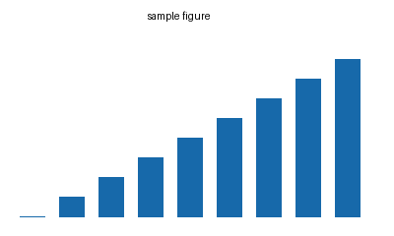
Figure 1: A placeholder figure

3 Conclusion
Everything above should survive the round trip.

References
[1] Smith, J. (2020). Word to LaTeX conversion. Journal of Examples, 1(1), 1-10.
[2] Lee, K. (2021). Regression tests for document tools. Proceedings of Nowhere, 11-20.
[3] Zhou, L. (2022). Typesetting for small journals. Example Press.

