 

6MMCS005C - Digital Marketing, Social Media and Web Analytics

BSc (Hons) in Business Information Systems

School of Computing & Engineering

University of Westminster

Student Name: Harithroo Wijayawardhana

Student ID: 2018531

UOW ID: w1742291

Lecturer Name: Mr. Prassanna Pathmanathan

25th of April 2022

**Website Link:** <https://janushikandanarachchi-businessanalyst.weebly.com/>

Table of Contents

List of figures

# Part A

## Web marketing; apply web marketing model to a given scenario

### Ash’s Funnel process

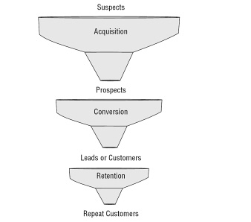

Figure - Ash’s Funnel process

Acquisition

This phase of the model makes a suspect a prospect. Suspect is a person that falls into the business’s target customer segment but might not yet aware of the business. Prospect is a person who is aware about the brand or website and has engaged with the site on a basic level, indicating that there is some interest. This is done through driving traffic to your website and **raise awareness** with your digital marketing campaigns.

Conversion

**Persuade** prospects to do something specific. Conversion phase converts a prospect into a Lead or a customer. Lead is someone who has the interest to purchase. Lead could eventually turn into a customer.

Retention

This last phase turns customers to retained customers. For the business to succeed it needs to **sustain** and **deepen** the customer relationship.

### How Funnel process applies to my journey of buying a laptop

Steps I went through during my journey to identify and decide to buy the laptop I want was,

First, I started my online search using Google search engine, since I want a laptop. First, I searched all kinds of laptops to get an overview of the price compared to the specifications of the laptop. The search query was “laptops”. After that I searched for the specific laptop with the required specification. The search query was “laptop 4gb ram 1tb hard drive in sri lanka”. At this stage my role would be a prospect and would be in the Acquisition phase of the Ash’s funnel modal.

When visiting the websites from the search results I first visited the websites/businesses that I have heard of because of the trust I already have. After that I browsed the laptops, then I used the in-site filter features to filter the results according to the requirements. Since I needed to get results from Sri Lanka, I converted the price range £450 - £550 to LKR which was at the time equals to Rs169525.69 - Rs207198.06 which I took as Rs160000 – Rs200000 to ease the search. Then I compared the resulting laptops by its look, processor, graphics card and the price. After deciding and choosing the laptop I wanted to buy, I added it to cart, went to checkout and purchased. This stage can be considered the conversion stage, from lead to a customer when I purchased the laptop.

Retention stage comes after the purchase, this stage depends on whether the customer remains with the business. Turns customer into retained customer. There are several benefits of retaining the customer. For the purpose of this course work I assumed the business offered me the best laptop for the lowest price which will make me recommend that particular business for my friend if they are looking to buy any which will help the business gain more customers. And also, if they sign me up to their newsletter and send me news about offers and discounts, I might be persuaded to buy from the same vendors that will also contribute to retaining the customer. Another main way to retain customer is to provide after sales services.

### Conclusions

In conclusion Ash’s funnel modal covers all the stages of a person becoming a customer and a retained customer, with the modal’s three stages. As for my personal view, first two stages can be assumed easily and described but retention stage depends on people on both sides.

# Part B

## Search Engine Optimization techniques (SEO)