**Informatics Institute of Technology**

**Enterprise Application Development**

**6COSC001W**

**Coursework Part A**

Date of Submission : 09/11/2021

Student ID : 2018383

Student UoW ID : w1742306

Student First Name : Shenal

Student Surname : Anthony

**Table of** **Contents**

**1 - Part A : Requirements** 4

1.1 Software/System Requirements 4

1.2 Non-Functional Requirements 5

1.3 Wireframes 6

**2 - Part B : Use Case Diagrams** 7

2.1 Use Case Diagram 7

2.1 Use Case Description 8

**3 - Part C : Classes** 28

3.1 CRC 28

3.2 Domain Model 33

**4 Part D : Collaboration** 34

4.1 Login 34

4.2 Create User 34

4.3 Create Ticket 35

4.4 Create Company 35

4.5 Create Project 36

4.6 Delete User 36

4.7 Delete Ticket 37

4.8 Delete Company 37

4.9 Delete Project 38

4.10 Update User 38

4.11 Update Ticket 39

4.12 Update Project 39

4.13 Manage User 40

4.14 Manage Tickets 40

4.15 Manage Company 41

4.16 Manage Projects 41

4.17 Assign User to Project 42

4.18 Assign Project to Company 42

4.19 Assign Ticket to User 43

4.20 Generate Productivity Report 43

4.21 Generate Development Progress Report 44

4.22 Manage Prediction 44

4.23 Number of projects each company will have 45

4.24 Number of users need to build projects 45

4.25 Display Tickets 46

**5** **Part E - Activity** 47

**6 Part F – Self Assessment Form and Report** 48

## **1 - Part A : Requirements**

### Software/System Requirements

**R1 :** The Software shall allow the user to create new users, companies, projects and tickets in the system

**R1.1 :** The software shall allow the user to create, delete, update and show all projects and tickets

**R1.2 :** The software shall allow the user to create, delete and show all users and companies

**R2 :** The software shall allow the user to assign new projects to a company

**R2.**1 **:** The software shall allow the user to remove the project from the company

**R3 :** The software shall allow the user to assign users to each projects

**R3.1:** The software shall allow the user to remove assigned users from the project

**R4 :** The software shall allow the user to assign a user to a ticket

**R4.1:** The software shall allow the user to update the ticket details

**R5 :** The software shall allow the user to change the state of the ticket

**R6 :** The software shall allow the user to display a board where all the tickets will be showed

**R7 :** The software shall allow the user to generate reports

**R7**.1: Generate the productivity of users report

**R7.2:** Generate the development progress report

**R8 :** The software should be able to do the following predictions

**R8.**1 **:** Number of projects each company have at a time

**R8.**2 **:** Number of people needed to complete each project(based on historic data)

**R9 :** The software should be able to let user login to the system

### 1.2 Non-Functional Requirements

**NF1:** The software must run on windows

**NF2:** The software must be implemented using C# language.

**NF3:** The software must be implemented using .NET framework.

**NF4:** The software must have a interface to let the user to interact.

**NF5:** The software must not have any bugs when the user is using it.

**NF6:** The software must have proper designs and documentation.

### 1.3 Wireframes

**UserLogin Create User**

**Create Company Create Ticket**

**Create Project**

## **2 - Part B : Use Case Diagrams**

### 2.1 Use Case Diagram

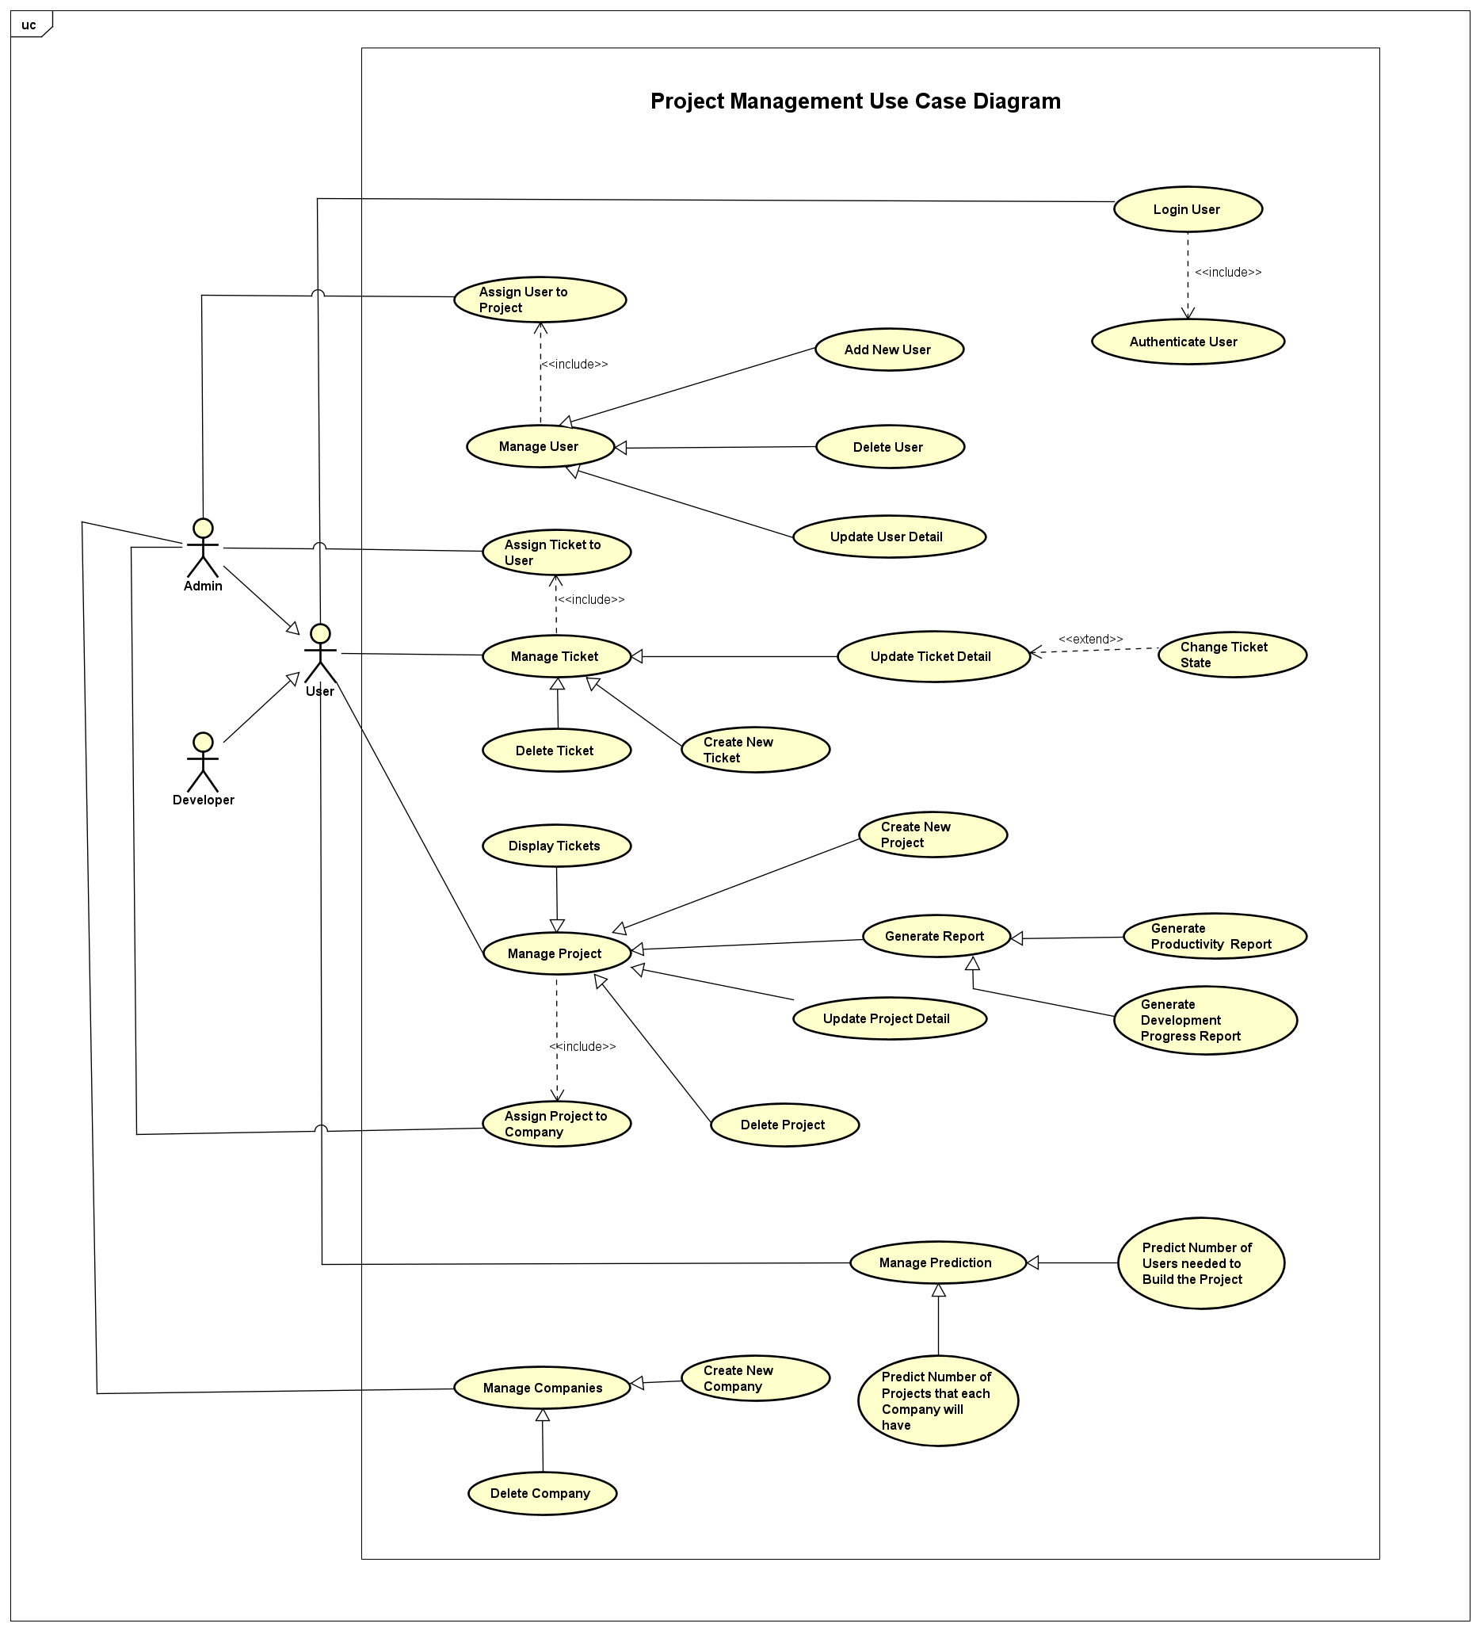

### 2.1 Use Case Description

|  |  |
| --- | --- |
| Id | UC-01 |
| Title | Login User |
| Description | User wants to login to the system to use it |
| Primary Actor | User |
| Supporting Actors | Admin, Developer |
| Stakeholders and Interests |  |
| Pre-Condition | User/Admin must be logged out of the system |
| Post-Condition | User/Admin has access to the functions inside the system |
| Trigger | User/Admin wants to login to the system using their account |
| Main Success  Scenario | 1. Opens the software 2. The login form would be displayed 3. User enters the username and the password 4. Clicks the login button 5. Checks the credentials user has entered 6. The main window will be opened |
| Variations |  |

|  |  |
| --- | --- |
| Id | UC-02 |
| Title | Authenticate User |
| Description | The credentials of the login form would be verified |
| Primary Actor | User |
| Supporting Actors | Admin, Developer |
| Stakeholders and Interests |  |
| Pre-Condition | User/Admin must have filled the login form and submitted the form. |
| Post-Condition | User/Admin will be logged into the system |
| Trigger | When the user/ admin submits the login form |
| Main Success  Scenario | 1. The login form gets submitted 2. The system will check if the user has filled all the fields 3. Then filled in data will be checked with the database 4. The password corresponding to the user name is correct 5. The confirmation that the credentials are correct. |
| Variations |  |

|  |  |
| --- | --- |
| Id | UC-03 |
| Title | Manage User |
| Description | Managing the users in the system and displaying all of them. |
| Primary Actor | Admin |
| Supporting Actors |  |
| Stakeholders and Interests |  |
| Pre-Condition | Admin must log in to the system |
| Post-Condition | Admin will be able to access all the users in the system |
| Trigger | Admin selects manage users from the menu |
| Main Success  Scenario | 1. Admin selects the manage users from the menu 2. The window with all the users will be displayed 3. The admin can add new users, update user details and delete user from the system |
| Variations |  |

|  |  |
| --- | --- |
| Id | UC-04 |
| Title | Add New User |
| Description | Under the manage users adding a new user to the system |
| Primary Actor | Admin |
| Supporting Actors |  |
| Stakeholders and Interests |  |
| Pre-Condition | Admin must log in to the system and selected the Manage Users from the menu. |
| Post-Condition | New user would be added to the system. |
| Trigger | Admin fills the add user form and submit it. |
| Main Success  Scenario | 1. Admin selects add new user from the menu 2. The form for adding a new user would be displayed 3. Admin would fill the form 4. Selects the submit button 5. Would check the data of the submitted form from the system. 6. A new user would be added to the system |
| Variations |  |

|  |  |
| --- | --- |
| Id | UC-05 |
| Title | Update User Detail |
| Description | Admin wants to update a user’s details |
| Primary Actor | Admin |
| Supporting Actors |  |
| Stakeholders and Interests |  |
| Pre-Condition | Admin must log in to the system |
| Post-Condition | The selected users details would be changed as per the Admins entries |
| Trigger | Admin changes the details wanted and select change button |
| Main Success  Scenario | 1. Admin selects the user from the list of user in the manage users window 2. A new window will be opened containing the user details would be opened 3. Admin changes the details that need to be changed 4. Submits the details to the system 5. The changed details would be saved in the system |
| Variations |  |

|  |  |
| --- | --- |
| Id | UC-06 |
| Title | Delete User |
| Description | Admin wants to delete a user from the system |
| Primary Actor | Admin |
| Supporting Actors |  |
| Stakeholders and Interests |  |
| Pre-Condition | Admin must log in to the system and must have selected the manage user details from the main menu |
| Post-Condition | The selected user’s details would be deleted from the system |
| Trigger | Admin clicks the delete button |
| Main Success  Scenario | 1. Admin selects the user that need to be deleted from the user’s list in user manage window 2. Clicks the delete button 3. A confirmation window will po up asking ‘Are you sure you want delete this user?’ 4. Admin selects yes from the pop up 5. The user gets deleted from the system |
| Variations |  |

|  |  |
| --- | --- |
| Id | UC-07 |
| Title | Assign user to project |
| Description | The admin/user assign a user to a project |
| Primary Actor | Admin |
| Supporting Actors | User |
| Stakeholders and Interests |  |
| Pre-Condition | Admin/user must log in to the system |
| Post-Condition | The user would be assigned to that certain project |
| Trigger | Selects the assign button from the manage user window |
| Main Success  Scenario | 1. Admin/user selects a user from the system 2. Selects the project from the system 3. Clicks assign button 4. The user would have been assigning with a project |
| Variations |  |

|  |  |
| --- | --- |
| Id | UC-08 |
| Title | Manage Project |
| Description | Managing the projects in the system and displaying all of them. |
| Primary Actor | User |
| Supporting Actors | Admin, Developer |
| Stakeholders and Interests |  |
| Pre-Condition | Admin must log in to the system |
| Post-Condition | Admin will be able to access all the users in the system |
| Trigger | Admin selects manage projects from the menu |
| Main Success  Scenario | 1. Admin selects the manage projects from the menu 2. The window with all the projects will be displayed 3. The admin can create new projects, update project details and delete projects from the system |
| Variations |  |

|  |  |
| --- | --- |
| Id | UC-09 |
| Title | Create New Projects |
| Description | Admin wants to create a new project inside the system. |
| Primary Actor | User |
| Supporting Actors | Admin, Developer |
| Stakeholders and Interests | Client |
| Pre-Condition | Admin must log in to the system |
| Post-Condition | A new project will be added to the system |
| Trigger | Admin select the add new project from the manage projects window. |
| Main Success  Scenario | 1. Admin selects add new project from the menu 2. The form for adding a new project would be displayed 3. Admin would fill the project details in the form 4. Selects the Add Project button 5. Would check the data of the submitted form from the system. 6. A new project would be added to the system |
| Variations |  |

|  |  |
| --- | --- |
| Id | UC-10 |
| Title | Update Project Detail |
| Description | Admin wants to update the project details of a certain project |
| Primary Actor | User |
| Supporting Actors | Admin, Developer |
| Stakeholders and Interests |  |
| Pre-Condition | Admin must log in to the system and selected the manage projects from the main menu |
| Post-Condition | The selected project details would be changed as per the admins entries |
| Trigger | Admin select the update button of the project the admin wants to change. |
| Main Success  Scenario | 1. Admin selects the project from the list of user in the manage projects window 2. A new window will be opened containing the project details would be opened 3. Admin changes the details that need to be changed 4. Submits the details to the system 5. The changed details would be saved in the system |
| Variations |  |

|  |  |
| --- | --- |
| Id | UC-11 |
| Title | Delete Project |
| Description | Admin wants to delete a project from the system |
| Primary Actor | User |
| Supporting Actors | Admin, Developer |
| Stakeholders and Interests |  |
| Pre-Condition | Admin must log in to the system and must have selected the manage projects from the main menu |
| Post-Condition | The selected project would be deleted from the system |
| Trigger | Admin clicks the delete button of the project |
| Main Success  Scenario | 1. Admin selects the project that need to be deleted from the projects list in projects manage window 2. Clicks the delete button 3. System will prompt a confirmation window asking ‘Are you sure you want delete this project?’ 4. Admin selects yes from the pop up 5. The project gets deleted from the system |
| Variations |  |

|  |  |
| --- | --- |
| Id | UC-12 |
| Title | Assign projects to company |
| Description | The admin/user assign a project to a company |
| Primary Actor | Admin |
| Supporting Actors |  |
| Stakeholders and Interests | Client |
| Pre-Condition | Admin/user must log in to the system and selected the option manage projects from the main menu |
| Post-Condition | The project would be assigned to the company selected |
| Trigger | Selects the assign button associates with the project from the manage projects window |
| Main Success  Scenario | 1. Admin/User selects a project from the system 2. Selects the company from the system 3. Clicks assign button 4. The project would be assigned to a company |
| Variations |  |

|  |  |
| --- | --- |
| Id | UC-13 |
| Title | Generate Report |
| Description | Admin wants to know of the progress to get an update |
| Primary Actor | Admin |
| Supporting Actors |  |
| Stakeholders and Interests | Client |
| Pre-Condition | Admin must log in to the system and selected the option produce report from the main menu |
| Post-Condition | Admin will be able to generate reports for the projects |
| Trigger | When the admin selects the Produce reports from the main menu |
| Main Success  Scenario | 1. Admin selects the produce report from the main menu 2. The system opens a window with the 2 options of report generations. |
| Variations |  |

|  |  |
| --- | --- |
| Id | UC-14 |
| Title | Development Progress Report |
| Description | Admin wants to generate development progress report of a project |
| Primary Actor | Admin |
| Supporting Actors |  |
| Stakeholders and Interests |  |
| Pre-Condition | Admin has to be logged into the system and selected the produce report from the manage projects. |
| Post-Condition | The system will provide development progress report of a certain project. |
| Trigger | Admin selects the Generate development progress report button of a certain project |
| Main Success  Scenario | 1. Admin selects a certain project from the manage projects window 2. The system opens up a window with the project details of it 3. Admin selects the generate development progress report button 4. System generate the development progress report. |
| Variations |  |

|  |  |
| --- | --- |
| Id | UC-15 |
| Title | Productivity Report |
| Description | Admin wants to generate the productivity report of a project |
| Primary Actor | Admin |
| Supporting Actors |  |
| Stakeholders and Interests |  |
| Pre-Condition | Admin has to be logged into the system and selected the produce report from the manage projects. |
| Post-Condition | The system will provide development progress report of a certain project. |
| Trigger | Admin selects the Generate productivity report button of a certain project |
| Main Success  Scenario | 1. Admin selects a certain project from the manage projects window 2. The system opens up a window with the project details of it 3. Admin selects the productivity progress report button 4. System generate the productivity report of that project. |
| Variations |  |

|  |  |
| --- | --- |
| Id | UC-16 |
| Title | Manage Ticket |
| Description | Managing the tickets of projects in the system and displaying all of them. |
| Primary Actor | Admin |
| Supporting Actors |  |
| Stakeholders and Interests |  |
| Pre-Condition | Admin must log in to the system. |
| Post-Condition | Admin will be able to access all the tickets in the system |
| Trigger | Admin selects manage tickets from the menu |
| Main Success  Scenario | 1. Admin selects the manage tickets from the main menu 2. The system opens a window with all the tickets of each projects |
| Variations |  |

|  |  |
| --- | --- |
| Id | UC-17 |
| Title | Create New Ticket |
| Description | Admin wants to create a new ticket inside a project in the system. |
| Primary Actor | Admin |
| Supporting Actors |  |
| Stakeholders and Interests |  |
| Pre-Condition | Admin must log in to the system and selected manage ticket should be selected |
| Post-Condition | A new ticket will be created in the project |
| Trigger | Admin select the add new ticket from the manage tickets window. |
| Main Success  Scenario | 1. Admin selects add new ticket from the menu 2. The system displays a form for add a new ticket 3. Admin would fill the ticket details in the form 4. Admin selects the submit button 5. System would check the data of the submitted form 6. System creates a new ticket |
| Variations |  |

|  |  |
| --- | --- |
| Id | UC-18 |
| Title | Delete Ticket |
| Description | Admin wants to delete a ticket from the system |
| Primary Actor | Admin |
| Supporting Actors |  |
| Stakeholders and Interests |  |
| Pre-Condition | The ticket should not be in inprogress state |
| Post-Condition | The selected ticket would be deleted from the system |
| Trigger | Admin clicks the delete button of the ticket |
| Main Success  Scenario | 1. Admin selects the ticket that need to be deleted from the tickets list in tickets manage window 2. Admin clicks the delete button 3. System will prompt a confirmation window asking, ‘Are you sure you want delete this ticket?’ 4. Admin selects yes from the pop up 5. System checks if the ticket is in the inprogress state 6. If the ticket is not in inprogress state the ticket gets deleted from the system |
| Variations |  |

|  |  |
| --- | --- |
| Id | UC-19 |
| Title | Update Ticket Detail |
| Description | Admin wants to update the ticket details of a certain ticket |
| Primary Actor | Admin |
| Supporting Actors |  |
| Stakeholders and Interests |  |
| Pre-Condition | Admin should have selected the ticket in order to update it |
| Post-Condition | The selected ticket details would be changed as per the admins entries |
| Trigger | Admin select the update button of the ticket the admin wants to change. |
| Main Success  Scenario | 1. Admin selects the ticket from the list of ticket in the manage tickets window 2. System will open a new window containing the ticket details. 3. Admin changes the details that need to be changed 4. Admin submits the details to the system 5. System changed details of the ticket and would save in the system |
| Variations |  |

|  |  |
| --- | --- |
| Id | UC-20 |
| Title | Change Ticket State |
| Description | Admin wants to update the state of a ticket |
| Primary Actor | Admin |
| Supporting Actors |  |
| Stakeholders and Interests |  |
| Pre-Condition | Admin should have selected the update ticket operation in order to change the state of it |
| Post-Condition | The selected ticket state would be changed |
| Trigger | Admin select the update state button of the ticket the admin wants to change. |
| Main Success  Scenario | 1. Admin selects the update sate button of the ticket 2. System will prompt the different sates available 3. Admin will select one state out of it and submit it 4. System will change the state of that ticket according to the state which the admin selected |
| Variations |  |

|  |  |
| --- | --- |
| Id | UC-21 |
| Title | Assign Ticket to User |
| Description | The admin assign a ticket to a user |
| Primary Actor | Admin |
| Supporting Actors | User |
| Stakeholders and Interests |  |
| Pre-Condition | Admin should have selected the ticket that need to be assigned |
| Post-Condition | The ticket would be assigned to the selected user |
| Trigger | Selects the assign button associates with the ticket from the manage tickets window |
| Main Success  Scenario | 1. Admin selects the assign button of the ticket 2. System prompt the users in the system 3. Admin select a user and submit it 4. System saves the details and assign the ticket to the selected user |
| Variations |  |

|  |  |
| --- | --- |
| Id | UC-22 |
| Title | Manage Company |
| Description | Managing the companies in the system and displaying all of them. |
| Primary Actor | Admin |
| Supporting Actors |  |
| Stakeholders and Interests |  |
| Pre-Condition | Admin must be in the main window |
| Post-Condition | Admin will be able to access all the companies in the system |
| Trigger | Admin selects manage company from the main menu |
| Main Success  Scenario | 1. Admin selects the manage company from the main menu 2. System opens a window with all the company names |
| Variations |  |

|  |  |
| --- | --- |
| Id | UC-23 |
| Title | Create New Company |
| Description | Admin wants to create a new company in the system. |
| Primary Actor | Admin |
| Supporting Actors |  |
| Stakeholders and Interests | Company CEO |
| Pre-Condition | The company that is going to be added cannot exists on the system already |
| Post-Condition | A new company will be created in the system |
| Trigger | Admin select the add new company from the manage companies window. |
| Main Success  Scenario | 1. Admin selects add new company from the menu 2. System displays a form for add a new company 3. Admin would fill the company details in the form 4. Admin selects the submit button 5. System would check the data of the submitted form 6. System creates a new company |
| Variations |  |

|  |  |
| --- | --- |
| Id | UC-24 |
| Title | Delete Company |
| Description | Admin wants to delete a company from the system |
| Primary Actor | Admin |
| Supporting Actors |  |
| Stakeholders and Interests | Company CEO |
| Pre-Condition | The company cannot have projects that are in progress |
| Post-Condition | The selected company would be deleted from the system |
| Trigger | Admin clicks the delete button of the company |
| Main Success  Scenario | 1. Admin selects the company that need to be deleted from the system 2. Admin clicks the delete button 3. System will prompt a confirmation window asking, ‘Are you sure you want delete this company?’ 4. Admin selects yes from the pop up 5. System checks if the company has any projects that are inprogress 6. If there aren’t any projects like that the company would be deleted from the system. |
| Variations |  |

|  |  |
| --- | --- |
| Id | UC-25 |
| Title | Manage Prediction |
| Description | Managing the predictions in the system and displaying the 2 types of prediction that can be done. |
| Primary Actor | Admin |
| Supporting Actors | User |
| Stakeholders and Interests |  |
| Pre-Condition | Admin must be in the main window |
| Post-Condition | Admin will be able to access the 2 types of predictions in the system |
| Trigger | Admin selects manage predictions from the main menu |
| Main Success  Scenario | 1. Admin selects the manage predictions from the main menu 2. System opens a window with displaying the 2 types of predictions available in the system |
| Variations |  |

|  |  |
| --- | --- |
| Id | UC-26 |
| Title | Predict Number of Projects that each Company will have |
| Description | Admin wants to predict number of projects each company will have using past data |
| Primary Actor | Admin |
| Supporting Actors | User |
| Stakeholders and Interests |  |
| Pre-Condition | Admin must have selected the manage prediction option from the main menu |
| Post-Condition | System would predict the number of projects each company will have |
| Trigger | Admin selects the predict number of projects each company will have button |
| Main Success  Scenario | 1. Admin selects the predict button 2. System execute the logic for the prediction 3. System will display the no of projects each company will have |
| Variations |  |

|  |  |
| --- | --- |
| Id | UC-27 |
| Title | Predict Number of Users needed to Build the Project |
| Description | Admin wants to predict number user need to complete a selected project using past data |
| Primary Actor | Admin |
| Supporting Actors | User |
| Stakeholders and Interests |  |
| Pre-Condition | Admin must have selected the manage prediction option from the main menu |
| Post-Condition | System would predict the number of user need to complete a certain project |
| Trigger | Admin selects the predict the number of user need to complete button |
| Main Success  Scenario | 1. Admin selects the predict button 2. System execute the logic for the prediction 3. System will display the number of users needed to complete each project in the system. |
| Variations |  |

|  |  |
| --- | --- |
| Id | UC-28 |
| Title | Display Ticket |
| Description | Admin wants to see all the tickets in a selected projects |
| Primary Actor | Admin |
| Supporting Actors |  |
| Stakeholders and Interests |  |
| Pre-Condition | Admin must have selected the manage projects option from the main menu |
| Post-Condition | System display all the tickets created for the selected project |
| Trigger | Admin selects display tickets button |
| Main Success  Scenario | 1. Admin selects a project from the manage projects window 2. System opens a window with the project details 3. Admin selects the display tickets button 4. System display all the tickets created for that project |
| Variations |  |

## **3 - Part C : Classes**

### 3.1 CRC

|  |  |  |  |
| --- | --- | --- | --- |
| **Class Name** | **Type** | **Responsibility** | **Collaborations** |
| User | Model | Handles all users details – username, password, first name, last name, email | UserController |
| AddUser | View | Displays the form to add new users to the system and add the new user to the system | UserController |
| DeleteUser | View | This is to delete users from the system | UserController |
| UpdateUser | View | This lets the admin to update details of the users | UserController |
| ManageUser | View | Display all the users in the system and access add, delete and update users | UserController |
| LoginUser | View | Displays the login form to let the user login to the system | UserController |
| UserDetails | Entity | Contains user details such as user id, username, first name, last name, password | - |
| UserController | Controller | Controls the data flow from the forms and the buttons of add user, delete user, update user , manage user, user login | User  AddUser  DeleteUser  UpdateUser  ManageUser  LoginUser |
| Project | Model | Handle all projects and project detail – project id, project title, project description | ProjectController |
| AddProject | View | This is to add new projects to the system | Project Controller |
| DeleteProject | View | This is to delete a project from the system | ProjectController |
| UpdateProject | View | This is to update details of the project | ProjectController |
| ManageProject | View | This will display all the projects in the system and add, delete and update project functions | ProjectController |
| ProjectsDetails | Entity | Contains the project details like project id, project title, project description, deadline date | - |
| ProjectController | Controller | Controls the data flow from the forms the action buttons of add project, delete project, update project, manage project | Project  AddProject  DeleteProject  UpdateProject  ManageProject |
| Ticket | Model | This will handle all the ticket details such as ticket id, ticket description, date added | TicketController |
| AddTicket | View | This is to add new tickets of a project to the system | TicketController |
| DeleteTicket | View | This is to delete ticket from the system | TicketController |
| UpdateTicket | View | This is to update ticket details | TicketController |
| ManageTicket | View | This is to display all tickets of each project and access to add, delete, update tickets functions | TicketController |
| TicketDetails | Entity | Contains the ticket details such as ticket id, ticket title, description, assigned username | - |
| TicketController | Controller | Controls the flow from the forms and the action buttons of add, delete, update and manage ticket | Ticket  AddTicket  DeleteTicket  UpdateTicket  ManageTicket |
| Company | Model | This will handle all the companies and their details like company id, company name, company description | CompanyController |
| AddCompany | View | This is to add new companies to the system | CompanyController |
| DeleteCompany | View | This is to delete companies from the system | CompanyController |
| ManageCompany | View | This is to display all companies and access to add company, delete company functions | CompanyController |
| CompanyDetails | Entity | Contains the company details such as company id, company name, company description | - |
| CompanyController | Controller | This will control the flow of data from the forms and the action buttons of add company, delete company and manage company | Company  AddCompany  DeleteCompany  ManageCompany |
| Report | Model | This will handle reports that can be generated in the system and the details of the reports such as report no, report type, date | ReportController |
| Development  ProgressReport | View | This will display the progress report of a certain project | ReportController |
| ProductivityReport | View | This will display the productivity report of the users working on a project (working hours of on the project) | ReportController |
| GenerateReport | View | Display the 2 types of reports that can be generated from the system | GenerateReport |
| ReportController | Controller | This will control the flow of data from the database to the system to generate the reports of productivity and development progress | Report  DevelopmentProgressReport  ProductivityReport  GenerateReport |
| Prediction | Model | This will handle the 2 types of prediction details in the system such as no of users, no of projects each company have | PrdictionController |
| NumberOfProjects  CompanyWillHave | View | This will show the number of projects each company will have in the future | PrdictionController |
| NumberOfUsere  NeededToBuildProjects | View | This will show the number of users need to build projects using past data | PrdictionController |
| ManagePrediction | View | This will show the 2 types of predictions available in the system | PrdictionController |
| PrdictionController | Controller | This will control the data flow from the database to the 2 types of prediction in the system | Prediction  NumberOfProjectsCompany  WillHave  NumberOfUsereNeededTo  BuildProjects  ManagePrediction |

### 3.2 Domain Model

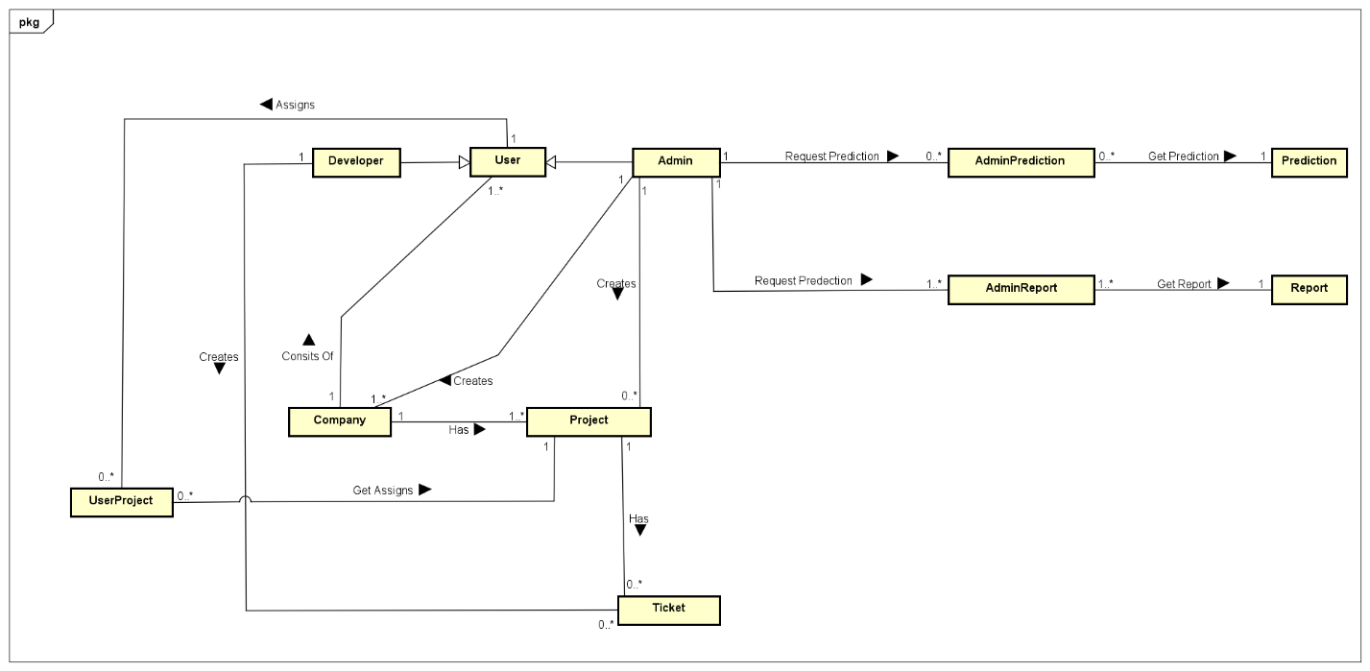

## **4 Part D : Collaboration**

### 4.1 Login

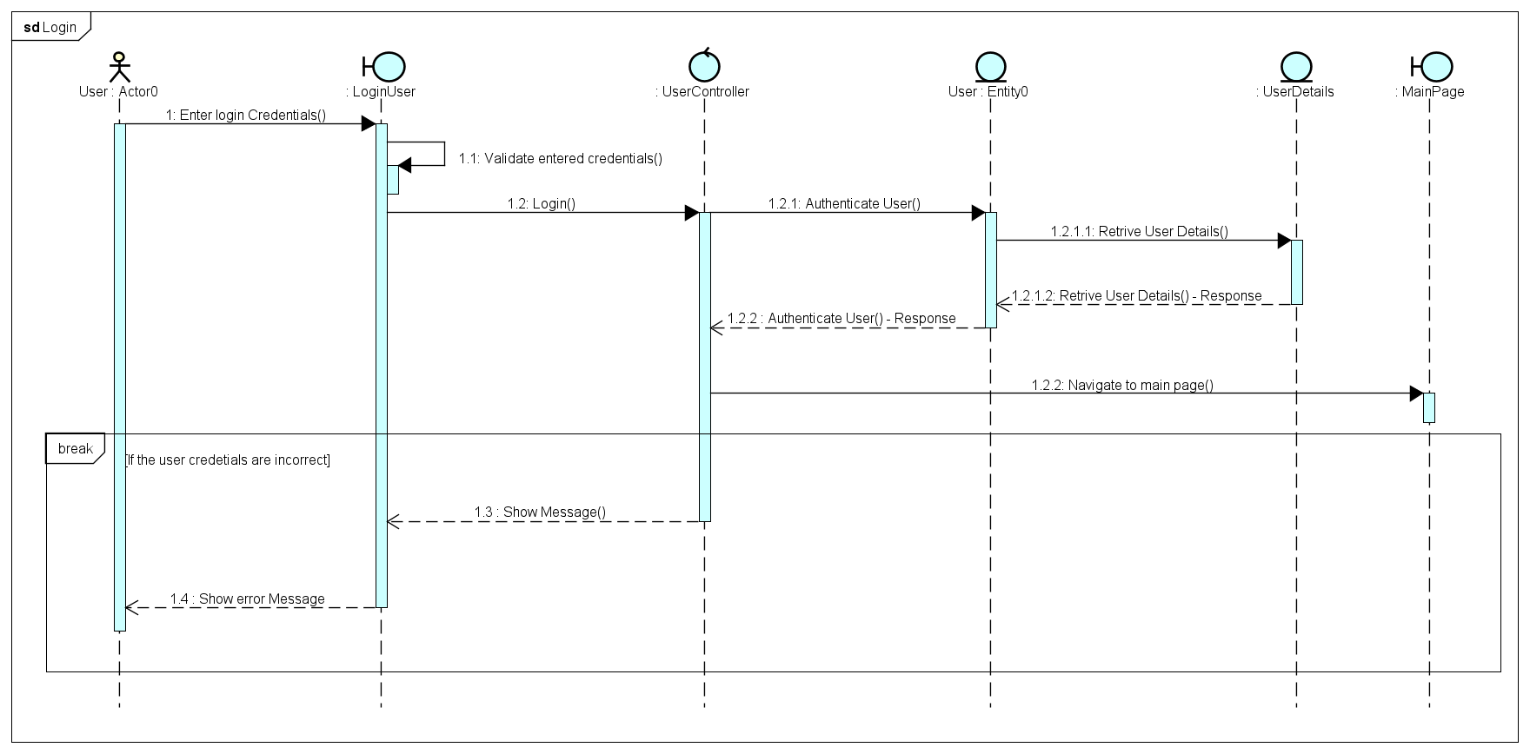

### 4.2 Create User

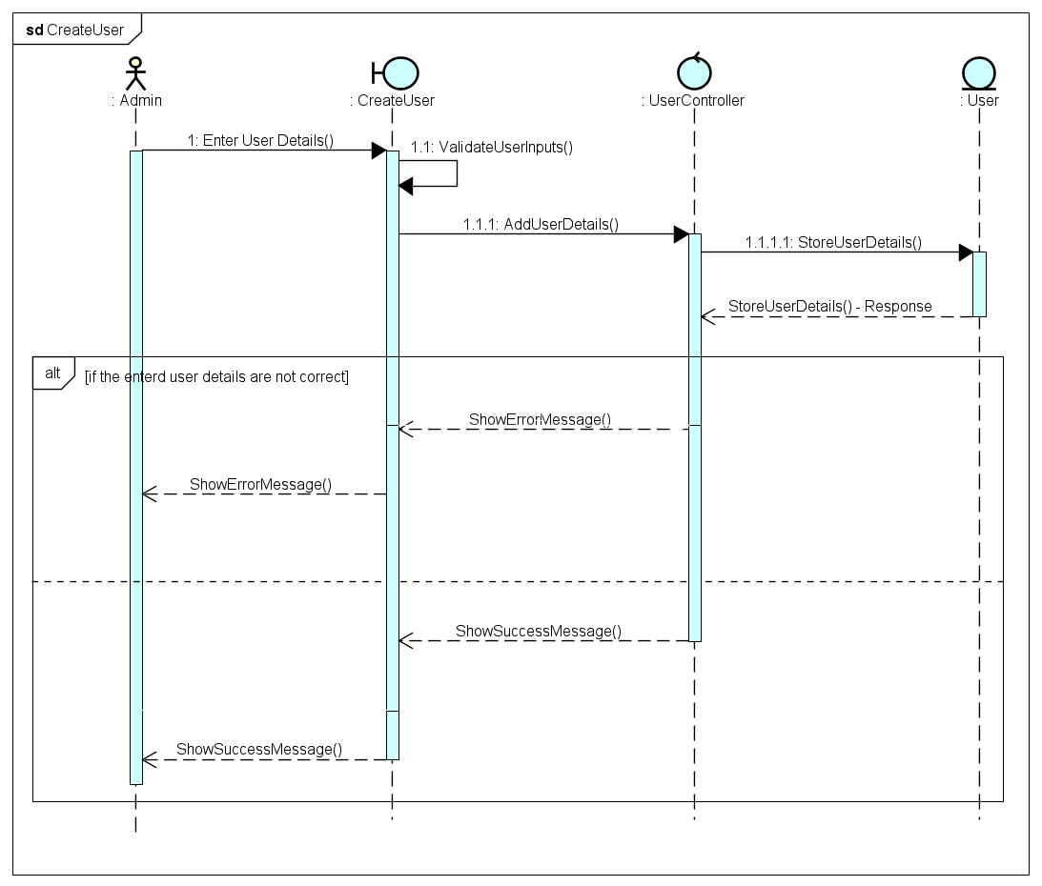

### 4.3 Create Ticket

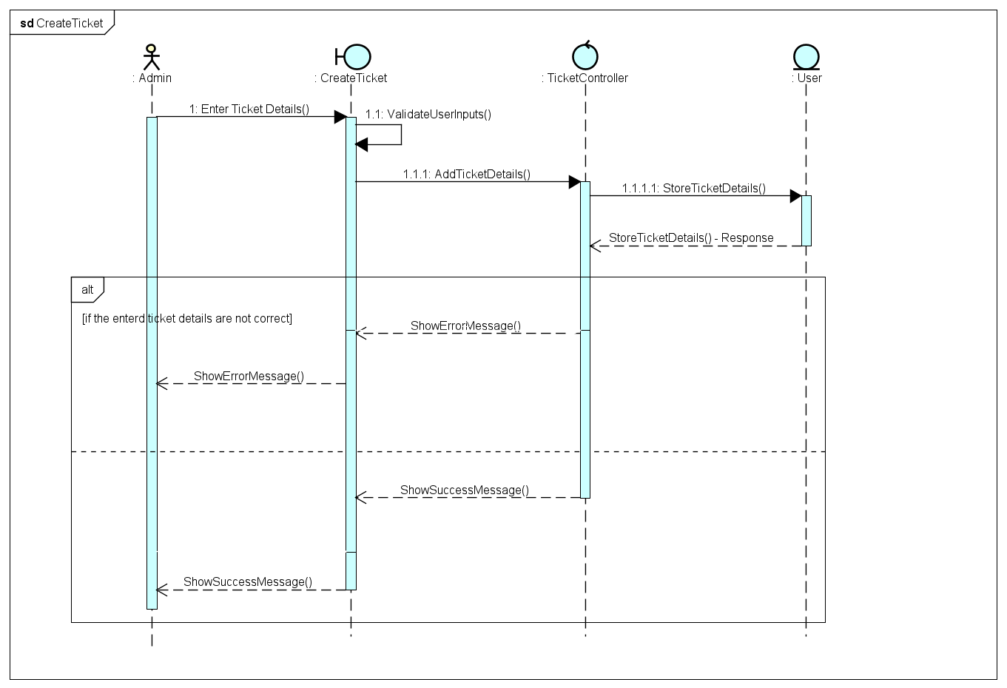

### 4.4 Create Company

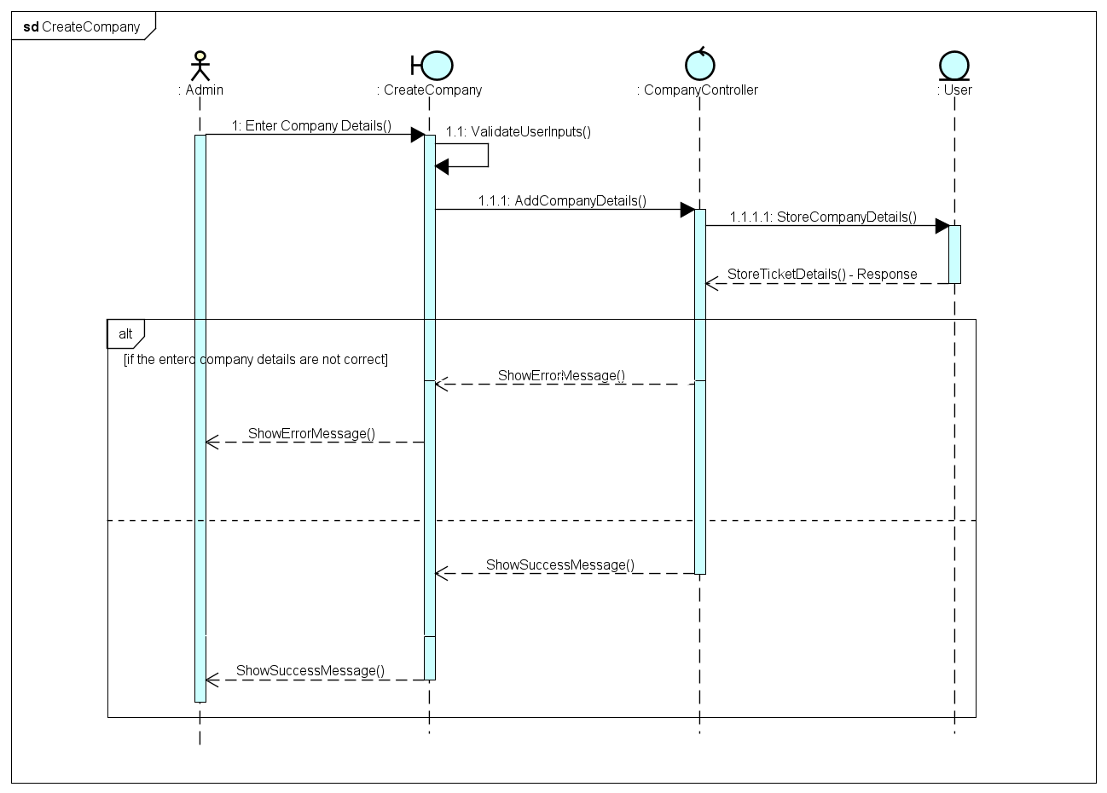

### 4.5 Create Project

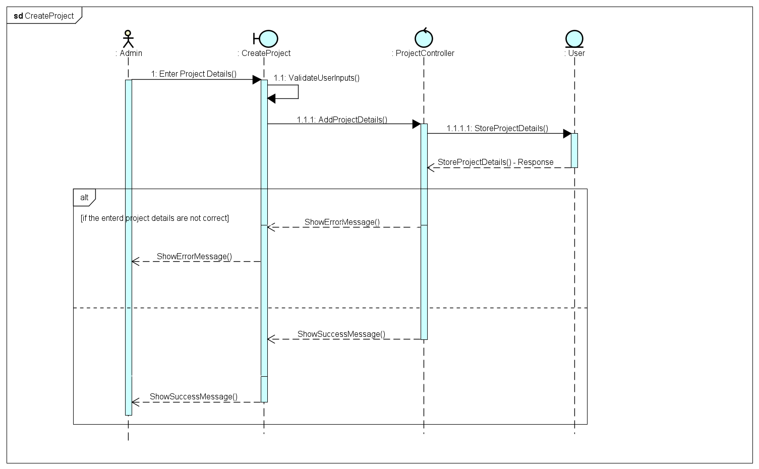

### 4.6 Delete User

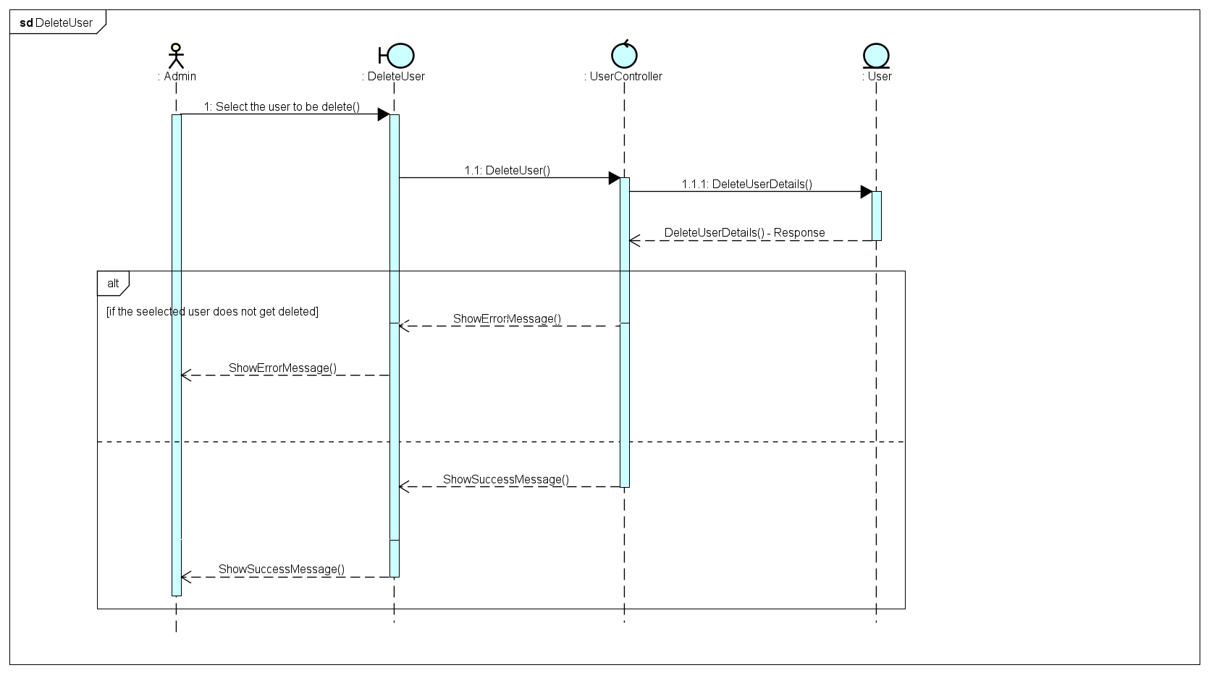

### 4.7 Delete Ticket

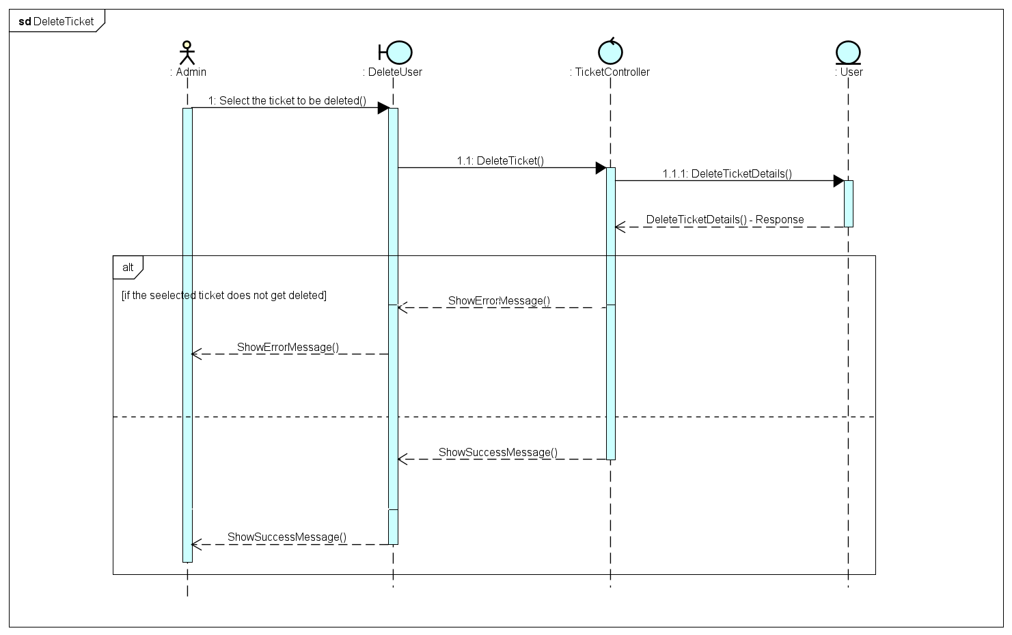

### 4.8 Delete Company

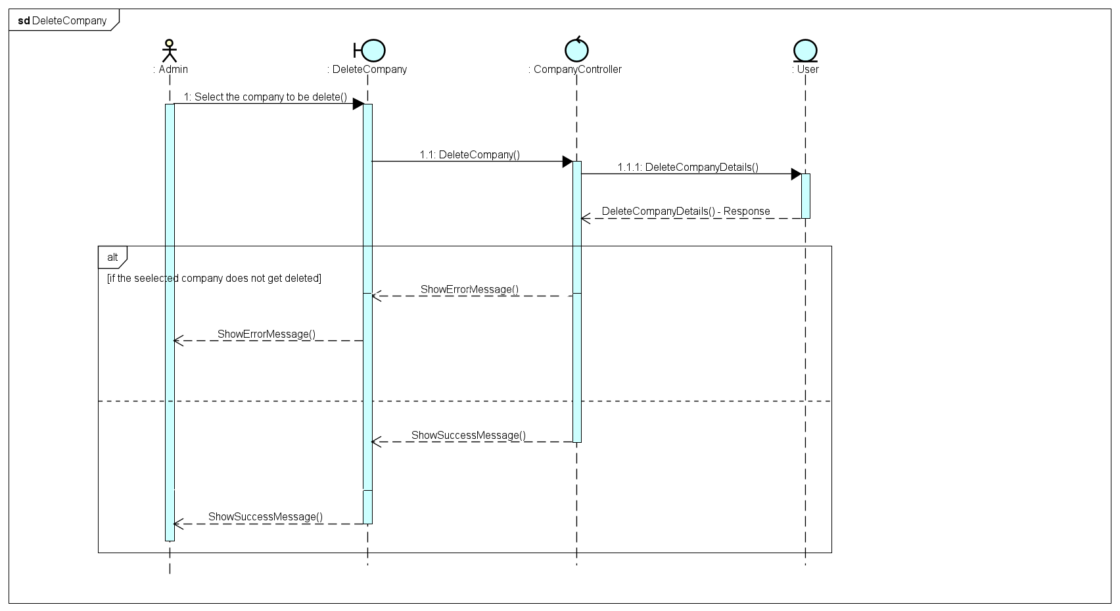

### 4.9 Delete Project

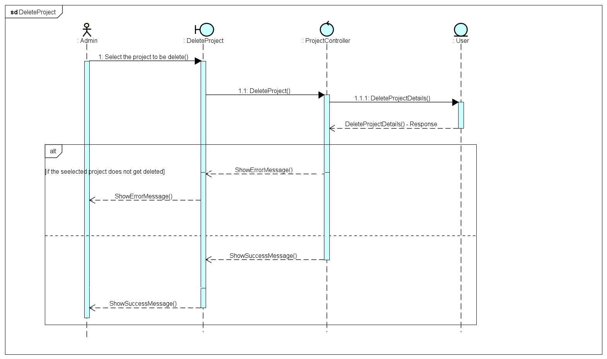

### 4.10 Update User

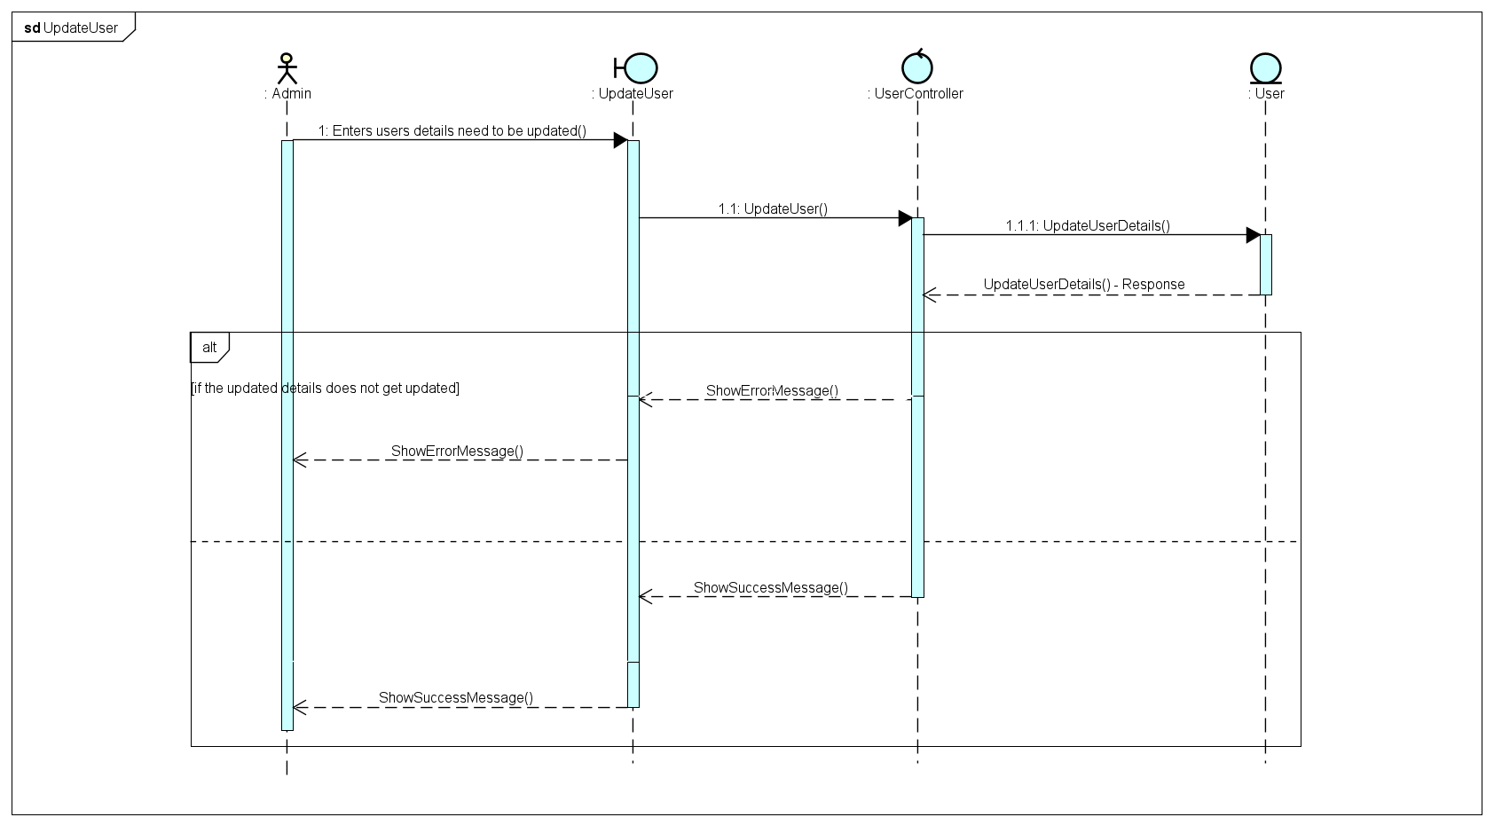

### 4.11 Update Ticket

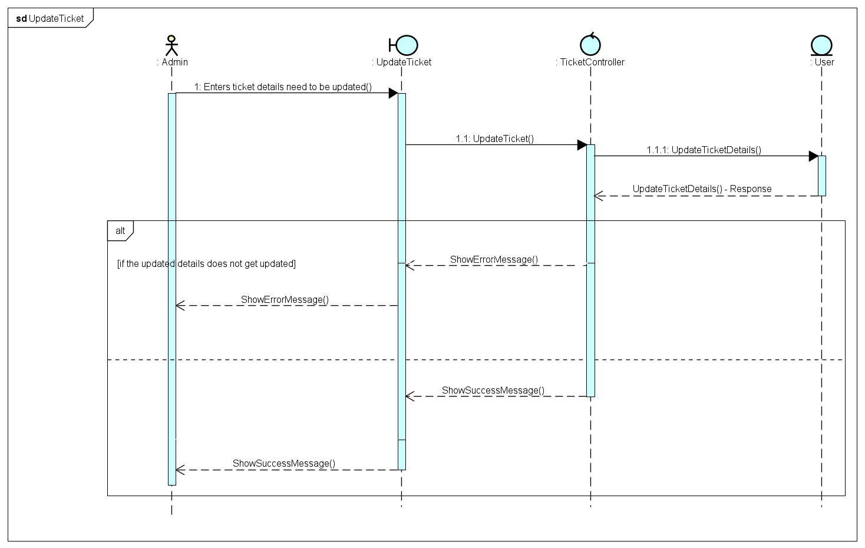

### 4.12 Update Project

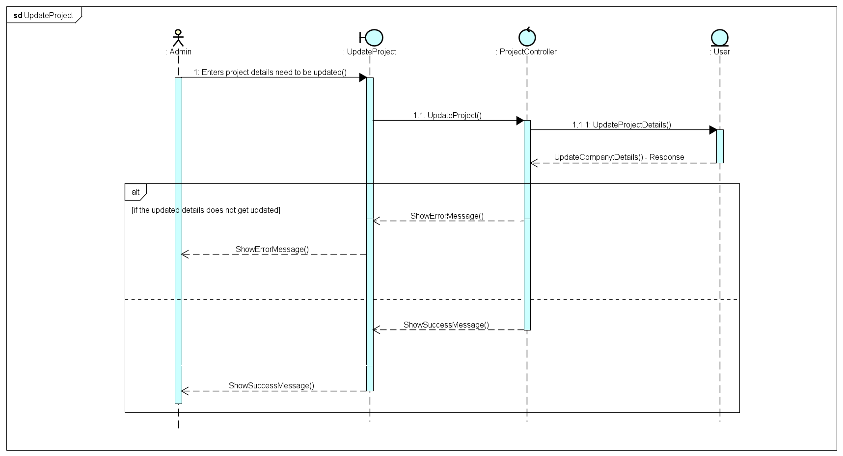

### 4.13 Manage User

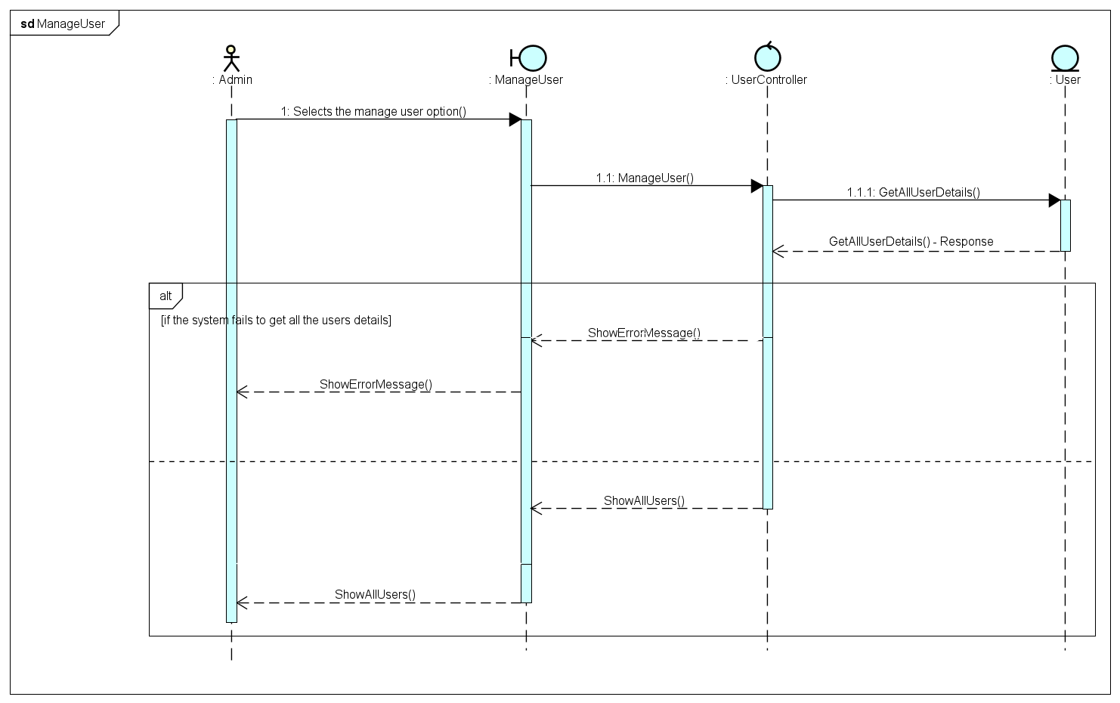

### 4.14 Manage Tickets

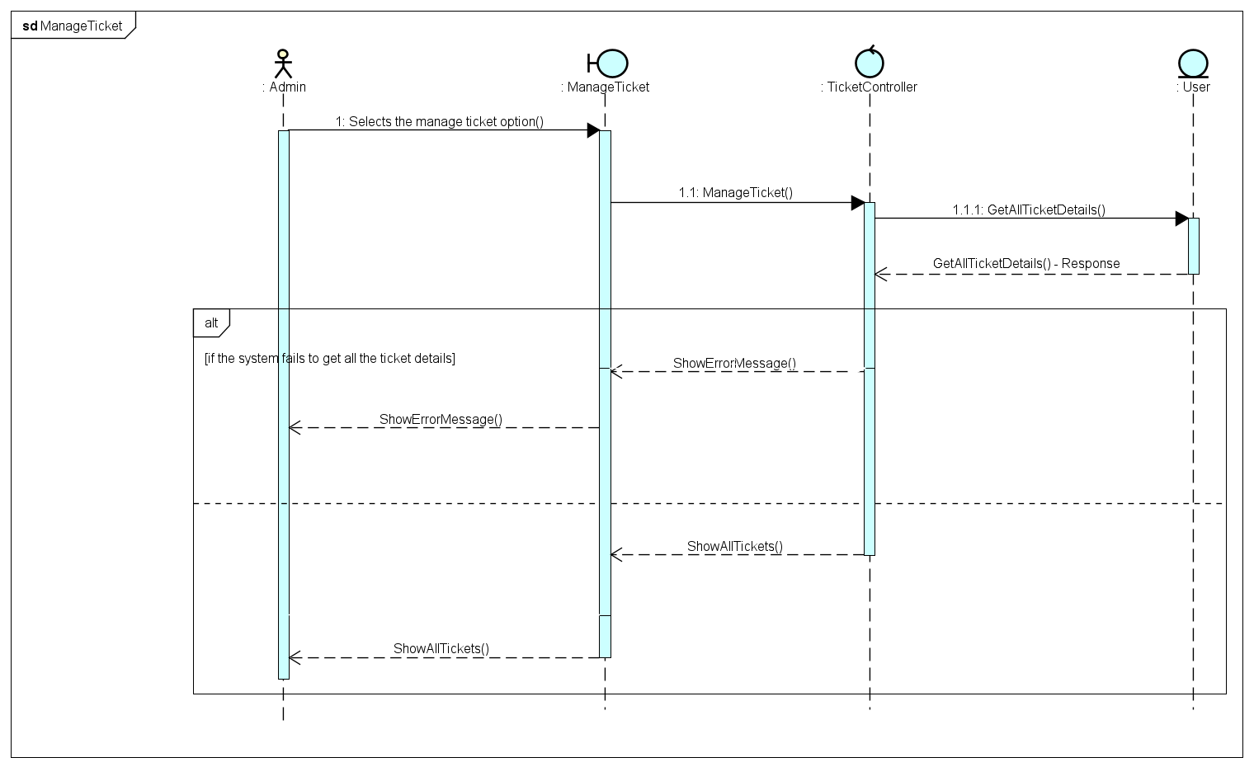

### 4.15 Manage Company

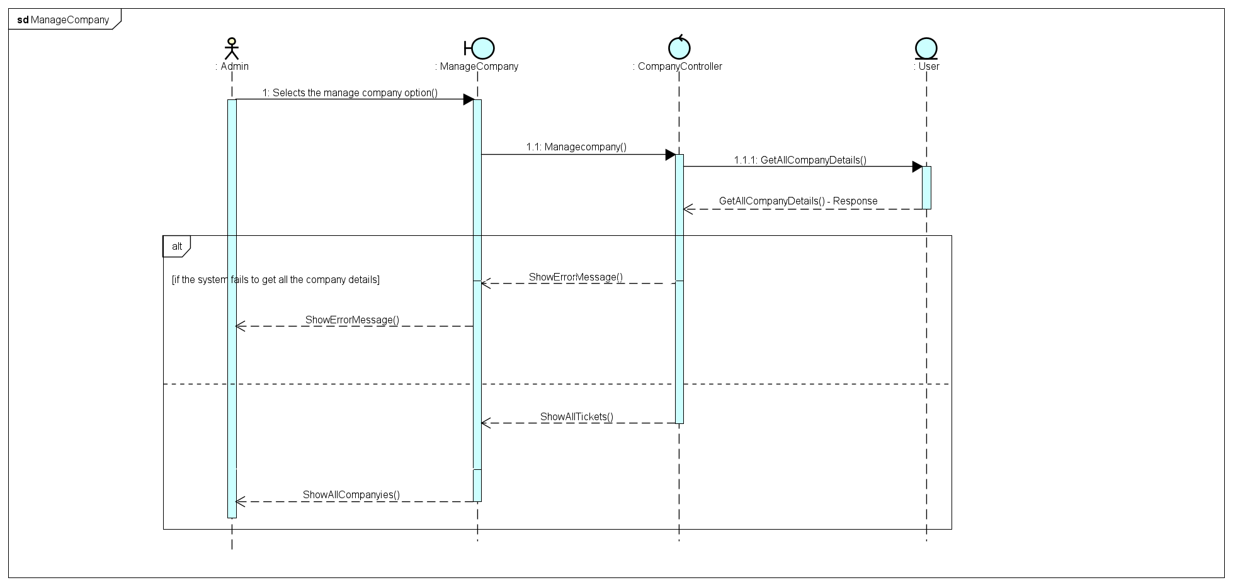

### 4.16 Manage Projects

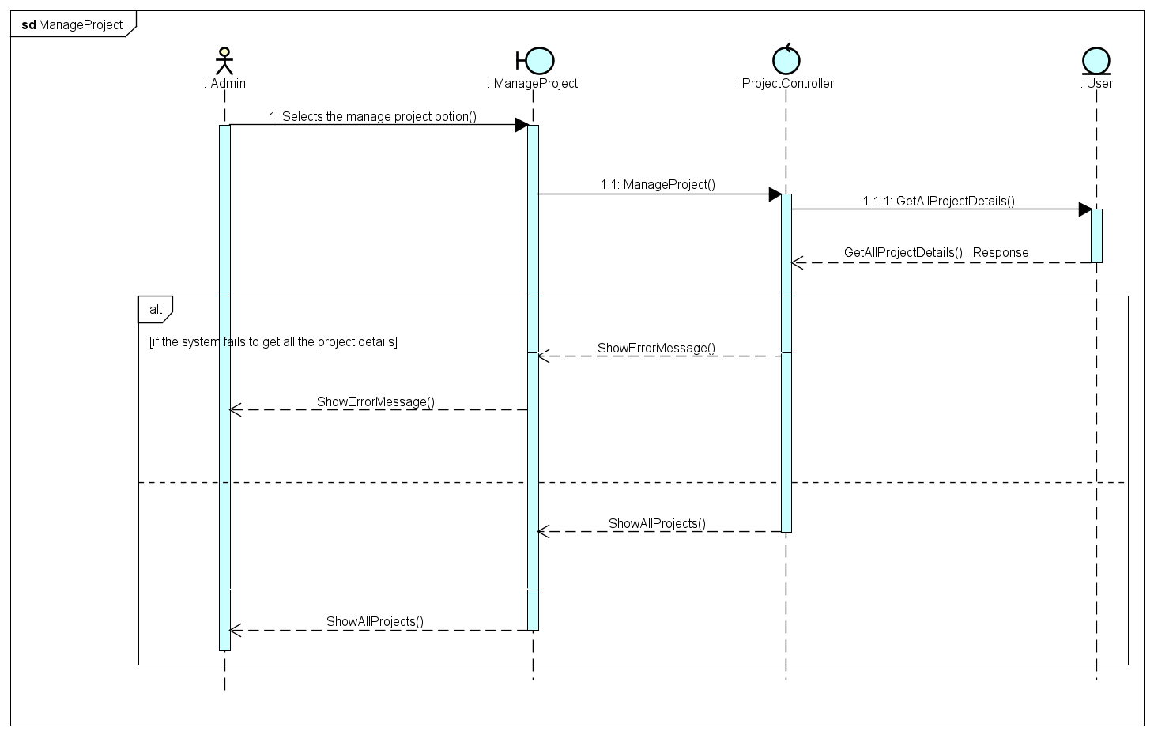

### 4.17 Assign User to Project

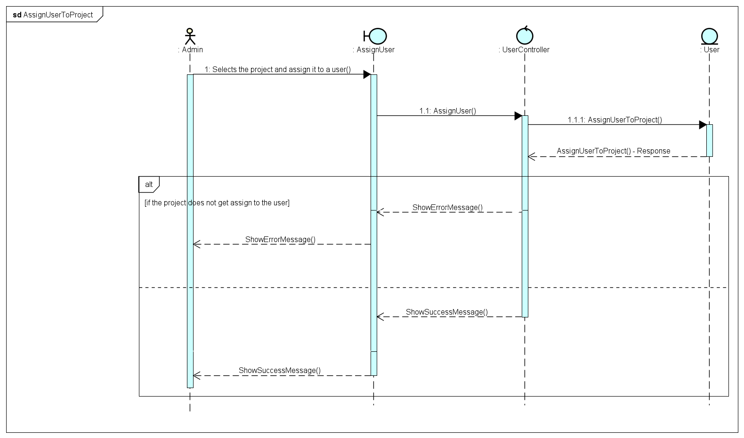

### 4.18 Assign Project to Company

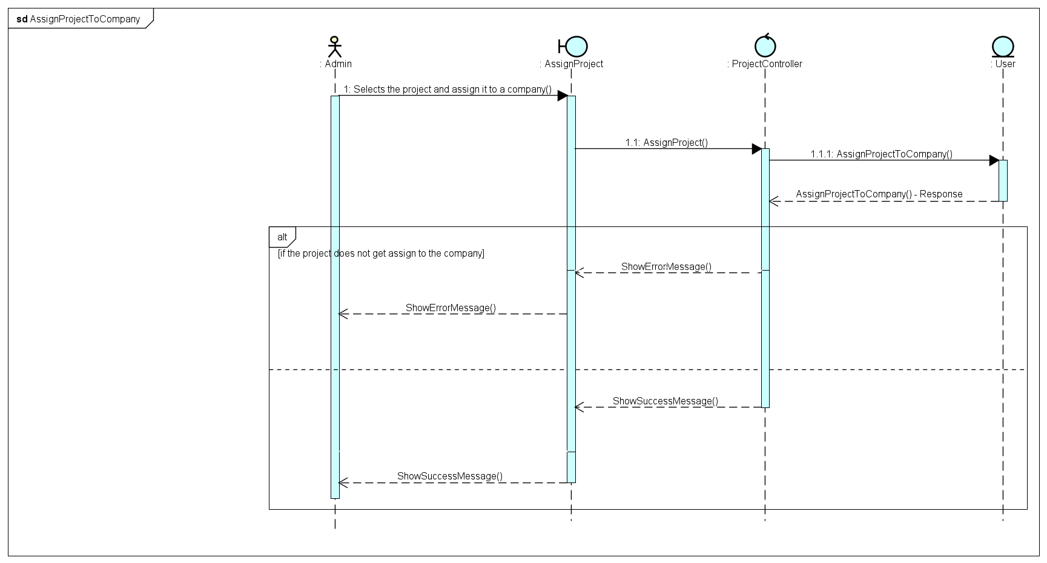

### 4.19 Assign Ticket to User

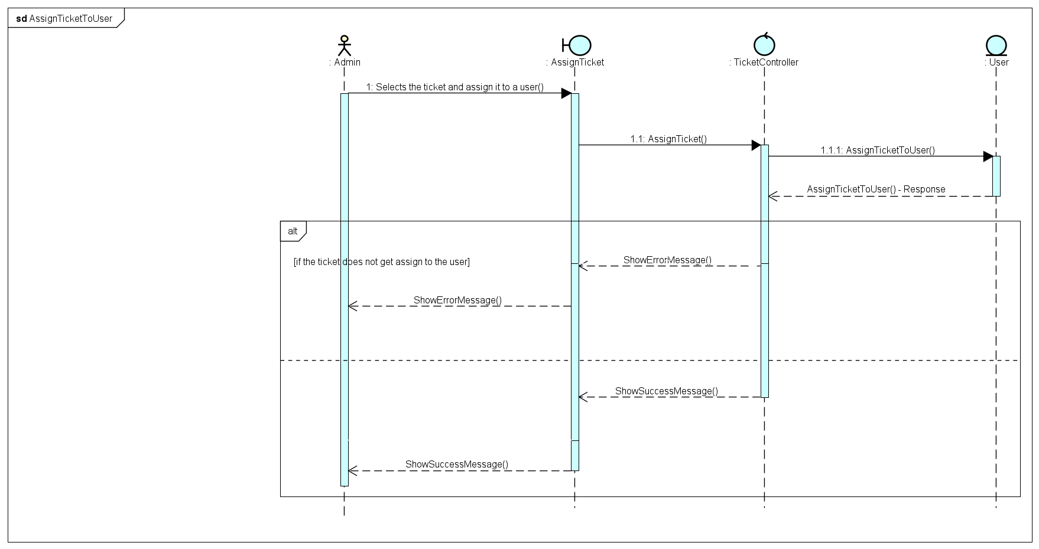

### 4.20 Generate Productivity Report

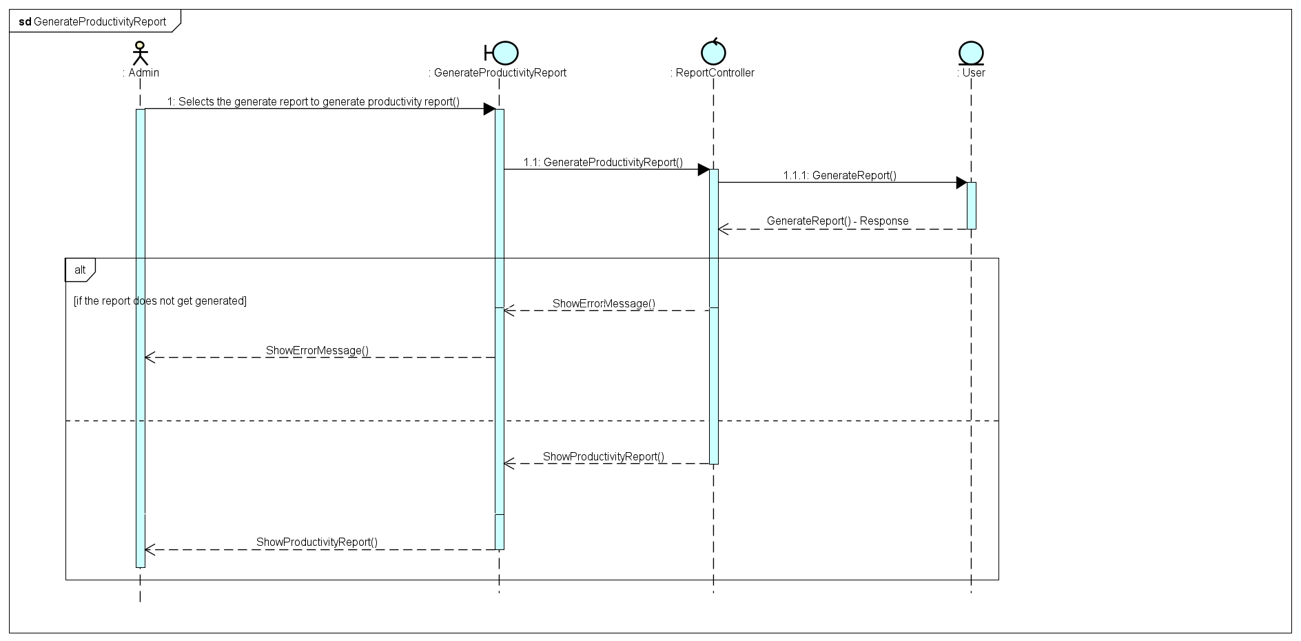

### 4.21 Generate Development Progress Report

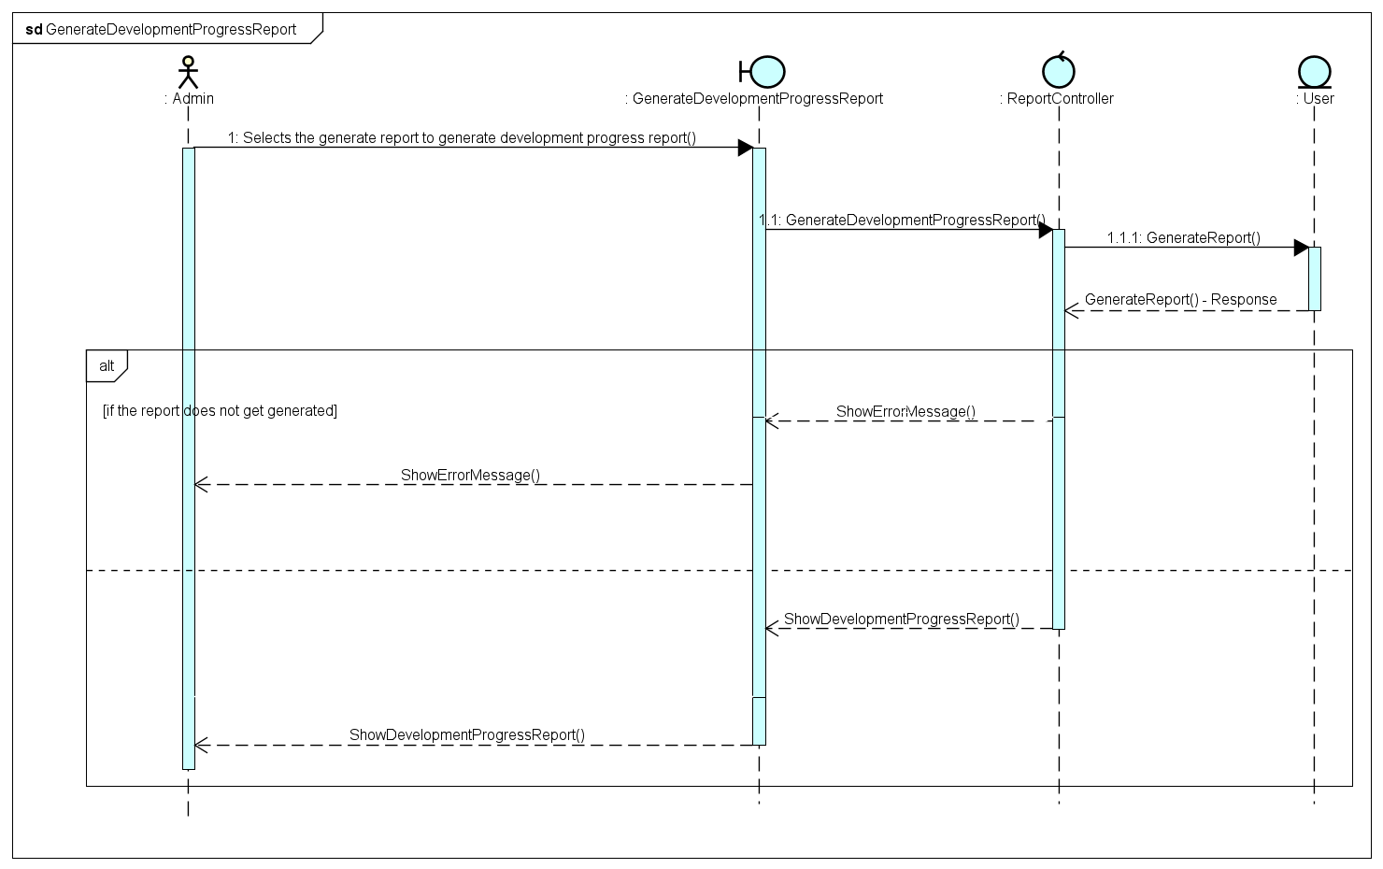

### 4.22 Manage Prediction

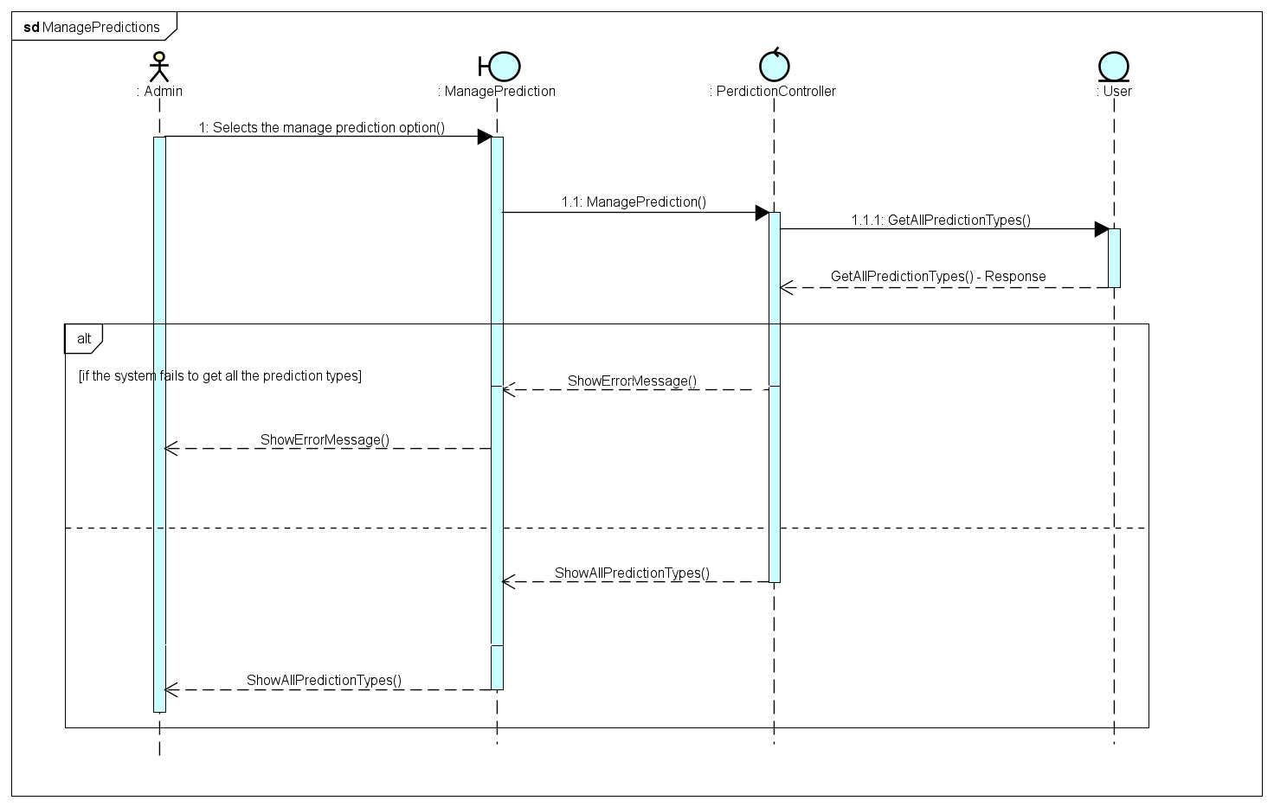

### 4.23 Number of projects each company will have

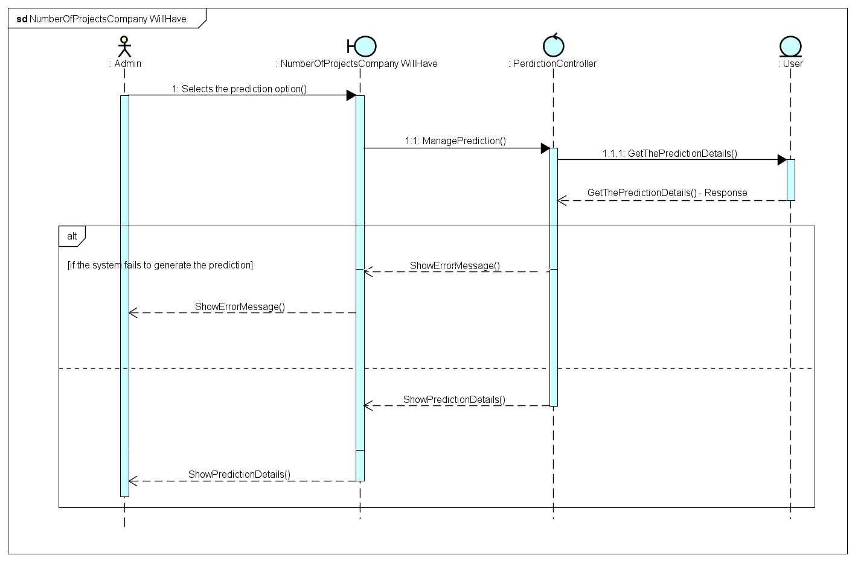

### 4.24 Number of users need to build projects

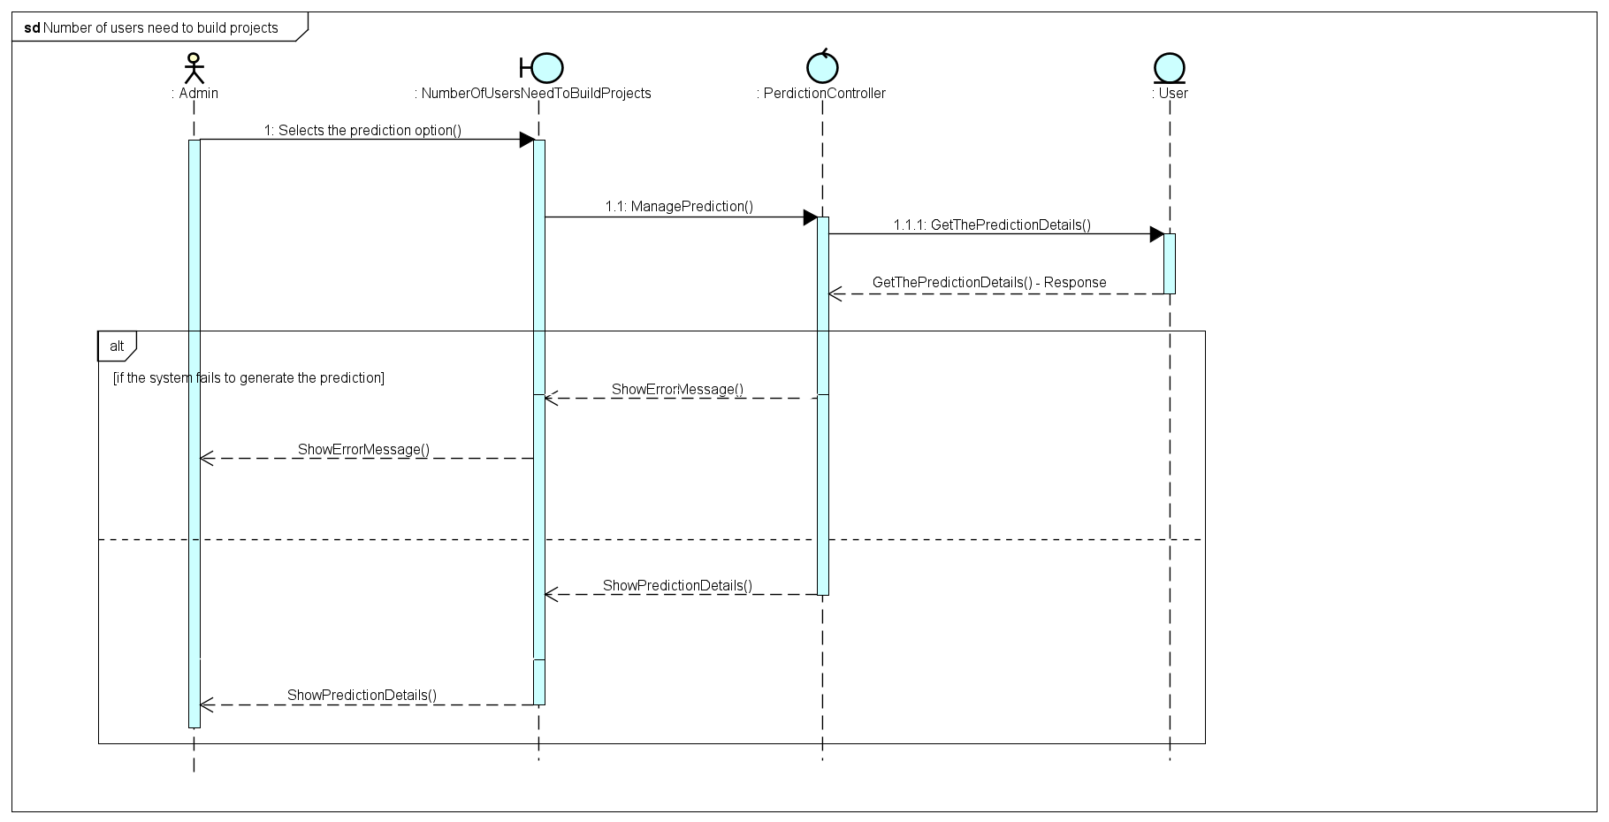

### 4.25 Display Tickets

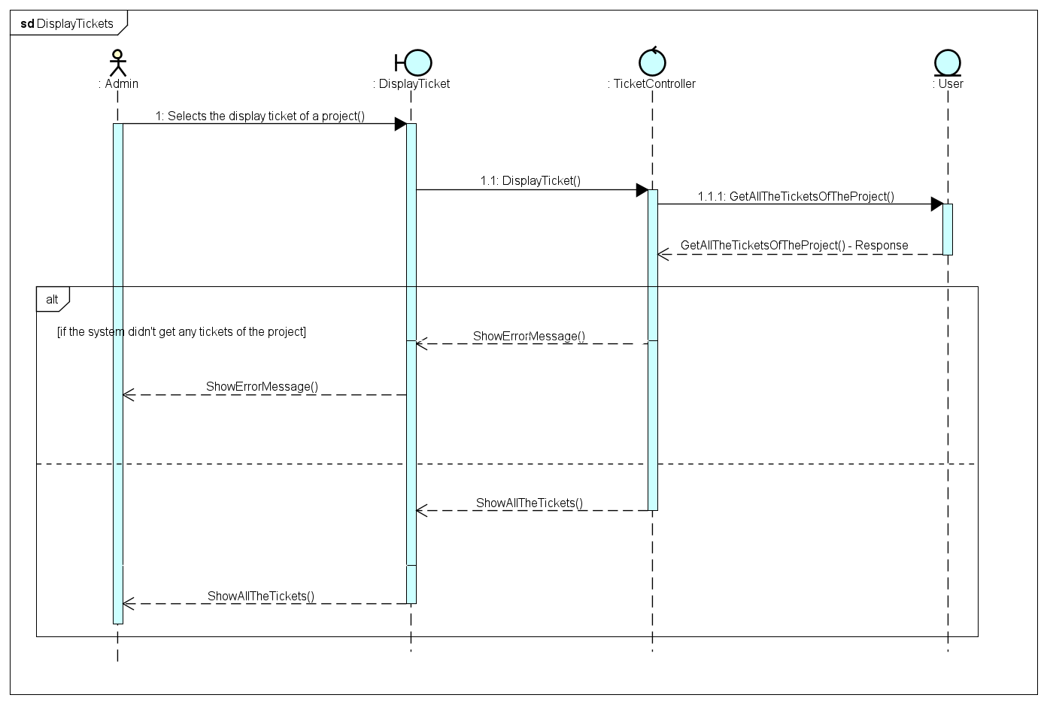

## **5** **Part E - Activity**

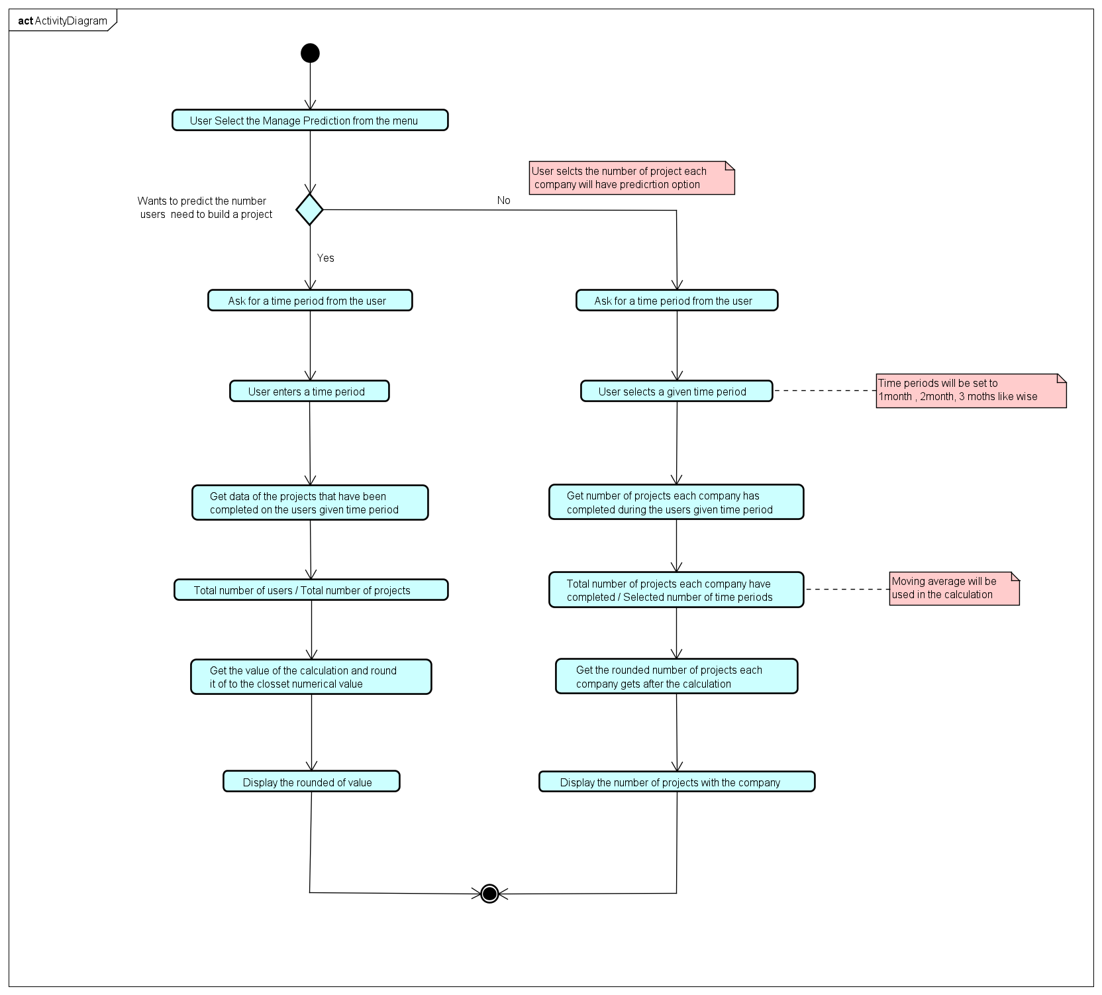

**Assumptions and Justifications for the Activity Diagram**

* The number of user needed for a project to complete prediction would only be applied for a project that has not started.
* The user must know how much time it would take to complete the project(roughly).
* That time would be taken from the system and then get the no users worked in the projects that was completed withing that time period(this time periods would be like 1month, 2months likewise).
* Past data should be available to do the prediction.
* The total number of users will be divided by the total number of projects and the answer would be rounded of to the closest numerical value and that value would be the total number of users that would take to complete that project.
* All the projects are taken as similar and requirements are also would be the same as previous projects this is to ensure that the projects are all equal.
* In the number of projects each company will have in a future date predictions the moving average method would be used to calculate the number of projects.
* The time periods would be pre-defined in the system for user to select out of it(this time periods would be like 1month, 2months likewise).
* This is to ensure that it would be easy to calculate the prediction in the system.
* Moving average method would be used here since its easy to get the number of projects according to the time period and categories them in to completed time base and get the average by adding the total number of projects and dividing it by the selected time period(1 , 2 , 3 .etc..) and round it off.

## **6 Part F – Self Assessment Form and Report**

In the beginning the design was hard to implement since it took time to understand the scenario. The first task of this assessment is the requirement gathering. The requirements are divided as functional and non-functional requirements. The author has identified the main requirements of the system, the functional requirements are clearly mentioned and easy to understand. What’s lacking in that area would be the correct assessment of each requirement. The scenario of each requirement should be identified and document. It is not enough just the main requirements it is also good to identify the sub requirements of each main requirements since it would be easy to identify more functions that should be in the system. It is a much help when those sub requirements are also identified and document with the main requirements.

When it comes to the non-functional requirements it is hard to assume the requirements would be used during the implementation stage since it would depend on the developers experience to see which will be best suited for these kind of system. The first diagram of the system is the use case diagram. The use case represent the main actions that would take place in the system. And all the actions that would be in the system are identified and have been added to the use case diagram. The actors that would be participating in the system are identified as admin and developer. The use case diagram can be formatted to look more formal. What’s lacking in the use case diagram would be the relationships of each use cases and the actors. The relation might have a slight problem when implementing since some of the features are not available to all the actors but it is described in the diagram.

The next part is the use case descriptions, the section where the designer justify the use cases in the use case diagram. All of the use cases have been captured and described in the use case descriptions. But not all the descriptions have captured all the details of it such as some of the use case descriptions does not have the supporting actors those should be identified since during the implementation the system might have a component that should have access to every user but it can only be access by the admin. And the main success scenario should also capture all the scenarios that could occur during that action so that in the implementation it is easy to identify the action and implement it.

Then when it comes to the CRC table it is important to go with a design pattern like the MVC(Model Control View). And also, many entities that should be in the CRC are missing also the controllers should be identified correctly since during the implementation the controllers plays a huge contribution to the system. The model diagram represent all the models that should be implemented but some models might not have the correct relationship with other. When it comes to the sequence diagram it should follow the CRC as well since it has been done using the MVC pattern. Few sequence diagrams have not been captured but it should be there. The activity diagram for the prediction system is not that very understandable it should be discussed briefly in the justification. Overall, the designs that are document is sufficient for the system implementation but it might change on course because its not that easy to implement every single part of the design.