Strategies for Escaping a Hurricane’s Wrath

1 Introduction

In 1999, evacuating the coast of South Carolina ahead of the predicted landfall of Hurricane Floyd led to a monumental traffic jam. One big problem was traffic slowed to a standstill on Interstate I-26, which is the principal route going inland from Charleston to the relatively safe haven of Columbia in the center of the state. It is normally an easy two-hour drive that took up to 18 hours to complete. Many cars simply ran out of gas along the way. The other one was traffic leaving Columbia going northwest was moving only very slowly.
Though the state officials have put forth some proposals to avoid a repeat of this traffic nightmare, such as, traffic reversal on I-26, so that both sides, including the coastal-bound lanes, have traffic headed inland from Charleston to Columbia, and traffic reversal on principal roads leading inland from Myrtle Beach and Hilton Head. Plans to carry them out have been prepared (and posted on the Web) by the South Carolina Emergency Preparedness Division [1, 2]. However, whether the plans are feasible or not should be further verified. More considerations must be taken to investigate what strategies may reduce the congestion observed in 1999 under different conditions. Following, we provide our strategies considering various conditions, such as the patterns of hurricanes, the evacuees and others, which can give directions for the state officials to put forth better plans to evacuate the coastal residents of South Carolina safely.

2 Assumptions

We make several assumptions regarding evacuation of the coast of South Carolina ahead of the predicted landfall of Hurricane.
- The interstates (e.g., I-26, I-77, I-20) have two lanes of traffic in each direction except in the metropolitan areas where they have three, which means the traffic entering a metropolitan (such as Columbia) can be smoothly separate into the routes leaving it in most case.
- The normal drive takes two hours to complete from Charleston to Columbia. The average drive speed for a car on the interstate I-26, I-77, and I-20 is limited to 60-80 mph, while the one for a car on principal roads (e.g., US501) is limited to 50-70 mph.
- Charleston has approximately 500,000 people, Myrtle Beach has about 200,000 people, and another 250,000 people are well-distributed along the rest of the coastal strip. Also, we should consider some evacuees from the coastline of Georgia and Florida in Question 6;
- Columbia has around 500,000 people. And, according to our rough search via Internet, the total number of the hotels and motels in Columbia and beyond Columbia, SC, is about 184 [3], which can occupy around 50,000 people. Hence, Columbia does not have sufficient hotel space to accommodate the evacuees (including people coming from farther north by other routes). So, some traffic must continue outbound on I-26 towards Spartanburg; on I-77 north to Charlotte; and on I-20 west to Atlanta.
- There are several tropical cyclone guidance models available to the NHC and CPHC forecasters for the hurricane season [4, 5]. These models range in complexity from simple statistical models to three-dimensional primitive equation models. According to their models, we assume that the National Hurricane Center (NHC) in Miami, Florida can issue 72 hour tropical cyclone track and intensity forecasts [5]. Also, hurricanes are possible in the specified area of the WATCH, usually within 36 hours, and are expected in the specified area of the WARNING, usually within 24 hours [2].
- Evacuees traveling on I-26 in the normal westbound lanes of travel will be allowed to exit at all interchanges between Charleston and Columbia. Evacuees traveling in the reversed lanes of travel will be allowed to exit at most, but not all, interchanges [2].

3 Development and Analysis of the Model

According to congestion observed in 1999 and Assumptions, we investigate different strategies to solve the traffic jam under different combined situations and compare them with performance measures of traffic flow on the principal routes. Based on the given Map of South Carolina, we first correspond the main routes of evacuation into a traffic network model, 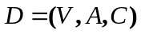,as shown in Fig. 1. The above model is actually a maximum flow problem, and can be extended to a more general traffic network with m nodes and n arcs. The model can be solved with general purpose linear programming algorithms. Following, we first describe the model in details. Then, some key factors affecting the algorithms are discussed. Moreover, since the traffic flow is an important performance measure in our model, we discuss how to find the traffic flow solution in details.
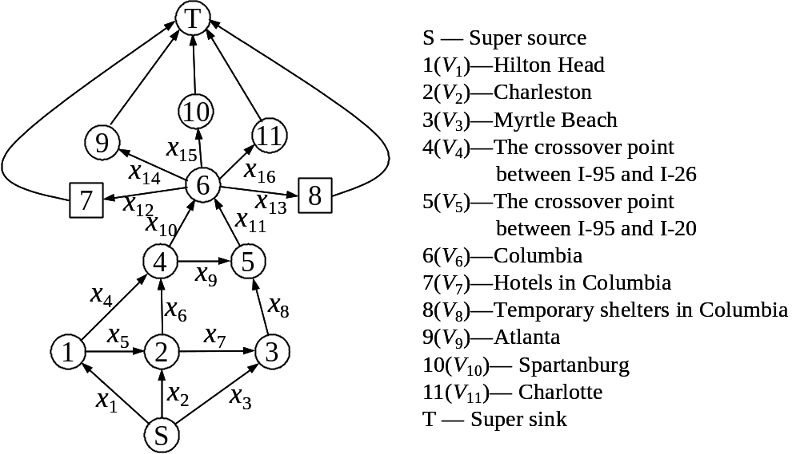

Fig. 1. The traffic network of the main routes of evacuation.

3.1 The maximum flow problem

The network flow model consists of nodes and arcs. In the context of modeling a problem, each node, shown as a circle, represents some aspect of the problem such as a physical location. Arcs are directed line segments. The arc passes from its original node to its terminal node. Flow is associated with the network, entering and leaving at the nodes and passing through the arcs. Flow is conserved at the nodes, implying that the total flow entering a node must equal to the total flow leaving the node. The arc flows are the decision variables for the network flow programming model. Flow is limited in an arc by the lower and upper bounds on flow. The lower bound is a constraint requiring that at optimality there must be a minimum number of units of flow through the arc. The upper bound restricts the flow so that it may not exceed a maximum amount. Sometimes the term capacity refers to the upper bound on flow. Networks that include such bounds are said to be capacitated, in that the arcs have capacities, or limits on their flow. The criterion for optimality is cost. Associated with each arc i is the cost per unit of flow . The arc gain, multiplies the flow at the beginning of the arc to obtain the flow at the end of the arc. The set of arc parameters are shown adjacent to arcs enclosed in parenthesis: (lower bound, upper bound, cost, gain). When a parameter is not shown, it assumes its default value. Default values are: 0 for lower bound, infinity for upper bound. The external flow at node i, is the flow that must enter or leave node i. A positive external flow enters the node, and a negative external flow leaves the node [6].
In a network with flow capacities on the arcs, the problem is to determine the maximum possible flow from the source to the sink while honoring the arc flow capacities. Consider a network with m nodes and n arcs with a single commodity flow. Denote the flow along arc by 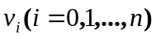. We associate with each arc a flow capacity, 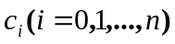. In such a network, we wish to find the maximum total flow in the network, D, from node l to node m. The network model may be solved with either special purpose network flow programming algorithms or with general purpose linear programming algorithms [6, 7]. Every network flow programming model has an equivalent linear programming (LP) model. In the LP formulation, the objective is to maximize D.

3.2 Model design

Model description

In the network model, , as shown in Fig. 1, every route is abstracted into an arc: 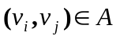, each with a maximum capacity, 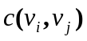. Regarding the concentrating point of evacuators 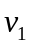, 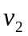, and 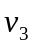 as the sources of the network flow, while 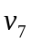, 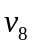, 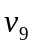, 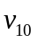, and 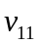 are viewed as sinks of the network flow. We establish a new source S (named super source) and a new sink T (named super sink). We use the arcs 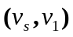, 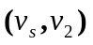, and 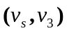, each of which has an infinite capacity, to connect S with , , and , respectively, and use the arcs 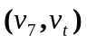, 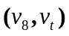, 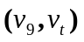, 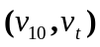, and 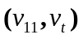, each of which has an infinite capacity, to connect T with the former sinks , , , , and [6]. In Fig. 1, we do further explanation on the evacuees in Columbia (node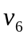), which include: some staying at the hotels and motels ( along 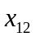); some staying at the temporary shelters ( along 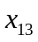); some continuing outbound on I-26 towards Spartanburg ( along 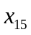); some on I-77 north to Charlotte ( along 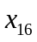); and some on I-20 west to Atlanta ( along 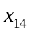).
Now we can use the maximum flow algorithm to get a group of flow 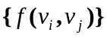, which makes the total flow at S,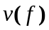 reach maximum and fits to:
(1) 0 ≤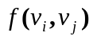≤ , , 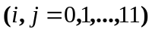,
(2) 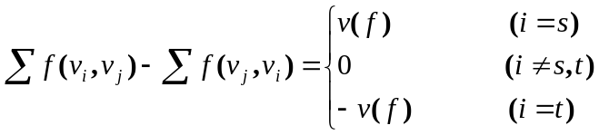,
where, 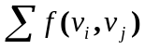denotes the sum of flow out of , and 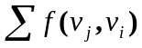 denotes the sum of flow into . According to Fig. 1, we can get the objective function and constraint conditions for Questions 1 to 6 except Question 2 as follows:
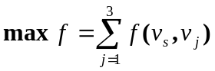, (1)
Subject to:
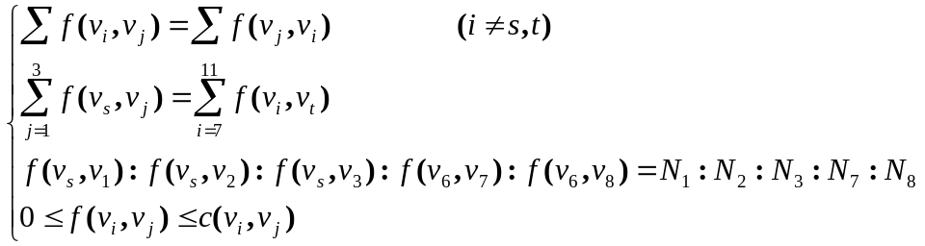 (2)
where 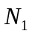, 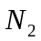, and 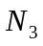 denote the evacuee number of the sources , , and , respectively, while 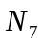 and 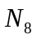 mean the evacuee number staying at the hotels and motels (node ) and the temporary shelters (node ) in Columbia, respectively.
For Question 2, which is under an alternative strategy that staggers the evacuation, county-by-county over some time period consistent with the pattern of how hurricanes affect the coast, the traffic network model is also shown in Fig. 1 and the object function is same with (1), but the constraint conditions are changed to:
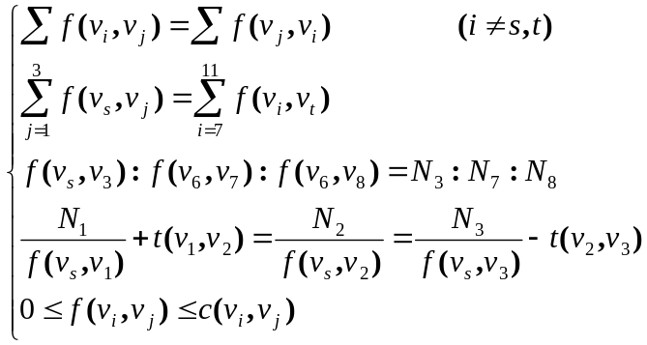 (3)
where, 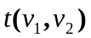 and 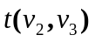 are the time periods for the hurricane moving from to , and from to , respectively. They could be calculated out through estimating the wind speeds of the predicated landfall of the hurricane. In (3), we add a constrain condition that the evacuation from should be completed prior to with the time period , and evacuation from prior to with the time period consisting with the pattern of hurricanes affect the coast, resulting in the equation:
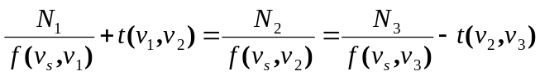 (4)

Evacuees from sources (Hilton Head, Charleston, and Myrtle Beach)

The evacuees from sources will affect with the traffic flow on the entire network, especially on routes I-26, I-95 and I-20. Based on Assumption 3, for the evacuees in sources, we should first deal with the 250,000 people well distributing along the rest of the coastal strip, and divide them into the sources , , and . Then we must consider two cases in our algorithms: (1) Non-consideration of the some of the coastal residents of Georgia and Florida came up I-95; (2) Consideration of some of the coastal residents of Georgia and Florida came up I-95.
According to the coming direction of the hurricane, it is straightforward considered that most of people in [,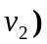 are evacuated along the route I-26, and the rest along the route I-95. Also, most of people in (, ) are evacuated along the route US501 because of the traffic jam of I-26, and the rest along the route I-26. We divide evacuees into the sources , , and as follows:
(1) We first calculate the number of people in [, ] and (, ), which are both 250,000/2=125,000, approximately.
(2) We then assume a division method of the evacuees leaving sources , , and . We divide the people in [, and (, ) according the method of famous Golden Section, resulting into four divisions [, 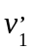], (,), (, 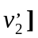, and (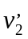, ), each of which has 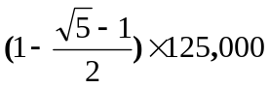, 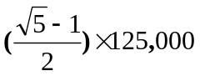, , people, respectively. As a result, the people evacuating along the route I-95 (), I-26 () and US501 () are
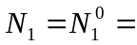, (5)
= 500,000+125,000=625,000, (6)
and
= 200,000+, (7)
respectively. Where, 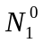 is the number of evacuees without considering some of the coastal residents of Georgia and Florida came up I-95.
(3) If we consider some of the coastal residents of Georgia and Florida came up I-95, and assume that number is 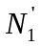, then total number leaving Hilton Head is
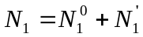 (8)

The impact of temporary shelters

The evacuees in Columbia include: some staying at the hotels and motels ( along ); some staying at the temporary shelters ( along ); some continuing outbound on I-26 towards Spartanburg ( along ); some on I-77 north to Charlotte ( along ); and some on I-20 west to Atlanta ( along ). If the traffic flow leaving Columbia on I-26, I-77, and I-20 approach their capacity, it will limit the traffic flow entering Columbia. According to Assumption 4, if more temporary shelters are established in Columbia, then it will reduce the traffic leaving Columbia onto I-77, I-26, and I-20, respectively. This is a bottleneck of the traffic network, and is the traffic jam leaving Columbia going northwest in 1999. We now give a qualitative analysis on it in details. Based on (2), the flow of entering Columbia and that of stayed at and outgoing Columbia should be equal to, so we can have the following equation:
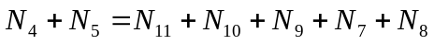, (9)
where,
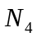 is the number of the evacuees on I-26 westbound traffic from the coastline to Columbia;
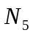 is the number of the evacuees on I-20 westbound traffic from the coastline to Columbia;
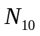 is the number of the evacuees on I-26 westbound traffic leaving Columbia;
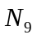 is the number of the evacuees on I-20 westbound traffic leaving Columbia;
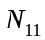 is the number of the evacuees on I-77 northbound traffic leaving Columbia;
is the number of the evacuees to be accommodated in hotels and motels in Columbia;
is the number of the evacuees to be accommodated in established temporary shelters in Columbia.
From (9), if more temporary shelters are established in Columbia, i.e. is not zero, then it will reduce the traffic leaving Columbia onto I-77, I-26 and I-20 (,, and ), respectively. So some strategies to solve the traffic jam leaving Columbia could be discussed, so that the traffic flow of the entire network could be improved.

3.3 The performance measure of traffic flow

The performance of a traffic system is the response of that system to given travel demand levels [8]. The traffic system consists of the network topology (street width and configuration) and the traffic control system (e.g.. designation of one- and two-way streets, and lane configuration). The number of trips between origin and destination points, along with the desires arrival and/or departure times comprise the travel demand levels. It is difficult to capture network performance with only one variable (travel time or speed in this case). The model should be generalized to estimate average network travel times (per unit distance).
In our model, we use the traffic flow to be an important performance measure. Now we discuss how to find the traffic flow solution. The procedures are as follows:
(1) Find the speed that would provide for maximum, but safe, traffic flow. We first need to define traffic flow. In often case, if an observation post is set up along the highway, the number of cars that travel past this post in a unit of time is a measure of traffic flow. This is equivalent to finding the number of seconds it takes one car to pass the post (or saying how many cars will pass every 1 second).
(2) If it is assumed that cars travel at the posted speed limit, it is reasonable to think that there is a relationship between the traffic flow and the speed limit. We will now attempt to determine that relationship. Since time and speed are variables in this problem, we might begin with the equation: Time=Distance/Speed.
(3) Assume all cars have the same length C and are separated by the same distance D. The Total Distance between the front bumpers of any two cars is the length of the car (C) plus the distance between the two cars (D).
Total Distance=C+D, (10)
Letting S represents Speed, Time can now be computed by:
Time=(C+D)/S (11)
where, Time is measured in seconds, Car Length (C) and Distance between cars (D) are measured in feet, and Speed (S) is measured in miles per hour.
Since the variables in equation (11) contain a mix of units (seconds and hours for time and feet and miles for length), we must convert to a consistent set of units, so we choose to convert miles to feet and hours to seconds. Substituting 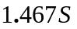 (feet/second) for S (miles per hour) in equation (11), we now have an equation in which the units of measure on the two sides of the equation are in agreement.
Time=(C+D)/1.467S (12)
Since traffic flow is defined in terms of time and an equation for Time has been developed, an equation for Flow can be written.
Flow = 1/Time (13)
Replacing Time by the expression in equation (12), equation (13) becomes
Flow=1.467S/(C+D) (14)
Equation (14) defines Flow as a function of the variables S and D and the constant C. However, equation (14) does not contain enough information about the variables to find the value of S that maximizes Flow.
(4) Determine how the variables and constants are related and form mathematical equations that express that relationship. Let's take a closer look at D, the "safe" distance between cars. Safe distance between two cars depends on two factors: the distance traveled during reaction time (R) and the braking distance (B): D=R+B. Reaction distance (R) and Braking distance (B) both depend on the speed of the car. There are accepted "rules" that suggest a relationship between speed and a safe distance. In our model, information taken from [9] will be used to discover this relationship. Finally, we obtain the following equation,
Flow=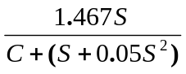 (15)
We now have a mathematical equation relating traffic Flow (the dependent variable) to the Speed (S) of the traffic. This equation can be used to set what speed limit in order to provide the maximum traffic flow in our model.

4 Simulation Results and Model Testing

We developed an Evacuation Package to implement the simulation of the network model. In our algorithms, we have done a numerous of computer simulations in MATLAB under different assumptions. The graphical interface is a very intuitive way to organize data and to see the effects of the modeling under different conditions. The strategies can be intuitively compared based on the predicted landfall of the hurricane. The influences of the evacuees from Georgia and Atlanta, and establishing temporary shelters in Columbia are also discussed. During the simulation, we should do the following procedures:
(1) Prepare a network model for the problem. (Note: One can define the network model according to a special process.) Define the objection function criterion, and the matrix form for the data entry. Also enter the number of nodes, and the arc or connection parameter/coefficient on the matrix. If there is no connection between two nodes, one may leave the corresponding cell empty or enter "M" for infinite cost.
(2) Use the commands to change the problem name, node names, objective function criterion, and to add or delete nodes. One may also change the flow bounds for the network flow problem.
(3) After the problem is entered, it can be saved. Then, one can run the program to solve the problem. Various figures can be plotted to demonstrate various strategies and their comparisons under different conditions.
For the traffic jam in 1999, we have run our program to compare different strategies according to Questions 1 to 5 considering two cases: (1) Non-consideration of the some of the coastal residents of Georgia and Florida came up I-95; (2) Consideration of some of the coastal residents of Georgia and Florida came up I-95, which is Question 6. We discuss the impacts on the evacuation traffic flow under various situations. Some typical figures are plotted (Figs. 2-4). Fig. 2 is the evacuation traffic flow on I-26 changing with the time period of the predicted landfall of the hurricane. Fig. 3 is the minimum total required traffic flow changing with the time period of the predicted landfall of the hurricane. Fig. 4 is the comparison of maximum traffic flow of evacuating county-by-county (Strategy V) and in a simultaneous way (Strategies I to IV) under the best situations (i.e., both considering the combination of Strategies I to IV). Each figure provides different regions of the strategies. Based on the simulation results, we now answer the questions of the problem.

4.1 Strategy I

Q: Under what conditions does the plan for turning the two coastal-bound lanes of I-26 into two lanes of Columbia-bound traffic, essentially turning the entire I-26 into one-way traffic, significantly improve evacuation traffic flow?
A: In order to move evacuees out of the coastal regions in a timely manner, lane reversals along certain interstate and primary routes may be necessary. Should it become necessary to reverse the flow of traffic on these roads depends on the predicted time period (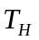) of the landfall of the hurricane and the maximum capacity of the evacuating routes. In our network model, we first calculate the maximum traffic flow of each arc according to the capacity of each lane and the numbers of the lane in that direction. Based on the maximum flow (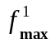) and the number of evacuees 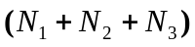, we can determine whether to turn the two coastal-bound lanes of I-26 into two lanes of Columbia-bound traffic or not if the following inequation satisfies:
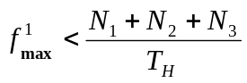. (16)
If yes, the capacities of the evacuation routes can be doubled and evacuation traffic flow significantly improved. If (16) is not satisfied yet after traffic reversal on I-26, reversal of traffic on US501 should be carried out, since it also can improve evacuation traffic flow. We named the above plan as Strategy I. Fig. 2 intuitively shows the evacuation traffic flow on I-26 changing with the time period of the predicted landfall of the hurricane, in which also gives the region for this situation.
In order to have a quantitative analysis, we now give an example to explain it. Using (16), we roughly calculate out that the traffic capacity of one lane on Interstate (e.g., route I-26) is 1120 cars/hour, and that on route US501 is 960 cars/hour. So,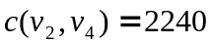cars/hour,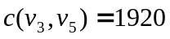cars/hour, and 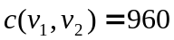 cars/hour. Assume a car is occupied by 2 persons and is 36 hours according to weather prediction. Based on the simulation results, the maximum traffic flows on the main routes are as shown in Table 1, we found that (16) was not satisfied, and I-26 and US501 should be reversed, so that the evacuating time became shorter.

4.2 Strategy II

Q: Several smaller highways besides I-26 extend inland from the coast. Under what conditions would it improve evacuation flow to turn around traffic on these?
A: If the traffic reversal on the principal routes (including I-26 and US501) cannot evacuate the coastal residents in time yet, we must consider the smaller highways around I-26 extend inland from the coast, which is our Strategy II. Since the use of the smaller highways is equivalent to improving the capacity of route I-26. In our model we change the capacity of I-26 to the sum of its original capacity and that of the smaller highways. The maximum flow (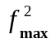) of Strategy I can be obtained and the inequation condition that Strategy II be adopted can also be derived as follows:
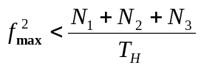. (17)
In the example for Strategy I, we found that (17) is not satisfied yet even if the traffic reversal on the principal routes I-26 and US 501 is carried out. This is because the traffic flow 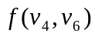 approach the maximum capacity 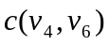, and the capacity of I-26 is inherence a bottleneck of the traffic network and limit the traffic flow from coast to Columbia. So we must turn around traffic on several smaller highways besides I-26 extend inland from the coast, such as US 178, US 176, and SC 6 in evacuating route published on the Web in 1999 [2], so that the capacity of I-26 can be indirectly improved. We also provide the results in Figs. 2, 3 and Table 1. From the table, we can see that the traffic flows on these roads are improved.

4.3 Strategy III

Q: What effect would it have on evacuation flow to establish more temporary shelters in Columbia, to reduce the traffic leaving Columbia?
A: As we know, the traffic flow entering Columbia depends on the traffic flow leaving Columbia on I-26, I-77, and I-20, and accommodation capacity in Columbia. If the traffic flows leaving Columbia on I-26, I-77, and I-20 approach their capacities, it will limit the traffic flow entering Columbia. This is another bottleneck of the traffic network. So if more evacuees are accommodated in Columbia, the traffic jam of the above bottleneck will be relaxed greatly. Also, recalling that the traffic leaving Columbia going northwest was moving only very slowly in 1999, so we should properly separate the evacuees onto I-26, I-77, and I-20. At the same time, the best way is to accommodate more evacuees in Columbia. Since there are only 184 hotels and motels in Columbia (Assumption 4), we must establish more temporary shelters to reduce the traffic leaving Columbia so that the traffic flow of the entire network can be improved. In our model, we simulate it by modifying the external flow of the nodes and , and add a constraint condition, 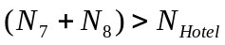, which means that the number of evacuees in Columbia is greater than that of people possibly accommodated in hotel and motel space in Columbia. As a result, the traffic flow leaving Columbia improved, and so the traffic flow entering Columbia did. The simulation results are also shown in Figs. 2, 3 and Table 1.

4.4 Strategy IV

Q: In 1999, many families leaving the coast brought along their boats, campers, and motor homes. Many drove all of their cars. Under what conditions should there be restrictions on vehicle types or numbers of vehicles brought in order to guarantee timely evacuation?
A: As we know, the capacity of each lane depends on the velocity of car and the capacity of each car, so restriction on the vehicle types or numbers of vehicles brought can improve the capacity of each route. When the capacity of each route improved, its maximum traffic flow can be improved and the evacuation time can be reduced. If we restricted the vehicle types, the drive speed on I-20 and US501 would be relatively increased, as a result, the capacity on I-20 and US501 would be increased. Also, the restriction on number of vehicles, resulting in the increment of number of people per car, can reduce the total evacuation time. If the above strategies I to III are carried out, and evacuation of the coastal residents cannot complete in time yet, this strategy (Strategy IV) must be taken into consideration. The condition is the maximum flow (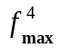) adopting strategies I to III satisfies:
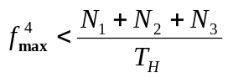. (18)
We also give the simulation results in Fig. 2, 3 and Table 1.

Table 1. The Strategies comparison leaving the coast to Columbia.
( Case 1 -- No compounding of the coastal residents of Georgia and Florida,
Case 2-- With compounding of the coastal residents of Georgia and Florida)

Performance measures of traffic flow (cars/hour) |  | Strategy I | Strategy II | Strategy III | Strategy IV
The Flow on I-26 | Case 1 | 4327.5 | 4496.8 | 5048.8 | 5770.1
The Flow on I-26 | Case 2 | 3854.4 | 3823.1 | 5049.5 | 5770.8
The Flow on US501 to I-20 | Case 1 | 1920 | 2240 | 2240 | 2560
The Flow on US501 to I-20 | Case 2 | 1920 | 2240 | 2240 | 2560
The Flow on I-95 | Case 1 | 330.6 | 356.5 | 385.7 | 440.8
The Flow on I-95 | Case 2 | 945.6 | 992.9 | 1193.7 | 1364.2

From the Figs. 2, 3, and Table 1, we can see that the evacuation times are different under different strategies with different traffic flows. The Strategy I is the worst case, while Strategy IV is the best one among the Strategy I to IV.

4.5 Strategy V

Q: In 1999, the simultaneous evacuation of the state's entire coastal region was ordered. Would the evacuation traffic flow improve under an alternative strategy that staggers the evacuation, perhaps county-by-county over some time period consistent with the pattern of how hurricanes affect the coast?
A: Considering the velocity of hurricanes and the length of coast, the time that the hurricanes pass over the coast after its landfall should not be ignored. According to the pattern of how hurricanes affect the coast (from the south to the north and from the east to west along the coast), the evacuees in the southern areas must complete the escaping ahead of those in the northeastern areas along the coast. So the strategy of evacuation county-by-county (Strategy V) maybe a good choice for this consideration.
To simulate the Strategy V, we first evaluate the time differences that the hurricanes reach Hilton Head, Charleston, and Myrtle Beach according to the velocity of hurricanes and the length of coast. Then we solve the model under the constrain conditions (3). We have combined Strategy V with the above Strategy I to IV, and their regions similar to those using only Strategy I to IV can also provided. Here, we only provide the comparison of maximum traffic flow of evacuating county-by-county (Strategy V combined with Strategy I to IV) and that of using only Strategy I to IV, as shown in Fig. 4. The evacuating times between them are compared and the results are shown in Table 2. From Fig. 4 and Table 2, we can see that: using Strategy V combined with Strategy I to IV, results in: (1) smaller required maximum traffic flow; and (2) shorter evacuating times than using only Strategy I to IV. That’s because we have considered the dynamic conditions of hurricanes in Strategy V.

Table 2. The comparison of evacuating times (hours) between using Strategy V combined with the Strategy I to IV and using only Strategy I to IV.
( Case 1 -- No compounding of the coastal residents of Georgia and Florida,
Case 2-- With compounding of the coastal residents of Georgia and Florida)

Strategy |  | I | II | III | IV
Completing simultaneously | Case 1 | 108.4571 | 72.2169 | 66.9649 | 61.8984
Completing simultaneously | Case 2 | 121.7968 | 78.1366 | 74.4905 | 63.8862
Escaping county-by-county | Case 1 | 105.4008 | 66.1916 | 61.0657 | 55.8962
Escaping county-by-county | Case 2 | 112.3379 | 72.7690 | 69.1319 | 56.5233

5 Sensitivity Analysis

There are two important implied factors to affect the performance of the entire network, which are the accommodation capacity in Columbia and the evacuees from Georgia and Florida came up I-95. Now we analyze how their changes will influence on the traffic flow of evacuation routes.
First, we discuss the impact of the accommodation capacity in Columbia on the model. Fig. 5 is the influence of evacuees accommodated in Columbia on the traffic flow on I-26. In the figure, we can see that, to strategy II, the accommodation capacity in Columbia (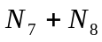) will have a great influence on the traffic flow of I-26. The traffic flow linearly increases with the number of the accommodated evacuees in Columbia. But the traffic flow on I-26 will has no change after the it reaches its capacity, even though the changing number of the accommodated evacuees. To Strategy I and strategy III, the variation of the accommodation capacity has no effect on the traffic flow on I-26 because the maximum flows of the routes leaving Columbia cannot reach their capacity, while the traffic flow of I-26 entering Columbia can reach its capacity. The above analysis results can also be extended to the combination of Strategy V with Strategy I to III.
Then, we analyze how the evacuees from Georgia and Florida came up I-95 influence on the traffic flow of evacuation routes. As we know, these evacuees will affect with the traffic flow on the entire network, especially on routes I-26 and I-95. Following, we provide two typical figures: Fig. 6 is the impact of evacuees from Georgia and Florida on the traffic flow on I-26; Fig. 7 is the impact of evacuees from Georgia and Florida on the traffic flow on I-95. From these figures, we can see that the evacuees escaping from Georgia and Florida will increase linearly the traffic flow on I-95, while have a different influence on the traffic flow on I-26 in Strategy I to IV. These changes depend on the capacity of I-26. The is the same case to the combination of Strategy V with Strategy I to IV.

6 Strengths and Limitations

6.1 Strengths

(1) In our model, we have in details discussed the impacts of the important factors, such as the traffic flow, the evacuees from Georgia and Florida, and established temporary shelters in Columbia. The macroscopic models for them are built, and computer simulations are also provided for further analysis. Though some assumptions in our model could make errors in our simulations, however, the model is flexible to be used in reality if real data are given.
(2) Our Evacuation Package considers many practical situations and contains many constants that are easy to be adjusted. Also, nodes can be added into or deleted from the network topology. One can easily prepare a general network model for a particular problem. Also, the objection function criterion, and the matrix form, the number of nodes, and the arc parameter/coefficient, and the flow bounds can be entered for the network connection.
(3) The graphical interface is a very intuitive way to organize data and to see the effects of the modeling. The measuring performances of different strategies are displayed in the screen simultaneously. One can intuitively compare the strategies based on the predicted landfall of the hurricane, traffic, hotel and other conditions. Also, the algorithms provide the best strategy which can give directions for the state officials to put forth better plans to evacuate the coast of South Carolina safely.
(4) The computer algorithm is fast. Given the practical data, the algorithms can quickly provide the best strategies for practical usage. Hence, our model can be applied in real time.

6.2 Limitations

There are several problems that our model must deal with.
(1) We could not test our model on real data. Further modifications need to be done so that the model is even more realistic. Such as, the estimated traffic flow on I-26, I-20, and US501, the evacuees from the coastal resident of Georgia and Florida, and the estimated hotel and motel space are not precise.
(2) Our assumptions may make our approximations with some errors. Such as, we have assumed that 250,000 evacuees spreading along the rest of the coastal strip were well distributed, and we divided them into the three sources , , and using the method of Golden Section.
(3) Though our model and the Evacuation Package can be extended to a general network model. But with the increase of nodes, the computation speed will be getting slow, and the accuracy of the solution will be influenced. Some more intelligent algorithms, such as genetic algorithms and neural networks, could be considered.

7 Discussions and Conclusions

We have presented a general maximum flow network model to evacuate the coastal residents of South Carolina, considering the traffic flow, population, route, hotel, and hurricane conditions and the congestion observed in 1999. We investigate different strategies to solve the traffic jam under different combined situations and compare them with performance measures of traffic flow. The traffic network model is constructed based on the given simplified map of South Carolina, but it could be extend to a general traffic network with m nodes and n arcs. Then we solve the model with general purpose linear programming algorithms. In our algorithms, five strategies under two different constraint conditions are discussed: (1) The simultaneous evacuation of the state's entire coastal region; (2) County-by-county evacuation strategy, according to the pattern of how hurricanes affect the coast. Also, an internal and an external factor are considered: (1) Non-consideration of the some of the coastal residents of Georgia and Florida came up I-95; (2) Consideration of some of the coastal residents of Georgia and Florida came up I-95, which will result in different evacuees leaving from sources of the coastline of South Carolina. Under various situations, we have compared different strategies and supplied the proper strategies to ensure the secure evacuating based on the regions in the figures. Moreover, since the traffic flow is an important performance measure in our model, we discuss how to find the traffic flow solution in details.
We developed an Evacuation Package to implement the simulation of the network model. In our algorithms, we have done a numerous of computer simulations under different assumptions. The graphical interface is a very intuitive way to organize data and to see the effects of the modeling under different conditions. The strategies can be intuitively compared based on the predicted landfall of the hurricane. Our Evacuation Package considers many practical situations and contains many constants that are easy to be adjusted. Given the practical data (including the current weather conditions and other data), the algorithms can quickly provide the best strategies for practical usage.
We should point out, since we could not test our model on real data, some assumptions in our model could make errors in our simulations. But the model is flexible to be used in reality if real data are given. Certainly, the reliability of the model could be advanced by further consideration on analyzing the network flow, such as, using the fuzzy flow analysis model [10]. Also, though our model and the Evacuation Package can be extended to a general network model. Some more intelligent algorithms, such as genetic algorithms and neural networks, should be applied on some situation, such as, by considering the increase of network size, so that the computation speed could be fastened, and the accuracy of the solution could be improved.

References

[1] Hurricane evacuation/lane reversal information, http://www.sctraffic.org/lane_reversal.html.
[2] http://www.state.sc.us/epd/.
[3] http://www.state.sc.us/.
[4] http://www.disastercenter.com/hurricf9.htm
[5] M. DeMaria (1997), Summary of the tropical prediction center/national hurricane center tropical cyclone track and intensity guidance models, http://www.nhc.noaa.gov/.
[6] Y.-A. Gan et al. (1998), Operational research, Tsinghua University Press, pp. 254-309.
[7] D.-Z. Du and P.M. Pardalos (eds.) (1993), Network optimization problems: algorithms, applications, and complexity, World Scientific Publishing Co. Pte. Ltd., Singapore, pp. 301-331.
[8] N. Gartner, G. J. Messer, and A. K. Rathi (eds.), Revised monograph on traffic flow theory, http://www.tfhrc.gov/its/tft/tft.htm.
[9] http://chilidog.lascruces.nmhs.edu/textbook/unit2/flow_solution.html.
[10] X.-H. Liu and H.-Y. Wang (1991), Network fuzzy stochastic analysis: theory, methods and program, Electronic Industrial Publishing Co..
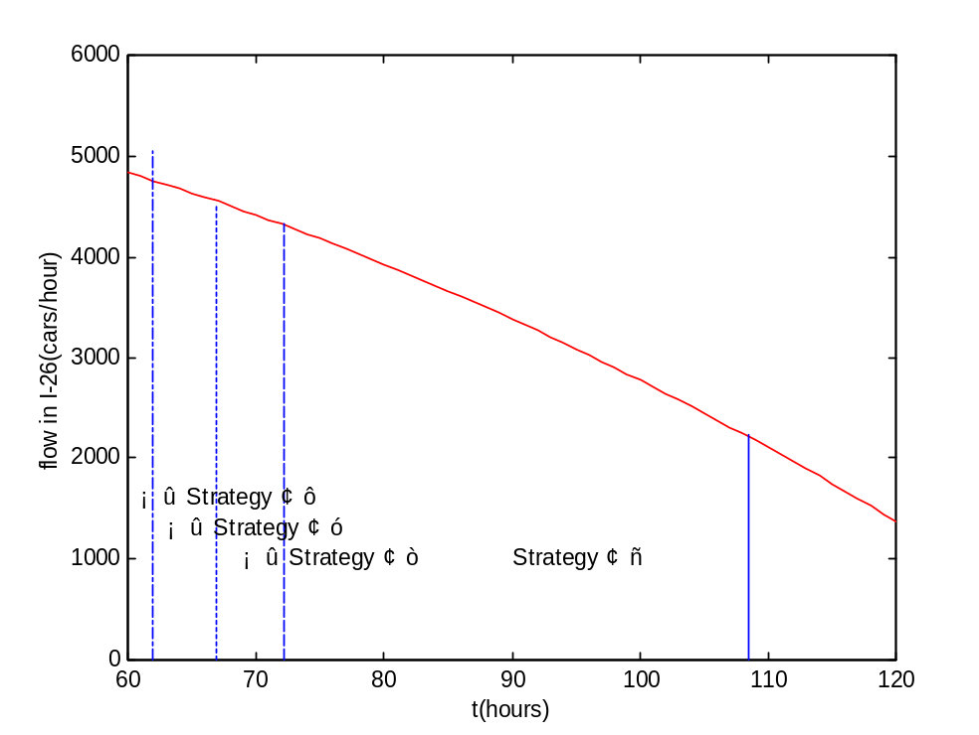
Fig. 2. The traffic flow on I-26 changing with the time period of predicted landfall of hurricane, resulting in different regions of the strategies (I to IV) to be carried out.
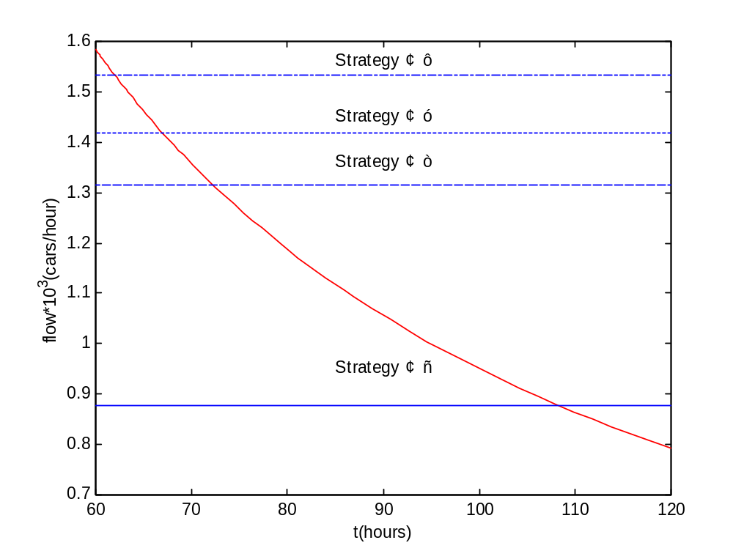

Fig. 3. The minimum total required traffic flow changing with the time period of predicted landfall of hurricane, resulting in different regions of the strategies (I to IV) to be carried out.

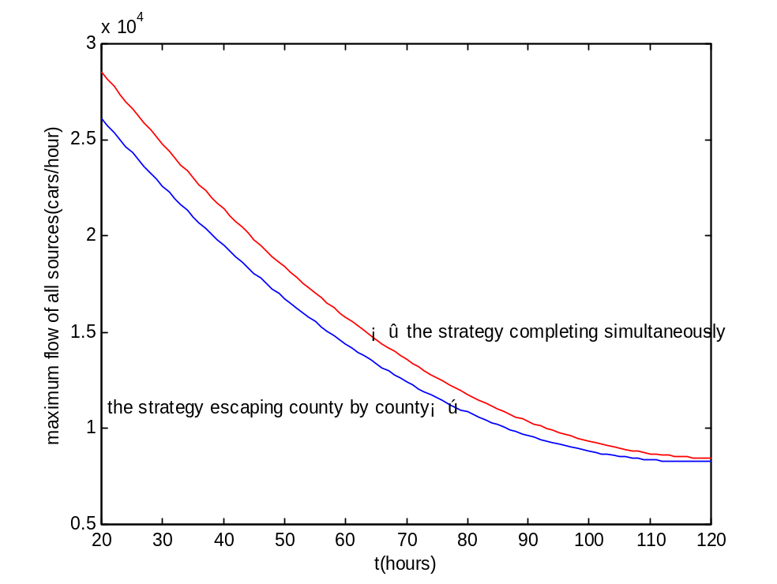
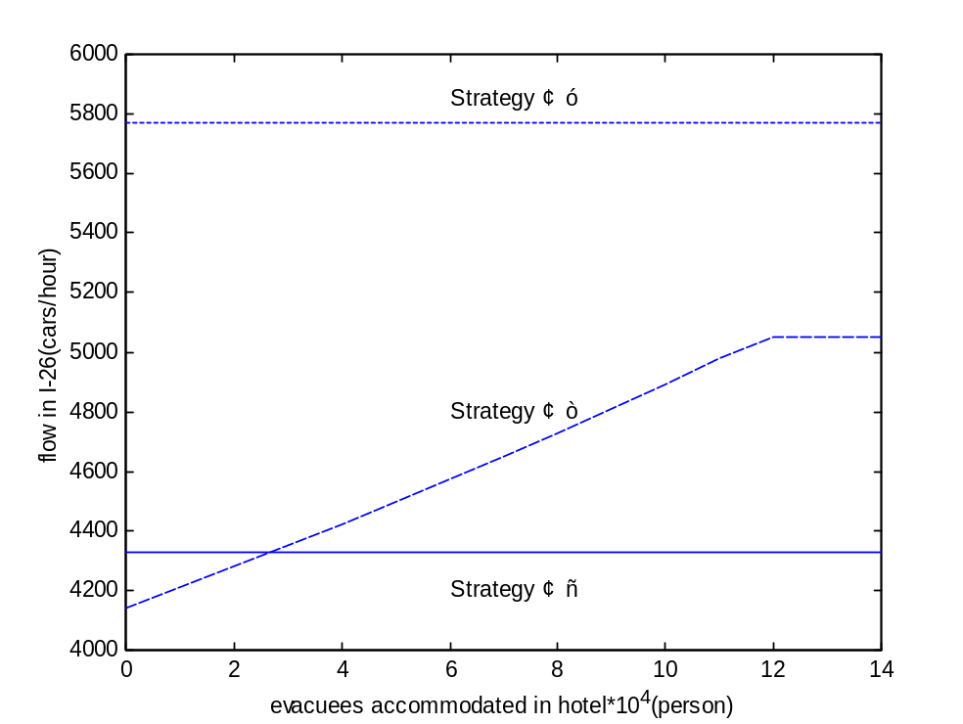
Fig. 4. The comparison of maximum traffic flow by evacuating county-by-county (Strategy V combined with Strategies I to IV) and in a simultaneous way (using only Strategies I to IV).

Fig. 5. The influence of evacuees accommodated in Columbia on the traffic flow on I-26, resulting in different regions of the strategies (I to III) to be carried out.

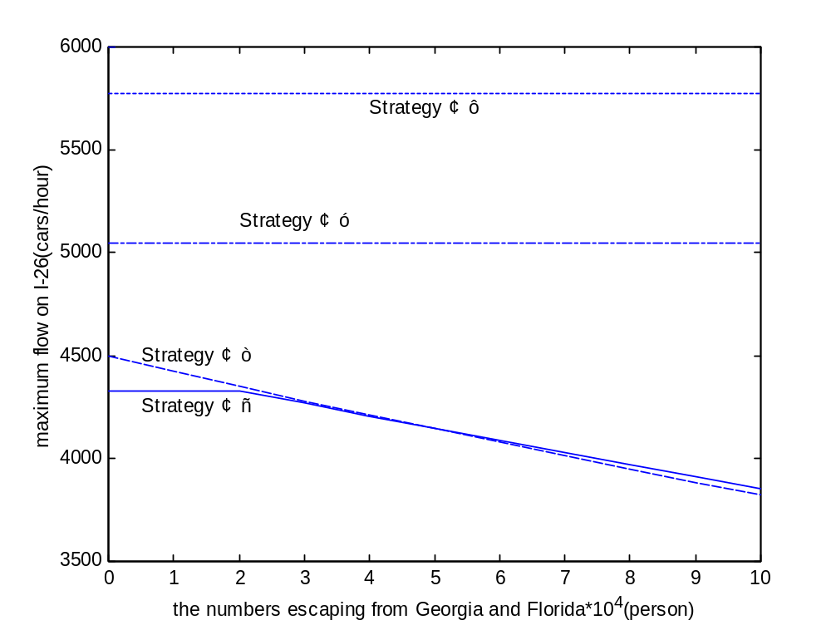
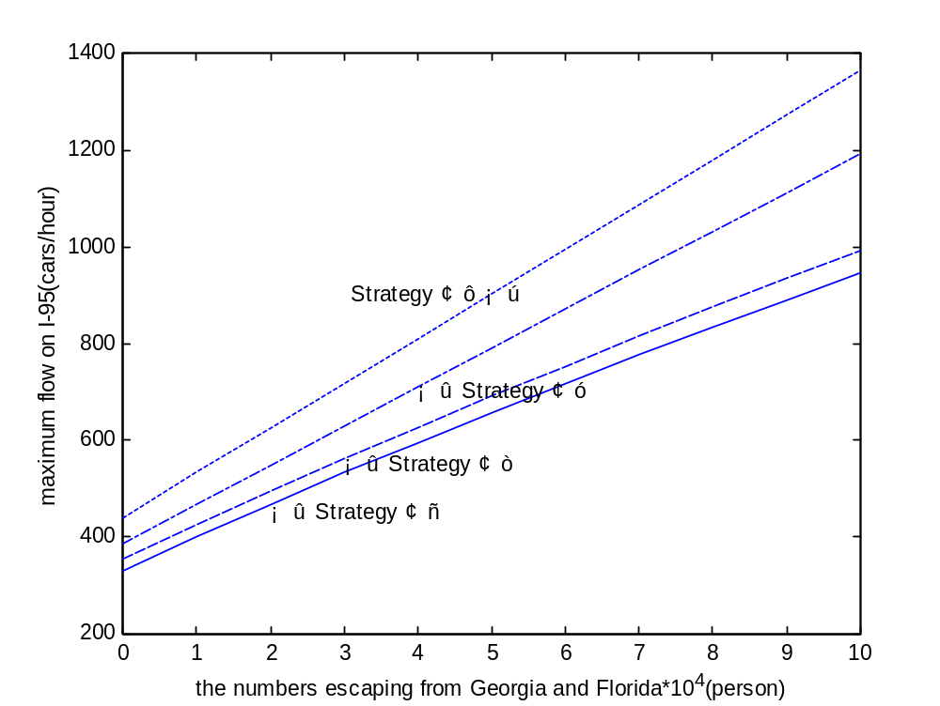
Fig. 6. The impacts of evacuees from Georgia and Florida on the traffic flow on I-26, resulting in different regions of the strategies (I to IV) to be carried out.

Fig. 7. The impacts of evacuees from Georgia and Florida on the traffic flow on I-95, resulting in different regions of the strategies (I to IV) to be carried out.

