“How much to overbook this flight?”

Introduction

Effective yield management can save airlines billions of dollars each year. One of the most important among the airline yield management problem is overbooking. The airline-overbooking problem arises from the propensity of airline customers. Occasionally, customers who have made reservations for a flight may not show up at flight time, because of schedule change or late arrival. In anticipation that no-show will occur, the airline may overbook the flight. The potential extra revenue from overbooking a flight must be balanced against its cost. These arise because in overbooking the airline runs the risk of not having sufficient seats to accommodate all customers, in which case it has to deny boarding of some passengers. Especially After 9.11, a horrific terrorist attack against the United States, the profit of airline has impressed very much. This also promotes us to seek better solutions in the current situation.
We developed a mathematical model to analyze the problem. All discussions are restricted to one-price single-class flight without large group-reservations.

Assumptions

- Most reservation requests are independent of each other , no group reservation.
- The flight is with one fare class and full price (i.e. no discount).
- The number of reservation requests is a random variable of Poisson distribution.
- Each passenger in possession of a booking shows up independently with some probability.
- A former cancellation can be substituted by a subsequent booking.
- Any no-show will obtain 100% refund for his ticket without any penalty.

Notations
 | price of one ticket
 | cost penalty of each oversold customer (included compensatory awards and loss of reputation)
 | random variable, the number of reservation requests
 | average of reservation requests
 | random variable, the number of on-shows
 | probability of a passenger with a ticket showing up.
 | capacity of the flight
 | booking level, the number of reservations set by airline company
d | refund percentage w.r.t the price of ticket
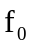 | necessary cost of one flight
(x) | cumulative probability function of standard normal distribution
φ(x) | probability density function of standard normal distribution

Model Development

Probability disrtibutions
Assume that follows Poisson distribution which average is , i.e. 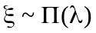. Each passenger with a ticket shows up independently with probability p. Thus, the distribution of depends on the value of . If the number of reservation requests is greater than the booking level, the number of on-shows follows binomial distribution with parameters,, i.e.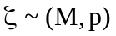. On the other hand, if , 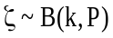.
Therefore, the universal distribution of follows
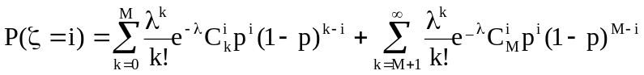 . (1)
where i = 1, 2, …,M.

Loss function
If the on shows matches the flight capacity, i.e. 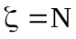, there is no loss for the airline and the revenue will get the ideal value 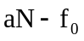. If 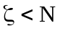, some seats are empty, the loss of airline is 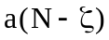. If 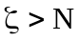, some of passengers will be denied boarding, and the loss of airline is 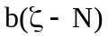.
So the loss function of the flight can be expressed
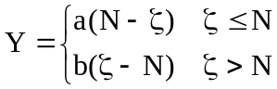. (2)
The revenue of airline in the flight will be
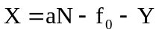 (3)
Notice that  gets the maximum as  gets the minimum.
From equation (1), The mean loss is
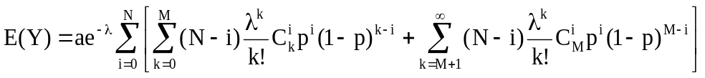 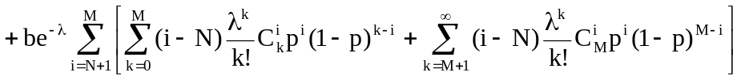 (4)

Approximation
The result of equation (4) might indeed be true, but the formula is too complex to compute. Usually it is convenient to treat and (the number of show up) as continuous (e.g. when is large), so we can use the normal distribution instead of the Poisson distribution and the Binomial distribution approximately.
Denote that μ = Mp, μ_{x} = xp, σ² =Mp(1-p), σ_{x}² =xp(1-p), z=(N-μ)/σ,
z_{x}=(N-μ_{x})/σ,u=(M-λ)/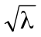, we have
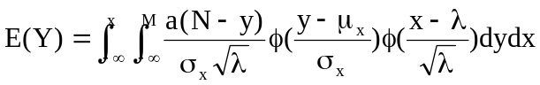
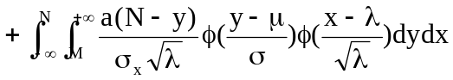
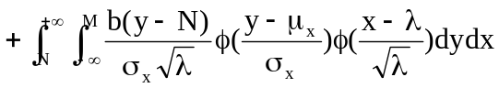
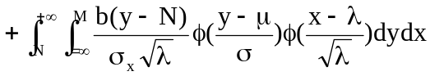
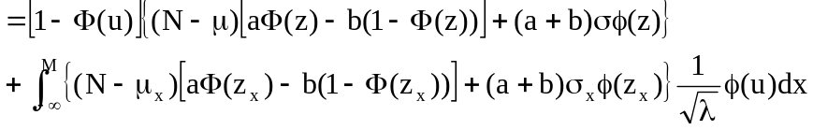 (5)
The optimal booking level can be decided by minimizing equation (5).
If λ is much higher than M, the second term in (5) will disappear, and appropriately,
E(Y) = (6)
Similarly, we can compute the variance of loss by
D(Y)=σ² [(a+b)²(z²Φ(z)+zφ(z)-(zΦ(z)+ φ(z))²)+a²Φ(z)+b²(1-Φ(z))]
(7)

Algorithm and Analysis

In order to find that gives maximum expected value, we take the partial derivative of equation (5) with respect to .
(8)
Set expression (8) equal to zero, after some cancellation terms, it implies
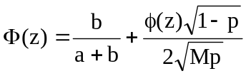 (9)
By solving the equation (9), we can get the optimal booking level.
Equation (9) is remarkably simple and consist with the findings of Bodily and Pfeifer in 1992. But their work is under the assumption that the optimal booking level is always reached. Our result is under uncertain actual bookings. Note that of equation (9) is independent of λ. So our model demonstrates that optimal booking level is independent of reservation requests in full-refund case.
From equation (9), we can conclude that the optimal booking level depends on three parameters: the on-show rate, the penalty proportion, and of course the capacity of flights.
The general decision rule given here for curtailing reservations maximizes expected contribution. This general rule provides useful guidance for making the overbooking decision in many situations, even those in which the decision is left to the judgment of an informed decision maker. It can also be used in a historical analysis of overbooking performance to determine if the company has been too conservative in its overbooking policy.

A Simple Rule:
Usually, the second term in equation (9) is very small, so the spoilage probability can be evaluated by the penalty proportion approximately. If a>b, we have M<N/p. If a<b, then M>N/p.

Part-refund model

It might be argued against the above model that each no-show will get 100% refund without any penalty. Following, we will give a model less restrictive.
Define 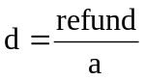 as the refund proportion
Then the loss becomes
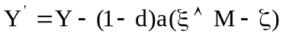 (10)
Here the symbol represents the small one between and , such that 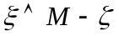 is the number of no-shows.
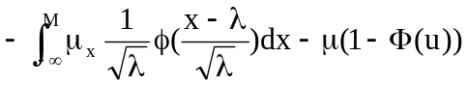
(11)
From equations (5), (10) and (11), optimal booking level follows the equation
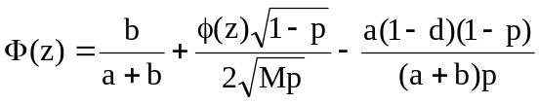 (12)
By solving the equation (12), we can get the optimal booking level for part-refund case.
Comparing with equation (9), we find when in part-refund case, the decision is still independent of the market demand. From the 3rd term in equation (12), the smaller the refund is, the smaller the spoilage probability. This implies the difference between fare and refund gives higher overbooking.

Numerical Analysis

To test our model, we numerically minimizing equation (4) to find a optimal strategy and compare it with the solution of equation (9). We find they match very well. And we test the sensitivity of optimal solution with respect to some factors. We find that the on-show rate is the main factor, which impressing the booking level very much. The compensate cost may make obvious influence on the net revenue of the company surely, but it has little influence on booking level. On the other hand, in a dead season or a midseason, the reservation requests have little influence on booking level, too.
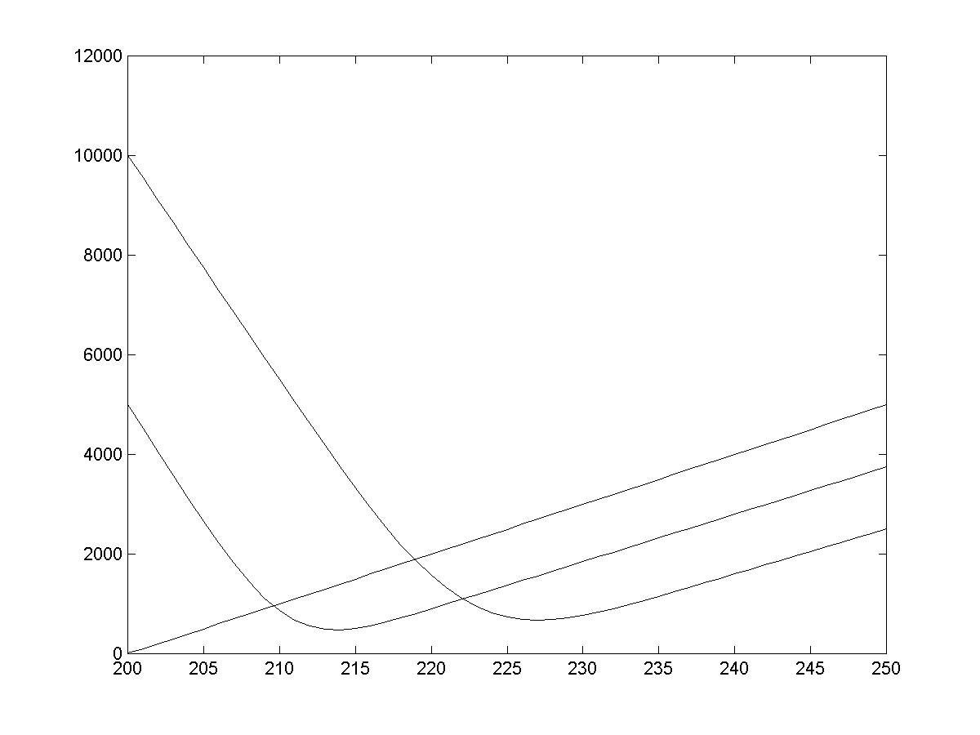
According to figure1, when 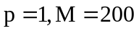, the airline company have no loss, which is consistent with practice. When 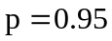or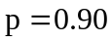, corresponding to the optimal booking level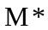, we can get the respective possibility of no less than 5 DB is 0.4131,0.5265. Namely, if  decreases, the optimal loss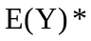, * and the DB number will increase.
Figure 1. The relationship of
and
with different showing up percentage
, where

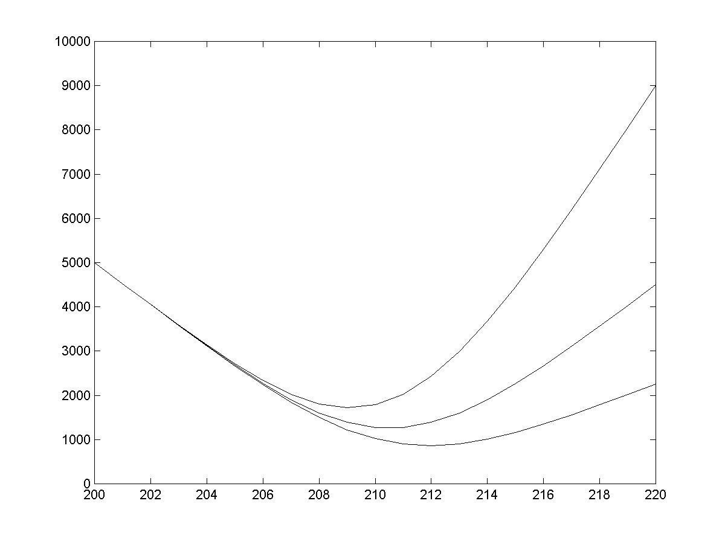
Figure 2. The relationship of
and
with different cost penalty
, where

According to figure 2, if increases, will increase, and will decrease. When 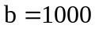, 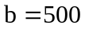 or 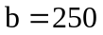, corresponding to , the respective possibility of no less than 5 DB is 0.0771, 0.1311, 0.2063. That shows DB number is sensitive to the change of . By contraries, is insensitive to it. In practice, the airline company takes a conservative overbooking strategy with high cost penalty.

Discussions

Less flights by airline from point A to point B
The amount of cost penalty depends on the length of time for which the traveler is delayed. If there are less flights by airline from point A to point B, high cost penalty will be paid. Therefore, lower booking level should be taken.

Heightened security at and around airport
The airport personnel check the passengers’ credentials before they board the planes. Passengers without credentials will become no-shows involuntary. In addition, it takes long time to perform intensive checks. Those who arrive late can’t have enough time to pass the fussy checks. Therefore, the probability of a ticket-booked passenger be no-show 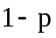will increase when security is enhanced at and around airport. According to our analysis, higher booking level should be taken in this situation.

Passengers’ fear
When some unexpected aero calamity happen in succession, those who have booked the tickets may be change their travel plan. Many passengers may be no-show in this situation, viz. will decrease. Therefore, the airline company will take higher booking level.

Loss of billions of dollars in revenue by airlines to date
The airline companies with poor financial situation cannot receive high risk. Once many people were denied boarding, they may not be capable to support the high cost penalty. So they prefer to a more conservative strategy. Namely, they want to get a lower variance of loss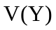. According to our analysis, p and b effects the possibility of high DB number. These airline companies will prefer to a higher and a low . The optimal booking level can be calculated from the equations in our model. If the loss in revenue to date is very large, the airlines appear to be too weak to suffer great loss, it should be more conservative.

Alternatives handling of “bumped” passengers

Handling of “bumped” passengers appropriately could depress the average compensate and reduce the loss of airlines. It depends on the cooperation of different flights and the treatment skills in practice. Usually ticket incentive is a good way for both the airlines and the passengers.
In practice, airline companies consider not only their own benefit, but also the passengers’ satisfaction. Now we discuss the effects that passengers’ satisfaction have on the maximization of the average revenue.
We assume the passengers’ satisfaction degree 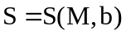. Higher cost penalty is more satisfactory, 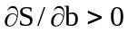. According to the rule of marginal utility depression, 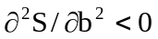. On the basis of practice, we make the following assumptions:
(a) 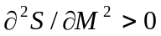 . Passengers are most satisfied at an adequacy . will be unsatisfactory if it is too high or too low.
(b) 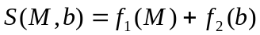 . The effects that or have on is not relational.
Therefore, if 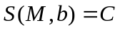is fixed, 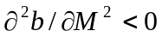.
Assume that when 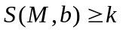, the strategy airline company taken is acceptable by passengers. 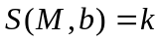 is passengers’ acceptance boundary.
The average revenue 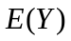is relative to and ,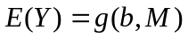. We can get the optimal s.t. 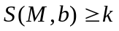, which reaches the balance of airline company benefit and the passengers’ satisfaction.

Comments
Returning our contest problem, from our model analysis we find often the problems of overbooking cannot be attributed to any single part of the system. For example, if major queues develop at security checks, is it because the security service is inefficient, or have the queues been caused by exceptional flight delays giving rise to unplanned traffic peaks? There may well be more effective solutions than conservative DB compensation standards which might be impractical. The wide variation in air travel products, from low-fare to first class travel and different airports with different on-show probability, passenger reservation request can hardly be expected to have uniform forecasting. For an airline company it might be a solution to have regional or specific voluntary agreements such as " compensation standards agreements" between airline company and their airline customers.

Reference

[1] Subramanian, J. and Stidham, S. Jr., and Lautenbacher, C. J., Airline yield management with overbooking, cancellations, and no-shows, Transp. Sci. 33: 147-167 (1999).
[2] Chatwin, R., Conyinuous-time airline overbooking with time-dependent fares and refunds, Transp. Sci. 33: 182-191 (1999).
[3] M.Rothstein, An airline overbooking model, Transp. Sci. 5: 180-192 (1971a).
[4] M. Rothstein, Airline overbooking: the state of the art, J. Transp. Econ. Policy 5, 96-99 (1976b).
[5] M. Rothstein, Hotel overbooking as a Markovian sequential decision process, Decision. Sci. 5: 389-404 (1974).
[6] M. Rothstein, Airline overbooking: fresh approaches are needed, Transp. Sci. 9, 196-173 (1975).
[7] M. Rothstein, O. R. and the airline overbooking problem, Opns. Res. 33, 237-248 (1985) .
[8] Vickrey, W.S., Airline overbooking : some futher solutions, Journal of Transport Economics and Policy 6, 257-270 (1972a).
[9] R.E. Chatwin,Multiperiod airline overbooking with a single fare class, Opns. Res. 46, 810-819 (1998).
[10] Weatherford, L.R. and Bodily, S.E., A taxonomy and research overview of perishable-asset revenue management: yield management, overbooking, and pricing, Opns. Res. 40, 5, 831-844 (1992).
[11] Bodily, S.E. and Pfeifer, P.E., Overbooking decision rules, Omega, 20,192-133 (1992).
[12] Meidan,A., Hui-Lin, C., Hotel reservation methods—a discriminate analysis of practices in English Hotels, International Journal Of Hospitality Management 14, 2, (June 1995).
[13] Kasilingam, R. G., Air cargo revenue management: Characteristics and complexities, European Journal Of Operational Research 96, 1 (January 1997).

Appendix: Memorandum to the airline’s CEO

How to decide the level of overbooking

As a part of your company yield management techniques, airlines regularly take more bookings than their capacity to compensate the proportion of passengers who have bookings be not show up ultimately. Computer analysis predicts the level of overbooking for each flight to ensure aircraft operate at its maximum capacity. By maximizing the available capacity, this practice benefits consumers as well as airlines. The alternative would be fling with empty seats, reducing capacity offered to customers and leading to great loss. In most cases the practice work fine. Occasionally when more passengers turn up than there are seats, some passengers are denied boarding. It can be a significant inconvenience to those it affects, and your company has to compensate for the inconvenience. Especially in light of the situation:
Less flights by airlines from point A to point B
Heightened security at and around airports
Passengers' fear
Loss of billions of dollars in revenue by airlines to date

Analysis and Findings

We are honored to build a mathematical model and to share our findings.
Firstly, we find the likelihood of passengers on-show is the main factor, which impressing the booking level very much. Secondly, the compensate cost will make obvious influence on the net revenue of the company surely, but it has little influence on booking level. On the other hand, in a dead season or a midseason, the reservation requests have little influence on booking level, too. Heightened security check may make some boldness passengers to be no-shows, as well as passengers’ fear would debase the on-show rate. Under both situations, the airlines should raise booking level properly. The optimal booking level can be calculated from the equations in our model.

Our suggestions

·From our model, we give a well-founded booking level algorithm. According to this algorithm the company can forecast the booking level approximately.
·Handling of “bumped” passengers appropriately could depress the average compensate and reduce the loss of airlines. Usually ticket incentive is a good way for both the airlines and the passengers.
· If the loss in revenue to date is very large, the airlines appear to be too weak to suffer great loss, it should be more conservative.

I am pleasured if our findings do some assistants to your company.

