第二届“认证杯”数学中国
数学建模国际赛
承 诺 书

我们仔细阅读了第二届“认证杯”数学中国数学建模国际赛的竞赛规则。
我们完全明白，在竞赛开始后参赛队员不能以任何方式（包括电话、电子邮件、网上咨询等）与队外的任何人（包括指导教师）研究、讨论与赛题有关的问题。
我们知道，抄袭别人的成果是违反竞赛规则的, 如果引用别人的成果或其他公开的资料（包括网上查到的资料），必须按照规定的参考文献的表述方式在正文引用处和参考文献中明确列出。
我们郑重承诺，严格遵守竞赛规则，以保证竞赛的公正、公平性。如有违反竞赛规则的行为，我们将受到严肃处理。
我们允许数学中国网站(www.madio.net)公布论文，以供网友之间学习交流，数学中国网站以非商业目的的论文交流不需要提前取得我们的同意。
我们的参赛队号为：1398
我们选择的题目是： B题
参赛队员 (签名) ：
队员1：吕骥

队员2：刘永

队员3：邹晨阳

参赛队教练员 (签名)： 无

第二届“认证杯”数学中国
数学建模国际赛
编 号 专 用 页

参赛队伍的参赛队号：（请各个参赛队提前填写好）：

1398

竞赛统一编号（由竞赛组委会送至评委团前编号）：

竞赛评阅编号（由竞赛评委团评阅前进行编号）：

Opportunity chain structure and its simulation modeling research in enterprise’s human resource management
Abstract: Human resource management is an important part for the modern enterprise development. However, there are so many problems existing in today’s human resources of China and how to manage human resources effectively is still a very practical subject. In this paper we have established an Opportunity Chain Model which is based on the subject, focusing on solving the human resource management issues in the enterprise and combined the small-world networks and the Monte Carlo simulation methods to discover the law of movement for persons within the enterprise for the purpose of solving the human resources consumption problems in the next five years.
For the problem (1),through the comparison of the "freeze" and "flow" system, we found a continuous flowing of job opportunity and abandonment of the existing work are the two necessary conditions to maintain the opportunity chain. And when comparing the worker’s salary change of position flow, we can find that each person’s salary level is increased.
For the problem (2), we understand the movement of persons within the enterprise before and after the change by introducing the main ideas and methods of modeling from the perspective of complex adaptive systems, and get the solution to determine the number of candidates by using the computer simulations to simulate individual behavior in this complex process work queue.
In the paper we constructed an Opportunity Chain Model, defined the state of the body through the conversion and the "small world" network model to describe the rules of conduct between the subject, and got a simple simulation modeling framework which could be used to simulate the flowing process. Thus, it is possible to set dynamically extensible rules and adjust the model parameters, which provides a convenient simulation environment for the researchers. Then according to the number of "vacancy", through Monte Carlo simulation to generate random Numbers, determine the number of applicants. It’s found that when there’s a vacancy, the enterprise need 10 candidates, two openings, need 20 candidates. Finally, according to the above results, we can determine the change of the human resource cost over the next five years.
Years | 1 | 2 | 3 | 4 | 5
Human resource cost | 29500 | 51500 | 56000 | 56000 | 53000

At the end of the paper, the model is evaluated and some improvement program are given for better future work .
Key words: Human Resource Management; Opportunity Chain; Complex Adaptive System; Human Resource Cost
Contents
1. Introduction………………………………………………………………………………………………..6
1.1 What is “opportunity chain”.................................................................................6
1.2 Why do we use the “chain”..................................................................................6
1.3 The analysis of the structure and function of opportunity chain……………… 6
1.4 Introduction about complex adaptive system which based on the subject……. 7
2. The Description of the Problem…………………………………………………..7
2.1 How do we approximate the changes in human resource consumption over the next five years................................................................................................................7
2.2 How to describe the change of people’s change..................................................7
2.3 How do we approximate the cost of human resource..........................................8
2.4 How to consider the question that how many job-seekers will meet the needs of employers and employees at the same time...................................................................8
2.5 What if there is no data available.........................................................................8
3.Models…………….…………………………………………...……………………8
3.1 Basic Model……………………………………………………………………..9
3.1.1 Definitions and Symbols………………………………………………………...9
3.1.2 Assumptions…………………………………………………………..…10
3.1.3 Chance chain simulation model which is based on the subject………….10
3.1.4 The model of ability change which is based on the “small world” network………………………………………………………………………………12
3.1.5 Human resource cost calculation model…………………………………13
3.2 Solution and Result……………………………………………………………………14
3.2.1 The answer for question (1)……………………………………………...14
3.2.2 The answer of question (2)………………………………………............15
3.2.3 Advantages and disadvantages…………………………………………..17
3.2.3.1 Advantages……………………………………………………….17
3.2.3.2 Disadvantages……………………………………………………18
4.Conclusions………………………………………………………………………..19
4.1 conclusion of the question……………………………………………………..19
4.2 Application of the model………………………………………………………19
5.Future Work………………………………………..……………………………..19
5.1 Improved Model……………………………………………………………….19
5.2 Another model………………………………………………………………...20
5.3 Another kind of flow…………………………………………………………..20
6.References…………………………………………………………………………21
7.Appendix…………………………………………………………………………..21

I. Introduction
In order to understand the “chain” model better, the following background is worth mentioning.

1.1What is “opportunity chain”?
The incumbents are eager to get a better career, so they will flow to the more attractive jobs. And this causes the original position vacancy, providing others with new jobs.The position vacancy, fill-up and exchange that resulted from internal employee’s turnover, and which also results in a series of career opportunities—called chance chain.
As is shown in picture 1:

C
out-
side
C
E
g
E
d
F
F
out-
side
g
d

Picture 1: the sketch map of chance chain

PS: The chain begins at the top, ending at the bottom. The upper of the ellipse is on behalf of people, the lower on behalf of the work or environment the people in (Position g is higher than position d), the arrows represent transfer among them, ···,then F comes into the network.

1.2 Why do we use the “chain”?
Human resource management is a theoretical, technical and practical work. But there are many problems, like the unreasonable human resource structure, serious brain drain from the work, less investment in human capital, backward training system and so on, in most companies in our country, when compared with the developed western countries’ standardize human resource management.
The application of the “chain” can help companies mining the relation between the internal positions. And we can solve problems, like the brain drain, imbalance between supply and demand, too old methods in management, which may appear in the work of human resource management, by analyzing the impact of career mobility, so that it can help companies excavate potential talents, improve the level of human resource management.

1.3 The analysis of the structure and function of opportunity chain
Opportunity chain is made up of vacancy chain, mobile chain.
Vacancy chain is formed by the position vacancy when employees leave from the work. Position vacancy can affect how the company work, so the HR department will bring in new employees to make sure that the company work well.
Mobile chain refers to the career mobile chain that resulted from the predecessor’s left and job seekers’ involved. With the development of the world, there is more and more space in career development, more and more alternative opportunities when seeking jobs. And people who have more capabilities are willing to pursue better career. So the mobile chain of career will always inject fresh blood to the human resource market, companies finding out the right employees, job-seekers owning better rewards and development for career.

1.4 Introduction about complex adaptive system which based on the subject
The main idea of CAS(complex adaptive system) is, the complexity of CAS is originated in the adaptability of the subject, the interaction between the subject and the environment, and other subjects, constantly changes themselves, also the environment. New structure and phenomenon of overall level and the more complex behavior will be highlighted through the interaction of the subjects.
Since the 1990s, simulation modeling technology which based on the subject(Agent) is widely used in research in the field of social economy and ecology, etc. This is a "bottom-up" object-oriented simulation modeling method, using the latest research achievements in the field of artificial intelligence and computer science, directly at the micro level simulation system of the main body, and based on the rules of the interaction between subject and subject, and thus the overall behavior of the system.

II. The Description of the Problem

2.1 How do we approximate the changes in human resource consumption over the next five years?
- Opportunity chain modeling and simulation mainly achieve three parts, the subject modeling (real-time data objects), the definition of simulation rule and the indication of simulation results.
- The subject modeling (real-time data objects): Analyzing the data base and research report, extracting the relevant information, adopting the OOM (Object oriented method), the subject of the program is created by modeling.
- Definition of simulation rule: We can define the rule of emulational subject’s state switching and its behavior by defining some indexes, for example, whether the subject is at the age of retire, whether there is some space to let its capability improve, whether its capability satisfy the vacant career’s need.
- Indication of simulation results: Let it come true when search the subject’s career, age, capability and so on.

2.2 How to describe the change of people’s change?
Due to the ability of people has obvious group, so we choose the “small world” model, which can reflect the influence of people’s ability, to study the impact among company’s internal person through their communication, so that we can know how it influence their ability.

2.3 How do we approximate the cost of human resource?
The cost of human resource includes selecting, training, employing, circulating and so on. So we will make an investigation on these aspects.
- Selecting cost: When the company appears career vacancy, we need to make a supplement for the position by selecting job-seekers or promoting internal employees, and the cost in this process can be a constant value in some cases.
- Training cost: The employees need training when he or she is in a new company or new position. The cost is inversely proportional to the subject’s ability when we use the basic model.
- Employing cost: When the new employees participate in the work, the company needs to pay salary and welfare to them which can satisfy each other.
- Circulating cost: When someone retired, the company will pay a severance.

2.4 How to consider the question that how many job-seekers will meet the needs of employers and employees at the same time?
When there is a career vacancy in an enterprise, in order not to affect the profits and competitiveness of the enterprise, it is necessary to go to the talent market for recruitment to make a supplement. From the perspective of the business, it hopes the vacancies can get a reasonable addition, and recruitment costs as little as possible as well.

2.5 What if there is no data available?
The adjustable parameters of the model can be divided into two categories, one is used to reflect the property and the mutual influence of the subjects, another is used to control the length of the model’s simulation cycle on the macro level. The subjective indicators are quantified by quantitative variables. The initial values of parameters is based on the summary, abstract or other simplified means of existed research materials.
Now suppose that a enterprise composed of 50 people, enterprises have five positions, salary is the same when in the same position and the salary is proportional to the position’s level.

III. Models

3.1 Basic Model
Simulation modeling steps which based on the "chain" are shown in figure 3
To abstract the Agent, and analyzes the relationship between the Agent
Select the scheduling class to control overall execution of the program

Choose the appropriate space to describe the relationship between the agents

Select the appropriate input and output; Set the parameters of the simulation program and input data; Run
the simulation program

;lkll

Implementate the subject and define its properties and behavior rules

Figure 3 Simulation modeling steps

3.1.1 Definitions and Symbols
1) Definitions:
1．The male workers retire at 60 years old, female workers at 55 years old
2. The workers who are younger than 45 years old can learn from the people around, improving their ability.
3. The age of workers in the enterprise conform to a rule, it’s age~N(45,30)
4. In order to measure the ability of each subject, the ability of initial strength A_{n} is measured by a number between 0 ~ 5, namely 0≤A_{n}≤5. The greater the value of A_{n}, the subject ability stronger; the smaller the value, the less subjective ability.
2) Symbols
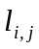：the matrix relationship between i, j
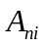：the first n years the ith personal ability
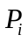：the ith personal position
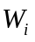：the ith personal salary
RC: recruitment costs
TC: training costs
KC: employing costs
FC: Circulating costs

The remaining symbols will be given instructions in the paper when used.

3.1.2 Assumptions
1. The “vacancy” only refers to the situation that resulted from retirement
2. The flow in the chain only take what is caused by “vacancy” into account, it means ignoring the personnel transfer, promotion, redundancy, etc
3.Work is defined as a person in a certain time only to have one job.
4. The subject’s position changes only from low to high.
5. The number of company position remains the same.
6. When there is a "vacancy", give priority to promote enterprise internal employees.
7. Subject's ability in the talent market obeys the 0-1 distribution.
8. Under the condition of the ability to achieve, people can adapt to the position (i.e. as long as the capacity is enough, people can adapt to all positions)

3.1.3 Chance chain simulation model which is based on the subject
1) The subject modeling:
Subject modeling uses the object-oriented method. Through the analysis of the related data items in existing enterprise system, extract the important factors influencing the personnel changes, the definition of main member variables of the class is shown in figure 4. The member variables can also be added or removed according to different simulation.
Member variables | Definition
ID | The logo of Agent
Age | The basic attribute information
Gender | The basic attribute information
Ability | Subject's ability
Position | Subject's position
Wage | Subject's salary

Figure 4 The definition of main member variables

2) The definition of the rule
Rules include position shift rule and the behavior rule, it is the basis to guide the Agent state transition, the change of the subject’s behavior and the execution of simulation program.

2.1)In the definition of state transition rule, subjects can be divided into two categories: the subjects of internal and external.
Internal subject state transition rules are defined in the condition of the transformation judgment: whether to reach retirement age, whether the ability to arrive at the new job requirements. When the subject comes to transition conditions, the state of the subject in the system will change, as is shown in figure 5.
Ability comes to the requirement of
new position
Original
position
environment
Not at the age
of retirement
At the age of retirement

Ability don’t match the new position

Figure 5 Internal subject state transition：

External subject state transition rules are defined in the condition of the transformation judgment: whether to reach into the requirement of the enterprise, whether to reach retirement age, whether the ability to arrive at the new job requirements. When the subject comes to transition conditions, the state of the subject in the system will change, as is shown in figure 6.
New position
Position
Training
Don’t meet the position’s require
Enterprise
Environ-
ment
Not at the retirement age

Meet the enterprise’s requirement
Meet the position’s requirement

Don’t
meet the
new
position’s
requirement
At the retirement age

Figure 6 External subject state transition

2.2) The rules of the simulation program execution are defined by the rules of behavior, it is the definition of space-time transformation process of subject’s property. In the flow, the behavior rules are determined by each subject according to their different age, ability, and the related influence rules. Each time step (1 year), will judge the current state of all the principals (the change of position and the ability), and in turn make a series of actions according to the various subject status, make it come true by calling the related function.

3) Indication of the simulation results: The simulation results mainly show the ability of the current and n years later, the current, n years later work level and its change and vacancies (n = 1, 2,..., 5).

3.1.4 The model of ability change which is based on the “small world” network
We put the enterprise as the nodes in the network, the contact relationship between people is expressed as connection between nodes. To the individual, for example, i now has the ability A_{n,i}(i=1,2,…,N) in the first n years. Might as well put the number of its people through interpersonal every day is K1, "effective vector" is (should be a relatively fixed value, thus assume~ N (0.05, 0.01), and use l_{i,j} to show the effect of the first j personal relationship matrix.
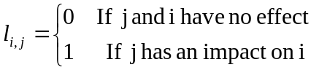 (1)
And meet
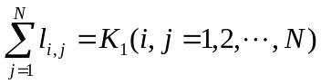 (2)
After a year’s contacts and influence, because of i contacting with different people, the i person’s increment of ability is:
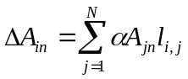 (3)
After a year's ability :
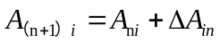 (4)

3.1.5 Human resource cost calculation model
By the analysis of 2.3, the costs of human resources includes recruitment, training, retain, flow and so on, and are related to the number of people. So we must examine respectively from the several links.
1) Recruitment costs:
Set up recruitment unit consumption costs for constant R, so cost for recruitment:
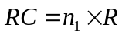 (5)
2) Training costs:
Set up training unit consumption costs for constant T, so cost for training:
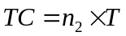 (6)
3) Retaining costs:
Set up retaining unit consumption costs for constant We , so cost for retaining:
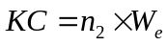 (7)
4) Circulating costs:
The severance for the workers who are retired should be proportional to the position. For the proportion coefficient k, therefore, the cost for Circulating is:
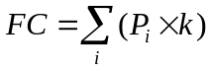 (8)
5)Total costs:
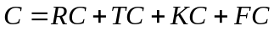 (9)

3.2 Solution and Result

3.2.1 The answer for question (1):
The exchange of work and social development strategy in the queue, is good for everyone. But we can't apply it to all of the industry, it needs to satisfy the following conditions:
According to vacancy model ^{[2]}, a system without "death" and new job is frozen, has no vitality, cannot make normal circulation flow of people to a more suitable job. As is shown in figure 7, when no vacancy, A, B and C account for their own work, flowing of A, B and C will not occur. Under the condition of invariable in digits, outsiders will not flow into the enterprise.
A
a
B
b
C
c

Figure 7 Freezing system schematic diagram
A continuous influx of new work and existing abandonment, is an important part of the cycle, and also is the necessary condition to simply maintain for the system. As is shown in figure 8.
C
out-
side
C
Select the appropriate input and output; Set the parameters of the simulation program and input data; Run
the simulation program

;lkll
E
g
E
d
F
F
out-
side
g
d

Figure 8 Freezing system schematic diagram
In addition, vacancy must have enough attraction to individuals with transfer, such as higher wages. It is necessary conditions to maintain the system easily. Figure 9 reflects the enterprise personnel flow, the arrow reflects the flow direction of the subject’s position a year later, the circle indicates the current vacancies.
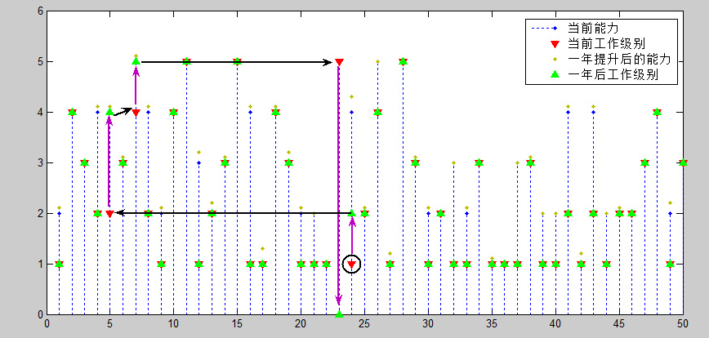
Current ability
Current work level
Improved ability
one year later
Work level one year later
Figure 9 Business flow diagram
Figure 10 reflects the transform of salary after changing work level (retired people ignored).
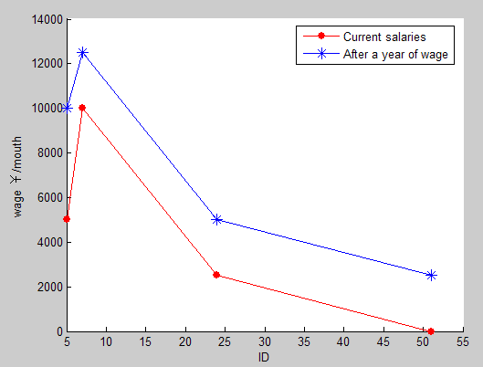
Figure 10 The comparison chart of salary change after the change of position
From the above, we can see everyone’s salary has improved after position flow.

3.2.2 The answer of question (2):
1) Analysis of job seekers’amount
Discovered by figure 5, the "open" position 1 by 24 subject a year later, need to be supplied by recruitment from the talent market. By assumption 5: subject's ability in the talent market obeys 0-1 distributed (p = 0.2), and now the MATLAB generated random number (the number is the number of applicants).
When n=5, the candidate’s ability to:
0 | 0 | 0 | 0 | 0
When n=10, the candidate’s ability to:
0 | 0 | 0 | 0 | 0
0 | 0 | 1 | 0 | 0

When n=15, the candidate’s ability to:
0 | 0 | 0 | 0 | 0
0 | 0 | 0 | 0 | 1
0 | 0 | 0 | 0 | 0

Therefore the above analysis shows that when n = 10, which need 10 candidates to meet the demand of Marketing Department in the first year of "vacancy", leading to the supplement of vacancies. In the same way, we can get the number of applicants that various departments need each year as shown in table 1:
年份 | 1 | 2 | 3 | 4 | 5 | 合计
所需人数 | 10 | 20 | 20 | 20 | 20 | 90
Table 1 The number of job seekers required
by all departments in the next five years
The results of inspection:
When p = 0.2, there is a vacancy, it needs ten candidates. Using MATLAB randomly generated 10000 times, the rate of there is more than one whose ability appears to 1 rate is reached 90%. Therefore, it can be thought of meeting the requirements.
When appeared two openings, it needs twenty candidates. Using MATLAB randomly generated 10000 times, the rate of there is more than 2 whose capacity is 1 reached 93%. Therefore, it also can be thought to meet the requirements.

2) The analysis of human resource cost in five years
By the analysis of the 3.15, we can understand its change trend by simply assignment for each parameter. Various parameters are determined by basing on the existing human resources cost summary, abstract, simplified methods, as shown in table 2. In the next five years the cost of human resources is shown in figure 11.
Parameter | Values
R | 100
T | 1000
W_{e} | 20000
k | 1500

Table 2 The selection of the parameters
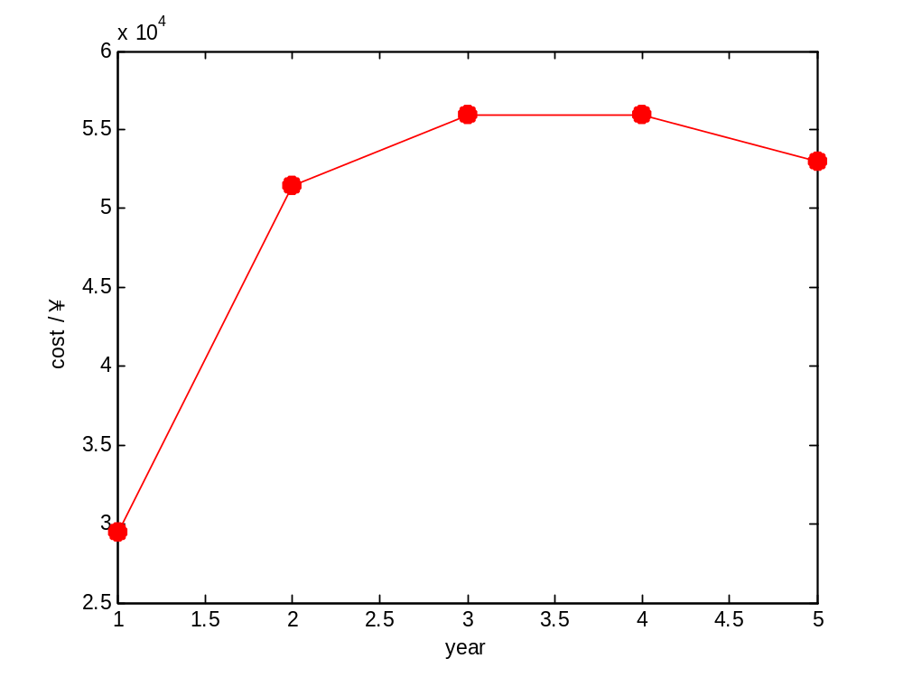
Figure 11 The change of the human resources cost in the next five years

3.2.3 Advantages and disadvantages

3.2.3.1 Advantages:
(1)Based on simulation modeling method, this pape realizes the framework and process simulation of the enterprise mobility between different jobs. What’s more, the paper also designs and defines rules of conduct of the relevant proper ties of each body by modeling the individual “person” in this flowing process. Then it gives us a reasonable number of job seekers and human resources in the next five years. This model is suitable to the position of supply less than demand.
(2) From the "small world" network model of the micro, introduce the abstract ability of person into the model reasonably, implementation the process of capability dynamic, which has more practical significance.
(3) Compared with the traditional markov chain [2], the classical model is based on the law, in the form of the equation, the mathematical analysis to solve; In this paper, on the other hand, the design of complex system is based on the simple rules and in the form of a computer instruction through simulation. It avoids the complex mathematical calculations, and is easy to analysis, having strong expansibility.

3.2.3.2 Disadvantages:
This model only offers simple model and simulation examples, and some aspects like the definition of subject flow, spread behavior rules and model parameter setting and the experimental data determined, all did simplify processing. For example:
(1)In the definition of subject's ability, because itself is an abstract concept, so when doing quantitative analysis, the model uses the number between 0 ~ 5 to measure. It seems to be subjective, and less segmentation, not obvious enough the individual difference is.
(2)When we study the flow between positions, assuming that people can adapt to all kinds of jobs, this is obviously not conform to the actual. In reality, there is may simply a department can be described.
(3)In the study of flow, we give priority to enterprise internal personnel promotion, but in reality, it often appears that internal personnel cannot meet the job requirements, and the enterprise needs to recruit from the talent market. (It will be discussed in optimization model)

IV. Conclusions

4.1 conclusion of the question
The text is based on complex-adaptation-system, and try to use the method of building computer model to analog the complex progress of opportunity-chain flow. From the simulation of flow progress, we get the more close to reality results, which illustrate the model is effective.
4.2 Application of the model
The model in the text is a typical short-supply network. Vacant jobs are scarce resources in network. The model of opportunity-chain can clearly link the liquidity to the vacancy and supply a frame that can analyze relation of company’s position and talent market. What’s more, the model contributes to analyzing the talent market’s selection mechanism. If it is combined with traditional methods of
Economics, it can promote the understanding of exchanges in queue, which promotes the capacity of resource distribution.

V. Future Work

5.1 Improved Model
With further research, we will extend through dynamic simulation framework model parameters and rules, constantly improve the model to improve the accuracy of the parameters, and gradually design and apply the data from the real company to achieve a more accurate simulation.
For example:
1.In the study of “vacancy” generation, it will not meet the actual situation if we consider the case caused by retirement only. In reality, there are possibility such as personnel mobilization, promotion, layoff and so on. So it’s necessary to make a change for assumption made before.
Assumption 1：There may be a sudden change for the body to reach the retirement age in a constant probability p.
2. When there is a "high" position vacancy in the enterprise, but at the same time there is no right person in the enterprise to replace him or her. So this time the company should go to the talent market to hire the right person. When it happens, assumption changes need to be made.
Assumption 2：The subject’s ability in the talent market obeys the following distribution function.
Ability | 0 | 1 | 2 | 3 | 4 | 5
Probability | P₀ | P₁ | P₂ | P₃ | P₄ | P₅

5.2 Another model
The final goal for a business is to maximize the benefits.
If the number of jobs means the company’s profits, then more company will choose this way(Increased interest equals to Increasing the benefits of jobs minus Consumption costs).Obviously this is a risk decision problem, and the policymakers could often use surveys or their experience to get these things’ happening possibility.
In the risk decision process, we use an expected value as a decision criterion. Now we choose the maximum expected decision criteria (EMV) t o realize the profit maximization.
Elements of decision matrix represents "policy - incident" to profit, 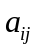is on behalf of all the events, the probability of each event is 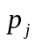, let’s calculate the expected profit of each strategy firstly:
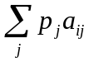，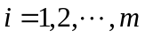 (10)
Then, from the selection of the expected profit of the largest person to strategies for decision-making and its corresponding strategy 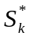,
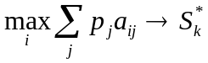 (11)

5.3 Another kind of flow
The model in this article only takes the internal flow into account. How can you achieve optimal allocation of human resources in the whole community if you consider the liquidity of the whole society? With the progress of the times, people's career development will be more vast, more opportunities to choose careers, a person who have ability will pursue a better career , and the capable people will move to better jobs when companies do not have "vacant" to meet his or her requirements. And this flow usually has a specific motivation (higher positions, interests and prestige, etc.), we can understand the flow of position in social space from the perspective of geometry, including the level of geographic dimension (the company's transformation) and vertical prestige dimension (shift change after prestige).

And the flow will have an impact on personal perception and understanding, this kind of perception and understanding would affect personal mobility opportunities and options. And from the view of business, retain talents not only to consider "the interests of keeping" but also to consider the "sentiments" and other methods.
VI. References
[1]Xu Jie. Opportunity chain structure and its application in enterprise human resources management [J]. Journal of commerce in China, 2012 (12)
[2]Harrison C [2] (mae), white Zhang Wenhong. Opportunity chain [j] due press, 2009.05.
[3]QuYiZhen, li3 qi2, etc. Based on Repast platform of SARS simulation and modeling study [J]. Journal of computer science, 2008 (35) transmission [J]. Journal of Beijing university (medical edition), 2003 (35)
[4] Vapnik V N. An Overview of Statistical Learning Theory[J].IEEE Trans. Neural Network,1999,10(5):988~999
[5] Lin Guoji, jia perishes, etc. With this small world network model research SA RS the spread of the virus [J]. Journal of Beijing university (medical edition), 2003 (35)
[6] Miller, page (mae), lung YunTao. Complex adaptive system [M]. Shanghai people's publishing house, 2012.09
[7] Allen B.D ownet, Zhang Longyi. Complexity thinking [M]. Machinery industry press, 2013.05

VII. Appendix
Figure 1 ~ 5 are the diagrams for the enterprise personnel changes in five years:
Current ability
Current work level
Improved ability
one year later
Work level one year later
Figure 1 Enterprise personnel changes in the first year diagram
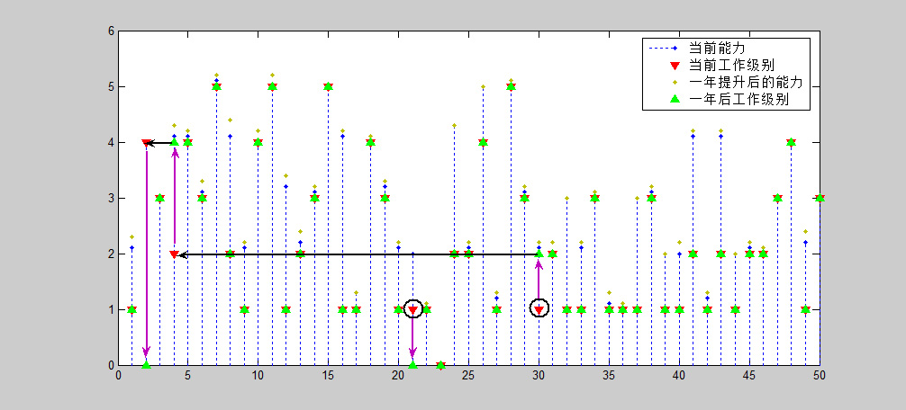
Figure 2 Enterprise personnel changes in the second year diagram
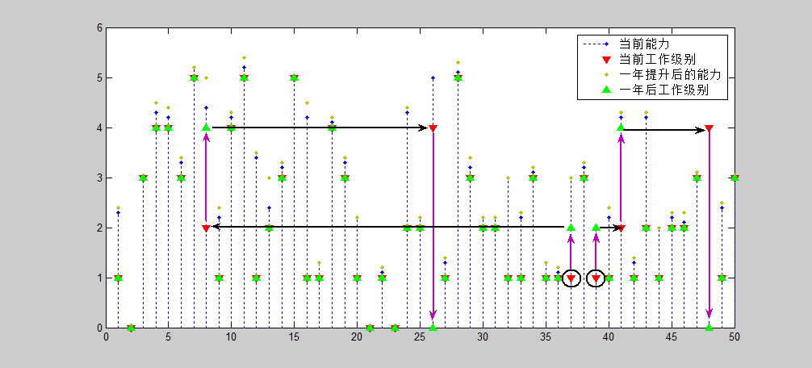
Figure 3 Enterprise personnel changes in the third year diagram
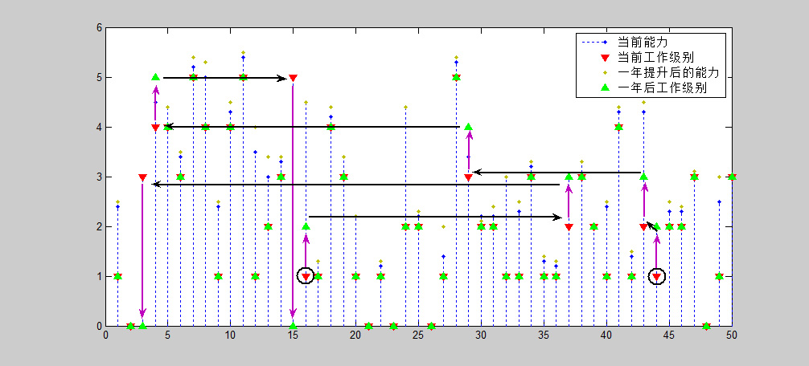
Figure 4 Enterprise personnel changes in the fourth year diagram
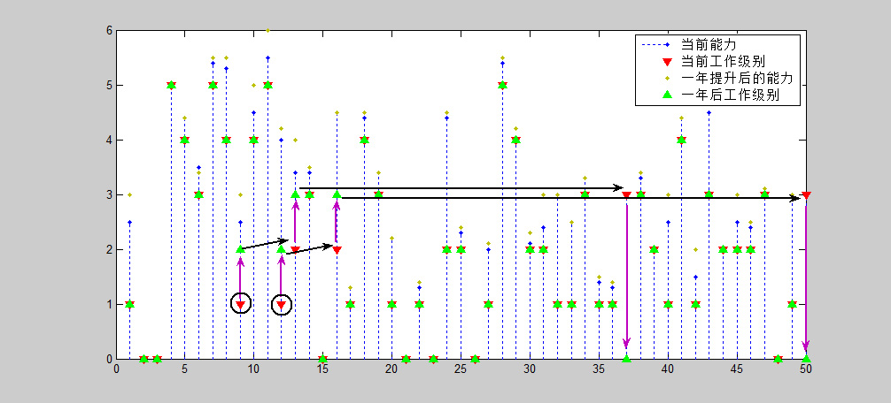Figure 5 Enterprise personnel changes in the fifth year diagram
The simulation program :
Ability Change.m
m=50;
L=wsNet(50,2,0.1);
deta=zeros(50,1);
for i=1:50
R = normrnd(0.01, 0.005, 1, 1);
A(i,6)=vpa(A(i,6),2);
if A(i,5)>=20&&A(i,5)<=45
for j=1:50
deta(i)=A(j,6)*R*L(i,j)+deta(i);
end
A(i,6)=A(i,6)+deta(i);
A(i,6)=vpa(A(i,6),2);
if (A(i,6)-fix(A(i,6))>0.50)
A(i,6)=round(A(i,6));
end
end
End

Adapt People.m
m=50;n=6;
A=randint(m,n,0);

for i=1:50
A(i,1)=i;
A(i,2)=1;
%A(i,3)=randint(1,1,[1,5]); % on behalf of work level
while (1)
A(i,3) = normrnd(1,3, 1, 1);
if (A(i,3)>=1&&A(i,3)<6)
break;
end
end
A(i,3)=fix(A(i,3));

if (A(i,2)==0)
A(i,3)=0;
end
A(i,4)=randint(1,1,[0,1]);
if (A(i,4)==0)
while (1)
A(i,5) = normrnd(45,30, 1, 1);
if (17<A(i,5)&&A(i,5)<60)
break;
end
end
else
while 1
A(i,5) = normrnd(40,30, 1, 1);
if (17<A(i,5)&&A(i,5)<55)
break;
end
end
end
A(i,5)=fix(A(i,5));
while (1)
A(i,6) = normrnd(1,3, 1, 1);
if (A(i,6)>=1&&A(i,6)<6)
break;
end
end
A(i,6)=fix(A(i,6));
if (A(i,6)<A(i,3))
A(i,6)=A(i,3);
end
End

Fun.m
function A=fun(A1,i)
A=A1;
preNeed=A(i,:);
A(i,2)=0;
A(i,3)=0;
A(i,6)=0;
preNeed(1)=0;

while(1)
for i=1:50
if (A(i,6)>=preNeed(3)&&A(i,3)<preNeed(3))
nextNeed=A(i,:);
A(i,2)=preNeed(2);
A(i,3)=preNeed(3);
preNeed=nextNeed;
break;
end
end
if i==50
break;
end
End

Need Add.m
function A=needAdd(A,m)
for j=1:50
for i=1:49
if (A(i,3)<=A(i+1,3))
p=A(i,:);
A(i,:)=A(i+1,:);
A(i+1,:)=p;
end
end
end

preNeed=A(1,:);
preNeed(1)=0;
preNeed(2)=1;
preNeed(3)=m;
while(1)
for i=1:50
if (A(i,6)>=preNeed(3)&&A(i,3)<preNeed(3))
nextNeed=A(i,:);
A(i,2)=preNeed(2);
A(i,3)=preNeed(3);
preNeed=nextNeed;
break;
end
end
if i==50
break;
end
end

for j=1:50
for i=1:49
if (A(i,1)>=A(i+1,1))
p=A(i,:);
A(i,:)=A(i+1,:);
A(i+1,:)=p;
end
end
End
Update Work.m
for i=1:50
A(i,5)=A(i,5)+1;
end

for j=1:50
for i=1:49
if (A(i,3)<=A(i+1,3))
p=A(i,:);
A(i,:)=A(i+1,:);
A(i+1,:)=p;
end
end
end

for i=1:50
if (A(i,5)>=60||(A(i,5)>=55&&A(i,4)==1))
preNeed=A(i,:);
A=fun(A,i);
end
end

for j=1:50
for i=1:49
if (A(i,1)>=A(i+1,1))
p=A(i,:);
A(i,:)=A(i+1,:);
A(i+1,:)=p;
end
end
End

Ws_Net.m
function l=wsNet(N,K,p)
%disp('WS Small world network model ')
%N=input(' Please enter the number of network nodes ');
%K=input(' Please enter the node number of nodes in the adjacent K / 2 ');
%p=input(' Please enter the random rewiring probability ');
angle=0:2*pi/N:2*pi-2*pi/N;
x=100*cos(angle);
y=100*sin(angle);
%scatter(x,y,'r');
%hold on;
% Generate the nearest neighbor coupled network；
l=zeros(N);
%disp(l);
for i=1:N
if i+K<=N
for j=i+1:i+K
l(i,j)=1;
end
else
for j=i+1:N
l(i,j)=1;
end
for j=1:((i+K)-N)
l(i,j)=1;
end
end
if K<i
for j=i-K:i-1
l(i,j)=1;
end
else
for j=1:i-1
l(i,j)=1;
end
for j=N-K+i:N
l(i,j)=1;
end
end
end
%disp(l);
% Randomization reconnection
for i=1:N
for j=i+1:N
if l(i,j)==1
pp=unifrnd(0,1);
if pp<=p
l(i,j)=0;
l(j,i)=0;
b=unidrnd(N);
while i==b
b=unidrnd(N);
end
l(i,b)=1;
l(b,i)=1;
end
end
end
end
%hold on;
% According to the adjacency matrix of attachment
%for i=1:N
% for j=1:N
% if l(i,j)==1
% %plot([x(i),x(j)],[y(i),y(j)],'linewidth',1);
% line([x(i),x(j)],[y(i),y(j)]);
% end
% end
% end
% hold off

%aver_path=aver_pathlength(A);
%disp(aver_path);

The Monte Carlo simulation testing procedures:
Sui ji.m
b=0;
for i=1:10000
r=binornd(1,0.2,1,20);
a=sum(r);
if a>=2
b=b+1;
end
end
c=b/10000
Website advertising board：
