第二届“认证杯”数学中国
数学建模国际赛
承 诺 书

我们仔细阅读了第二届“认证杯”数学中国数学建模国际赛的竞赛规则。
我们完全明白，在竞赛开始后参赛队员不能以任何方式（包括电话、电子邮件、网上咨询等）与队外的任何人（包括指导教师）研究、讨论与赛题有关的问题。
我们知道，抄袭别人的成果是违反竞赛规则的, 如果引用别人的成果或其他公开的资料（包括网上查到的资料），必须按照规定的参考文献的表述方式在正文引用处和参考文献中明确列出。
我们郑重承诺，严格遵守竞赛规则，以保证竞赛的公正、公平性。如有违反竞赛规则的行为，我们将受到严肃处理。
我们允许数学中国网站(www.madio.net)公布论文，以供网友之间学习交流，数学中国网站以非商业目的的论文交流不需要提前取得我们的同意。
我们的参赛队号为：1137
我们选择的题目是： B题
参赛队员 (签名) ：
队员1： 李 明

队员2： 申江荣

队员3： 王维芳

参赛队教练员 (签名)： 花 强

第二届“认证杯”数学中国
数学建模国际赛
编 号 专 用 页

参赛队伍的参赛队号：（请各个参赛队提前填写好）：

1137

竞赛统一编号（由竞赛组委会送至评委团前编号）：

竞赛评阅编号（由竞赛评委团评阅前进行编号）：

Hermit Crabs Evolve Employment Pattern of Human
Abstract:
Hermit crabs provide us an ideal model system for distributing human resources. In all populations in which they occur——whether human or animal——vacancy chains apper to organize a variety of social processes in nearly identical ways.
In order to slove the two problems, this paper first explores the behavior of hermit crabs’ exchanging shells then provides a vacancy-driven model through analyzing the similarities between hermit crabs and jobs switching. It is the simplest job chain model, which one level in it can be ranked along a single dimension. In order to make the model more efficient, we used data analysis and multiplier effect theories to solve specific chain length and welfare impacts. Further, we used the sensitivity of welfare to analyse the results.
However, considering the real situation, we must take into account the competi- tion for jobs among employees. Innovatively, we improved the previous model so that it can be more realistic. Further, we analysed the changes of parameters e.g. the length of chains and the welfare, after improving the model through Markov transition matrix and job ladder theories. Finally, we summarized the strength and weakness of this model, then made a conclusion.
On the basis of the previous improved model, this paper presents another computational model for problem 2, trying to predict future staffing needs for an organizations by investigating the regularity in the formation of vacancy chains depending on the number of strata, the starting stratum, the size of the neighborhood and the organizational structure. The simulation results showed that this model can analyze the organization's future staffing needs effectively.

Key words: Markov matrix，Vacancy Chain, Mobility，Vacancy-Driven model, Computational model

Contents
I. Introduction 5
1.1 Problem Background: 5
II. The Description of the Problem 6
2.1 Problem Definition: 6
2.2 Problem Analysis: 6
2.2.1 Hermit Crabs and Employees 6
2.2.2 Vacancy Chains and Associated Individuals and Institutions 7
2.2.3 Vacancy Chains and Market Competition 7
2.2.4 Using Vacancy Chain Theory to Solve the Problems 8
III. Models 10
3.1 Vacancy-Driven Model of Problem 1 10
3.1.1 Terms, Definitions and Symbols 10
3.1.2 Assumptions 10
3.1.3 The Foundation of Model 11
3.1.4 Solution and Result 13
3.1.5 Analysis of the Result 13
3.2 Improved Vacancy-Driven Model 14
3.2.1 Update Assumptions 14
3.2.2 The Foundation of Model 14
3.2.3 Solution and result 17
3.2.4 Result analysis 17
3.3 Computational Model of Problem 2 19
3.3.1 Extra Symbols 19
3.3.2 Additional Assumptions 19
3.3.3 The Foundation of Model 19
3.3.4 Solution and Result 24
3.3.5 Analysis of the Result 27
IV. Conclusions 29
4.1 Conclusion of Problem 1 29
4.2 Conclusion of Problem 2 29
VI. References 30
Appendix 31

I. Introduction

1.1 Problem Background:
Hermit crabs use abandoned shells as shelters, usually snail shells. Crabs of increasing age need shells of increasing size, when it outgrows its shell, it switches to a larger one.
When a lone crab found one of the new shells, it immediately inspected the shelter with its legs and antennae and scooted out of its current shell to try on the new shelter for size. If the new shell was a good fit, it immediately pulls itself inside.Thus, an empty shell released in the environment. But if the new shell was too big, the crab did not leave away, instead, it stood by the shell for some time, waiting. Eventually other crabs showed up, each one trying on the shell. If the shell was also too big for the newcomers, they hung around too, sometimes forming groups as large as 20. The crabs did not gather in a random arrangement, however. Rather, they clamped onto one another in a conga line stretching from the largest to smallest animal. As soon as a crab claimed its new home, all the crabs in queue swiftly exchanged shells in sequence. The largest crab at the front of the line seized the crab's abandoned shell. The second largest crab stole into the first's old shell. And so on. Hermit crabs really have to think about and evaluate these shell resources—these are life and death decisions.
Sociologists and economists use the term “vacancy chain” to describe a sequential exchange of resources that benefits every individual in the sequence. Vacancy chain theory describes a unique mechanism for the sequential distribution of animal resources across multiple individuals. In recent decades scientists have gathered evidence that not only the hermit crabs but also other animals—use vacancy chains, too. Studying how these animals behave may help us improve how we distribute resources—such as apartments, cars and jobs—among ourselves.

II. The Description of the Problem

2.1 Problem Definition:
Problem 1:
Evolve social strategies to exchange jobs in queue so that everyone benefits. Can we apply the model to all industries? If not, what conditions need to meet?
Problem 2:
Now a new Human Resource website want to adopt your idea, How many job applicants do need to satisfy both employers and employees. Run your model to predict the change of HR expends for some enterprise customers within the next five years.

2.2 Problem Analysis:

2.2.1 Hermit Crabs and Employees
Hermit crabs rely on abandoned gastropod shells for shelter, and a single vacant shell may initiate a chain of sequential shell switches that distributes new resources across many individuals. Thus, in this case the vacancy chains act as a mechanism for resource allocation. vacancy chains are an excellent way to distribute resources: Unlike more typical competition, a single vacancy chain benefits everyone involved—each individual gets an upgrade. Figure 2-1 illustrates the the behavior of shells switching.
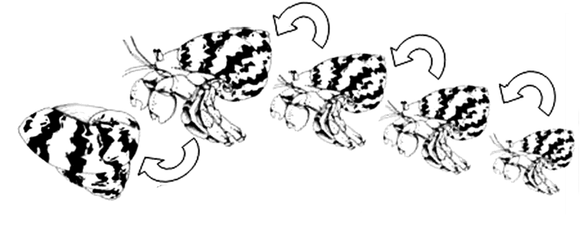
Figure 2-1: Process of hermit crab switching shells

Hermit crabs provide us an ideal model system for distributing human resources.
Suppose, for example, that an employee A quits from the labor force (e.g. employee retiring), creating a job vacancy. This vacancy provides an opportunity for someone else who covet A's job. Suppose that B takes A's old position. If B is employed, B's quit creates a further vacancy. Now suppose that C takes B's old position; if C is employed, the vacancy chain continues. However, if C is unemployed or out of the labor force, the chain of vacancies, which began with A's departure from his or her job, ends. The length of a vacancy chain can be defined as the number of job switches that occur. The longer the vacancy chain, the more jobs switched. Thus, everyone in the queue may benefit. Figure 2-2 shows the above description. Upward arrow denotes a vacany position.

Figure 2-2: "Employment-To-Employment" job switches

Vacancy chains are triggered by the creation of autonomous vacancies. The latter occur because of new job creation, withdrawal of workers from the labor force, and voluntary quits into unemployment. Vacancy chains end only when a vacancy is filled by an individual who is either unemployed or out of the labor force [2]. However, under certain conditions vacancy chains, rather than market or other forms of competition, determine the allocation of the resource.

2.2.2 Vacancy Chains and Associated Individuals and Institutions
Vacancy chains have patterned effects upon other individuals and, in the human case, institutions connected to the primary individual actually getting resources in the chains. Longer chains and more costly resource units generate freater benefits, while shorter chains and less costly units generate smaller benefits, for the individuals and institutions involved.

2.2.3 Vacancy Chains and Market Competition
Allocation of human resources may be achieved by means of monetary compromises enabled by market interactions, by means of open fights, or by means of a combination of incomplete information and idiosyncratic needs engendered by a particular organization. Both market interactions and open fights involve competition.
On the contrary, human resource allocation does not require competition if only one subject is able to fulfill certain requirements to the knowledge of those who must assign a resource.
Consider for instance internal labor markets. Most of the times, promotion of subordinates does not take place by posting available positions and hiring the one who offers the longest working hours for the lowest wage. Most of the times, managers observe subordinates long enough to know their abilities and eventually offer a position to the one they deem is most able to do a particular job. In this particular example, a lot of competition may have taken place among subordinates in order to be deemed the most able to cover that position. However, the position was not allocated by means of an open competition, but simply because only one person was around when it became available. We shall see other examples where the same mechanism of resource allocation operates without any form of competition.
It is important to realize that the above view of the labor market is opposite to that neoclassical economics. In fact, the latter assumes willful accumulation of human capital in order to obtain certain positions. On the contrary, the above view assumes that positions are available independently of the capabilities of applicants, and that a position is only assigned if it becomes vacant.
However, since real organizations are characterized by a mixture of vacancy chains and markets or other allocative mechanisms based on competition, a vacancy chain may stop to operate as a mechanism for resource allocation well before its end. Consider again the case of internal labor markets. A vacancy may be triggered by a retirement, which triggers a chain of vacancies through subordinates. At the beginning only one subordinate is available to replace the retired employee, so the vacancy chain acts as a means for allocating a resource. However, by descending the hierarchy jobs may become less idiosyncratic, until two or more equally qualified persons apply for the same position. From that point, the resource is allocated by the market. However, the vacancy chain can still be traced through employees of decreasing status and eventually through the external labor market. The fact that a vacancy chain is identified does not imply that it is the prime mover of resource allocation. Likewise, the fact that a monetary transaction takes place does not imply that a resource is allocated by the market.

2.2.4 Using Vacancy Chain Theory to Solve the Problems
Usually when a vacancy occurs the bulk of the people who fill the position(s) come from the inside the internal labor market rather than hiring someone new. The individuals being moved and or promoted to a new job/position often gain a higher salary of more benefits which has an important impact on the organization [3].
Individuals affected by vacancy chains starting in an organization usually are upwardly mobile in small to moderate jumps in status or laterally mobile within their same status; they rarely experience downward mobility. In systems in which they operate, vacancy chains have a strong influence upon organizational demographics. Such factors as length of service distributions for individuals within the organization, rates of advancement within the system, the age distribution of individuals within particular strata, cohort effects for mobility within the system, and waiting times for advancement.
The number and initial strata of the vacancy chains created influence the career possibilities of the individuals in the internal labor market and those about to enter. The more chains initiated at higher levels, the more mobility opportunities for individuals throughout the system, as the chains move downward, and the greater the speed with which individuals advance to high status or large units and positions. On the other hand, if chains are mostly initiated at lower levels, individuals already in high status positions will see their careers plateau while only those at lower levels will move comparatively quickly before they reach a career bottleneck caused by the lack of opportunities at higher levels [2].
Problem 1 asked us to evolve social strategies to exchange jobs in queue so that everyone benefits. It is a Resouce Allocation of Internal Labor Market problem. According to the previous analysis, we develops a vacany-driven model as a mechanism for resource allocation in order to improve social strategies to exchange jobs in queue so that more employees can benefit.
Problem 2 asked us to predict the change of HR expends for some enterprise customers within the next five years. It’s a Human Resource Forecasting problem. Organizations need to do human resource planning so they can meet business objectives and gain a competitive advantage over competitors.
HR Forecasting attempts to determine the supply and demand for various types of human resources, and to predict areas within the organization where there will be labor shortages or surpluses.
In order to slove the problem, we improved our model. By studying the regularity in the formation of vacancy chains depending on the number of strata, the starting stratum, the size of the neighborhood and the organizational structure, we try to make a prediction of the change of HR expends for some enterprise customers in the future.

III. Models

3.1 Vacancy-Driven Model of Problem 1

3.1.1 Terms, Definitions and Symbols
Symbols | Definition
p1 | The probabilities of an employee occupy- ing a job on the rung immediately below the vacancy moves up.
p2 | The probabilities of an individual not currently employed along the ladder obtains the job in question.
p3 | The probabilities of the job disappears.
m | Hiring multiplier.
d | The ratio of wage.
w | The wage of the vacancy being filled.
V | The total expected welfare gain set off by the creation of a job paying a wage of w
Q | matrix
q_{ij} | The chance that a job vacancy of a j-type position is taken by a worker currently in an i-type position.
m_{i} | Thegross number of local i-type vacancies generated by a j type vacancy.  M: the matrix of m_{ij}.
M | The matrix of m_{ij}.
Rj | Rawlesian welfare measure.

3.1.2 Assumptions
- Resource allocation does not require competition if only one subject is able to fulfill certain requirements to the knowledge of those who must assign a resource
- People’s ability can be measured by some certain standards and can be divided into their relevant levels
- People in a consistent level jobs have a level which is consistent.
- In a consistent level jobs only have one people.

3.1.3 The Foundation of Model
1) Introduction to Vacancy Chain
By studying the social behavior that hermit crab exchange shells, we can come up with a vacancy chain model, it can be applied to evolve the employment pattern of human.
Vacancy chains are started when an individual vacancy comes into a population a new snail shell created or a new job created or an existing unit is vacated by someone leaving the system under consideration an employee retires, a hermit crab dies leaving the snail shell it occupied intact.
Vacancy chains ends usually when a new recruit enters the system someone moving into the job or the last unit in a chain is abandoned, merged, or destroyed the duties of a vacant job are distributed among other employees.
A vacancy chain is simply the sequence of moves that a vacancy makes from initial entry into a system to final terminate.
In all populations in which they occur whether human or animal vacancy chains appear to organize a variety of social processes in nearly identical ways.
Sociologists and economists use the term “vacancy chain” to describe a sequential exchange of resources that benefits every individual in the sequence.
2) The Relationship between Hermit crabs and Jobs
Individuals who ostensibly have nothing in common uch as hermit crabs occupying empty snail shells, people gaining new jobs are all alike in that they gain new physical resource or social positions through vacancy chain mobility processes. Underneath all the apparent diversity of behavior, culture, and cognitive ability in different systems, vacancy chains produce similar patterns of short-term mobility, generate about the same average number of mobility opportunities per chain, affect career and demographic distributions in the relevant systems in about the same way, and influence analogous patterns of aggregate benefits for mobile individuals as well as for other individuals connected to those moving.
The job vacancy chain is an analytic device that lets us estimate the amount of movement triggered off by a new job and to record the traffic in and out of the newly created position until it ceases to exist.
- Vacancy-driven model of Job Vacancy Chains

a) The description of the job vacancy-driven model
Vacancy-driven model is an easy model which do not considerate competition, it based on the behavior of hermit crabs’ exchanging shells. It is consistent of different levels of jobs, and every level only has one person. So, in the job queue people can use mobility of jobs to benefit.
b) Chain length
To move from intuitions to serious empirical work, we need to construct a formal model of job chains. We now consider the simplest possible job chain model, one in which all jobs can be ranked along a single dimension. Consider a local economy in which each job grouping can be represented by a rung along a single well-defined job ladder. A job vacancy is resolved in one of three ways:
• An employee occupying a job on the rung immediately below the vacancy moves up.
• An individual not currently employed along the ladder obtains the job in question. Such individuals might be drawn from the locally unemployed, those not currently in the labor force, or in migrants to the community.
• The job disappears. The probabilities of these three outcomes (p₁, p₂, p₃) sum to 1.0 and are fixed for the system.
In this setting, a newly created job opens a vacancy at the corresponding rung of the job ladder. Whatever its position in the ladder, it will be filled either by someone in the immediately lower rung or by someone not currently employed in the local economy. The rigidity of the given probabilities necessitates a hiring multiplier, m, the expected number of local job vacancies created and filled as the result of the appearance of a new job on any rung on the job ladder.
To see this, consider the probability that a new job will give rise to at least one more vacancy that is subsequently filled. This probability is just given by the probability that the new job was filled by someone on the ladder, [p1 / (1- p3)], times the probability that the job vacancy opened in this move was not destroyed, (1- p3). This product is simply p1. Now clearly the probability that this filled vacancy will give rise to another must also be p1, and so forth down the line. The expected number of filled vacancies generated by the new job will be:
m = 1 + p₁ + (p₁)² + (p₁)³ + … = 1 / (1- p₁)
- Welfare effects
To use this multiplier to estimate welfare effects, we must assign an expected welfare gain to each worker who fills a vacancy. A worker moving up the ladder forgoes his or her present wage, in order to obtain a higher wage w at the next rung up. From the individual’s perspective the lower wage is the opportunity cost of the higher wage. His or her welfare gain is just the difference between the two wages. For simplicity, assume the ratio d remains independent of the rung in question and incorporates any non-monetary differences in working conditions. In this context, filling a single vacancy from the rung below increases welfare by (1- d) w, where w is the wage of the vacancy being filled. But what of the welfare gains achieved by those who move into a vacancy from outside the labor force, from unemployment, or through migration? These are complex transitions; their welfare values have been long debated. For the present exercise, we keep matters simple and conservative by assuming that these transitions render the same welfare gain as a move up the ladder, i.e. (1- d) w. This assumption sets the opportunity cost of individuals moving onto the job ladder at an amount equal to the wage of the job just below the one they take. Such a proposition can be plausibly defended for both in- migrants and entrants to the labor force, but very likely underestimates the gains of those moving out of involuntary unemployment.
Now the calculation is straightforward:
V = (1- d) w [1 + d p₁ + (d p₁)² + (d p₁)³ + …] = [(1- d) / (1- d p₁)] w,
where V represents the total expected welfare gain set off by the creation of a job paying a wage of w.

3.1.4 Solution and Result
1) Chain length
Interestingly, the length of the chain depends only on p₁. This is true even though we count those moving onto the ladder in the same manner as those already on it. To appreciate this point, consider two sets of probabilities. Both have the same value for
p₁, but in the first, vacancies can only be filled from the job ladder otherwise they disappear. This means p₂ = 0 and p₃ = 1- p₁. In the second, jobs never disappear (p₃ =
0), but they may be filled from off the ladder (p₂ = 1- p₁). For either set of probabilities the new job is filled. Now, under the first case this must mean a vacancy is created. That vacancy in turn has a probability p₁ of not disappearing and being filled; and so on down the chain. For the second case, we again start with a filled vacancy, but now there is a probability, p₂ = 1- p₁, that it is filled from off the chain and produces no second vacancy. This means that the likelihood of a filled second vacancy is just p1 again; and so on down the chain.
- Welfare impact
As to welfare, this result has two interesting and interrelated implications. Under the assumptions of the simplest job chain model, a new job in a community will yield an expected welfare gain less than its wage, since (1- d) < (1- d p₁). But under those same assumptions, a new job will generate a gain larger than that enjoyed by the worker who actually fills it, since the probability of vacancies being filled from existing jobholders is taken greater than zero (i.e. p₁ > 0).

3.1.5 Analysis of the Result
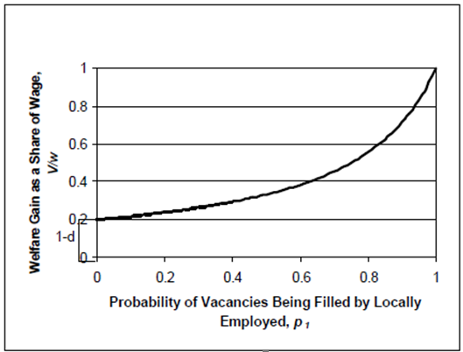
Figure 3-1
Empirical estimates of V/w are presented below. These are contingent on establishing values for the p and d parameters. At this juncture however we make a few educated guesses to at least narrow the likely range.
In this spirit, we set p2 at about .3, perhaps divided more or less equally between in- migrants and local residents not employed in the recent past. In average times, p3 is likely to be considerably smaller, say .05. This leaves us with an estimate of .65 for p1. To allow a range for the crudeness of the estimate, we take p1 to lie between .6 and .7.
These parameters imply that on average a job chain will have a length of about three filled vacancies so m=3. On each link we assume that the worker (whether an in-migrant, unemployed, out of the labour force or previously employed) has a reservation wage (d) equal to 80-90% of his or her new wage. Putting these estimates of d and p1 into our basic equation suggests that the welfare gain associated with an average new job will be between 20% and 40% of the new job’s wage.

3.2 Improved Vacancy-Driven Model

3.2.1 Update Assumptions
- Resource allocation does not require competition if only one subject is able to fulfill certain requirements to the knowledge of those who must assign a resource
- People’s ability can be measured by some certain standards and can be divided into their relevant levels
- People in a consistent level jobs have a level which is consistent.

3.2.2 The Foundation of Model
- Why we need to improve this vacancy-driven model
In fact, allocation of scarce resources may be achieved by means of monetary compromises enabled by market interactions, by means of open fights, or by means of a combination of incomplete information and idiosyncratic needs engendered by a particular organization. Both market interactions and open fights involve competition.
So, we improve this model considering market competition, which is called competition-vacancy complex model.
- The structure of the improve model--the competition-vacancy complex model
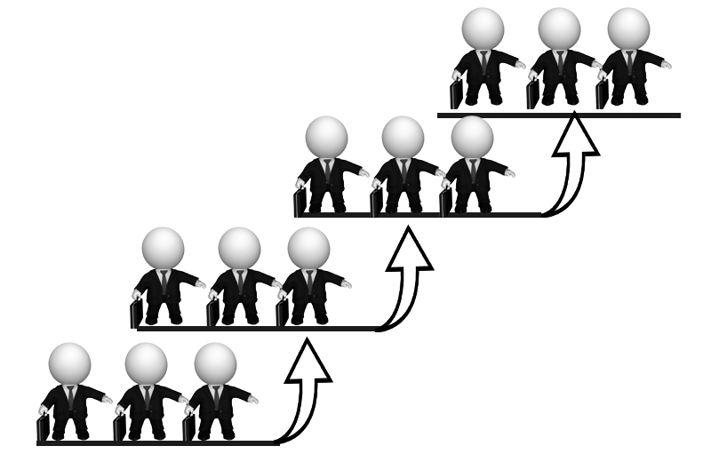
Figure 3-2
Competition-vacancy complex model is a ladder-type hierarch, which combines market competition with vacancy chain model to describe the exchange of works. Lateral model is reflected in market competition and the longitudinal model is reflected vacancy chains, taking into account both the actual existence of competition in the market with the application vacancy-driven model to ensure that more people benefit.
Each level of model reflect market competition, contains a number of competitors, the ability of these competitors have the same ability or a same previous job, by way of deciding who gets to compete on a upgrade position. Between the various levels of the model is the vacancy chain model, which will eventually benefit between the various layers.
Next we need to study the detail things about this model to apply it to exchange jobs, such as chain length and welfare impacts.
- The chain length of improved model
Our competition-vacancy complex model approach starts with the recognition that recruitment may look very different across the rungs of the job ladder. Some job vacancies will be filled only with workers already holding very narrowly defined skills/jobs, while others may draw on a wider range of candidates. If we can categorize all jobs into meaningful groupings on the basis of skill requirements, remuneration and conditions of work, then we can think of a new job vacancy as setting off a ‘multiplier’ effect as successive workers move from one job to another. The inter-rung probabilities can be represented as a square (origin-destination) matrix (Q) with elements, qij, which show the chance that a job vacancy of a j-type position is taken by a worker currently in an i-type position. Notice that the sum of these elements over i for a given j will be less than one. The difference will be made up largely by workers drawn from unemployment, out of the labor force, and immigration. Finally, some vacancies will simply result in job destruction or disappearance. These terminating events play a role similar to primary inputs and imports in an input-output matrix. They act as leakages that dissipate the flow of demand in the local area.
We have strong theoretical reasons for modeling Q as a triangular matrix. In general, workers will not voluntarily move from a better job to a worse one. Of course many such moves do take place, but presumably they are involuntary. In the context of a chain begun by an economic development project, such involuntary moves effectively guarantee that job vacancies always move ‘down’ the job ranking. For example, consider the consequences of a project-created semi-skilled (type 2) job being taken by a worker who was fired from a high skilled (type 1) job. The type 1 vacancy would occur whether or not the economic development project takes place. It is not part of the chain generated by the project. However, this high skilled worker would presumably have been able to take a job at the semi-skilled level even in the absence of the development project. The counter-factual is not that the high skilled vacancy would not have been created, but that a semi-skilled vacancy would have been taken by this worker. In this sense vacancies can only move ‘down’ and never ‘up’ the job ranking.
The Q matrix allows us to approximate the net consequences of job creation at each job level. A simple Leontief-type inversion of the locally based origin destination matrix (I-Q)-1, will yield a multiplier-type matrix of mij’s which show the gross number of local i-type vacancies generated by a j type vacancy. Summing down the columns of this matrix gives us the total number of links or vacancies per chain, triggered-off by jobs of different types. Thus Mj =Σimij gives the total number of expected vacancies associated with a newly created j-type job including that initial vacancy. It seems natural to call Mj the length of a type j chain. A rough approach to estimating chain length has been presented above for the simple model. Here as there, the key to measuring the length of chains is estimating the probabilities of a chain being truncated by an in- migrant, unemployed worker or new entrant. But, since all of these can differ depending on the initial ‘new job’s’ leve l, expected chain length will also vary across levels. Because Q is taken to be triangular, the chain lengths, Mj , are relatively easy to calculate in a recursive manner. In particular, if we rank skill levels from 1 as the highest to n as the lowest, then:
Mn = 1/(1- qnn),

Mn-1 = [1/(1- q(n-1)(n-1))] [ 1 + qn(n-1) Mn ],

Mn-2 = [1/(1- q(n-2)(n-2)) ( 1 + q(n-1)(n-2) Mn-1 + q(n(n-2) Mn ).
- Welfare
Having sketched the theory of chain lengths, we turn to an analysis of differences in the expected increments in local welfare arising from the creation of different new jobs. Again we emphasize the importance of opportunity costs in evaluating welfare gains. In particular for each type of vacancy, i, the welfare gain is equal to Σk qkj(wi-wk ), where (wi-wk) represents the difference in wages between the new job I and the old job k. Notice we assume here that those changing jobs within the same occupational group, i, will experience no gain (or perhaps, only a negligible one), i.e. wi-wi=0. For in- migrants, unemployed or entrants who might take a vacancy at level I we assume that their opportunity cost is just equal to the wage of the group at the next lowest level, i+1. Again we take wages at each level to be a constant fraction, d, of the wages at the next highest level. Putting these elements together then suggests an overall expected gain of adding a j- type job (Vj) is given by:

Vj = Σimij [(Σkqki (wi-wk ) + (1-Σkqki )(wi- wi+1)].
= wj Σimij di-j [(Σkqki (1- dk-i ) + (1-Σkqki )(1-d)].

Finally we can use the chains matrix to make calculations concerning the distribution of gains across various groups of workers. In particular we might ask for any given chain, how much welfare gain goes to the lowest group of workers—those who would take the worst group-n jobs if they were available. Given the assumptions used in the above equation this Rawlsian welfare measure, Rj, can be easily calculated for each j. The result is given in equation (4.5).

Rj = wn mnj (1-qnn )(1-d)

The only term on the right hand side of this equation to vary with j is mnj. Hence, this measure of the distributional consequences generated by a new type j-job depends only on the number of vacancies of the lowest level that ‘end’ the job chain.

3.2.3 Solution and result
So we can use competition-vacancy complex model to exchange jobs in queue to make everyone benefits. But it cannot be applied to all industries, there are some conditions which need to use this model to solve this problems:
1. The resource units are reusable, discrete, identifiable and utilized by one individual or social group at a time;
2. A unit must be vacant before it can be taken by a new occupant;
3. Individuals must need or want new and usually bigger or better units;
4. Vacant units must be scarce;
5. Most individuals in a group already must have units so they can leave one behind when they move to a new one.
According to Sørensen, vacancy chains require that:
a) The predetermined and well specied nature of positions;
b) The inde nite duration of matches between people and positions;
c) Allocations that represent the outcomes of authority decisions rather than market exchanges.

3.2.4 Result analysis
So in this model tells us: input matrix, every column in the resulting Q matrix adds up to less than one. The residual in each column indicates the probability that jobs of that group are filled outside of a vacancy chain. Summarizing the above results for the hypothetical instruments manufacturing plant considered here and expanding an impact evaluation model to include job vacancy chain effects suggests the following:
• more people than first estimated are positively affected by the economic development project.
• overall benefits are substantially lower than “new earnings.”
• trickle down increases the proportion of benefits going to those starting in the two lowest earnings groups.

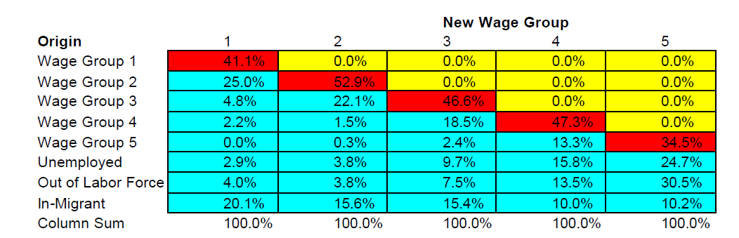

Figure 3-3

The data in the matrix suggest several generalizations. First, job changes within a wage group, the diagonal elements of the matrix, are somewhat more common for groups 2, 3 and 4 than for the highest group. But group 5 vacancies are less likely to go to those already employed in the group. Second, upward job movement remains largely limited to workers leaving their current job to fill a vacancy in the immediately higher group. Third, the importance of recruiting from the unemployed and the out of the labor force groups falls steadily as wage level rises. Finally, the share of vacancies filled by in-migrants rises steadily with rising wage levels. Expected chain length for the lowest wage jobs are short. Calculating Leontief multipliers for each of the other wage groups shows a rise in expected length with skill/wage level. The longest chains, with an average of 3.5 links, are found in the top two wage groups. These results answer one of our key questions. Yes, immigrants are more likely to fill high-wage vacancies and the unemployed are more likely to fill low wage vacancies.

3.3 Computational Model of Problem 2

3.3.1 Extra Symbols
Signs and definitions indicated above are still valid. Here are some extra signs and definitions.

Symbols | Description
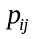 | The probability that a vacancy in stratum moves to stratum
 | The stratum
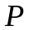 | The Markov matrix

3.3.2 Additional Assumptions
We assumes that positions are available independently of the capabilities of applicants, and that a position is only assigned if it becomes vacant. Since a vacant position is eventually occupied by someone who makes another position available, chains of vacancies are triggered whenever an incumbent dies or retires. Eventually, vacancy chains stop if the resource is destroyed or exits the field of observation.

3.3.3 The Foundation of Model
1) Model’s Organization
The model is organized as follows. A set of agents are placed on a square. Each position on the square belongs to a stratum. Strata are ordered by decreasing importance, top to bottom of a hierarchy. It is a partial ordering, i.e. two or more agents may belong to the same stratum. Strata may represent hierarchical levels in an organization, or degrees of quality of houses, or size of shells, or path lengths in a routing problem, or else. The model is initialized by producing vacancies at all positions belonging to a particular stratum. Subsequently, vacancies propagate to the lower strata. At each step, an agent is eligible for a vacancy if it is close enough to it and if it belongs to a stratum that is just one grade lower. If there is only one such agent, occupation of the vacancy is made by private agreement so the vacancy chain acts as an allocation mechanism. The agent moves up, a new vacancy is produced and the chain proceeds. If, on the contrary, several agents are able to fill the vacancy, the resource must be allocated by competition. In this model, chains are truncated at this point.
2) NetLogo
The model is built on the NetLogo platform，Version 5.0.4 .
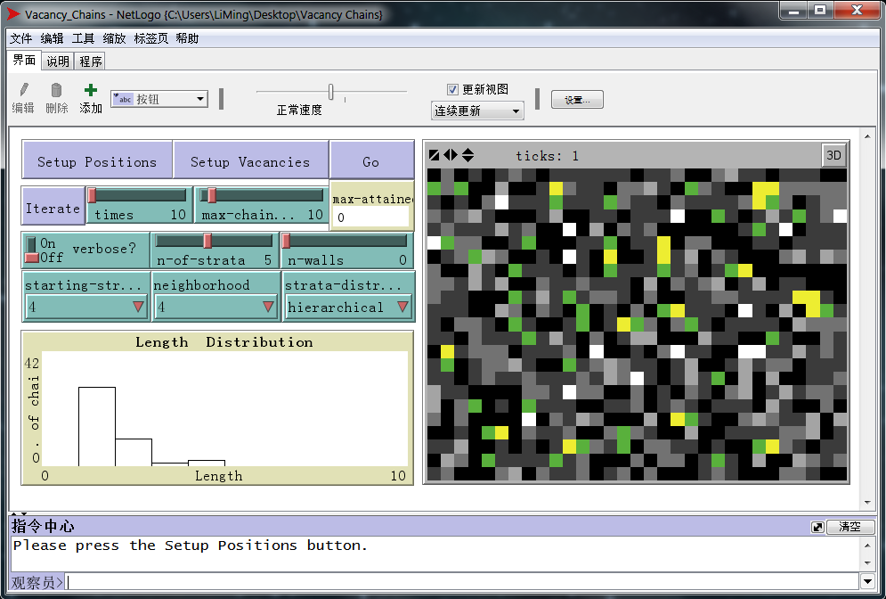
NetLogo is a programmable modeling environment for simulating natural and social phenomena. It was authored by Uri Wilensky in 1999 and has been in continuous development ever since at the Center for Connected Learning and Computer-Based Modeling. NetLogo is particularly well suited for modeling complex systems developing over time. Modelers can give instructions to hundreds or thousands of "agents" all operating independently. This makes it possible to explore the connection between the micro-level behavior of individuals and the macro-level patterns that emerge from their interaction. For more information about NetLogo please see Appendix. Figure 3-4 shows its user Interface.

Figure 3-4: NetLogo on Windows7. The graphical interface of the vacancy chains model. On the right, the available positions in shades of gray depending on the stratum to which they belong. Darker grays denote lower positions. On the left, the buttons to run the simulation and choose its parameters. At the lower left corner, a graph with the distribution of chain length.

3) Explanation of Figure
The area on the right of Figure 3-1 entails the available positions. Positions are ordered according to the stratum to which they belong: White positions rank highest, followed by grays of increasing darkness. Black positions belong to the stratum zero. If the other strata represent hierarchical levels in an organization, then the stratum zero represents the outer world. For instance it may represent the external job market, or homeless people, or shelless crabs, or idle robots. The number of strata can be selected by means of the slider n-of-strata, which takes values between 1 and 10. If the number of strata is 1, then vacancy chains take place in an organization that is perfectly flat. Thus, the model area will entail positions of only two colors: white positions inside the organization, and black positions outside the organization. If the number of hierarchical levels is 2, the model area will entail positions of three colors: white positions for the managers, grey positions for their subordinates, and black positions outside the organization. And so on, obviously. The distribution of strata represents the organization of positions in terms of importance. As we shall see, the organizational form has a strong impact on the properties of of vacancy chains. In particular, in the model positions can be assigned to strata according to the following distributions:
- A decreasing exponential distribution from low to high strata, if strata-distribution is set to 1. The functional form is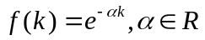, where 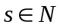 is the number of strata and k = 0,1,2,3...s. This distribution corresponds to the familiar experience of a hierarchy with far less managerial positions than subordinate positions. With respect to a pyramidal structure, a decreasing exponential describes a hierarchy where the ratio of the number of positions in neighboring strata is lower in lower strata than in upper strata. Thus, career advancements are most dificult at the bottom of the hierarchy. This representation is consistent with classical accounts of the span of control as well as with mathematical applications of vacancy chains to organizations.

Figure 3-5: Hierarchy

- A decreasing exponential distribution from high to low strata, if strata-distribution is set to 2. The functional form is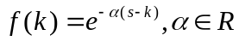, where is the number of strata and k = 0,1,2,3...s. This distribution corresponds to an inverted hierarchy with many more managers than subordinates. It is a clearly irrealistic organizational form, that has been considered in order to evaluate the effect of an assumptions that is opposite to the usual one.

Figure 3-6: Inverted Hierarchy

- A uniform distribution, if strata-distribution is set to 3. The functional form is simply f (k) = 1 where is the number of strata and k = 0,1,2,3...s, this distribution corresponds to an organization where there are just as many managers as subordinates. The corresponding linear organization chart is not necessarily a set of independent sequences of units, for the lines of command may still cross one another. This organizational form is just as irrealistic as No. 2, but also a midpoint between No. 1 and 2. It has been included in order to evaluate the linearity of the properties of vacancy chains with respect to organizational form.

Figure 3-7: Linear

- Half the positions assigned to strata according to a decreasing exponential distribution from low to high strata as in the above point (1), half the positions assigned to strata according to a poisson distribution from high to low strata, if strata-distribution is set to 4. In this second case the functional form is 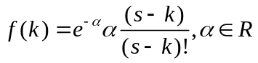, where is the number of strata and k = 0,1,2,3...s. This mixed distribution generates a hierarchy with proportionately less middle managers than a simple pyramid. This structure is such that upward movement is more dif_cult for middle managers than for both top managers and low-level employees, the so-called “Venturi tube” effect.

Hierarchy, mixed distribution The Venturi tube effect
Figure 3-8

4) Markov Chains
In the seminal work where vacancy chains were first introduced, an analytical description based on Markov chains was proposed. In this section, the agent-based model presented will be described in terms of Markov chains. Let 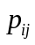 denote the probability that a vacancy in stratum moves to stratum, with,= 0, 1, 2, 3,… where is the number of strata over the zero level. In particular, since stratum 0 represents the outer world, the probability that a vacancy moves from stratum i to the outside is pi0. Let us arrange probabilities in a 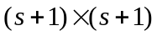 matrix P. The model assumed that a vacancy can only move one stratum lower at each step. Thus, it implicitly assumed that P has the following form:
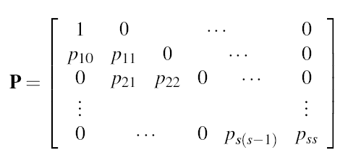
where the (0,0) element is 1 because vacancies cannot move once they reached stratum 0.
Probabilities are such that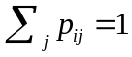. Since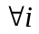 the only non-zero elements are 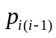 and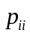, and since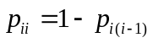, probabilities are sufficient to determine P.
It is now our task to express probabilities in terms of the parameters of the model. Let us first consider the case of a uniform distribution of strata (strata-distribution set to 3).
Let n denote the size of the neighborhood, with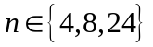. The number of ways of arranging any number of (s+1) different strata in n positions is the number of dispositions with repetition of s+1 elements of class n, which is equal to 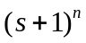. This will be the denominator of the fraction that yields the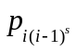.
The number of dispositions where a particular position is on a particular stratum, all others being on any different stratum, is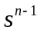. The number of dispositions where any position is on a particular stratum, all others being on any different stratum, is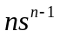. Thus, the probability of finding exactly one position on the required stratum in a neighborhood of size n is:
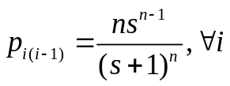
Let us now consider the case of a non-uniform distribution of strata strata-distribution set to 1, 2 or 4. Let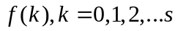denote the distribution of strata. For instance, we considered hierarchies with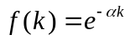.
A non-uniform distribution of strata implies that certain strata are overrepre- sented, others are underrepresented. Instead of s, we should consider the integral of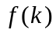. On the numerator, this integral extends over the s strata obtained by excluding the i one. On the denominator, this integral extends over all s+1 strata. Furthermore, the n at the numerator should be corrected by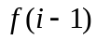. In conclusion, we obtain:
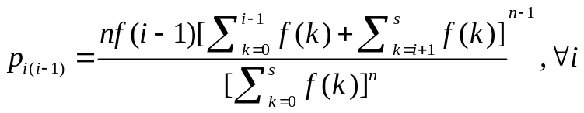

which reduces to eq. 1 if 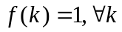.
Let us consider the matrix Ps. Its (i, j) element is the sum of the probabilities of all chains that start at stratum i and end at stratum j in s moves. Thus, these probabilities describe the outcomes of the simulation model expounded.
Matrix Ps can be used to derive statistics about the length of vacancy chains. For instance, > 0 the sum of the elements of Ps for j < i represents the probability that a chain starting at stratum i has a length greater than one. The reader will note that this quantity corresponds to the indicator that will be observed.

3.3.4 Solution and Result
1) Some Experiments
The aim of the model is to investigate whether there exists any regularity in the formation of vacancy chains depending on the number of strata, the starting stratum, the size of the neighborhood and the organizational structure. Since the equation derived in 3.2.3 can only be solved numerically, all investigations will be directly carried out on the numerical model.
Let us explore the behavior of the model on hierarchical organizations. Let us pose strata-distribution to 1 and investigate what happens to the chain length distribution when when n-of-strata, starting-stratum and neighborhood change.
2) Simulation Figures
The figures below are the results of the simulation.
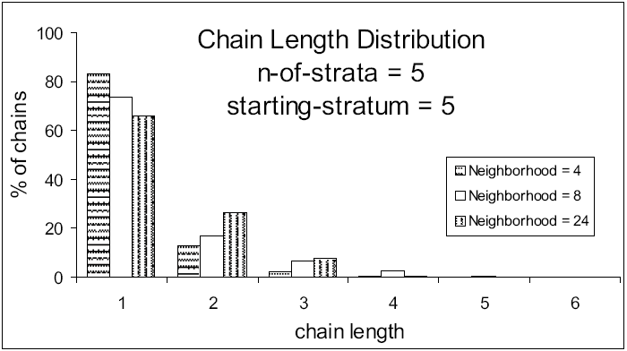
Figure 3-9 Chain length distributions with strata-distribution = 1, n-of--strata = 5, starting-stratum = 5 and neighborhood = 4, 8, 24. All values have been averaged over 1,000 runs.
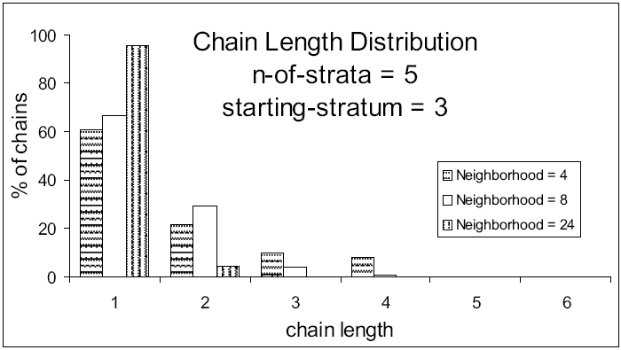
Figure 3-10 Chain length distributions with strata-distribution = 1, n-of--strata = 5, starting-stratum = 3 and neighborhood = 4, 8, 24. All values have been averaged over 1,000 runs.

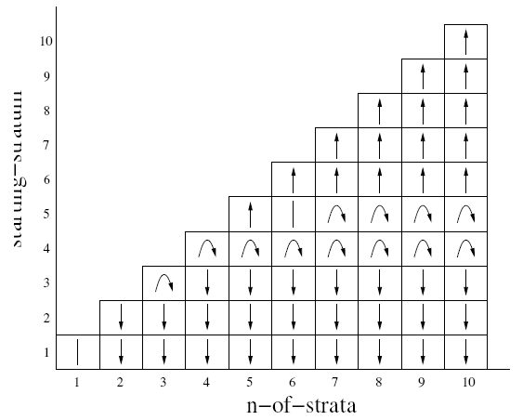
Figure 3-11: Hierarchy, variation of the proportion of vacancy chains with increasing neighborhood size. Upward arrows denote parameters combinations such that the proportion of vacancy chains increases when the size of the neighborhood passes from 4 to 8 to 24. Downward arrows denote parameters combinations such that the proportion of vacancy chains decreases when the size of the neighborhood passes rom 4 to 8 to 24. Finally, curve arrows denote parameters combinations such that the proportion of vacancy chains first increases when the size of the neighborhood passes from 4 to 8, then decreases when the size of the neighborhood passes from 8 to 24. Undirected bars denote parameter sets that produced outcomes differing from one another by less than 1%.

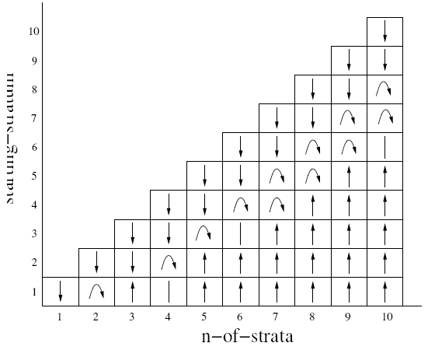

Figure 3-12: Inverted hierarchy, variation of the proportion of vacancy chains with increasing information (neighborhood size).
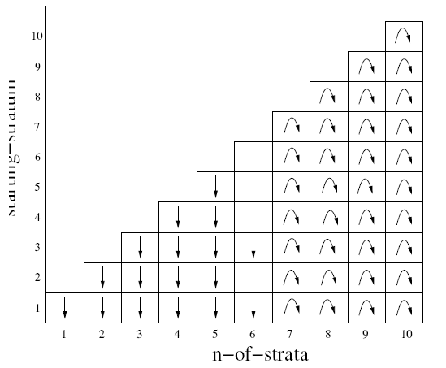
Figure 3-13:Linear organization, variation of the proportion of vacancy chains with increasing information (neighborhood size).
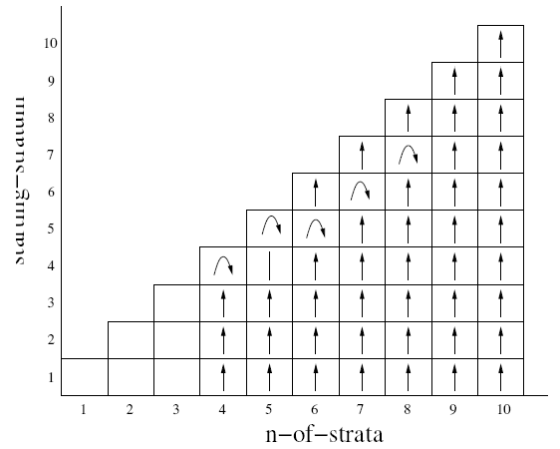
Figure 14: Organization giving rise to a Venturi tube in upward mobility, variation of the proportion of vacancy chains with increasing neighborhood size. Since this organization requires at least four hierarchical levels in order to be implemented, the first three columns are blank.

3.3.5 Analysis of the Result
Figure 3-9 illustrates the distribution of chain length in a hierarchical organization with 5 strata, where vacancies occur at the highest stratum, for various sizes of the neighborhood. It is clear that larger neighborhoods produce longer vacancy chains, evidently because it is easier to find an agent who is occupying a position exactly one stratum lower than the one where a vacancy occurred.
Figure 3-10 illustrates the distribution of chain length in a hierarchical organization with 5 strata, where vacancies occur at stratum 3, for various neighborhood sizes. Here the picture is opposite to that of figure 5. In fact, larger neighborhoods produce shorter chains. Evidently, low hierarchical levels are so many that with larger neighborhoods more than one agent able to fill the vacancy is found, so the chain stops.
The difference between figures 5 and 6 is extremely interesting. In fact, it suggests that for certain organizations and for certain starting strata, increasing information and communications (the size of the neighborhood) does not create markets or other forms of resource allocation by competition. Rather, increasing information fosters resource allocation by means of vacancy chains. For other organizations and starting strata, it is just the opposite. Thus, it is interesting to see which parameters originate distributions like in figure 5 as opposed to those that originate distributions like in figure 3-9.
Figure 3-11 illustrates the behavior of hierarchical organizations for all possiblecombinations of the number of strata and starting stratum. Vacancy chains of length one are isolated vacancies. Thus, the proportion of vacancy chains of length greater than one over total vacancy chains denotes the proportion of vacancies that actually originate a chain before market competition intervenes. This will be called the proportion of vacancy chains henceforth. Parameter combinations such that the proportion of vacancy chains increases with neighborhood size (like in figure 5) have been denoted by an upward arrow. Parameters combinations such that the proportion of vacancy chains decreases with neighborhood size (like in figure 6) have been denoted by a downward arrow. Finally, curve arrows denote combinations of parameters where the proportion of chains increases when the size of the neighborhood passes from 4 to 8 but decreases when the size of the neighborhood passes from 8 to 24.
Figure 3-11 highlights that there exists a region where vacancy chains are favored by more information (larger neighborhood), separated from a region where vacancy chains are impaired by more information (larger neighborhood). The area between these two regions is rather thin, and almost horizontal. Thus, the effect of information on the proportion of vacancy chains does not depend on the number of strata. On the contrary, the starting stratum is crucial. Only vacancy chains originating sufficiently high in the hierarchy are favored by more information.
Let us consider inverted hierarchies, i.e. organizations where there are far more high-ranked positions than low-ranked ones. Let us pose strata-distribution to 2, all other parameters as above.
Figure 3-12 shows quite a different pattern from figure 3-11. Contrary to the previous case, vacancy chains are impaired by more information if they start close to the top of the inverted hierarchy, whereas they are favored by more information if they are sufficiently far from it. Furthermore, note that the separating region is not horizontal. Thus, the effect of information on the proportion of vacancy chains depends on both the number of strata and the starting stratum.
Let us consider the intermediate organizational structure considered in this model, the linear organization obtained by setting strata-distribution to 3. Figure 3-13 illustrates the corresponding table.
This intermediate organizational form does not exhibit intermediate properties between the hierarchy and the inverted hierarchy. Since it has the same number of positions in any stratum, the starting stratum does not affect the outcome. In both the hierarchy and the inverted hierarchy, larger neighborhoods have a positive impact on the proportion of vacancy chains when contiguous strata have a very different number of positions (at the top of a hierarchy, at the bottom of an inverted hierarchy). In the linear organization, any two strata have the same number of positions. Thus, larger neighborhood. e.g more information never has a positive impact on the proportion of vacancy chains. The impact is generally negative or, if there are sufficiently many strata first positive and then negative. These are the curve arrows on the right of figure 13. Finally, organizations with less middle managers than purely pyramidal organizations are very important for studies on vacancy chains. In fact, figure 10 shows that this organizational form is such that in any case a small increase of information always favors the allocation of resources by means of vacancy chains (curve arrows). Furthermore, most of the times even a large increase of information favors the allocation of resources by means of vacancy chains (upward arrows). Thus, organization with shapes as in figure 3-8 are likely to make a large use of vacancy chains in order to allocate resources.
Note that a common feature of figures 3-11, 3-12, 3-13 and 3-14 is that all curve arrows first go up and then turn down, no one does the opposite. In other words, it never happens that by slightly increasing the size of the neighborhood the chains of vacancies become shorter and by increasing it further they become longer. It is so because larger neighborhoods may allow longer chains to the extent that they provide more agents able to fill a vacancy, and this effect is most prominent when the neighborhood is still small and does not include one instance of each stratum.
Conversely, larger neighborhoods may force chains to be short to the extent that they include several instances in the same stratum, and this effect becomes prominent when the neighborhood becomes very large.

IV. Conclusions

4.1 Conclusion of Problem 1
So we can use competition-vacancy complex model to exchange jobs in queue to make everyone benefits. But it cannot be applied to all industries, there are some conditions which need to use this model to solve this problems:
1. The resource units are reusable, discrete, identifiable and utilized by one individual or social group at a time;
2. A unit must be vacant before it can be taken by a new occupant;
3. Individuals must need or want new and usually bigger or better units;
4. Vacant units must be scarce;
5. Most individuals in a group already must have units so they can leave one behind when they move to a new one.
According to Sørensen, vacancy chains require that:
a) The predetermined and well specied nature of positions;
b) The inde nite duration of matches between people and positions;
c) Allocations that represent the outcomes of authority decisions rather than market exchanges.

4.2 Conclusion of Problem 2
The simulations carried out in this paper highlighted that organizations have alarge infiluence on the ability of vacancy chains to act as a device for allocating scarce resources. In particular, hierarchical organizational forms with less middle managers than straight pyramids are most likely to be regulated by vacancy chains.
Organizations should reduce the size of of middle management in order to make the most use of vacancy chain as a mechanism for resource allocation.

VI. References
[1] Andrew Abbott. Vacancy models for historical data. In Ronald L. Breiger, editor, Social Mobility and Social Structure, chapter IV, pages 81.102. Cambridge University Press, Cambridge, 1990.
[2] Yosef Blum, Alvin E. Roth, and Uriel G. Rothblum. Vacancy chains and equilibration in senior-level labor markets. Journal of Economic Theory, 76(2):362.411, 1997.
[3] Ivan D. Chase. Vacancy chains. Annual Review of Sociology, 17(1):133. 154, 1991.
[4] Ivan D. Chase, Marc Weissburg, and Theodore H. DeWitt. The vacancy chain process: A new mechanism of resource distribution in animals with application to hermit crabs. Animal Behaviour, 36:1265.1274, 1988.
[5] Ivan D. Chase and Theodore H. De Witt. Vacancy chains: A process of mobility to new resources in humans and other animals. Social Science Information, 27(1):83.98, 1988.
[6] David D. Van Fleet and Arthur G. Bedeian. A history of the span of management.
Academy of Management Review, 2:356.372, 1977.
[7] Ray Forrest and Alan Murie. The dynamics of the owner-occupied housing market in southern England in the late 1980s: A study of new building and vacancy chains. Regional Studies, 28(3):275.289, 1994.
[8] Peter Hedstr_om. Organizational vacancy chains and the attainment process.
Journal of Mathematical Sociology, 17(1):63.76, 1992.
[9] Suresh L. Konda and Shelby Stewman. An opportunity labor demand model and markovian labor supply models: Comparative tests in an organization. American Sociological Review, 45(2):276.301, 1980.
[10] Sam Marullo. Housing opportunities and vacancy chains. Urban Affairs Quarterly, 20(3):364.388, 1985.
[11] Lawrence T. Pin_eld. The Operation of Internal Labor Markets. Plenum Press, New York, 1995.
[12] Aage B. Sørensen. The structure of inequality and the process of attainment. American Sociological Review, 42(6):965.978, 1977.
[13] Aage B. Sørensen. Processes of allocation to open and closed positions in social structure. Zeitschrift f_ur Soziologie, 12(3):203.224, 1983.
[14] Aage B. Sørensen and Nancy Brandon Tuma. Labor market structures and job mobility. In Donald J. Treiman and Robert V. Robinson, editors, Research in Social Strati_cation and Mobility, volume 1, pages 67.94. JAI Press, Greenwich (CT), 1981.

Appendix
- Algorithms
The hierarchical organization has been modeled by means of a truncated exponential distribution decreasing from low to high strata. Note that NetLogo does not require to set the exponent but the mean:
set elevation n-of-strata + 1
while [elevation > n-of-strata]
[set elevation round random-exponential (1 + n-of-strata)/4]
The inverse hierarchical organization has been modeled by means of a truncated exponential distribution decreasing from high to low strata:
set elevation -1
while [elevation < 0]
[set elevation n-of-strata - round random-exponential (1
+ n-of-strata)/4]
The linear organization has been modeled by means of a uniform distribution of strata across positions:
set elevation random (1 + n-of-strata)
Finally, the organization whose chart is steeper at the top and the bottom than in the middle, has been modeled by combining an exponential distribution decreasing from low to high strata with a poisson distribution from high to low strata:
ifelse (random 2 = 0)
[
set elevation n-of-strata + 1
while [elevation > n-of-strata]
[set elevation round random-exponential (1 + n-of-strata)
/ 4]
]
[
set elevation -1
while [elevation < 0]
set elevation n-of-strata - round random-poisson (1 + n-of-strata)/ 4]
]
- NetLogo
NetLogo is a programmable modeling environment for simulating natural and social phenomena. It was authored by Uri Wilensky in 1999 and has been in continuous development ever since at the Center for Connected Learning and Computer-Based Modeling.
NetLogo is particularly well suited for modeling complex systems developing over time. Modelers can give instructions to hundreds or thousands of "agents" all operating independently. This makes it possible to explore the connection between the micro-level behavior of individuals and the macro-level patterns that emerge from their interaction.
NetLogo lets students open simulations and "play" with them, exploring their behavior under various conditions. It is also an authoring environment which enables students, teachers and curriculum developers to create their own models. NetLogo is simple enough for students and teachers, yet advanced enough to serve as a powerful tool for researchers in many fields.
NetLogo has extensive documentation and tutorials. It also comes with the Models Library, a large collection of pre-written simulations that can be used and modified. These simulations address content areas in the natural and social sciences including biology and medicine, physics and chemistry, mathematics and computer science, and economics and social psychology. Several model-based inquiry curricula using NetLogo are available and more are under development.
NetLogo can also power a classroom participatory-simulation tool called HubNet. Through the use of networked computers or handheld devices such as Texas Instruments graphing calculators, each student can control an agent in a simulation. Follow this link for more information.
NetLogo is the next generation of the series of multi-agent modeling languages including StarLogo and StarLogoT. NetLogo runs on the Java virtual machine, so it works on all major platforms (Mac, Windows, Linux, et al). It is run as a standalone application. Models and HubNet activities can be run as Java applets in a web browser. Command line operation is also supported.

