第二届“认证杯”数学中国
数学建模国际赛
承 诺 书

我们仔细阅读了第二届“认证杯”数学中国数学建模国际赛的竞赛规则。
我们完全明白，在竞赛开始后参赛队员不能以任何方式（包括电话、电子邮件、网上咨询等）与队外的任何人（包括指导教师）研究、讨论与赛题有关的问题。
我们知道，抄袭别人的成果是违反竞赛规则的, 如果引用别人的成果或其他公开的资料（包括网上查到的资料），必须按照规定的参考文献的表述方式在正文引用处和参考文献中明确列出。
我们郑重承诺，严格遵守竞赛规则，以保证竞赛的公正、公平性。如有违反竞赛规则的行为，我们将受到严肃处理。
我们允许数学中国网站(www.madio.net)公布论文，以供网友之间学习交流，数学中国网站以非商业目的的论文交流不需要提前取得我们的同意。
我们的参赛队号为：
我们选择的题目是：
参赛队员 (签名) ：
队员1：高立钊

队员2：李鹤宇

队员3：阮小可

参赛队教练员 (签名)： 无

第二届“认证杯”数学中国
数学建模国际赛
编 号 专 用 页

参赛队伍的参赛队号：（请各个参赛队提前填写好）：

Team # 1224

竞赛统一编号（由竞赛组委会送至评委团前编号）：

竞赛评阅编号（由竞赛评委团评阅前进行编号）：

The Application of Vacancy Chain in Labor Flow
Abstract:
For the first model, we establish a Human Resource Allocation Mechanism based on vacancy chains. The process can be described like that a vacancy passes through positions of different strata and eventually goes into the market. This process can benefit every individual in the chain. We also apply the model in different forms of organization. We found that for the linear structure and the pyramid structure, vacancy chain works better as a resource allocating mechanism than the market or other forms of allocating. Since vacancy chain is not suitable for the negative exponential type and pyramid with less middle type, we induce internal competition, external recruitment channels, solving the limitation problem.

For the second model, we induce external recruitment on the basis of the former model. Besides, we develop an internal recruitment priority rule to meet the company’s both requirements for employees and employers. In terms of decreasing exponential type, we establish a constant Markov chain model. By running numerous of Matlab simulations, we calculate the transition probability for each stratum. Finally, we get the overview of enterprise’s labor flow (including internal competition, external recruitment, vacancy chain etc.) We also have established a mechanism for labor costs and estimated these four former forms’ costs respectively.

Finally, we design an advertisement for a human resources website to present our ideas and conclusions, which can reflect our core advantages.
Key words: vacancy chain, structure of organization, internal competition, external recruitment, Markov chain

CONTENT
I. Introduction 3
1.1 The definition of the vacancy chain 3
1.2 The trigger of a vacancy chain 4
1.3 The conditions for a vacancy chain to proceed 4
1.4 The conditions to stop a vacancy chain 4
1.5 The fields where the vacancy chain allocates resources in major 5
II. The Description and Analysis of the Problem 5
Description 5
Analysis of the Problem 5
III. Models 6
3.1 Basic Model 6
3.2 Improved Model 13
IV Model for Predicting 16
4.1 Model based on Markov-vacancy chain 16
V Advertisement (next page) 20
VI Appendix 22

I. Introduction
Vacancy chain is a useful mechanism which can solve the problem of allocating scarce resource, nowadays widely applied in the research of inside labor market as well as real estate market. The paper mainly states how to solve the issue of the human resources change in corporations by means of an allocation mechanism based on vacancy chain. To better understand the content of the paper, the following background information should be known in advance.

1.1 The definition of the vacancy chain
A vacancy chain is a social structure through which resources are distributed to consumers. In a vacancy chain, a new resource unit that arrives into a population is taken by the first individual in line, who then leaves his/her old unit behind, this old unit is taken by a second individual, leaving his/her old unit behind, and so forth.

1.2 The trigger of a vacancy chain
According to the definition above, a vacancy chain needs to be triggered first. For a corporation, when a staff (not at the bottom of the hierarchy) dies, retires or does job-hopping, his original position will be vacant. However, the company still needs someone else to fill in the vacant position for the normal work. Under that circumstance, a vacancy is produced as the head of a vacancy chain in this vacant position. Therefore, the trigger of a vacancy chain is a starting vacancy.

1.3 The conditions for a vacancy chain to proceed
The following conditions need to meet when a vacancy chain is proceeding:
1. The vacancy is scarce;
2. The range of a vacancy chain is limited in an organization;
3. A vacancy can proceed more than one time;
4. Every single staff wants a position higher than his;
5. If a vacancy wants to proceed, its neighborhood needs to meet the “only candidate” requirement.
The above candidate means:
1. His position is lower than that of the vacancy by one;
2. He exactly knows the news that the upper position is open;
3. His skills match what are required by the position;
Therefore, the “only candidate” can be explained that in the neighborhood of the vacant position, there exits one but only one candidate.

1.4 The conditions to stop a vacancy chain
A vacancy chain could proceed from the top to the bottom, and finally stop when meets some conditions. Generally speaking, a chain would end when meeting either condition of the following:
1. The neighborhood of the vacancy does not meet the “only candidate” requirement, which includes two conditions:
1. There is no candidate;
2. There is more than one candidate.
Under the first condition, a company would often recruit staff from outside. Well, the second condition would first trigger the competition in appropriate candidates, and then the market comes into play.
2. The vacancy chain proceeds to the bottom stratum.

1.5 The fields where the vacancy chain allocates resources in major
By tuition, some fields would make the best of the vacancy chain as a mechanism. For example, promotions mechanism for government officer, soldier, doctor, professor etc. which are evaluated most by age, working age or some other objective indexes, may make use of the vacancy chain.
In addition, for some positions, a staff should acquire extremely high skills, which costs a lot of society resources for training. Because of the specialization of the position, there is little or even no competition. For these experts, they can always get promotion by a vacancy chain, such as scientists working for the country.
Of course what mentioned above is only our tuition, more research will be done after the foundation of the model.

II. The Description and Analysis of the Problem

Description
When a lone crab encountered a beautiful new shell, all the crabs in queue would exchange their shells one after one. Sociologists and economists use the term “vacancy chain” to describe a sequential exchange of resources that benefits every individual in the sequence. So it makes sense that hermitcrabs have evolved sophisticated social behaviors to make the most of vacancy chains.
Goals of your model
1. Evolve social strategies to exchange jobs in queue so that everyone benefits.
Can we apply them to all industries? If not, what conditions need to meet?
2. Now a new Human Resource website want to adopt your idea, How many job applicants do need to satisfy both employers and employees. Run your
model to predict the change of HR expends for some enterprise customer within the next five years.

Analysis of the Problem
2.1 How to understand “exchange jobs in queue so that everyone benefits”?
We use the basic vacancy chain model to realize the position movement, which means exchanging jobs.
2.2 How to divide industries into different types?
There are different kinds of principles for dividing industries. We distinguish different industries with the distribution of a company’s hierarchy which influences the model effects most.
2.3 How to judge whether the model can apply to an industry?
We set up a series of evaluation criteria based on the data from simulation. We have paid a lot attention to the quantizing of indexes work and the analysis of the index change.

2.4 How to improve the model to meet the all kinds of enterprises?
We combine the original vacancy model with other allocating mechanism as a new method to solve the problem in labor flow.
2.5 How to predict the labor flow for a company in the future?
We first read a lot of data about labor flow, and get the separation rate of every stratum in a company. We regard the separation rate as the probability of producing a vacancy. And we use the improved model to get the data of one time of labor flow. Finally, we put the data in Markov chain theory to get the labor flow data in the future.
2.6 The quantification of HR expends
We refer to a large amount of paper, list the major expends in labor flow. What is more, a formula is given to calculate the finial expends.

III. Models

3.1 Basic Model
Our aim is to allocate the vacant positions based on vacancy chain model in different types of industries. Through simulations and analysis, we can evaluate the effect of the model used in certain industries.
3.1.1 Terms, Definitions and Symbols
- number-of-strata the number of total strata in an organization
- start-stratum the first stratum where appears vacancy
- neighborhood the range where vacancy can move to
We set three types of neighborhoods, the numbers of which is four, eight, twelve. (as figure 1) .
The size of neighborhood represents the communication efficiency and the co-operation frequency among different positions in a company.
- organization structure the distribution of a company’s hierarchy
We set four types of organization structures (as figure 2), line, decreasing exponential distribution, pyramid, and pyramid with less middle.
- start-number the number of vacancies appearing at first
- chain-length the length of a vacancy chain
When a vacancy moves by one step, the length of it will increase by one. And the original length is 0.
- N（L） number of a certain length vacancy chain
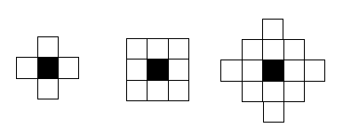
Figure 1: Left to right, the neighborhoods size is 4, 8, 12.

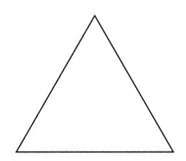

Line pyramid
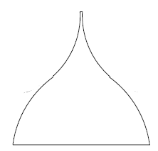
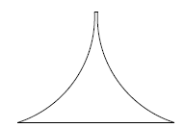

decreasing exponential pyramid with less middle
Figure 2: Different structures
3.1.2 Assumptions
- Before simulation, all positions are filled;
- The range of a vacancy chain is limited in the organization;
- A vacancy can proceed more than one time;
- Every single staff wants a higher position;
- Positions of different strata in an organization are randomly distributed;

3.1.3 The Foundation of Model
1. Initializing
We have designed a big grid chart to simulate a company’s distribution of positions. Every grid represents a position. These positions belong to different strata. In a company’s hierarchy, stratum is arranged from number-of-strata to 1 (bottom) according to its importance. In a grid chart, these positions are randomly distributed, filling all the grids. And the number of positions of different strata is regulated by the organization structure.
2. Running process
When the model starts running, all the positions of the very start-stratum become vacant. Then, all the vacancies start proceeding. For every step, a vacancy could move to the next position only when satisfying the following conditions: 1) the position is in the vacancy’s neighborhood; 2) the next position’s stratum is lower than the vacancy’s by one; 3) the position is the only one in the vacancy’s neighborhood. After each successful move, the original vacancy is filled with a staff of the same stratum, and the next position become vacant.
3. Ending
When all the vacancy chains stop, the process ends. The stop conditions have been discussed in 1.4.
3.1.4 Solution and Result
1. Method for simulation
We edit a program by Matlab, the grid chart is represented by a big matrix. And every position is represented by an element in the matrix. The stratum of a position is showed by the value of the element, and 1 represents the bottom.
2. Data collecting
We use counters in the program to calculate the numbers of different chain-lengths. At the end, we put the data out.
3. Dynamic display
We add some program to visualize the dynamic process of vacancy moving. Figure 3 is the dynamic result.
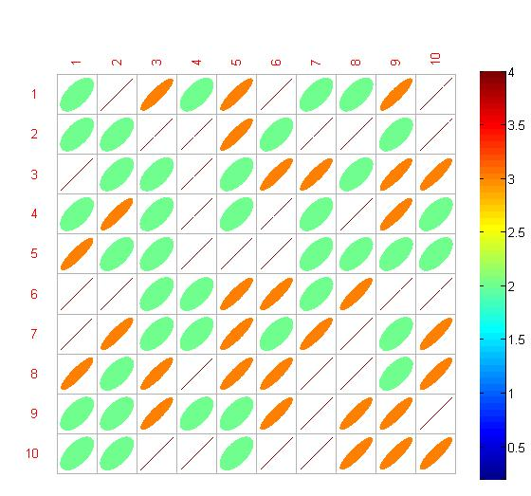
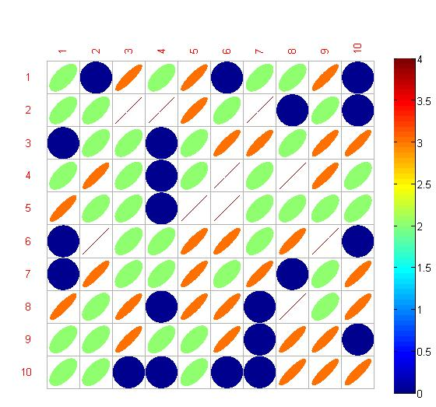

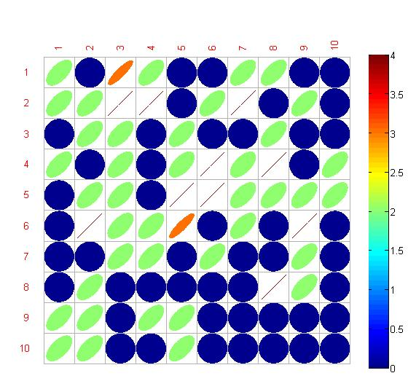
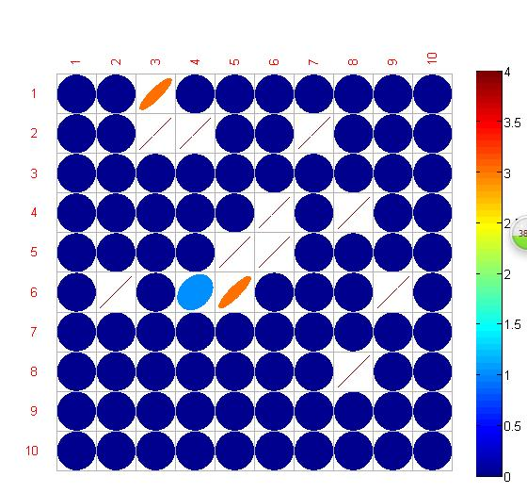
First step Second step

Third step Fourth step
Figure 3: dynamic result
3.1.5 Analysis of the Result
1. Inducing evaluating index
a) ratio-of-length： ratio of the number of a certain length vacancy chain and the number of the beginning vacancies
formula: N（L）/start-number
b) ratio-of-all-length ratio of the sum of all chain-length and the number of the beginning vacancies
formula: ΣN（L）/start-number
Both of the indexes in a) and b) reflect the probability for vacancy proceeding. The bigger the indexes become, the better the vacancy chains proceed.
2. Research about the variables’ influence on evaluating index

- Neighborhood size
From Figure 4, for line structure, the ratio-of-length of every different length do not vary much from 4 neighbors and 8 neighbors. However, the ratio dramatically declines when the neighbors rise up to 12.
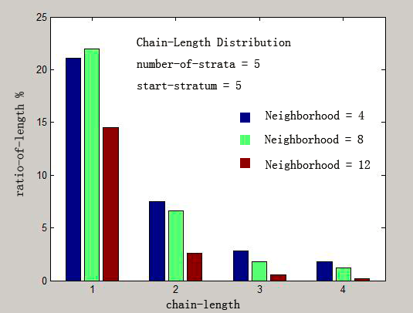

Figure 4: Chain-length distributions with line structure.
All values have been averaged over 1,000 runs.

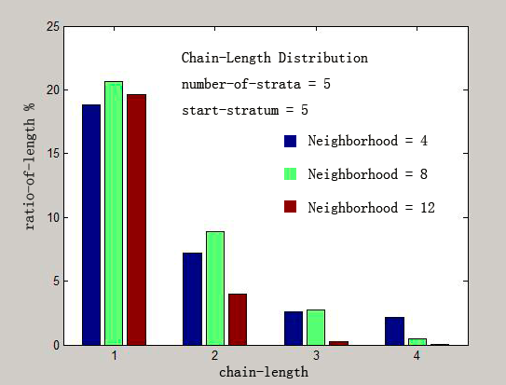
From Figure 5, for pyramid structure, the ratio-of-length for most lengths slightly increases when the neighbors rise from 4 to 8, and then declines when neighbors go on to rise.

Figure 5: Chain-length distributions with pyramid structure.
All values have been averaged over 1,000 runs.
Reason: since the vacancy chain stops when it meets more than one candidates or no candidate, it is this two conditions that influence the ratio-of-length. When neighborhood size is small, the issue of no candidate is in major. And once enlarging the neighborhood size, the major issue would be solved, so the ratio-of-length (probability for vacancy proceeding) increases. But if adding the neighborhood size, the competition of candidates becomes the major issue, then the ratio turns to decline. So we set 8 neighbors in the following experiments.

2. start-stratum
We set the number-of-strata=5. In this section, we use ratio-of-all-length as the evaluation criteria to judge the influence of different start-stratum (Figure 6)
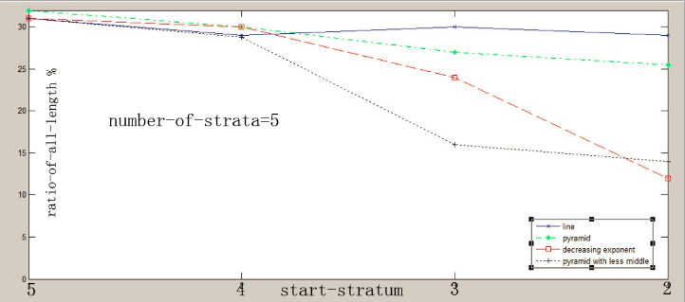
Figure 6: influence of different start-stratum

1) line structure
The ratio keeps almost constant at value of 30 percent with the start-stratum decreasing from 5 to 2.
2) pyramid structure
The ratio keeps constant at first and then declines slightly.
Reason: The similar phenomenon between 1) and 2) is because the two structures do not change their ratio of positions in neighboring two strata at different strata. Thus, the promotion pressure is similar for each stratum. So wherever the vacancies appear, the situation for vacancy proceeding is similar. Considering that in pyramid structure, positions in lower strata is much more than those in the upper, so the competition seems more fiercely. Thus the ratio would decline just a little.
3) decreasing exponential structure
The ratio keeps stable in the first two strata while declining largely at the lower two strata.
Reason: At the lower strata, the ratio of positions in neighboring strata varies much, leading to scarce positions but many candidates. The fierce competition fails the vacancy chain. Well, at the higher strata, the ratio of positions in neighboring strata varies slightly, the number of candidates is similar to the number of vacant positions, which helps the vacancy proceeding.
4) pyramid with less middle
The ratio varies slightly at the first two strata and at the last two strata, but declines dramatically from 3 to 2.
Reason: the ratio of positions in neighboring strata varies slightly at higher and lower strata, but varies significantly in the middle. Thus the competition is much more fierce in the middle than that at the top or bottom. The vacancy chain fails from the middle.

3. Conclusion
1) Line structure can make the best of the vacancy chain model as a mechanism for allocation. Unfortunately, corporation of this structure does not really exist in real life.
2) Pyramid structure ranks only second to the line. Organizations with this structure are common, such as the government, state-owned enterprise etc. where hierarchy is strict from bottom to top.
3) The vacancy chain has limitation when applied to decreasing exponential structure although it works well at the middle and top. Organizations with this structure are common, such as factory, service industry and some other labour intensive industries. In these fields, the bottom workers with inferior education background have difficulty climbing the corporation ladder. While those new staffs with abundant education experience, would be set to the middle class from the very beginning, and has less competition for promotion.
4) The last is the pyramid structure with less middle. Corporation with this structure has least effect of vacancy chain model. Nowadays more and more small and medium-sized enterprises adopt this structure for its numerous advantages such as the efficiency in management. However, the disadvantage is also obvious such as the extreme promotion embarrassment for the middle class.
3.1.6 Strength and Weakness
- Strength: In despite of this, the model has proved that the vacancy chain as an allocation mechanism plays better when the ratio of positions in neighboring strata varies less. Moreover, we have drawn a useful conclusion that the effects of vacancy chain have relations with the neighborhood size, which represents the communication efficiency and the co-operation frequency among different positions.
Weakness: This model just applies to limited types of industries. The vacancy chain is easy to stop under several conditions. To solve this problem, we should combine the chain with other allocating mechanism. That’s just what we should do in the improved model.
3.17 The theory support the model
下面的矩阵体现空穴链的移动情况
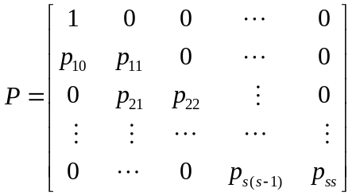
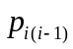表示的是空穴从第i层传递到第i-1层。对于直线型，有
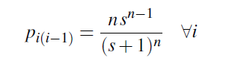、
对于负指数型，有

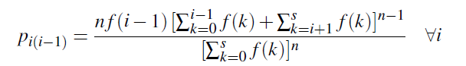

3.2 Improved Model
3.2.1 Additional Assumptions
  - The kinds and quantity of a company’s positions is constant in five years.
  - The company can always find the right external candidate to fill the vacancy positions.
  - When the company is determined to promote an internal staff leaping promotion is banned.
  - The match of external candidate and staff is equal.
  - In a complete position change, the change number of position and staff is no more than once.
  - Assumptions concerning the anterior process are the same as the basic model.
3.2.2 The Foundation of Model
- Rules should be observed
Follow the principles of the internal priority
A vacancy is generated when a staff has resigned.
When a vacancy stops, due to more than one candidate in neighborhood, introduce competition mechanism and select a suitable candidate from the next layer around.
When there is no proper candidate in the vacancy’s the next layer around, recruit one external candidate.
- Programming ideas
Establishment of a matrix
Randomly generated each level according to the probability
Randomly generated each Phenomenon resignation according to the probability
Two vacancy-flowing chain cannot conduct at the same time.
When every vacancy in the matrix have disappeared, a period of personnel changes is accepted.

- Process
Step1: When a vacancy position occurs, the first ring of a vacancy chain generated.
Step2: Faced with the vacancy position, our prior selection is choosing a staff to fill the position. In other words, we use vacancy chain model first. We can meet three situations.
Step3: On the first situation, there is only one staff suitable of the vacancy position, we promote the person. After promotion, the staff’s former position is vacant.
Step4: On the other situation, more than one staff is fit for the vacancy position. In this condition, the most suitable staff is selected by competition. We use 360-degree assessment to gain data which can reflect a competitor’ ability exactly. We gain the right staff by the data. The competition, bring about a new vacant position.
Step5: Besides the two former situations, we may not find any suitable staff. Under this condition, the company needs to find a external person to fill the position. While conducting recruitment, a plenty of candidate are applied. Through a selection mechanism, the company can get the right candidate.
Step6: When we meet the first or second situation, the above method is continued to use.
Step7: The complete position change is ended when the third situation occurred.
Step8: There is another way to end the complete position. As the vacancy position flows, the third situation never appears. Finally, the vacancy position appears in the lowest position level. Then, the company has to recruit a person from human resource market.
3.2.4 Result
1. Selected Customer
The company we choose has the following characters:
1. size：100 people
2. structure：decreasing exponent
3. number-of- strata : 3
4. share of each stratum：[0.1483 0.289 0.5627]
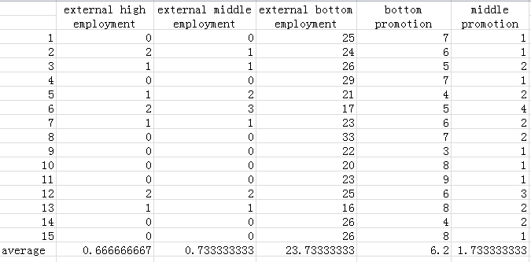
5. average separation rate：High 0.1 Middle 0.2 Bottom 0.5

3.2.5 Analysis of the Result
The numbers of recruitment of middle and high strata is less than that of the promotion (including vacancy chain and inside competition) from the bottom stratum, which reaches the expectation that inside promotion should be first considered.

3.2.6 Strength and Weakness
- Strength: The Improved Model aims to make up for the neglect of competition between internal staffs and situation of no suitable staff of the vacancy position. The result seems to declare that this model is more reasonable than the Basic Model and much more effective than the existing design.
- Weakness: With the development of the market, the division of positions is more and more complex. This model. Thus, for different position, aiming is also vastly different. Based on the position, importance such as positions regarding high technology or finance use this model can have a good result. Positions like marketing had better to be filled with external persons. When a company is developing fast, using this model is a good choose. Not only does the motivation is enhanced, but also staff is more united. On the contrary, the company should introduce external personnel to a proper extent when it condition is not good. By this way, the company is rejected energy. Thus the model is still an approximate on a large scale. This has doomed to limit the applications of it.

3.2.7 Conclusion
No matter what method does a company choose to high-level vacancies are required to establish employment strategy based on the existing strategic planning and analysis of human resources. Establishing employment strategy includes cleating the company’s employment strategy, establishing internal training and selection system and expanding the recruitment and selection of work purposefully. It is fair and opportunity, reasonable staff echelon that is achieved. Finally, the company can develop smoothly by this way.

IV Model for Predicting

4.1 Model based on Markov-vacancy chain
4.1.1 Assumption
1. The period of personnel changes is one year.
According to the data, resignation rate is calculated by year. So we choose one year as a period.
2. The company operates steady so that resignation rate keep in a stable range.
3. Every staff have the possibly of resignation.

4.1.2 Definition of some terms
1. Markov process
For any finite sequence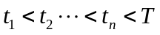, if the random process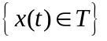corresponding state 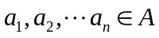
We call a random process with this feature Markov process. When a random process state of sequence is known, random process’s state when sequence after is only relative to the state of sequence.
2. Markov chain
Assume a random process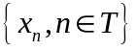.For any integer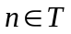and any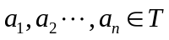, if conditional probability is suit for
We call this random process Markov chain.
Conditional Probability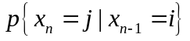stand for the probability of state i at sequence and transforming into state j at sequence, denoting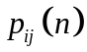. Generally, Transfer Matrix consist of Conditional Probability is
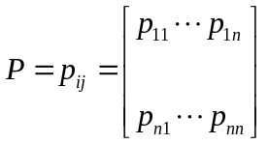

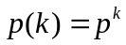 means the k times Transfer Matrix.

3. Invariance Markov chain
Assume a random process.For any integer, if Conditional Probability is suit for
We call this random process invariance Markov chain. Invariance Markov chain’s transition probabilities only depend on the transfer steps of.Our model is based on the assumption that human resources management policy is constant in a period so that our model satisfy the requirement of Markov chain.

4.1.3 The foundation of Markov model of human resource supply forecasting
We use the chain - competition model with probability and Markov chain to forecast the company’s personnel changes in five years.
1. The determination of the initial matrix
Rank the company’s positions into k layer and mark them with1, 2, …,k respectively. The higher the number becomes, the lower the grade. Human resource’ initial distribution is 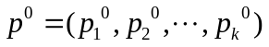
2. The determination of the Transfer Matrix
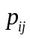 means the rate of transfer from i kind of staff to j kind of staff. The first staff Transfer Matrix is generated by this. Considering the particularity of human resource supplying, we add an object “demission” in the Transfer Matrix. The Transfer Matrix’s last element is one, meaning the addition of outgoing staff.

In the first model, we mentioned the probability of holes moving in terms of Markov chain. These two’s conversion relationship is
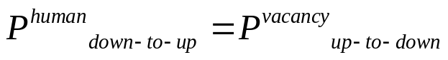
That means, the probability of vacancy transforming for grade i to grade i-1 equals to the probability of vacancy transforming for grade i-1 to grade i. We cannot use the above question’s model to gain the result because personnel Changes of every grade is unconstant.
According to the assumption, we know the turnoff rate of every grade which is the company's personnel changes in macroeconomic performance. Through the first model, we can gain the average probabilities representing one grade’s staffs transforming to another by calculating repeatedly. Using these probabilities wo can establish a matrix of personnel changes. That is human resources’ transition probability matrix.The determination of Transfer Matrix staffs of one grade transforming to another influence the forecast’s accuracy directly. Finally, substituting data, we get the Transfer Matrix, as follows.
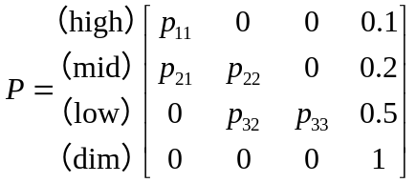

3. prediction of the HR change in 5 years
Use this model to predict the company’s Personnel changes in next five years.
The fifth transfer matrix is 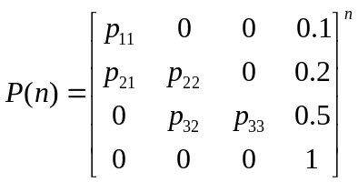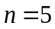
Then, the ith year’s personnel changes is
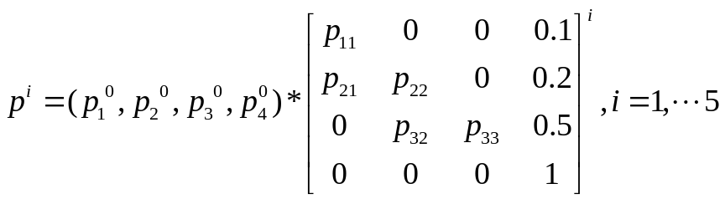

4.1.4. Vacancy-flowing chains’ computer simulation
We think of another way that conduct a simulation with Vacancy-flowing chains model by Matlab.
The specific steps is as follows:
1.Run the program a time,that is to get the personnel changes in the first year
2.Use the first resulting matrix as the module.Through the second run of the program, get the personnel changes in the second year.
3.And so on,we can obtain the cases of the other three years.

4.1.5 Comparison and analysis of the two models
Due to time’s constraint,the statistical data of first model is not finished.The first model is more convincing than the second model, since the first model of the transfer matrix is an average, it reflects the situation as a whole, while the second model has a certain randomness.

4.1.6 Costing transition

1. Promoting by vacancy chain
In this method,when a position is vacant,there is only a staff suitable for the position.Thus,the staff is the successor. In this process,we can neglect the cost.
CONSUMEHOLE=0

2. Promoting by internal competition
The mechanism of staff evaluating includes informal discussions and questionnaires. The form below is the detail spend by one person.
Items of spending | number/frequency | cost
informal discussions（The place of informal discussions is in the company.Thus,this part can be neglect.） | 1 | 0
questionnaire | 50 | 50*0.1
distribution | 1 | 50
Considering the number of competitors and the number of competitions in a period.According to the data,we assume a competition has five competitors in average.We use C represent the cost of competition,N represent the number of competitions in a period and CONSUME represent the total cost of competition.
C=5*50*0.1+50=75
CONSUMELINE=N*C

3.Employing external senior staffs
By referring to literature,we get the constitution of costs.Among them,advertising costs(newspaper) is twenty thousands per time when occupying one fourth of the whole page.Interviewing costs is mainly about the pay to the interviewers,which is eighty yuan per hour.The applicants are senior staffs,so we assume the number of interviewers is six.The total interview duration is eight hours.For the same reason, settling costs is high relatively speaking.Let the number of applicants is three.Transportation costs is mainly considered applicants’ cost from location to company.According to statistics, two applicants are from outland on average.
Items of spending | number/frequency | cost
advertising costs(newspaper) | 1 | 20000
advertising costs(internet) | 1 | 8000
interviewing costs | 1 | 80*6*8
transportation costs | 3 | 100+1000*2
settling costs | 1 | 10000

The total costs is
CONSUMEEXTERNAL=20000+8000+80*6*8+100+1000*2+10000=43940

4.Recruiting junior staff
We set the recruitment is campus recruitment.The cost is two thousand per time.Due to the applicants number of campus recruitment is high,we set the time of interview three,the number of interviewers fifteen and the days six.Taking recruiting 10 applicants every campus recruitment into account,the cost should be divided by ten to gain the costs of per applicant.

Items of spending | number/frequency | cost
Adverting | 1 | 20000/10
campus recruitment | 1 | 2000/10
SMS | 1000 | 10000*0.1/10
Training | 1 | 5000/10
Poster and flyer | 5000 | 5000*1/10
interviewing | 3 | 80*15*8*6/10

V Advertisement (next page)

With market mechanism developing, companies are faced with fierce competition. Companies should improve all aspects of mechanism to survive in the market. Human resources, the foundation of a company, is always flowing between the old and the young. Thus, completing position-handover smoothly makes a big different to a company. Vacancy Chain Model, based on the above situation, by analyzing the diverse staff-composition of the companies and validate, is mechanism put forward to optimize human resources.

The core idea of this model is that when vacant positions occur, prior selection is promoting internal staffs. If there is no proper candidate among internal staffs, the company will recruit from outside.

Advantage of this model
Through statistics and calculation, we can get the costs of per internal promotion without competition, internal promotion with competition, external recruitment and grassroots market inflow.

Supplementary Methods of vacancy position | costs
internal promotion without competition | 0
internal promotion with competition | 75
external recruitment | 43940
grassroots market inflow | 9070

It is clearly that, prioritizing internal promotion can greatly reduce costs.

Prioritizing internal promotion can inspire staffs initiative. In addition, internal staffs have a better understanding of the company and the industry, enabling the company to run better. On the contrary, reducing external candidate recruitment can decline risk, especially in some technical, financial sectors.

Skipping promotion is banned. This rule allows employees to adapt to the new position fast and complete the transition of work smooth.

VI References
[1] Harrison C. White. Chains of Opportunity. Harvard University Press, Cambridge
(MA), 1970.
[2] Fioretti G. A model of vacancy chains as a mechanism for resource allocation[J]. The Journal of Mathematical Sociology, 2009, 34(1): 52-75.
[3] 徐婕. 机会链的构成及其在企业人力资源管理中的应用[J]. 中国商贸, 2010 (28).
[4] 方四平. 基于马尔科夫链的企业内部人力资源供给预测[J]. 北京工业职业技术学院学报, 2004, 10(3): 101-101.
[5] 孙红丽, 何永贵, 张文建, 等. 马尔科夫模型在企业人力资源供给预测中的应用[J]. 华北电力大学学报, 2004, 5(8): 5.

VII Appendix
Part of the code
clc,clear
XVarNames = {'1','2','3','4','5','6','7','8','9','10'};

num_stra=3;
start_stra_high=3;
start_stra_mid=2;
start_stra_low=1; %¿ªÊ¼²ãÊý
% start_num; %¿ªÊ¼²ã¸öÊý
width=10; %¾ØÕó±ß³¤
%¹¹Ôì¾ØÕó
index=2;

x=rand(width);
d=[];
for i=1:num_stra
d(i)=index*i/num_stra;
end
P=[];%%¹¹½¨¸ÅÂÊ¾ØÕó£¬Ê×ÏàÎª0£»
for i=1:num_stra
P(i+1)=(1-exp(-d(i)))/(1-exp(-index));
end
disp(P);
for j=1:(width^2)
if x(j)~=1
for(i=1:num_stra)
if x(j)<P(i+1)&&x(j)>=P(i)
x(j)=i;
end
end
else
x(j)=num_stra;
end
end
x
%µÈ¼¶È·¶¨
%matrixplot(x,'XVarNames',XVarNames,'YVarNames',XVarNames,'DisplayOpt','off','FigSize','Auto','ColorBar','on','FigShape','e');
%·ÖÅä·ÖÊý£¬¼ÙÉè¸ß²ãÎª0.1£¬ÖÐ²ãÎª0.2£¬µ×²ãÎª0.5
%ÀëÖ°ÂÊÒÔÒ»ÄêÎªÖÜÆÚÍ³¼Æ

cir_high=0;
cir_mid=0;
cir_low=0;
m=0;
for i=2:width-1
for j=2:width-1
x(i,j)=x(i,j)+rand(1); %Èç¹ûÊÇ¸ß²ã£¬ÇÒ·¢ÉúÀëÖ°
if x(i,j)>=3.9
cir_high=cir_high+1;
x(i,j)=start_stra_high;
cir_high=cir_high+1;
for k=1:start_stra_high-1
n=0;
if (2<=i&&i<=width-1)&&(2<=j&&j<=width-1)
if x(i-1,j)==start_stra_high-k
n=n+1;
a=i-1;
b=j;
end
end
if (2<=i&&i<=width-1)&&(2<=j&&j<=width-1)
if x(i,j-1)==start_stra_high-k
n=n+1;
a=i;
b=j-1;
end
end
if (2<=i&&i<=width-1)&&(2<=j&&j<=width-1)
if x(i+1,j)==start_stra_high-k
n=n+1;
a=i+1;
b=j;
end
end
if (2<=i&&i<=width-1)&&(2<=j&&j<=width-1)
if x(i,j+1)==start_stra_high-k
n=n+1;
a=i;
b=j+1;
end
end
%%%%%%%%%%
if (2<=i&&i<=width-1)&&(2<=j&&j<=width-1)
if x(i-1,j-1)==start_stra_high-k
n=n+1;
a=i-1;
b=j-1;
end
end
if (2<=i&&i<=width-1)&&(2<=j&&j<=width-1)
if x(i+1,j-1)==start_stra_high-k
n=n+1;
a=i+1;
b=j-1;
end
end
if (2<=i&&i<=width-1)&&(2<=j&&j<=width-1)
if x(i-1,j+1)==start_stra_high-k
n=n+1;
a=i-1;
b=j+1;
end
end
if (2<=i&&i<=width-1)&&(2<=j&&j<=width-1)
if x(i+1,j+1)==start_stra_high-k
n=n+1;
a=i+1;
b=j+1;
end
end

if n>1 %²úÉú¾ºÕù
i=a;
j=b;
comp_high(cir_high,k)=1;
else comp_high(cir_high,k)=0;
end
if n==1 %¿ÕÑ¨Á´¼ÌÐø
chain_high(cir_high,k)=1;
i=a;
j=b;
else chain_high(cir_high,k)=0;
end

if n==0 %Ã»ÓÐÌæ´úÕß£¬¿ªÊ¼Íâ²¿ÕÐÆ¸
exte_high(cir_high,k)=1;
break
else exte_high(cir_high,k)=0;
end
end
end
%Èç¹ûÊÇÖÐ²ã£¬ÇÒ·¢ÉúÀëÖ°

if x(i,j)>=2&&x(i,j)<2.2
cir_mid=cir_mid+1;
x(i,j)=start_stra_mid;
cir_mid=cir_mid+1;
for k=1:start_stra_mid-1
n=0;
if (2<=i&&i<=width-1)&&(2<=j&&j<=width-1)
if x(i-1,j)==start_stra_mid-k
n=n+1;
a=i-1;
b=j;
end
end
if (2<=i&&i<=width-1)&&(2<=j&&j<=width-1)
if x(i,j-1)==start_stra_mid-k
n=n+1;
a=i;
b=j-1;
end
end
if (2<=i&&i<=width-1)&&(2<=j&&j<=width-1)
if x(i+1,j)==start_stra_mid-k
n=n+1;
a=i+1;
b=j;
end
end
if (2<=i&&i<=width-1)&&(2<=j&&j<=width-1)
if x(i,j+1)==start_stra_mid-k
n=n+1;
a=i;
b=j+1;
end
end
%%%%%%%%%%
if (2<=i&&i<=width-1)&&(2<=j&&j<=width-1)
if x(i-1,j-1)==start_stra_mid-k
n=n+1;
a=i-1;
b=j-1;
end
end
if (2<=i&&i<=width-1)&&(2<=j&&j<=width-1)
if x(i+1,j-1)==start_stra_mid-k
n=n+1;
a=i+1;
b=j-1;
end
end
if (2<=i&&i<=width-1)&&(2<=j&&j<=width-1)
if x(i-1,j+1)==start_stra_mid-k
n=n+1;
a=i-1;
b=j+1;
end
end
if (2<=i&&i<=width-1)&&(2<=j&&j<=width-1)
if x(i+1,j+1)==start_stra_mid-k
n=n+1;
a=i+1;
b=j+1;
end
end
if n>1 %²úÉú¾ºÕù
i=a;
j=b;
comp_mid(cir_mid,k)=1;
else comp_mid(cir_mid,k)=0;
end
if n==1 %¿ÕÑ¨Á´¼ÌÐø
chain_mid(cir_mid,k)=1;
i=a;
j=b;
else chain_mid(cir_mid,k)=0;
end

if n==0 %Ã»ÓÐÌæ´úÕß£¬¿ªÊ¼Íâ²¿ÕÐÆ¸
exte_mid(cir_mid,k)=1;
break
else exte_mid(cir_mid,k)=0;
end
end
end
%Èç¹ûÊÇµ×²ã£¬ÇÒ·¢ÉúÀëÖ°
if x(i,j)>=1&&x(i,j)<1.5
m=m+1;
x(i,j)=start_stra_low;

end
end
end

%¶ÔÓÚ¸ß²ã
sum_exte_high = sum(exte_high)
sum_chain_high=sum(chain_high);
sum_comp_high=sum(comp_high);

%sum_low2middle=sum_chain_high(2)+sum_comp_high(2)
%¶ÔÓÚÖÐ²ã
sum_exte_mid =sum(exte_mid)

sum_chain_mid=sum(chain_mid);
sum_comp_mid=sum(comp_mid);
%sum_low2mid=sum_chain_mid(1)+sum_comp_mid(1)
%×ÜµÄ³É¹û

sum_mid2high=sum_chain_high(1)+sum_comp_high(1)
sum_exte=sum_exte_high+sum_exte_mid;
sum_low2mid=sum_chain_high(2)+sum_comp_high(2)+sum_chain_mid(1)+sum_comp_mid(1)
m

%matrixplot(x,'XVarNames',XVarNames,'YVarNames',XVarNames,'DisplayOpt','off','FigSize','Auto','ColorBar','on','FigShape','e');

