第二届“认证杯”数学中国
数学建模国际赛
承 诺 书

我们仔细阅读了第二届“认证杯”数学中国数学建模国际赛的竞赛规则。
我们完全明白，在竞赛开始后参赛队员不能以任何方式（包括电话、电子邮件、网上咨询等）与队外的任何人（包括指导教师）研究、讨论与赛题有关的问题。
我们知道，抄袭别人的成果是违反竞赛规则的, 如果引用别人的成果或其他公开的资料（包括网上查到的资料），必须按照规定的参考文献的表述方式在正文引用处和参考文献中明确列出。
我们郑重承诺，严格遵守竞赛规则，以保证竞赛的公正、公平性。如有违反竞赛规则的行为，我们将受到严肃处理。
我们允许数学中国网站(www.madio.net)公布论文，以供网友之间学习交流，数学中国网站以非商业目的的论文交流不需要提前取得我们的同意。
我们的参赛队号为：1428
我们选择的题目是：Problem B
参赛队员 ：
队员1：王蓬桢(Pengzhen Wang)

队员2：潘凯星(Kaixing Pan)

队员3：杨青青(Qingqing Yang)

参赛队教练员： (无)

第二届“认证杯”数学中国
数学建模国际赛
编 号 专 用 页

参赛队伍的参赛队号：1428

竞赛统一编号：

竞赛评阅编号：

Hermit Crabs Evolve
Employment Pattern of Human

December 8, 2013

Pengzhen Wang
Kaixin Pan
Qingqing Yang

Abstract:

The chain of opportunities is a social phenomenon caused by original job loss, leading to a relevant jobs transformation, fill or rotation.

The purpose of this paper is to propose innovative improved chains of opportunities system. Using ideas of area chart, statistics and analyze, our model can be applied into other industries. Our model can deal with the idea of human resources prediction including the industries interior human resource needs, transfer condition and the industries exterior inflow.

Firstly, we use three models to predict the company’s human resource costs and demands and supply fitted every individual’s interest.
The Markov Chain Model provides a clear formula for what conditions to meet to apply this theory to all industry. Markov chain model is mainly used to analyze the probability of mobilization. We can figure out the personnel changes.
The Unitary Linear Regression Equation Model is used to analyze the Human Resources demand forecasts.
The Gray Forecast Model is used to predict expense prediction when given a data of amount of Human Resource.

With the further analysis and comparison of Markov model, linear regression model, gray prediction system, we predict a certain company’s human resource costs with the data collected from a website. Given the initial data and salary changing rate, we calculate different classes’ costs and finally, we get the total costs.

Key words:

The Markov Chain Model, The Unitary Linear Regression Equation Model, The Gray Forecasting Model, Hermit crab, Human Resource
Contents
- Introduction··································································7
1.1Background Information·······················································7
1.2Analysis of the problem·······················································7
- Motivation for models····················································8
- The Models·····································································8
3.1 Model I (The Markov Chain Model) ············································8
3.1.1 Assumptions······························································8
3.1.2 Equations··································································9
3.1.3 Variables s·································································10
3.1.4 Function·····························································10
3.1.5 Applying the model························································10
3.2 Model II (The Unitary Linear Regression Equation Model)··················16
3.2.1 Assumptions·······························································17
3.2.2 Equations··································································17
3.2.3 Parameters································································17
3.2.4 Variables·································································17
3.2.5 Applying the model·······················································17
3.3 Model 3 (The Gray Forecast Model) ·····································20
3.3.1Equations······························································20
3.3.2 Parameters······························································21
3.3.3 Variables·································································21
3.3.4 Applying the model·····················································21
4. Conclusions··································································22
4.1 Strength and Weakness······················································23
4.1.1 ModelⅠ（The Markov Chain Model）···································23
4.1.2 ModelⅡ（The Unitary Linear Regression Equation Model）··········23
4.1.3 ModelⅢ（The Gray Forecast Model）·······························23
4.2Conditions needed in all industry·············································23
5. References··································································25
6. Appendix··································································26
Programs and codes（Matlab file）················································26
I. Introduction

1.1 Background Information
In order to indicate the origin of the Hermit Crabs Evolve Employment Pattern of
Human, the following background is worth mentioning:

Hermit crabs live in other creatures shell to protect themselves. When a lone crab encountered one of the beautiful new shells, it tried on the new shelter for size. If it was too big, the crab did not scuttle away disappointed—instead, it stood by its discovery for anywhere between 15 minutes and 8 hours, waiting. Eventually other crabs showed up, each one trying on the shell. If the shell was also too big for the newcomers, they hung around too, sometimes forming groups as large as 20. The crabs did not gather in a random arrangement, however. Rather, they clamped onto one another in a conga line stretching from the largest to smallest animal----a behavior the biologists dubbed "piggybacking." As soon as a crab claimed its new home, all the crabs in queue swiftly exchanged shells in sequence. The largest crab at the front of the line seized the crab's abandoned shell. The second largest crab stole into the first's old shell. And so on. Hermit crabs really have to think about and evaluate these shell resources—these are life and death decisions, It make sense to look at this phenomenon from that perspective and to compare it with human society.

1.2Analysis of the problem
Nowadays, different industries have the same problem in applicant recruitment and employees distribution .Employees from different levels sometimes need to be mobilized between different positions. To solve this problem, we can evolve social strategies to exchange jobs in queue so that everyone benefits. We can apply the way how hermit distribute their shells to all industries. Meanwhile, we must consider what conditions need to meet to apply the strategies.

Besides, many problems in human resources come into view in modern society, and job candidates' abilities are not often appropriately match the position's needs. When job applicants apply for a certain job, the HR division is supposed to get his strength and weakness then put him into a proper position so that the whole function is able to run appropriately.

Comparing the way how hermit crabs distribute their shells with the way human distribute social resources—such as apartments, cars and jobs. It makes people wonder how important intelligence, ethnicity, education or socioeconomic status is for getting jobs or homes. These questions are significant in people's own right. But they sometimes prevent humans from discovering other processes that influence how resources get distributed, and they can obscure commonalities across species. We tend to build a model based on vacancy chain and mobile chain to handle them.

II. Motivation for models

In this paper, we will establish a model to analyze the advantages for individual and entirety when applying the way how hermit distribute their shells to arranging individual jobs in human society and predicting the change of Human Resource' expense.

Our main model, the Markov Chain Model, provides a clear formula for what conditions to meet to apply this theory to all industry. Markov chain model is mainly used to analyze the possibility of a person transferred to another post within a certain period of a job, in short, the probability of mobilization. A basic assumption of the model is that the probability of past personnel changes and future trends generally consistent. In fact, this method is to analyze the flow of trends and probabilities of human resources within the enterprise, such as promotion, transfer, deployment or separation, etc., In order to provide the basis for the deployment of internal human resources. Its basic idea is: by finding the organization and personnel changes in the regulation in the past, we can speculate on the future supply situation organizational personnel. Markov chain model is usually divided into several periods of data collection, and then get an average. These data represent the frequency of each of the positions in personnel changes, so we can figure out the personnel changes.

III. Models
3.1 Model Ⅰ（The Markov Chain Model）
Markov Chain Model provides a clear formula for what conditions to meet to apply this theory to all industry. We use it to analyze the job mobilization problems.

3.1.1 Assumptions
- Assuming the internal mobility between various levels approach is stable, and not influenced by some unexpected dramatic factors of society and environment.

- Considering the particularity of human resource supply, assume the present leaving staff of 2%. Leaving positions includes: retirement, resignation, redundancy, etc.

- Assuming employees' mobility of the year isn't affected by last year, the company's human resources source is stable.

- Assuming the cost of human resources are divided into development costs, acquisition costs and maintenance costs, the cost of older employees includes the development costs, maintenance costs. The cost of new employees includes acquisition costs, development cost and maintenance costs.

- Assuming human resource costs is on a yearly increase, select an average growth rate to calculate costs.

3.1.2 Equations [3]
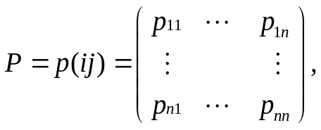

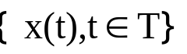

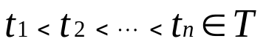
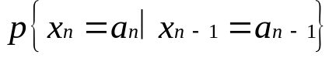

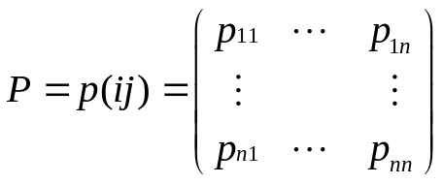 , 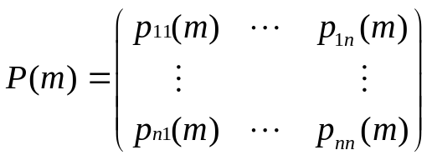,
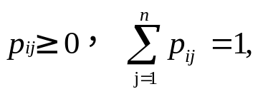 (m)=p^{m}
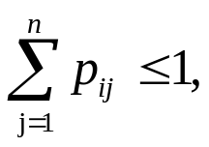
Above all, we can draw the conclusion:
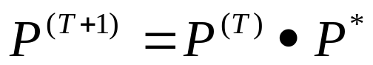 (T=1，2，3，…，N) (1)

Signs and definitions indicated above are still valid.
3.1.3 Variables
T：time
3.1.4 Function
：the array of employees' mobility
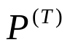：the initial condition of employees' distribution in the T year
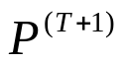：the condition of employees' distribution in the T+1 year

    - Applying the model
Table Ⅰ
The employment chat of a enterprise in 2007（Unit: person）

Information  Management | No .1Technology  Department | No .2Technology  Department | No.1Market  Department | No.2Market  Department | No.1Production Department | No.2Production Department | Actual employees number
400 | 1600 | 1500 | 5000 | 5000 | 6000 | 6000 | 25000

Chat Ⅰ
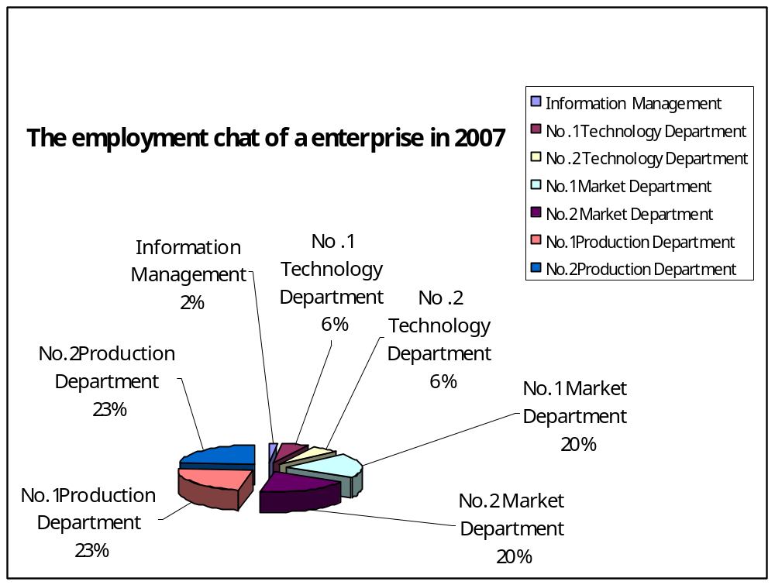

Markov transfer array model was initially used in Holland Army , then it expanded to apply in enterprises, It use quantified method to predict numbers shared the same interval time point of various employees. The basic theory is to find the regulation of the past and therefore predict the condition of employees in the future.

Suppose that an enterprise has 7 departments including Information Management, No .1 Technology department, No.1Market department, No.2 Market department, No.1 Production department and No.2 Production department. It is already known that since beginning year (the end of 2007) four departments have400, 1600, 1500, 5000, 5000, 6000 and 6000 people respectively: Combing the transfer rate of different departments, we got transfer arrays of different departments, which indicates how seven departments mobilize from the beginning to the end of this year. The illustration is shown from chat as follow.
Department

TableⅡ employees transfer

Post | Initial Number | Information Management | No.1 Technology Department | No.2 Technology Department | No.1 Market Department | No.2 Market Department | No.1 Production Department | No.2 Production Department | Resignation Rate
Information Management | 400 | 0.9 |  |  |  |  |  |  | 0.1
No.1 Technology Department | 1600 | 0.1 | 0.7 |  |  |  |  |  | 0.2
No.2 Technology Department | 1500 |  | 0.1 | 0.75 | 0.05 |  |  |  | 0.1
No.1 Market Department | 5000 |  |  | 0.1 | 0.75 |  |  | 0.05 | 0.1
No.2 Market Department | 5000 |  |  |  | 0.8 | 0.1 |  |  | 0.1
No.1 Production Department | 6000 |  |  |  |  | 0.2 | 0.7 |  | 0.1
No.2 Production Department | 6000 |  |  |  |  |  | 0.2 | 0.6 | 0.2

Assume that the data is calculated based on the actual condition of the enterprise in a certain period, and don't consider the state of past years. Besides, the array's feature won't change as time goes by (after one year, two years...n years). As a result we get the prediction of employees' distribution in the enterprise in the next 5 years by building Markov model.
Analyzing Process：
1. Establish the prediction array of mobility of employees in the future. According to the formula:
(T=1，2，3…,N)
is the array of employees' mobility, is the initial condition of employees' distribution in the T year，is the condition of employees' distribution in the T+1 year.
Specific data calculation is as follow:
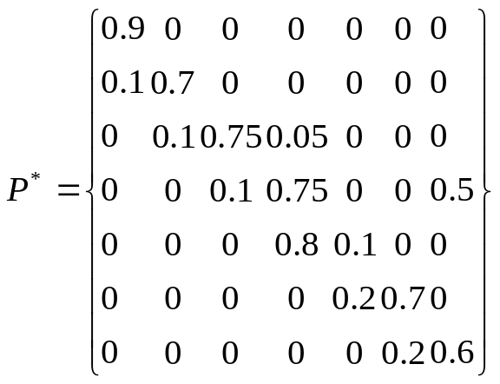

2.Bring in specific numbers and calculate：

Total number of human resource of the first year = 520+1270+1625+7825+1700+5400+3850=22190

Total number of human resource of the second year = 595+1052+2001+7310+1250+4550+2701=19459

Total number of human resource of the third year = 641+936+2232+6583+1035+3725+1986=17138

Total number of human resource of the forth year = 670+879+2332+5877+849+3005+1521=15133

Total number of human resource of the fifth year = 691+848+2337+5203+686+2408+1206=13379

(Unit: person)

The chat is as follow:

Table Ⅲ
Items  Year | Information  Management | No .1Technology  Department | No .2Technology  Department | No.1Market  Department | No.2Market  Department | No.1Production Department | No.2Production Department | Actual employees number
First year (2008) | 520 | 1270 | 1625 | 7825 | 1700 | 5400 | 3850 | 22190
Second year  (2009) | 595 | 1052 | 2001 | 7310 | 1250 | 4550 | 2701 | 19459
Third year  (2010) | 641 | 936 | 2232 | 6583 | 1035 | 3725 | 1986 | 17138
Forth year  (2011) | 670 | 879 | 2332 | 5877 | 849 | 3005 | 1521 | 15133
Fifth year  (2012) | 691 | 848 | 2337 | 5203 | 686 | 2408 | 1206 | 13379

（unit：person）

Table Ⅳ Cost of HR for the beginning year[2]

Costs and calculations associated with employees mobility
Main subject | Parameter or explanation
Cost Category A: Separation Cost
Training and other education cost for its employees before leaving his post | Internal training and external training
The cost of the loss of intellectual property rights | 50% wages of one employee leaving per year，at an increasing rate 10%
Maintaining and recovering cost on losing client | Establishing purchasing, logistics and selling post 5 times more than maintaining one
Economic compensation cost | 2-5 times of salary
Labor arbitration and legal action cost | 100 hours on average
separation cost calculation：6000 yuan (The annual increment by 10%)
Cost Category B: Vacancy cost
Internal employees to fill the vacancy | 45-60 days per period
Additional cost for temporary employment | According to actual calculation
Vacancy cost calculation：4000 yuan (The annual increment by 10%)
Cost Category C: Replacement Cost
Internal recruitment cost | Whole process costs 30-100 hours
Advertising, recruiting and headhunting cost | 2000-10000 yuan
Replacement Cost calculation：12000 yuan（The annual increment by 10%）
Cost Category D: Training Cost
Trainers' payment | 40-80 hours
Training material | 100-500 yuan a person
Learners' payment and welfare | 100 hours on average
Training Cost calculation：35000 yuan (The annual increment by 20%)
Cost Category E: Lost Productivity Cost
The cost of the loss of productivity after 1-2 month departure | 50%-70% of normal Productivity
Lost Productivity Cost calculation：5000 yuan (The annual increment by 10%)
Total：62000 yuan

According to chat Ⅳ, the cost of HR is 62000 yuan in 2007.

Cost of human resource of the first year (2008) is 71700 yuan.
Cost of human resource of the second year (2009) is 83070 yuan.
Cost of human resource of the third year (2010) is 96417 yuan.
Cost of human resource of the forth year (2011) is 112106.7 yuan.
Cost of human resource of the fifth year (2012) is 130575.29 yuan.

TableⅤ

Year  Items | First year（2008） | Second year（2009） | Third year（2010） | Fourth year（2011） | Fifth year  （2012）
Cost of human resource（Unit：yuan/person） | 71700 | 83070 | 96417 | 112106.7 | 130575.29
The total number of human resource（Unit：person） | 22190 | 19459 | 17138 | 15133 | 13379
The total cost of human resource (Unit: yuan) | 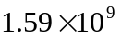 | 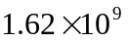 | 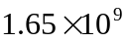 | 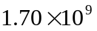 | 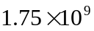

3.2 Model Ⅱ（Unitary Linear Regression Equation Model[4]）
We use the Unitary Linear Regression Equation Model to Analyze the Human Resources demand forecasts.

3.2.1 Assumptions
- Number of people in the company that years be predicted and HR showed a significant linear relationship increased year by year.
- The next five years, the total of human resources and time to meet the Unitary Linear Regression Equation Model.

3.2.2 Equations
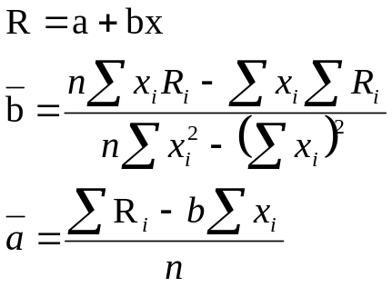 （2）
3.2.3 Parameters
a: model parameter
b: model parameter
R: the total number of Human Resource
n: years
i: numbers

3.2.4 Variables
x: time

3.2.5 Applying the model
TableⅥ The total number of Human Resource

X(Annual) | （1）  2002 | （2）  2003 | （3）  2004 | （4）  2005 | （5）  2006 | （6）  2007
R(The total number of human resource) | 22100 | 22700 | 23400 | 23900 | 24500 | 25000

ChartⅡ the total number of human resource
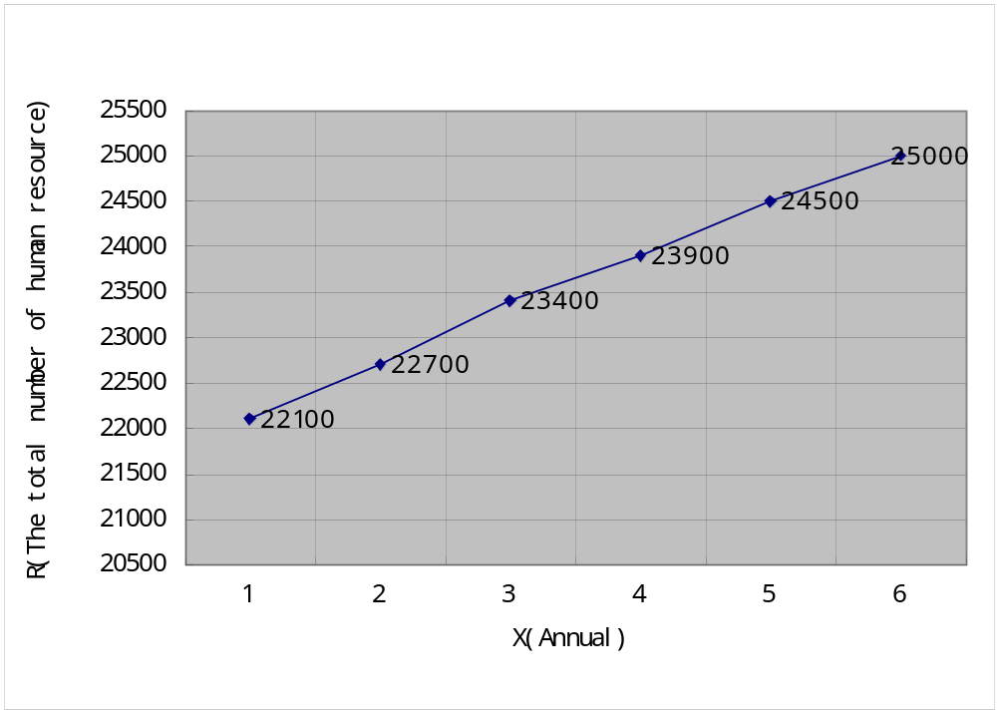

- From the chat, the total number of Human Resource in the company increase year by year, the year and the total showed a linear relationship and meet the assumptions above. We can use the Unitary Linear Regression Equation Model to predict it. Here the parameter R is the total of HR to be predicted, the variable x is time (year). The model is established according to chatⅠ.

In this case n=6, we calculate as follow:

Put the result into formula:

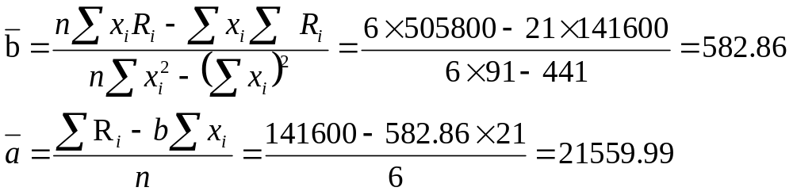

Thus, we can get the total number of linear predictive models of human resources:

Since the year 2008, 2009, 2010, 2011 and 2012 corresponded to x = 7, x = 8, x = 9, x = 10, x = 11. Bring it into the prediction model, and get the predictive value of the next five years as follows:

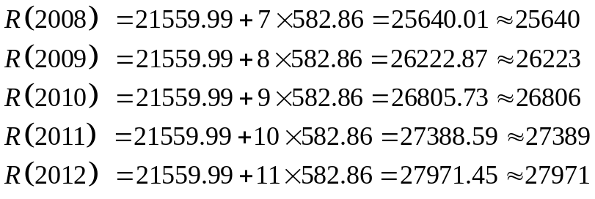

The image programmed by Matlab is shown as below,

Chart Ⅲ Prediction of Human Resource demand in a linear regression model 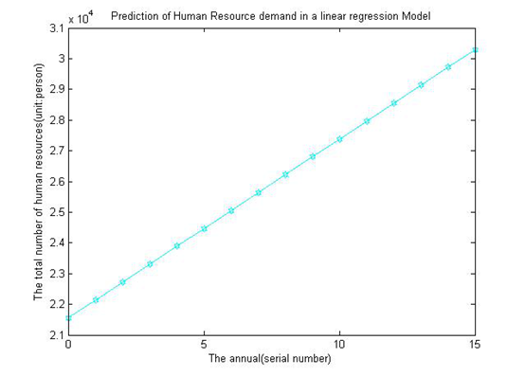
3.3 Model Ⅲ （The Gray Forecast Model[1]）
3.3.1 Equations
Set 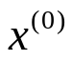 as initial array:
=( (k) ×k=1,2,…，n)=( (1)，(2)，…， (n))
Set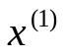 as forming array:
=((k)×k=1,2，…，n)=( (1)，(2)，…，(n))
Suppose 与 meet the following relation, that is:
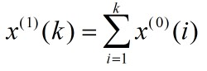
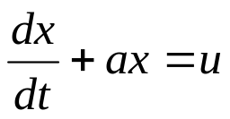 (3)
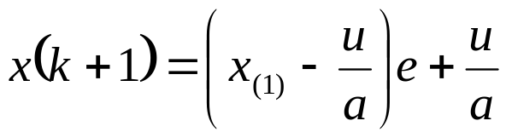
3.3.2 Parameters

α: developing gray number；
u: internal control gray number

3.3.3 Variables

x: year

3.3.4 Applying the model

According to the TableⅥ used in model 2, we can make gray forecasting by Matlab complies.
TableⅥ The total number of Human Resource

X(Annual) | （1）  2002 | （2）  2003 | （3）  2004 | （4）  2005 | （5）  2006 | （6）  2007
R(The total number of human resource) | 22100 | 22700 | 23400 | 23900 | 24500 | 25000

And get the diagram below:
ChatⅣ
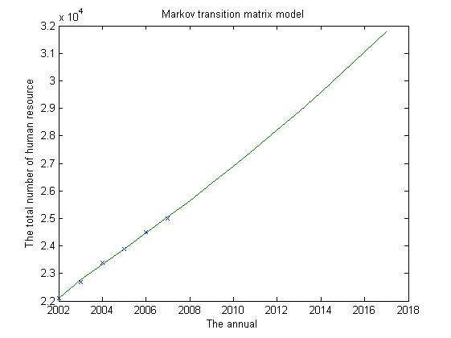
As is shown in ChatⅣ, the first 6 point represent the actual initial data，deep blue line for predicted number of people, compiled MATLAB program shows a comparison between predicted data and initial data, therefore, we can see the predicted data is scientific and accurate.
Ⅳ. Conclusions

4.1 Strengths and Weaknesses
4.1.1 Model Ⅰ (The Markov Chain Model [6])
Strengths:
Markov transition matrix can be used with any human resource predicting measures, enabling enterprises to formulate relevant planning and schemes with the data of supply and demand. The model requires small data and costs few. Through scientific computing, the outcome generally has high accuracy and stability. On the problem of transferred personnel, the Markov model gets its biggest advantage. It is practical and applicable to a large capacity data’s prediction. When it comes to small capacity data, the predictions are still accurate.
Weaknesses:
Since the enterprise personnel allocation and liquidity situation is not static, on the contrary, it’s always changeable. Worse still, the enterprises’ relevant regulations and policies are mutative. Since then, we must consider the two points that the assumed matrix’s characteristics are fixed over time and the state of the start year is not taken into consideration. Otherwise, the transfer matrix will lose its scientific and practical.
4.1.2 Model Ⅱ (The Unitary Linear Regression Equation Model)
Strengths:
Unitary Linear Regression Equation Model is practical for forecasting human resource needs. It's established under the conditions of time being a variable, and finds a mathematical relationship between the level of production and business activities with the demand for workers. In despite of this, the model has proved that the formula is simple, the diagrams are intuitive, and calculation is easy. Moreover, we have drawn some useful conclusions that given the corresponding values ​​of the independent variables, the model can calculate the corresponding relations and predict the future. The model is fit for short-term prediction such as the range of 1 to 5 years, which are more accurate and less cost. Comparing the front figure with the later one, we can see that the actual and predicted values trend to be same, showing the high predictive accuracy of the model.

Weaknesses:
This model just applies to the condition when previous data demonstrates that the human resources have approximate linear trend, which has a slight limitations. When the model is used to predict the human resource more than 10 years, there will be some difference with the actual situation and it requires more data. That’s just what we should do in the improved model.

4.1.3 Model Ⅲ (The Gray Forecast Model)
Strengths：
The Gray Forecast Model has a strict theory basic，and its biggest advantage is practical. Using The Gray Forecast Model to get the result is stable, and it not only can be used to predict mass data, but when data is little, the predicted result is still correct. Combing our expense prediction with the model, first, we use gray forecast model to predict the supply of HR. Then, refer to the cost of HR to get data statistics. The solution is easier and convenient. Meanwhile, Grey model is the inverse of the data processing result of the model prediction value obtained by generating the data model, it can identify the original data by the law of the system changes, then generates of random data. And the image obtained from the model established in time. We can see from the model neither detaches initial data can be supplied to the scientific prediction of the amount of human resources costs.
Weaknesses:
The data resulted from Gray model must generate inverse and be restored then. Sometimes unqualified or accuracy of the model is not ideal phenomenon.

4.2 Conditions needed in all industry

Hermit crabs' "long conga dance" is called "the opportunity chain" in sociology by a famous American sociologist Harrison White. [5] In the social industries, the incumbents are eager to have better career development, so they will move toward more suitable and attractive jobs, resulting in the original job vacancies. Job vacancies offer newcomers new employment opportunities. Post vacancies, filling, rotation, and a series of career opportunities arising from internal staff mobility is called opportunity chain.

Opportunity chain is composed of the vacancy chain and mobility chain. Vacancy chain is a chain of vacancies arising from staff resignation. Mobility chain refers to a occupational mobility chain of former workers leaving post and job seekers filling in the gap.

Mobility of the labor is the cause of the existence of mobility chain. In the social environment, the flow of employees achieves the "match" between employees and organization. People post match job requirements and the needs of the individual strengths organically combine to get the best effect of human resource management. Human resources supply and demand analysis can effectively control the internal supply forecast liquidity position and industry insiders sport mode, making a perfect match people and positions, and ultimately to optimize the overall efficiency of the organization.

So these optimization opportunities chain hermit crabs in the community or industry conditions applicable to the Company should be as follows:

1) The number of jobs to maintain the growth trend. (-- More shells)
For relatively stable socio-economic position, once increase the supply of jobs and the vacancy on the part of the chain, that is, has more cake for allocation. First, the vacancies attract people of internal organization; the second is to attract people outside the organization (from school or other organization). Work to fill the gap when the individual is coming from outside the organization, or the last one was withdrawn Kong Gang vacancy chain is closed.

2) Each staff member has a good career planning capabilities, and improve the ability to work with their desire is more suitable for professional development work. (-- Each hermit crab shell wants a bigger shell)
With the ability and experience accumulated by working hours, staff rising, motivated employees who have a certain sense would consider enhancing the social value of a combination of factors, honor, etc... They will want a better position.

3) Industry planners grasp the scientific job analysis and personnel evaluation methods. (-- Hermit crabs can exchange shells by size queuing)
If employees feel that existing jobs can not match their actual ability, they hope to find more challenging work (get a better job), then the companies will take the appropriate measures to retain talent, the individual's career goals with organizational goals combined. Such as promotion or lateral moves to fit their positions in order to equal to their talent, increase employees' job satisfaction in order to ensure the future of the organization to have enough qualified personnel supply.

Ⅴ. References
[1] Jinwu Zhuo. Application of MATLAB in Mathematical Modeling. Beijing University of Aeronautics and Astronautics Press. April 2011
[2] Jie Kong. China Enterprise Best Case in 2003 - Human Resources. Commercial Press. January 2003
[3] Li Lin. Human Resource Management. Tsinghua University Press. May 2012
[4] Yongle Zhao. Human Resource Planning. Electronic Industry Press. January 2010
[5] Harrison. C. White. Chains of Oppotunity, Gezhi Press. March 1970
[6] Hongli Sun. Markov model's application in human resource supply Prediction. North China Electric Power University Paper. September 2004
Ⅳ. Appendix

Programs and codes（Matlab file）：
Matlab File of Table Ⅲ

P=[0.9,0,0,0,0,0,0;0.1,0.7,0,0,0,0,0;0,0.1,0.75,0.05,0,0,0;0,0,0.1,0.75,0,0,0.05;0,0,0,0.8,0.1,0,0;0,0,0,0,0.2,0.7,0;0,0,0,0,0,0.2,0.6;]

P =

0.9000 0 0 0 0 0 0
0.1000 0.7000 0 0 0 0 0
0 0.1000 0.7500 0.0500 0 0 0
0 0 0.1000 0.7500 0 0 0.0500
0 0 0 0.8000 0.1000 0 0
0 0 0 0 0.2000 0.7000 0
0 0 0 0 0 0.2000 0.6000

P1=[400,1600,1500,5000,5000,6000,6000]

P1 =

Columns 1 through 5

400 1600 1500 5000 5000

Columns 6 through 7

6000 6000

P2=P1*P

P2 =

Columns 1 through 5

520 1270 1625 7825 1700

Columns 6 through 7

5400 3850

P3=P2*P

P3 =

1.0e+003 *

Columns 1 through 6

0.5950 1.0515 2.0013 7.3100 1.2500 4.5500

Column 7

2.7012

P4=P3*P

P4 =

1.0e+003 *

Columns 1 through 6

0.6406 0.9362 2.2319 6.5826 1.0350 3.7253

Column 7

1.9863

P5=P4*P

P5 =

1.0e+003 *

Columns 1 through 6

0.6702 0.8785 2.3322 5.8765 0.8486 3.0049

Column 7

1.5209

P6=P5*P

P6 =

1.0e+003 *

Columns 1 through 6

0.6910 0.8482 2.3368 5.2028 0.6858 2.4076

Column 7

1.2064
Matlab File of ChatⅣ
syms a b;
c=[a b]';
A=[22100,22700,23400,23900,24500,25000];
B=cumsum(A);
n=length(A);
for i=1:(n-1)
C(i)=(B(i)+B(i+1))/2;
end
D=A;D(1)=[];
D=D';
E=[-C;ones(1,n-1)];
c=inv(E*E')*E*D;
c=c';
a=c(1);b=c(2);
F=[];F(1)=A(1);
for i=2:(n+10)
F(i)=(A(1)-b/a)/exp(a*(i-1))+b/a;
end
G=[];G(1)=A(1);
for i=2:(n+10)
G(i)=F(i)-F(i-1);
end
t1=2002:2007;
t2=2002:2017;
G

G =

1.0e+004 *

Columns 1 through 11

2.2100 2.2774 2.3323 2.3885 2.4461 2.5050 2.5654 2.6272 2.6906 2.7554 2.8218

Columns 12 through 16

2.8898 2.9595 3.0308 3.1038 3.1786

plot(t1,A,'x',t2,G)
title('Markov transition matrix model');
xlabel('The annual');
ylabel('The total number of human resource');

